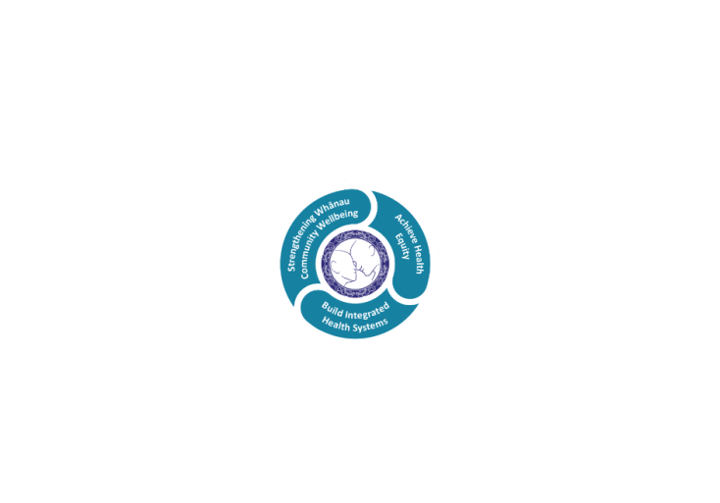

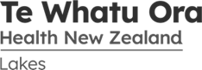

# POSITION DESCRIPTION

|  |  |  |
| --- | --- | --- |
| **Position**: | Service Manager Medical Services | |
| **Responsible to:** | Group Director Operations | |
| **Direct Reports:** | * Service Leadership Team (SLT) * Personal Assistant * Administration Support Team * Clinical Nurse Managers * Medical Staff | |
| **Location:** | Based in Rotorua Rotorua & Taupō | |
| **Functional relationships:** | **Internal:**  Executive Relationships with all Managers operating across the Te Whatu Ora - Lakes  Executive Management Team  Lakes Management/Governance Team  Manager, Quality Risk & Clinical Governance  Human Resources Consultants  Management Accountants  Māori Health/Te Aka Matua Service  SMOs  Nursing Staff  Allied Health Staff  Administration Staff  Other Te Whatu Ora - Lakes Staff | **External**:.  General Practice  NGOs |
| **Financial delegations:** | $25,000 | |
| **Date**: | January 2024 | |



### Primary purpose(s) of the position

1. Delivers an excellent people centred results focussed service which live the values and aspirations of Te Whatu Ora Lakes through inspired leadership, robust and skilled management, effective communication and the principles contained in Te Iti Kahurangi.
2. Delivers to a one service, two sites philosophy to ensure that services are maximised and provided safely in both Rotorua and Taupō
3. Decision making is facilitated by Service Partnership in the form of a Senior Leadership Team (SLT). The service manager is responsible for providing information and analysis to the Service Leadership Team
4. At all times demonstrates and fosters a positive image of the Services and Te Whatu Ora - Lakes. Is an active participant in clinical governance and planning/funding partnerships.
5. Responsible and accountable for leading, planning, managing and delivering Services in alignment with the strategic and operational direction of Te Whatu Ora - Lakes.
6. Delivers clinical and financial stability through effective systems and proactively manages the day to day business requirements in a timely way.
7. Develops and embeds a culture and environment for learning and innovation and which recognises excellence in quality, performance, and patient safety.
8. Management of the following Service Teams:

* Adult Medicine
  + Inpatients
    - Medical Unit
    - Inpatient Unit – Taupō
    - Chemotherapy/Medical Day Stay
  + Outpatient Service delivery (including production management, clinical standards, ESPIs, waiting times)
    - General Medicine
    - Cardiology
    - Respiratory
    - Gastroenterology
    - Diabetes/Endocrinology
    - Infectious diseases
    - Visiting Specialists in: Neurology, Dermatology, Renal, Haematology
    - Oncology & Chemotherapy
    - Chronic Diseases and Clinical Nurse Specialists – including Taupō
      * Diabetes
      * Respiratory Sleep
      * Cardiac
      * Cancer Care Coordination
      * Renal Satellite Unit & Renal Specialists Nurses
* Older Persons & Rehabilitation Services (OPRS) – including Taupō & dedicated Allied Staff
* ICU/CCU – including “outreach” nursing
* District Nursing and Hospital in the Home

|  |  |  |
| --- | --- | --- |
| **Key Objectives** | Description | Expected Outcomes |
| **One Service Two sites** | Services are supported to be provided at Taupō | * Support for clinicians operating in isolation * Ability to rotate clinical staff between sites as appropriate * Operational risk at Taupō minimised * Taupō to be a more attractive recruitment potential * Relationship with Taupō primary/community sector improved and functional * Likelihood of patient referrals outside of Lakes minimised * Clinical services which are appropriate and safe provided closer to patient homes * Visits Taupō site at least monthly and provides support to the Taupō Site Manager |
| **Service Partnership** | * Responsible for development and maintenance of the Service Senior Leadership Team * Accountable for consequences to the whole systems as a result of any actions taken * Supports and promotes clinical decision making in the direction and delivery of services * Responsible for leading the service annual planning process providing information and analysis to the Service Leadership Team to support decision making | * Service Leadership team established * Clinical perspective considered in decision making * Ensures consideration on whole of system with any proposed action * Service annual operational plan prepared, agreed and achieved within the required timeframes * Service achievements reported quarterly |
| **Leadership** | * Demonstrates consistent leadership that inspires and enables aspirations of the Te Whatu Ora - Lakes and staff to succeed and to build a culture of positivity, achievement and success. * Proactively models the vision and values of Lakes. * Positive attitude demonstrated to change management and lean thinking methodology. * Consistently behaves in an ethical and professional manner. * Proactively instils pride and upholds the image of Lakes. | * Active management with documented outcomes within Te Whatu Ora - Lakes delegations. * Solutions and issues managed as close to the problem as appropriate. * Situations escalated appropriately and in a timely manner to Interim District Lead. * Delivers clear, timely direction and guidance to direct reports. * Articulates actions and demonstrates an excellent understanding of the service issues and opportunities for resolution and or advancement. * Judgement executed in alignment with organisational direction and goals. * Leads negotiations and processes to achieve the best possible outcome for patient and staff. * Celebrates success and recognises quality and excellent performance of teams and individuals. * Service is known as responsive, innovative and a leader in the Te Whatu Ora - Lakes. * Is regularly visible within the Service. * Ensures robust Clinical Governance model within the service. Operates an effective monthly clinical governance meeting, providing assurance, continuous quality improvement within agreed clinical governance framework. * Provides robust orientation to new leaders and support to reports to perform to a high level. |
| **Service Delivery** | * Operationalises and manages the day to day operations, commercial interests and financial affairs of the service efficiently and effectively in accordance with Lakes policies, directions of the Interim District Lead * Manages the patient care experience and patient care service delivery as a priority. * Forms part of the 24 /7 After hours Managers on Call roster * Development of achievable business and quality plans. * Develops and implements methods and systems to monitor performance against objectives and target * Manages the delivery of the Service within the contractual parameters * Works in partnership with the Service Management Accountants | * With the SLT ensures clinical input into the delivery of services including Service Level Agreements, contracts, business, financial and quality planning * Ensures optimal clinical input into the delivery of service and patient care daily/weekly/monthly basis. * Delivers patient surveys/feedback as per Lakes policy guidelines and implements “learnings” into the service. * Actively supports evidence based practice into the clinical environment. * Actively supports an inclusive multidisciplinary approach. * Maintains a patient focus environment for patients and their families including Māori support services. * Undertakes service surveys at least annually and forms part of the District Annual Plan. * Completes the investigation process and writes letter to complainant following formal patient complaint. * Delivers achievable business and quality plans with clear objectives and targets for service delivery. * Reports monthly against established resource and financial parameters and manages variances effectively. * Investigates and writes reports on developing trends. * Works to support Acute Flow within own departments through effective and efficient service delivery, and processes to support acute flow across the system * Completes service production plans to meet service needs. * Meets ESPI organisational requirement met at all times * Evidence of sustainable systems and reports demonstrating compliance and action plans. * Discharge planning, transition of care and length of stay monitored and reported on monthly. * Dashboard developed for service and staff are conversant with targets and results * Accountable for the budgets of the Service and responsible for any corrective action * Communicates financial, volume delivery issues, risks to Interim District Lead * Meets monthly with the Interim District Lead reporting on progress and plans * Works actively to manage workloads within the departments calmly, consistently and positively * Provides robust monthly report in agreed format within required timeframe |
| **Internal Connectivity and Integration** | * Working with other services within Clinical Services to optimise efficiency and effectiveness. | * Initiates actions to maximise bed management protocols * Delivers effective human resource management to maximise safety at the most cost effective solution * Is cognisant of the impact of change on all other services * Communicates and advocates for own service * Communicates activity to other services * Maintain an effective working relationship with HR, Finance, Decision Support, Quality & Risk, Communications, Hotel and Security Services. |
| **Continuous Quality Improvement** | * Establishes and leads Continuous Quality Improvement programme | * An Annual Quality Plan as part of the Annual Operational Plan is developed, implemented & monitored * Clinical Audit Programme is supported * Organisational CQI programmes and initiatives are supported within the service |
| **Change Management** | * Facilitates and supports change management within and across services | * Responsible for developing a staff orientation and culture whereby change is considered a dynamic part of the health sector development. * Change management led by other divisions and services is supported * Demonstrates effective change management |
| **Communication** | * Ensures effective communication | * Creates and fosters environment for all parties of mutual trust and respect that enables information sharing with effective communication between individuals, teams and clinical governance |
| **Financial and Resource Management** | * Ensures prudent financial and resource Management | * Effective and efficient use of resources within budget to deliver robust financial performance * A continual process of review, evaluation/ analysis and implementation of initiatives which delivers optimum cost savings, revenue generation, quality and service gains are achieved |
| **People Management** | * Provides people management service for all medical staff at Lakes. This includes, recruitment, orientation, leadership in performance management, undertaking remuneration reviews and service job sizing. * The Service complies with the “good employer” requirements of the Health and Disability Support Services Act and with the requirements of the Health and Safety in Employment Act * Develops and implements a workforce plan to meet the requirements of the Service. * The Service values its staff and develops processes to empower and positively reinforce the Te Whatu Ora - Lakes values. * Oversights high quality rostering for all medical staff and compliance with all relevant MECA | * Accountable for planning, monitoring, delegation and coordination of team work processes to achieve service delivery * Evidence of comprehensive inclusive workforce plan actively managed in the Service * Manages people management processes including recruitment, performance management, learning and development policy compliance in accordance with Lakes Policies and Procedures. * Supports Service Managers with performance management processes for SMOs and Registrars within their service * Responsible for ensuring RMO rosters meet the service delivery needs and are consistent with union agreements. * Responsible for accountabilities and responsibilities of direct reports are understood and maintained. * Responsible to reporting staff receiving timely, accurate and constructive feedback on performance. * Supports other Service Managers to manage the appropriate professional development of SMOS and RMOs within their service. * Promote that at minimum meets the requirements of the professional scope of practice and are aligned with service goals and outcomes. * Ensures orientation and ongoing professional development opportunities are implemented. * Responsible for the service to complete annual appraisals for all staff within the service * Actively manages for staff within the service, annual leave, sick leave and actions according to Lakes policies. * Implements performance management processes according to Lakes policies. * Proactively manages FTE levels to agreed budget through recruitment and retention strategies |

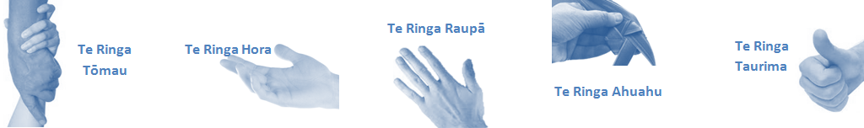

|  |  |  |
| --- | --- | --- |
| **Capabilities** | Capability definition | Achievement Indicators  *(Examples – add/ amend or delete as specific to role using matrix to assist)* |
| **Communication and Personal Interaction**  **Te Ringa Hora**  ***the open hand (denoting someone who is sociable)*** | Operates at a Te Whatu Ora - Lakes wide level understanding the implications of communications within own service and other services. | * Ensures information gets to the appropriate people within the organisation to facilitate effective decision making. * Meets regularly, formally and informally with all reporting teams on a regular basis |
| Presents clear and articulate messages to all levels of the organisation | * Transfers information effectively altering language and tone as necessary to reach different staffing levels or groups. * Provides timely monthly and other reports as required and responds in a professional manner to emails and requests for advice * Communicates clearly - verbally, presentations and in writing |
| **Strategy & Performance**  **Te Ringa Raupā**  ***the roughened hand (symbolising a hard worker)*** | Proactively searches out solutions to problems and makes timely and appropriate decisions. | * Demonstrates effective and timely decision making/problem solving techniques. * Strives for improved work processes that will result in greater effectiveness and efficiencies both within reporting departments and across the system |
| Understands the implications decisions within the service or individual units have on the wider organisation and other services. | * Aware of the potential impact on other services of decisions on service delivery and consults as appropriate utilising available resources. * Is involved in robust local and regional planning within service area |
| Works collaboratively with stakeholders to maximise overall effectiveness. | * Provides information to stakeholders before any change occurs. * Seeks feedback from stakeholder groups on service delivery. * Modifies and enhances service delivery in collaboration with stakeholders. |
| **Development and Change**  **Te Ringa Ahuahu**  ***the hand that shapes or fashions something (refers to someone who is innovative)*** | Provides innovative solutions to problems. | * Will change or modify own opinions and will switch to other strategies when necessary |
| Supports and guides staff through change. | * Encourages problem solving, solution finding and hardwiring of agreed changes. * Is empathetic and inclusive in finding solutions. * Engages with staff to understand concerns and provide feedback on possible solutions. * Encourages teams to put forward ideas for strategic change. |
|  |  | * Collects data on deliverables and changes. Reports and celebrates success |
| **Personal Accountability**  **Te Ringa Tōmau**  ***the hand that is trustworthy*** | Manages own and encourages others to foster work/life balance. | * Ensures regular breaks are taken and own annual leave accruals are used within the 12 months following accrual. * Ensures employees within their service are taking regular annual leave breaks for the purpose of rest/recreation throughout the year |
| Actively manages own career aspirations and development. | * Is constantly striving to acquire and maintain knowledge, skills and/or experience. * Has own career development plan and succession planning. * Seeks out development opportunities to expand knowledge and capability. * Engages in projects and activities readily which are above and beyond scope of current role. |
| **Culture and Values**  **Te Ringa Taurima**  ***the hand that nurtures, encourages, supports*** | Inspires team to achieve whilst maintaining Te Whatu Ora - Lakes values. | * Works with teams to identify plans for their unit and selves that will contribute to the organisation’s annual plan, vision/mission etc. |

|  |  |  |
| --- | --- | --- |
| **Compulsory Requirements** | Description | Expected Outcomes |
| **Māori Health** | Māori philosophies and values of health are demonstrated in work practice. | * Meaningful relationships are established and maintained with Te Aka Matua (Rotorua and Taupo Hospitals) * Practices are consistent with Te Tiriti o Waitangi /The Treaty of Waitangi when working with Māori. * Delivery of safe services for Māori are facilitated by ensuring they can access treatment options and are involved in the planning and delivery of their care. * Promotes appropriate service improvements within organisational direction that reduce inequities and improve health outcomes for Maori * Māori are enabled to access and participate in cultural activities provided by the Lakes. * A commitment to improving the wellbeing of Māori by increasing cultural knowledge in the Lakes is shown. |
| **Te Iti Kahurangi** | The Lakes Way, Our Place Our Culture | * Works within the Te Iti Kahurangi framework and supporting guide document. |
| **Record Keeping** | Accurate and high quality record keeping supports robust management practice | * Complies with the Lakes Corporate Records Management policy to create and maintain full and accurate records. * Maintains appropriate records to support and evidence robust management practices |
| **Quality & Risk** | Patient safety is paramount to the service we deliver at Lakes. This is to be achieved in a clinical governance framework that is culturally responsive and identifies and manages risk and opportunities to improve. | * Delivers quality improvement within service * Ensures that the service has a monthly Clinical Governance meeting and provides required written report to Lakes Clinical Governance Executive. * Employees are supported to lead by example and implement a culture of continuous quality improvement. * Risks that may prevent Lakes from achieving their goals are identified, reported, and managed. * Māori patients are provided patient-centred care to achieve positive Māori health outcomes. * Needs of Māori are reviewed and reported in the further development of practice, process and or policy. * Evidence-based methodologies are used to support improvements, e.g. kaupapa Māori methodology. * Quality care is provided to certification standards. |
| **Health & Safety** | Each individual is responsible for ensuring the safety of themselves, their colleagues, patients and their visitors and to comply with all organisational health and safety policies, procedures and guidelines. | * Implementation and reinforcement of a proactive healthy work place culture which reflects relevant Lakes policy and legislative requirements. * Healthy lifestyles are actively promoted and participated in, within the work area. * Employees participate in Health and Safety within areas of work. * Health and Safety activities are appropriately documented within specified timeframes. * Health and Safety policies have been read and understood and are applied in the workplace. * Health and Safety policies are appropriately documented within specified timeframes and incidents are reported immediately. * Any opportunities for improving Health and Safety are reported and acted upon in a timely manner. * All near misses/incident/accidents are reported to the appropriate line manager within 24 hours. |

**Signatures:**

|  |  |
| --- | --- |
| Line Manager:  (position description approved): |  |
| Employee:  (acceptance of position description): |  |

*(Please also initial all other pages to show acceptance of position description.)*

|  |  |  |
| --- | --- | --- |
| **Person Specification** | **Essential:** | **Desirable:** |
| **Education and Qualifications:** | * Tertiary qualifications in management or a health-related field. | Qualifications as a health clinician |
| **Experience:** | **Human Resources:**   * Human Resources management experience at a mid to senior business partner level.   **Leading & Motivating:**   * Articulates a compelling vision for their service within the organization * Makes it clear how people’s work fits into the overall business direction and strategic priorities * Promotes and models a strong customer focus   **Managing People:**   * Makes sure staff know what is expected of them * Communicates often with staff about their performance and progress * Recognise and celebrates/rewards good performance * Addresses any poor performance or inappropriate behavior immediately, open and directly * Personally puts time into coaching and mentoring staff * Gives staff the opportunities and freedom to develop * Considers development needs when delegating work to staff * Demonstrates resilience and positive disposition when managing high workload prioritizing competing demands * Puts in place effective and efficient systems based on Te iti kahurangi to promote self-accountability * Readily establishes and maintains credibility in the role and to work effectively as part of the Service Management team   **Strategic Management:**   * Maintains a big picture view of own area of the business * Ensures shorter term objectives are tied to the broader strategic direction * Recognizes the impact of broader issues and emerging trends on the area of responsibility * Challenges others to improve and innovate * Seeks feedback form internal and external customers and implements changes to improve   **Operational management:**   * Has experience and demonstrates competency in operational service management of services * Demonstrates effective operational management , knowledge of lean methodology and service delivery | * .. Able to demonstrate previous experience managing a health service or similar is highly desirable |
| **Knowledge:** | * Te Tiriti O Waitangi in the provision of health care services and support to Māori. * Te Tiriti O Waitangi in practice, process, policy development and decision making. * Strong financial operational experience and understanding of financial sustainability in health service delivery. * Knowledge to deliver financial improvement in service performance * Ability to balance clinical needs with business, financial and other priorities * Effectively balances key priorities when making business decisions (i.e. financial, customer, internal processes, learning and growth) * Identifies and confronts problems early before they get out of hand * Resolute and committed to address important performance issues * Makes tough pragmatic decisions when necessary * Seeks an appropriately wide perspective of advice before making decisions | * .. |
| **Skills:** | * Pronunciation of Te Reo Māori words and names * High attention to detail and timely delivery of outcomes   **Technical Expertise:**   * Competent at computer use * Prepared to learn new software application * Prepared to complete CIMS Training   **Communication & Relationship Skills:**   * Promotes a credible image and inspires confidence * Actively shares information, ideas and experience with others * Works at building trusting relationships with consumers/customer and key stakeholders * Communicates sensitive messages or disagreements with tack and diplomacy * Treat people with respect and courtesy * Brings conflict in to the open and facilities resolution * Encourages the expression of differing and appraising views.   **Customer Services:**   * Has a focus on improving customer services and reducing complaints. * Work with all staff addressing systems, processes and personal behaviours that lead to complaints. | Competency with conversational Te Reo |
| **Personal Attributes:** | **Interpersonal Skills:**   * Motivates and inspires people to do their best * Promotes positive attitude towards change * Encourages teamwork and cooperation * Leads the team by encouraging others to contribute their opinions and builds on them, engages in collaborative practice with colleagues, maintain mutual respect and trust in relationships with peers and service consumers * Facilitates an effective team through encouragement, coaching and mentoring, providing direction, accommodating diversity in approach and fostering both professional and personal development * Embraces innovation and uses initiative in dealing with work problems and opportunities * Encourages staff to think creatively about systems, processes and opportunities   **Accountability:**   * Takes personal responsibilities * Reinforces Te Whatu Ora - Lakes vision and values and leads by example * Supports and advocates Te Whatu Ora - Lakes’ position on all issues * Demonstrates personal ownership of decisions made by the management team * Acts ethically and with integrity * Is open and honest with others * Actively pursues self-learning and development |  |

**ABOUT TE WHATU ORA - LAKES**

At Te Whatu Ora - Lakes we place the highest value on the health and wellbeing of everyone in our community. As such all healthcare workers are expected to play a part in the creation and promotion of an environment which lives the following vision, mission and values:

### VISION

Healthy Communities – Mauriora! In this vision Mauriora refers to the Mauri - being the life essence and the source of well being, and ora - describing the state of wellness.

### STRATEGIC MISSION

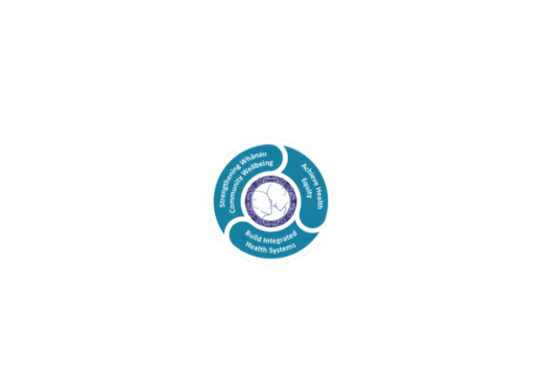

* Achieve equity in Māori health
* Build an Integrated health system
* Strengthen people, whanau & community wellbeing

### THREE CORE VALUES

Manaakitanga respect and acknowledgment of each other’s intrinsic value and contribution

Integrity truthfully and consistently acting collectively for the common good

Accountability collective and individual ownership for clinical and financial outcomes and sustainability

### TE ITI KAHURANGI – THE LAKES WAY, OUR PLACE, OUR CULTURE – WE WILL

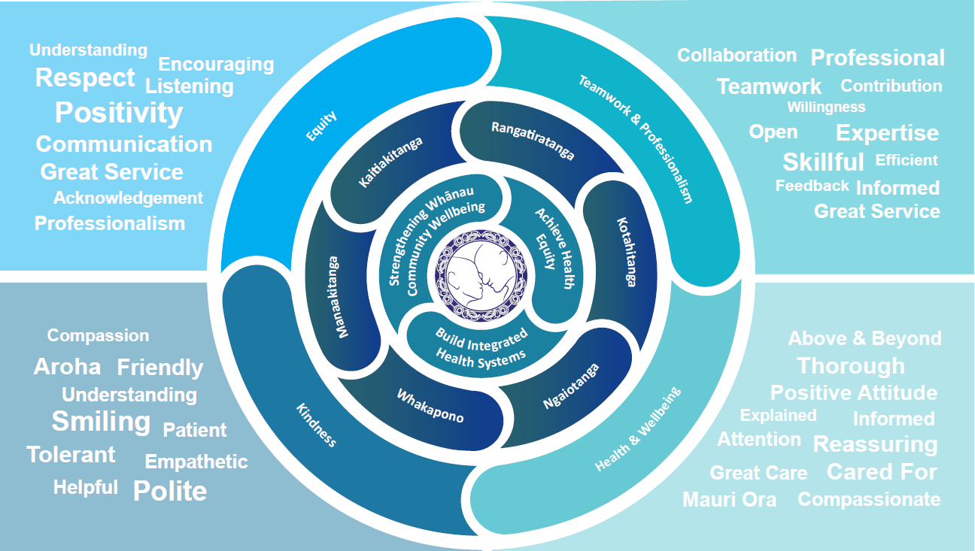

### TE TIRITI O WAITANGI

**Our expression of Te Tiriti o Waitangi**

The text of Te Tiriti, including the preamble and the three articles, along with the Ritenga Māori declaration, are the enduring foundation of our approach to achieving health and independence. Based on these foundations, we will strive to achieve the following four goals, each expressed in terms of mana.

**Mana whakahaere**

Effective and appropriate kaitiakitanga and stewardship over the health and disability system. Mana whakahaere is the exercise of control in accordance with tikanga, kaupapa and kawa Māori. This goes beyond the management of assets and resources and towards enabling Māori aspirations for health and independence.

**Mana motuhake**

Enabling the right for Māori to be Māori (Māori self-determination); to exercise their authority over their lives and to live on Māori terms and according to Māori philosophies, values and practices, including tikanga Māori.

**Mana tangata**

Achieving equity in health and disability outcomes for Māori, enhancing the mana of people across their life course and contributing to the overall health and wellbeing of Māori.

**Mana Māori**

Enabling Ritenga Māori (Māori customary rituals), which are framed by te ao Māori (the Māori world), enacted through tikanga Māori (Māori philosophy and customary practices) and encapsulated within mātauranga Māori (Māori knowledge).

Lakes is committed within the framework of the New Zealand Public Health and Disability Act (2000) to supporting the Crown’s commitment to upholding its Tiriti promises.

### ORGANISATION STRUCTURE

