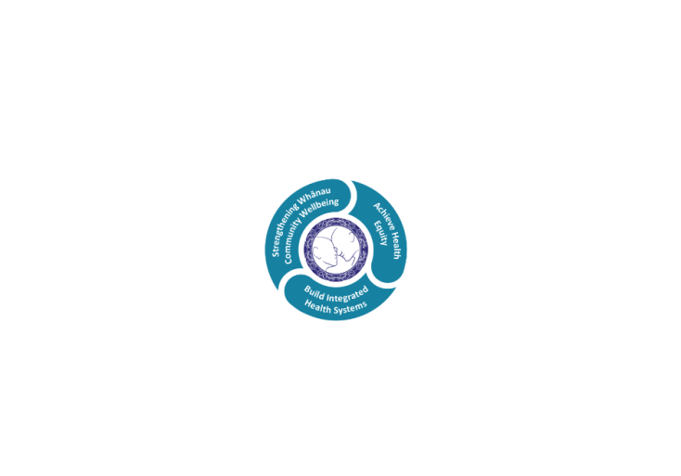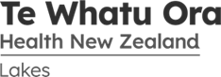

# POSITION DESCRIPTION

|  |  |  |
| --- | --- | --- |
| **Position:** | Waiariki Mana Ake Early Intervention Clinician | |
| **Responsible To:** | Clinical Team Lead, Waiariki Mana Ake  Clinical Manager, Waiariki Mana Ake  Service Manager, Mental Health & Addiction Services | |
| **Direct Reports:** | N/A | |
| **Location:** | Waiariki | |
| **Functional Relationships:** | **Internal:**  Programme Lead  Project Team  Clinical Services  Hospital and Specialist Services  Learning Support Co-ordinators  Kahui Hauora Lead / Clinician  CAMHS  Professional Advisors  Te Whatu Ora Lakes and Hauora a Toi Bay of Plenty | **External:**  Primary Health  Intersectoral agencies  Ministry of Education  Principals  Kaupapa Māori Kura  School / Kura Learning Support Team  Non-Government Organisations  Iwi |
| **Financial Delegations:** | N/A | |
| **Date:** | September 2023 | |

Professional Advisor

(Nursing; Psychology; Allied Health (Social Worker; Occupational Therapist others))

### Primary purpose(s) of the position

This role will be responsible for delivering early interventional health and wellbeing guidance, support and service within Primary and Intermediate schools within the Waiariki area. The Mana Ake service is led by health but delivered in collaboration with education, enabling the delivery of support where initial discovery of wellbeing need is often identified.

The Mana Ake workforce is made up of both registered clinical and non-registered kaimahi with an aim to deliver evidence informed individual, group and whole of class/school wellbeing programmes and interventions, targeted at tamariki with low level issues. The goal of Mana Ake is to address issues early, thereby minimising the need for escalation to more intensive specialist services.

The Clinician will be expected to provide support, guidance, education and an appropriate range of mental health interventions for tamariki experiencing learning and behavioral issues. This will include working with teachers, other school staff and whānau to identify and implement care plans that support tamariki to thrive and learn. The Clinician will also work collaboratively with non-registered peers within the Mana Ake service to support the delivery of strategies.

The Mana Ake service supports Te Ara Tauwhirotanga- “pathways that lead us to act with kindness” Model of Care, enabling an optimal environment and service to effect a service users wellness and recovery.

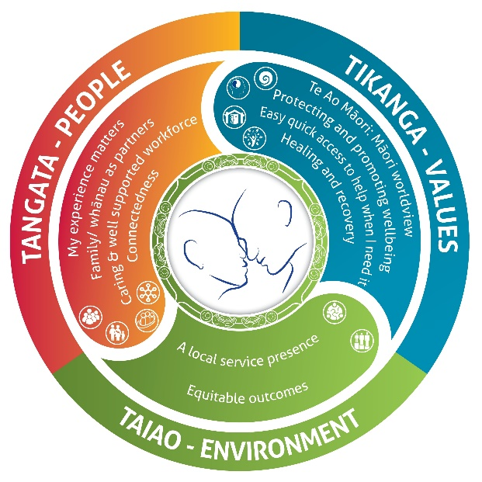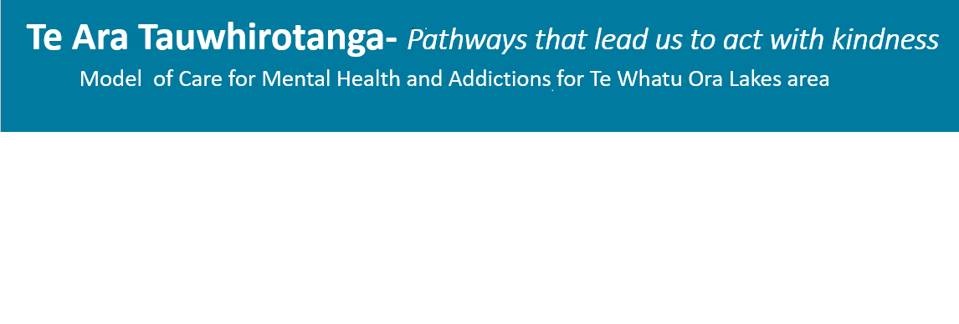

* **Tangata – People**
  + My experience matters
  + Family/Whanau as partners
  + Caring and well supported workforce
  + Connectedness
* **Tikanga –Values**
  + Te Ao Maori: Maori worldview
  + Protecting and promoting wellbeing
  + Easy quick access to help when I need it
  + Healing and recovery
* **Taiao – Environment**
  + A local service presence
  + Equitable outcomes

| **Key Objectives** | **Description** | **Expected Outcomes** |
| --- | --- | --- |
| **Delivery of Care** | Delivers quality evidence based care/therapies in line with registration and current practising certificate and competency requirements of the New Zealand discipline specific authority | * Ensure a timely response and facilitation of the smooth transition of the tamariki/whānau along the care pathway. * The principles and practice of culturally appropriate partnerships with service users and their families/whānau are incorporated in all facets of the treatment pathway. Support and participation from Iwi/hapu, pasifika and other culturally relevant services is expected. * Knowledge of relevant legislation including Mental Health (Compulsory Assessment and Treatment) Act 1992, Privacy Act 1993, Health and Disability Act 2000, Health Practitioners Competency Assurance Act 2003, and the Social Workers Registration Act 2019. * Conduct assessment, formulation, and risk management planning and takes appropriate actions in crisis situations or emergency situations or when unexpected responses or other situations occur that may compromise learner/whānau or another’s safety. * Conduct accurate and comprehensive assessment and formulation of clients in a variety of settings using suitable assessment tools underpinned by evidenced based knowledge. * Provide health education, appropriate to the needs of the tamariki, whānau, the caregiver, the education provider and relevant community members. * Provide clinical guidance to non-registered team members to support top of scope practice. * Provide clinical wellbeing support / guidance to team and cross-sectorial members seeking advice to establish an appropriate pathway of support for the child or young person. * Ensure the whānau are provided with appropriate information about their rights and explanation of the effects, consequences and alternatives of proposed treatment options to give informed consent according to their cultural and other preferences. * Facilitate treatment care planning in collaboration with whānau and cross-sectorial members and coordinate referrals for appropriate services. * Provide planned and appropriate care and therapeutic interventions to achieve identified outcomes and apply appropriate procedures and psychosocial skills in a competent and safe way. * Evaluate progress and outcomes against treatment goals and reflect with peers and members of the multidisciplinary team the effectiveness of the treatment. * Take responsibility for transitioning tamariki and whānau safely to other health/social providers. * Discuss ethical issues related to the area of practice with whānau and the multi-sectorial team. * Actively use strategies to enhance Recovery Principles and to challenge stigma and discrimination. |
| **Te Ara Tauwhirotanga Model of Care** | Follows the principles of the model of care “Te Ara Tauwhirotanga – Pathways that lead us to act with kindness.” | * Utilises Te Ara Tauwhirotanga – “Pathways that lead us to act with kindness” model of care to engage with tamariki, whānau and multidisciplinary teams. * Provides clinical care following the principles of the model of care Te Ara Tauwhirotanga – Pathways that lead us to act with kindness. * Incorporates and follows the principles of the model of care Te Ara Tauwhirotanga – Pathways that lead us to act with kindness into day to day business activities. |
| **Professional**  **Responsibility** | Accepts responsibility for own professional development to maintain and develop current clinical and management knowledge base.  Ensures that skills, knowledge and professional perspectives are made available to assist in a positive and proactive manner to all stakeholders.  Engages in regular, structured and reflective practice with a credentialed supervisor  Demonstrates Cultural competence | * Accept responsibility for ensuring that decisions, practice and conduct meets the standards of the professional, ethical and legal standards in accordance with relevant legislation, codes, and policies and upholds client rights derived from that legislation. * Demonstrates commitment to the Treaty of Waitangi, the application of the Treaty principles into practice, and the improvement of Maori health status * Participates in In-service programmes, maintains mandatory certification and relevant training requirements and takes responsibility for own professional development. * Evaluates the effectiveness of own care through participation in clinical supervision and seeking of assistance and knowledge as necessary * Takes responsibility for keeping up to date with contemporary developments, maintaining own professional development and mandatory organisational training requirements. * Contributes to the support, direction and teaching of colleagues and cross sectorial members to enhance professional development and increase knowledge of mental health. * Participates in regular Performance Reviews and contributes to peer review * Maintains a professional portfolio * Resolve problems and conflicts effectively using organisational structures and processes * Ensures that relevant cultural, spiritual and family relational requirements for tamariki and whānau within the context of their wider community is taken into consideration during clinical discussions and treatments in a manner that the whānau determines as culturally safe. * Promotes an environment that enables whānau safety, independence, quality of life, and health * Identifies and takes into consideration the complexity of physical, social, and wider community environmental issues. * Use a formal evaluation process with supervisor to capture the experience and gains from monthly supervision. * Takes personal responsibility for own performance. |
| **Coordination &**  **Cross-Sector, MDT Working** | Interacts collaboratively  with tamariki,  family/whānau, Kahui  Hauora, community groups,  support agency and  other health  professionals  Engage in a manner that encourages partnership and empowers all participants. | * Regular liaison with key stakeholders. * Navigation and supports referrals for tamariki and/or whānau to access other appropriate services. * Follows all service processes to ensure timely and efficient referrals. * Engages collaboratively with colleagues and community to determine best practice approach. * Demonstrates knowledge of community services and resources. Establishes and maintains networking relationships with education providers, cross sectorial members, relevant government and community agencies. * Provides consultation as necessary and involves stakeholders in planning, provision and monitoring of services. |
| **Service Development** | Actively participates and  contributes to service  improvements in order  to further develop the  Kahui Hauora role | * Facilitates Kahui Hauora meetings * Ensures ongoing evaluation activities are undertaken and findings identify trends which inform future Service development * Identifies area of unmet needs or gaps in service delivery, and escalates this to the Clinical Team Lead. * Participates in continuous quality service improvement initiatives and demonstrates flexibility to adapt to service changes to monitor and improve standards * Participates in review and audit of practice and policies based on research and evidence |
| **Teamwork** | Attitude and work ethic promotes effective teamwork within the project team and with all other internal divisions and external providers and organisations. | * Blends effectively into teams when needed; contributes strong morale and spirit in his/her team; shares wins and successes; fosters open dialogue; lets people finish and be responsible for their work; defines success in terms of the whole team; creates a feeling of belonging in the team. * Works in a constructive way to build a “one entity” organisation. This includes having a flexible and team approach to the total organisation in the achievement of outcomes. * Inspires self and non-registered peers to commit to the Mana Ake vision, strategies and direction, and focuses peers on achievement of team goals. * Works as an active, positive, creative and supportive team member. * Gets to know their team members and treats them with respect, valuing their individuality and contributions. |

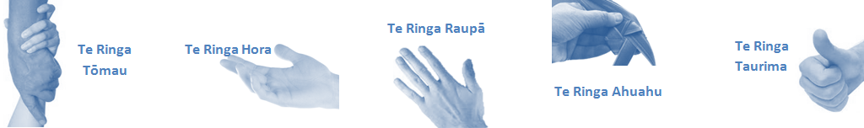

| **Capabilities** | | **Capability Definition** | | **Achievement Indicators** |
| --- | --- | --- | --- | --- |
| **Communication and Personal Interaction**  **Te Ringa Hora**  ***the open hand (denoting someone who is sociable)*** | | Communicates relevant information in a timely manner to those who need to know at a level that is understood. | | * Transfers information effectively verbally and writes clearly, coherently and succinctly. * Shares well thought out, concise and timely information with others using appropriate mediums. * Builds team spirit, facilitates resolution of conflict, promotes/protects team reputation, shows commitment to contributing to the teams’ success. * Maintains and promotes high standards of social, ethical and organisational norms. |
| Fosters a team environment and encourages collaboration between team and departments within Lakes. | | * Articulates differing perspectives on an issue and can see the merit of alternative points of view. * Connects with others, listens, reads people and situations and communicates tactfully. |
| Connects with people to build trust and confidence. | |  |
| **Strategy & Performance**  **Te Ringa Raupā**  ***the roughened hand (symbolising a hard worker)*** | | Delegates appropriately within team utilising individual skills to achieve results. | | * Understands individuals’ strengths and weaknesses to utilise or increase skills for those individuals. * Ensures decision making complies with organisational strategies. * Ensures decision making complies with organisational strategies. * Recognises decisions made affect overall results of the service and Te Whatu Ora Lakes. |
| Understands the unit requirements and the implications of the units achievements on the overall service delivery. | |  |
| **Development and Change**  **Te Ringa Ahuahu**  ***the hand that shapes or fashions something (refers to someone who is innovative)*** | | Works to include staff in change minimising barriers to implementation. | | * Continually strives for new and improved work processes that will result in greater effectiveness and efficiencies. * Openly broaches concern from the outset asking for ideas and possible solutions. * Gives examples of what might help to resolve the issue/concern. * Encourages participation in possible solution process. * Gives careful consideration of ideas and offers alterations to suggestions where necessary. * Allows feedback to decision to enable change process to be actioned where appropriate. * Seeks opportunities to improve performance and seeks feedback to measure and improve. * Informs response to the team including trends, data, process and benefits. |
| Articulates decisions and reasoning behind change enable buy-in to results. | |  |
| **Personal Accountability,** **Integrity and Trust**  **Te Ringa Tōmau**  ***the hand that is trustworthy*** | | Manages own and encourages others to foster work/life balance.  Actively manages own career aspirations and development. | | * Is widely trusted; is seen as a direct, truthful individual; can present the unvarnished truth in an appropriate and helpful manner; keeps confidences; admits mistakes; doesn’t misrepresent him/herself for personal gain; works autonomously but also a team player. * Ensures regular breaks are taken and own annual leave accruals are used within the 12 months following accrual. * Engages in projects and activities readily which are above and beyond scope of current role when requested to. |
| **Culture and Values**  **Te Ringa Taurima**  ***the hand that nurtures, encourages, supports*** | | Makes decisions based on facts and without personal bias. | | * Is proactive and effective when problem solving is required. * Critically examines repeatable risk factors. |
| Engages with mentors and supervisors for personal skill development. | | * Is constantly striving to acquire and maintain knowledge, skills and/or experience. * Demonstrates a commitment to and takes responsibility for going professional development. |
| Plans, prioritises and organises work to deliver on short and long term goals. | | * Purposeful about where time is invested. * Delivers relevant results within expected timeframes. |
| Encourages and promotes Lakes values and expectations. | | * Role models expected behaviours and practices. * Uses appropriate empathy to gain organisational objectives. * Is solution focused. |
| **Compulsory Requirements** | **Description** | | **Expected Outcomes** | |
| **Māori Health** | Māori philosophies and values of health are demonstrated in work practice. | | * Meaningful relationships are established with Te Aka Matua (Rotorua and Taupo Hospitals) and Te Aka Whai Ora division in the planning and delivery of services. * Practices are consistent with Te Tiriti o Waitangi /The Treaty of Waitangi when working with Māori. * Delivery of safe services for Māori are facilitated by ensuring they can access treatment options and are involved in the planning and delivery of their care. * Māori are enabled to access and participate in cultural activities provided by the Te Whatu Ora Lakes. * A commitment to improving the wellbeing of Māori by increasing cultural knowledge in the Te Whatu Ora Lakes is shown. | |
| **Te Iti Kahurangi** | The Lakes Way, Our Place Our Culture | | * Works within the Te Iti Kahurangi framework and supporting guide document. | |
| **Record Keeping** |  | | * Complies with the Te Whatu Ora Lakes Corporate Records Management policy to create and maintain full and accurate records. * Ensure documentation is current, accurate, timely and maintains confidentiality within legal, organisational and ethical requirements. * Demonstrate computer skills necessary to organise data for essential care delivery and to report on data as required. * Maintains accurate data recording and meet reporting requirements. | |
| **Quality & Risk** | Patient safety is paramount to the service we deliver at Te Whatu Ora Lakes. This is to be achieved in a clinical governance framework that is culturally responsive and identifies and manages risk and opportunities to improve. | | * Employees are supported to lead by example and implement a culture of continuous quality improvement. * Risks that may prevent Te Whatu Ora Lakes from achieving their goals are identified, reported, and managed. * Māori patients are provided patient-centred care to achieve positive Māori health outcomes. * Needs of Māori are reviewed and reported in the further development of practice, process and or policy. * Evidence-based methodologies are used to support improvements, e.g. kaupapa Māori methodology. * Quality care is provided to certification standards. | |
| **Health & Safety** | Each individual is responsible for ensuring the safety of themselves, their colleagues, patients and their visitors and to comply with all organisational health and safety policies, procedures and guidelines. | | * Implementation and reinforcement of a proactive healthy work place culture which reflects relevant Te Whatu Ora Lakes policy and legislative requirements. * Healthy lifestyles are actively promoted and participated in, within the work area. * Employees participate in Health and Safety within areas of work. * Health and Safety activities are appropriately documented within specified timeframes. * Health and Safety policies have been read and understood and are applied in the workplace. * Health and Safety policies are appropriately documented within specified timeframes and incidents are reported immediately. * Any opportunities for improving Health and Safety are reported and acted upon in a timely manner. * All near misses/incident/accidents are reported to the appropriate line manager within 24 hours. | |

**Signatures:**

|  |  |
| --- | --- |
| Line Manager:  (position description approved): |  |
| Employee:  (acceptance of position description): |  |

*(Please also initial all other pages to show acceptance of position description.)*

|  |  |  |
| --- | --- | --- |
| **Person Specification** | **Essential:** | **Desirable:** |
| **Education and Qualifications:** | * Clinical Qualification(s) with current practicing certification in Psychology, Counselling, Social Work, Nursing, Occupational Therapy or related field. | * Qualification(s) and/or training in counselling and facilitation skills in individual, group and whānau situations |
| **Experience:** | * Experience in community engagement and the ability to communicate and work effectively with people, tāngata whenua and mana whenua at all levels * Relevant work experience, relationship skills and the ability to work effectively in a team | * Experience in setting up new processes and systems |
| **Knowledge:** | * Te Tiriti O Waitangi in the provision of Health Care services and support to Māori. * Te Tiriti O Waitangi in practice, process, policy development and decision making. * Knowledge of crown obligations of Te Tiriti * Te Whatu Ora Lakes is a Reorua organisation knowledge and understanding of Te Reo/ Correct pronunciation. * Understanding of trauma informed care |  |
| **Skills:** | * Effective time management skills * Use of research to support best practice * Analytical thought process * Conflict resolution skills * Relationship management skills * Effective and confident written and oral communication skills * Excellent planning, organisational and prioritising skills and competent in delivering within financial constraints and timeframes |  |
| **Personal Attributes:** | * Cultural sensitivity and safety * Open and approachable with the ability to build rapport * Solution focused * Integrity * Non-judgmental * High level of motivation, initiative and anticipation with ability to work independently as well as in a team. * Adaptability and ability to pivot within a rapidly changing environment * Sense of humour | * Non-smoker/vaper preferred |
| **Other** | * Full driver’s license * Covid-19 Vaccinated |  |

**ABOUT TE WHATU ORA LAKES**

At Te Whatu Ora Lakes we place the highest value on the health and wellbeing of everyone in our community. As such all healthcare workers are expected to play a part in the creation and promotion of an environment which lives the following vision, mission and values:

### VISION

Healthy Communities – Mauriora! In this vision Mauriora refers to the Mauri - being the life essence and the source of well-being, and ora - describing the state of wellness.

### STRATEGIC MISSION

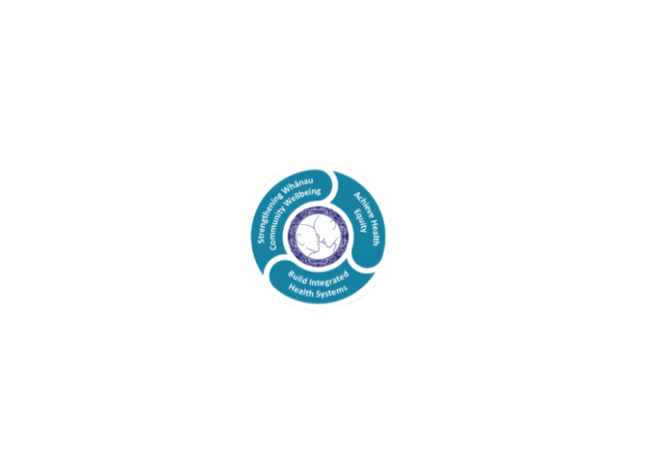

* Achieve equity in Māori health
* Build an Integrated health system
* Strengthen people, whānau & community wellbeing

### THREE CORE VALUES

Manaakitanga respect and acknowledgment of each other’s intrinsic value and contribution

Integrity truthfully and consistently acting collectively for the common good

Accountability collective and individual ownership for clinical and financial outcomes and sustainability

### TE ITI KAHURANGI – THE LAKES WAY, OUR PLACE, OUR CULTURE – WE WILL

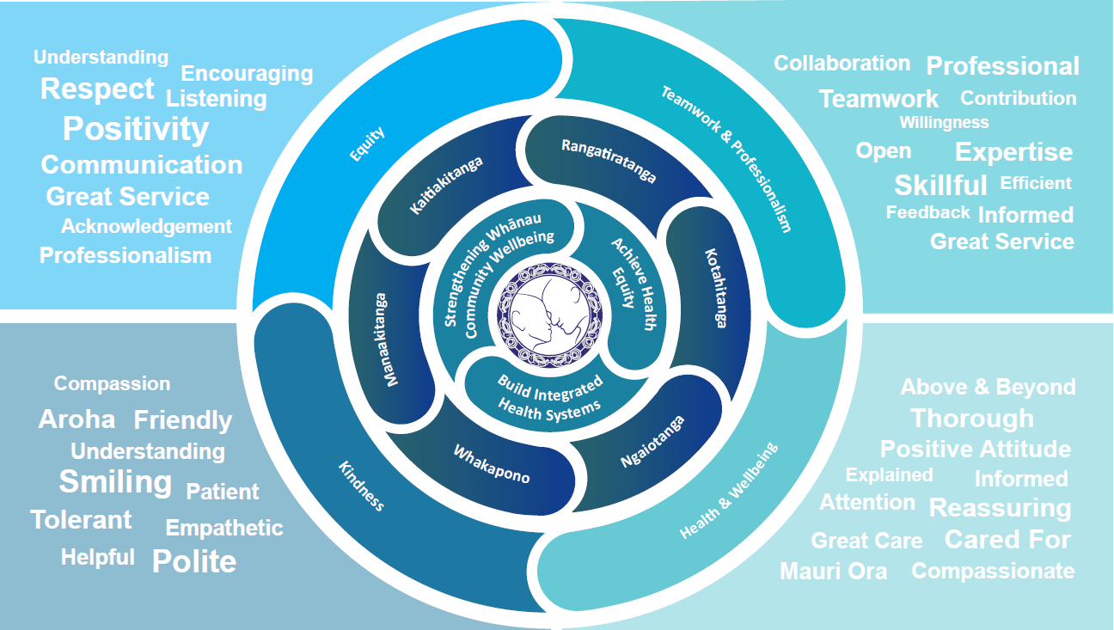

### TE TIRITI O WAITANGI

**Our expression of Te Tiriti o Waitangi**

The text of Te Tiriti, including the preamble and the three articles, along with the Ritenga Māori declaration, are the enduring foundation of our approach to achieving health and independence. Based on these foundations, we will strive to achieve the following four goals, each expressed in terms of mana.

**Mana whakahaere**

Effective and appropriate kaitiakitanga and stewardship over the health and disability system. Mana whakahaere is the exercise of control in accordance with tikanga, kaupapa and kawa Māori. This goes beyond the management of assets and resources and towards enabling Māori aspirations for health and independence.

**Mana motuhake**

Enabling the right for Māori to be Māori (Māori self-determination); to exercise their authority over their lives and to live on Māori terms and according to Māori philosophies, values and practices, including tikanga Māori.

**Mana tangata**

Achieving equity in health and disability outcomes for Māori, enhancing the mana of people across their life course and contributing to the overall health and wellbeing of Māori.

**Mana Māori**

Enabling Ritenga Māori (Māori customary rituals), which are framed by te ao Māori (the Māori world), enacted through tikanga Māori (Māori philosophy and customary practices) and encapsulated within mātauranga Māori (Māori knowledge).

Te Whatu Ora Lakes is committed within the framework of the New Zealand Public Health and Disability Act (2000) to supporting the Crown’s commitment to upholding its Tiriti promises.

### ORGANISATION STRUCTURE

