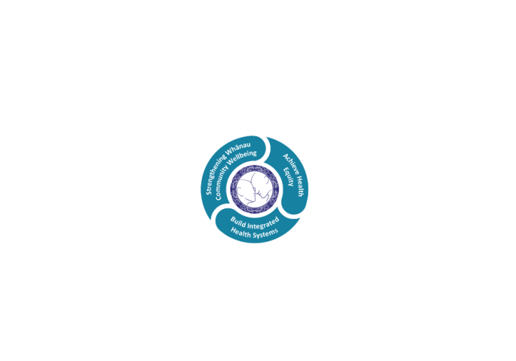

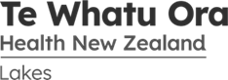

# POSITION DESCRIPTION

|  |  |  |
| --- | --- | --- |
| **Position**: | Administrative Support – Casual Duties… | |
| **Responsible to:** | Manager/Personal Assistant, Taupo Hospital | |
| **Location:** | Rotorua & Taupō (Based in Taupo Hospital..) | |
| **Functional relationships:** | **Internal:**  Administration Staff  Nursing Staff  Allied Health Staff  Medical Staff  Facilities Staff  Other Departments | **External**:  General Practitioners  Public  Police  External Providers |
| **SECTION ONE:**  **Employment Status:** | Casual 0FTE | |
| **Financial delegations:** | Nill | |
| **Direct Reports/ Staff Delegations:** | Nill | |
| **Date**: | July 2023 | |

### Primary purpose(s) of the position

To provide a confidential and professional administrative service to Taupo Hospital.

To maintain administration staffing levels at Taupo Hospital including scheduled and unscheduled leave.

|  |  |  |
| --- | --- | --- |
| **Key Objectives** | Description | Expected Outcomes |
| |  |  |  | | --- | --- | --- | | **Administrative Support** | To provide a confidential and professional, administrative service to Taupo Hospital. | * Outpatient referrals are processed as per Ministry of Health guidelines. * All Clinic appointments are made following Lakes DHB procedures, and individual staff will work to an agreed Position Specification, attached to their Job Description which distributes and assigns clinic work as may be agreed from time to time. * Correspondence is processed in a professional manner. * Accurate statistical data entry for appropriate services. * Where appropriate, organising of inpatient identified appointments e.g. MRI scans etc., including transport. * Relevant clinical information is made available upon request. * Photocopying is provided in a timely and accurate manner. * Workload is assessed, prioritised and completed in a timely manner to meet the service requirements. * Meetings/appointments are made as required with both internal and external parties. * Filing of clinical information is accurate and within timeframes. * Clinical files are maintained appropriately * Utilising of deskfile to gain maximum information. * Code timesheet to areas worked. | |  |  |
| |  |  |  | | --- | --- | --- | | **Systems Support** | To ensure all information, filing and office systems are developed and maintained for the effective management of the Taupo Hospital Administrative team. | * Office procedures are followed, systems are developed and maintained/updated in an accessible, current and readily retrievable manner. * Information databases are maintained as requested * Electronic requisitions are raised according to Lakeland Health policy and within budget * Confidentiality is maintained at all times | | **Teamwork** | Work to promote a high functioning team that support the clinical staff | * Member of Taupo Administrative Team. * Participates in Administrative Team activities. * Provides cover and support for other team members on sick or scheduled leave whenever possible. This includes: Clinical Records, Radiology, Maternity, Taupo Inpatient Unit, Taupo Front Office Reception and Outpatients, Clinical Typing, Personal Assistant, Allied Health Admin. * To work in areas as requested by Line Manager or Site Manager. | | **Revenue Collection** | To receive all monies coming into Taupo Hospital and following procedures for documentation | * To receipt all monies received. * To process all non NZ chargeable patients as per Lakes DHB guidelines. | |  |  |
| **General** |  |  |

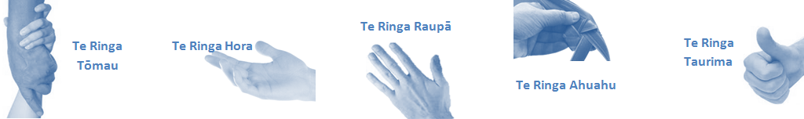

|  |  |  |
| --- | --- | --- |
| **Capabilities** | Capability definition | Achievement Indicators |
| **Communication and Personal Interaction**  **Te Ringa Hora**  ***the open hand (denoting someone who is sociable)*** | Openly communicates and cooperates with all levels of Lakes employees, patients and visitors | * Listens actively, absorbs messages and responds appropriately. * Builds effective working relationships. * Establishes rapport with others and gains their respect while being adaptive in relating to different types of people and situation. * Openly and constructively participates in conversations with multi-disciplinary teams, patients, manages and visitors. * Patients and visitors are appropriately welcomed and treated while within Lakes. |
|  | * Collegiality with team mates and Multi-disciplinary teams. * Accepts differences of opinion can occur but these happen respectfully and without any continued animosity. |
| **Strategy & Performance**  **Te Ringa Raupā**  ***the roughened hand (symbolising a hard worker)*** | Spends energy on delivering role requirements and meeting objectives  Organises own time to deliver on required tasks and duties | * Has an energetic approach to work and is self motivated. * Accepts direction and instruction of manager but is able to work effectively without direction or guidance. * Organises time and resources effectively. * Understands and work towards achievement of the organisation’s goals. * Utilises effective time management strategies to meet duties and works towards achieving objectives in any spare moments. |
| **Development and Change**  **Te Ringa Ahuahu**  ***the hand that shapes or fashions something (refers to someone who is innovative)*** | Accepts change in day to day practices and contributes to decision making of the team.  Makes suggestions to increase efficiency of the unit. | * Can adjust behaviour to the demands of the work environment in order to remain productive through periods of transition, ambiguity, uncertainty and stress * Works with managers and team to make any changes within practices work * Contributes to change processes, offering solution based ideas * Constructively makes suggestions to improve process or practices and gain efficiencies * Accepts when ideas are not accepted for implementation |
| **Personal Accountability**  **Te Ringa Tōmau**  ***the hand that is trustworthy*** | Is open with manager and colleagues and open to accepting feedback and critique to improve upon practice.  Looks for and undertakes development activities appropriate for role and career development. | * Offers constructive criticism and accepts feedback. * Establishes rapport with others and gains their respect while being adaptive in relating to different types of people and situations, to allow improvements to be made. * Accepts all feedback and participates in feedback discussions appropriately * Responds and queries how improvements can be made * Advises manager wherever issues may be impacting on performance * Recognises areas that could be improved in own practice * Requests learning and development opportunities to enhance practice in role and/ or to assist where improvements can be made |
| **Culture and Values**  **Te Ringa Taurima**  ***the hand that nurtures, encourages, supports*** | Encourages and promotes DHB values and expectations. | * Role models expected behaviours and practices * Treats staff, patients, visitors with dignity and respect * Uses appropriate empathy to gain organisational objectives * Is solution focussed |

|  |  |  |
| --- | --- | --- |
| **Compulsory Requirements** | Description | Expected Outcomes |
| **Māori Health** | Māori philosophies and values of health are demonstrated in work practice. | * Meaningful relationships are established with Te Aka Matua (Rotorua and Taupo Hospitals) and Te Whatu Ora Lakes Maori Health division in the planning and delivery of services. * Practices are consistent with Te Tiriti o Waitangi /The Treaty of Waitangi when working with Māori. * Delivery of safe services for Māori are facilitated by ensuring they can access treatment options and are involved in the planning and delivery of their care. * Māori are enabled to access and participate in cultural activities provided by the Te Whatu Ora Lakes. * A commitment to improving the wellbeing of Māori by increasing cultural knowledge in the Te Whatu Ora Lakes is shown. |
| **Te Iti Kahurangi** | The Lakes Way, Our Place Our Culture | * Works within the Te Iti Kahurangi framework and supporting guide document. |
| **Record Keeping** |  | * Complies with the Te Whatu Ora Lakes Corporate Records Management policy to create and maintain full and accurate records. |
| **Quality & Risk** | Patient safety is paramount to the service we deliver at Te Whatu Ora Lakes. This is to be achieved in a clinical governance framework that is culturally responsive and identifies and manages risk and opportunities to improve. | * Employees are supported to lead by example and implement a culture of continuous quality improvement. * Risks that may prevent Te Whatu Ora Lakes from achieving their goals are identified, reported, and managed. * Māori patients are provided patient-centred care to achieve positive Māori health outcomes. * Needs of Māori are reviewed and reported in the further development of practice, process and or policy. * Evidence-based methodologies are used to support improvements, e.g. kaupapa Māori methodology. * Quality care is provided to certification standards. |
| **Health & Safety** | Each individual is responsible for ensuring the safety of themselves, their colleagues, patients and their visitors and to comply with all organisational health and safety policies, procedures and guidelines. | * Implementation and reinforcement of a proactive healthy work place culture which reflects relevant Te Whatu Ora Lakes policy and legislative requirements. * Healthy lifestyles are actively promoted and participated in, within the work area. * Employees participate in Health and Safety within areas of work. * Health and Safety activities are appropriately documented within specified timeframes. * Health and Safety policies have been read and understood and are applied in the workplace. * Health and Safety policies are appropriately documented within specified timeframes and incidents are reported immediately. * Any opportunities for improving Health and Safety are reported and acted upon in a timely manner. * All near misses/incident/accidents are reported to the appropriate line manager within 24 hours. |

**Signatures:**

|  |  |
| --- | --- |
| Line Manager:  (position description approved): |  |
| Employee:  (acceptance of position description): |  |

*(Please also initial all other pages to show acceptance of position description.)*

|  |  |  |
| --- | --- | --- |
| **Person Specification** | **Essential:** | **Desirable:** |
| **Education and Qualifications:** |  |  |
| **Experience:** | * Microsoft Office Suite * Computer literacy | * To work unsupervised utilizing the programmes within the Suite |
| **Knowledge:** | * Te Tiriti O Waitangi in the provision of health care services and support to Māori. * Te Tiriti O Waitangi in practice, process, policy development and decision making. * Te Whatu Ora Lakes is a Reorua organisation knowledge and understanding of Te Reo/ Correct pronunciation. |  |
| **Skills:** | * Pronunciation of Te Reo Māori words and names * Able to adapt to different areas of work without ongoing training. * Proven ability to be flexible and set priorities when under pressure. | * Te Reo Māori * To provide ongoing support to clinical staff while encumbent is on leave. |
| **Personal Attributes:** | * Well presented and tidy in appearance. * Ability to maintain calm disposition under stress.. | * Non-smoker preferred * An ability to work with all cultures and personalities |

**ABOUT TE WHATU ORA LAKES**

At Te Whatu Ora Lakes we place the highest value on the health and wellbeing of everyone in our community. As such all healthcare workers are expected to play a part in the creation and promotion of an environment which lives the following vision, mission and values:

### VISION

Healthy Communities – Mauriora! In this vision Mauriora refers to the Mauri - being the life essence and the source of well being, and ora - describing the state of wellness.

### STRATEGIC MISSION

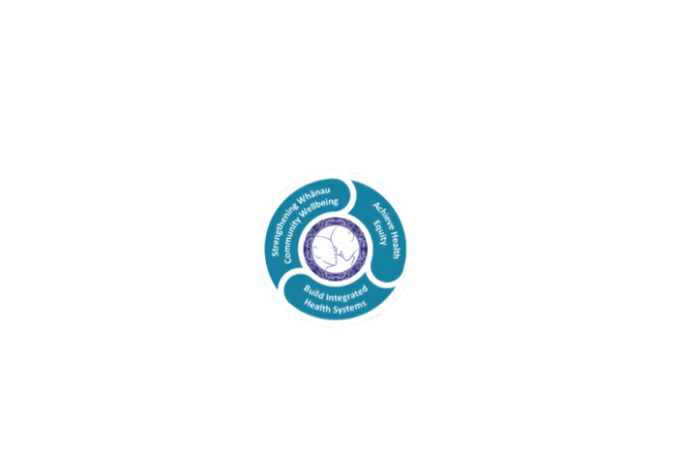

* Achieve equity in Māori health
* Build an Integrated health system
* Strengthen people, whanau & community wellbeing

### THREE CORE VALUES

Manaakitanga respect and acknowledgment of each other’s intrinsic value and contribution

Integrity truthfully and consistently acting collectively for the common good

Accountability collective and individual ownership for clinical and financial outcomes and sustainability

### TE ITI KAHURANGI – THE LAKES WAY, OUR PLACE, OUR CULTURE – WE WILL

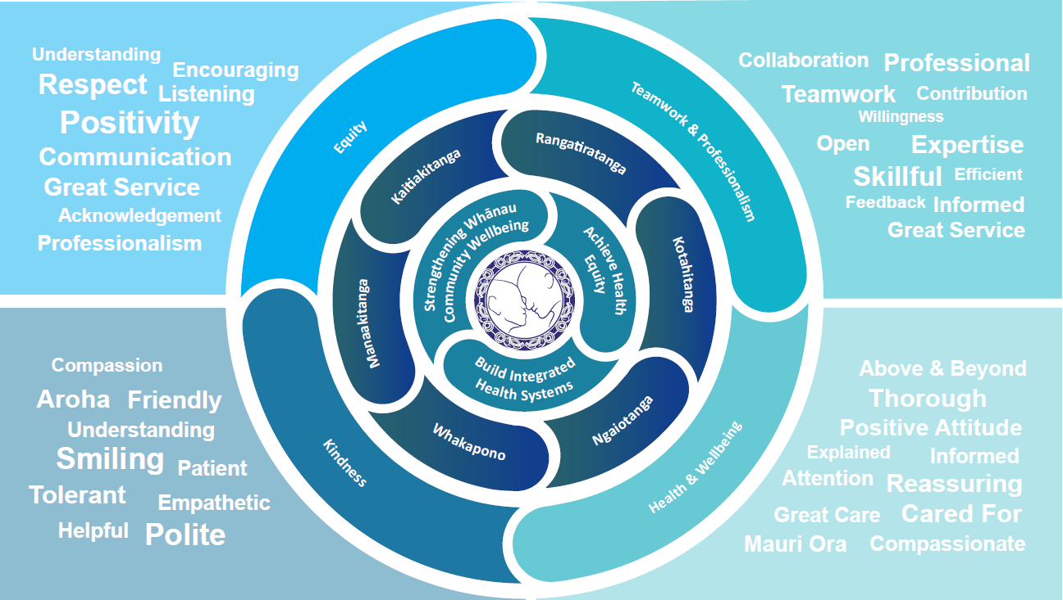

### TE TIRITI O WAITANGI

**Our expression of Te Tiriti o Waitangi**

The text of Te Tiriti, including the preamble and the three articles, along with the Ritenga Māori declaration, are the enduring foundation of our approach to achieving health and independence. Based on these foundations, we will strive to achieve the following four goals, each expressed in terms of mana.

**Mana whakahaere**

Effective and appropriate kaitiakitanga and stewardship over the health and disability system. Mana whakahaere is the exercise of control in accordance with tikanga, kaupapa and kawa Māori. This goes beyond the management of assets and resources and towards enabling Māori aspirations for health and independence.

**Mana motuhake**

Enabling the right for Māori to be Māori (Māori self-determination); to exercise their authority over their lives and to live on Māori terms and according to Māori philosophies, values and practices, including tikanga Māori.

**Mana tangata**

Achieving equity in health and disability outcomes for Māori, enhancing the mana of people across their life course and contributing to the overall health and wellbeing of Māori.

**Mana Māori**

Enabling Ritenga Māori (Māori customary rituals), which are framed by te ao Māori (the Māori world), enacted through tikanga Māori (Māori philosophy and customary practices) and encapsulated within mātauranga Māori (Māori knowledge).

Te Whatu Ora Lakes is committed within the framework of the New Zealand Public Health and Disability Act (2000) to supporting the Crown’s commitment to upholding its Tiriti promises.

### ORGANISATION STRUCTURE

