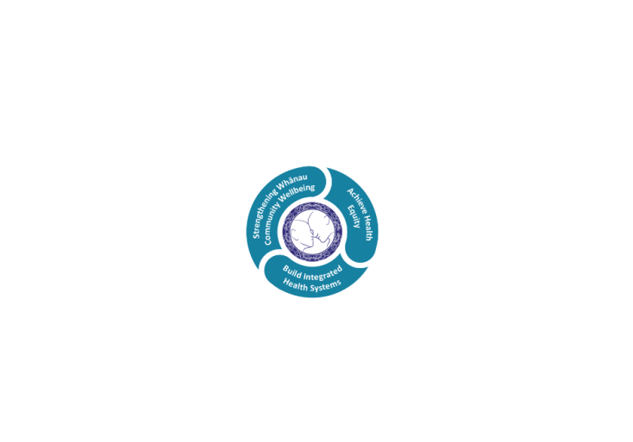



# POSITION DESCRIPTION

|  |  |  |
| --- | --- | --- |
| **Position**: | Clinical Nurse Specialist – Neurology / Stroke | |
| **Responsible to:** | Clinical Nurse Manager – Nurse Specialist Team, Medical Services | |
| **Direct Reports:** | nil | |
| **Location:** | Rotorua & Taupō | |
| **Functional relationships:** | **Internal:**  Patients and families/whanau  Medical Specialists  Clerical Staff  Nursing Staff  Allied Health Staff  Medical Staff  Maori Health Teams  Other Departments | **External**:  Visiting Neurology specialists  General Practices  Consumers/whanau/family/significant others  General Practitioners  Primary care providers  Community support organisations  Other speciality Nursing Groups  Tertiary education providers and students |
| **Financial delegations:** | Nil | |
| **Date**: | July 2024 | |

### Primary purpose(s) of the position

The Neurology / Stroke Clinical Nurse Specialist (CNS) is responsible for providing specialist nursing care and expertise both in direct care delivery in support of a defined patient group/area of specialty practice.

The nurse is required by the Medicine Service to be a key part of the multidisciplinary team (MDT) in coordinating the care of the patients with long term neurologic conditions and stroke patients. The nurse will work closely with medical, nursing and allied health professionals to provide optimal clinical care underpinned by best clinical guidelines.

As a senior nurse, the role has a responsibility for improving the quality of professional nursing practice and safe guarding high standards of care in Health NZ Lakes through researching, evaluating, developing and implementing standards of nursing practice in the specific area of practice and supporting an environment in which excellence in clinical care can flourish.

The Clinical Nurse Specialist will provide assessment, support and assistance with appropriate treatment and follow-up of patients / tangata whaiora requiring complex care with neurological conditions, and stroke patients in the hospital and coordinate access to appropriate services in the community.

The CNS will aim to:

* See patients and their whanau during acute stroke admission to provide information and support.
* Support “Code Stroke” calls and thrombolysis service
* Perform as a clinical expert and role model for junior staff and MDT.
* Facilitate nurse-led Neurology clinics to support the needs of the patients within their care.
* Be responsible for stroke data collection, entry and reporting.
* Participate in and/or leadservice improvement and research in both specialty areas.

|  |  |  |
| --- | --- | --- |
| **Key Objectives** | Description | Expected Outcomes |
| **Nursing practice** | Delivers quality nursing care in line with registration and current practising certificate competency requirements of the Nursing Council of New Zealand. | * Demonstrates continuing achievement of competencies within the four domains for registration with Nursing Council of New Zealand (http://www.nursingcouncil.org.nz/content/download/263/1205/file/Nursing%20comp%20for%20RN.pdf)  1. Professional Responsibility 2. Management of nursing care 3. Interpersonal relationships 4. Inter-professional health care and quality improvement  * Meets practice and educational hours in accordance with NCNZ minimum requirements. * Maintains currency in organisational core certification as relevant to the clinical area. * Meets the orientation and on-going knowledge and skill requirements for relevant clinical areas. * Maintains knowledge of and works within scope of practice as defined at any given time by New Zealand Nursing Council and as required to maintain registration. (http://www.nursingcouncil.org.nz/Nurses/Scopes-of-practice/Registered-nurse) * Must comply with any specific conditions on practice as determined by NCNZ |
| **Professional Responsibilities** | Professional Leadership  Clinical Leadership  Professional development and competency | * Fosters the provision of positive patient / client outcomes and person-centred care. * Leads professional conduct by example, acting as a role model for staff and adapts flexible approach to teaching both clinical and non-clinical agenda * Applies critical reasoning and professional judgement to all nursing practice issues / and decisions. * Promotes an environment that maximises client safety, independence and quality of life. * Identifies situations of clinical risk and takes appropriate action to ensure a safe environment for patients/clients, families/whanau and staff. * Actively enhances professional nursing practice and performance by participating in relevant nursing and service forums. * Fosters the implementation of organisational and nursing goals and values, promotes LDHB as a centre of excellence for nursing practice. * Role models culturally and clinically safe nursing practice and contributes to the development of the profession locally, regionally and nationally. * Undertakes or leads specific service or organisational portfolio responsibilities as required. * Clinical leadership is evident through the empowerment and motivation of others. * Maintains and extends own clinical nursing expertise and nursing knowledge * Organises/prioritises work to manage changes in work load. * Facilitate and monitor the quality of the specialty process, establishing audit tools to monitor role of CNS in the service * Monitors, reports on trends in specialty service delivery * Takes prospective action to minimise anticipated/potential problems * Takes prompt action to minimise untoward occurrences * Organises and prioritises work distribution to manage changes in work load * Promotes cost effective use of human and material resources * Role models culturally and clinically safe nursing practice. * In collaboration with the CNM, CNEs, allied health evaluates learning activities to ensure programmes meet stated objectives and assessment criteria and meet the identified learning needs of all staff working in the stroke service. * Supports “Code Stroke” calls and thrombolysis service, as required. * Identify and implement strategies to follow up/monitor patients involving all members of the multidisciplinary team, and other services as appropriate. * Advocates for seamless and effectiveness in patient care through enhancing collaborative relationships between services. * Participates in Regional and national stroke networks, as required. * Practices in accordance with legal, ethical, culturally safe and professional standards. * Commitment to and involvement with nursing education and professional development * Practices in accordance with legal, ethical, culturally safe and professional nursing Standards * Maintains professional portfolio and annual practice registration. * Pro-actively participates in own performance development and review. * Demonstrates use of nursing and medical research in clinical practice and a commitment to nursing education and professional development * Uses organisational, national and best practice knowledge to maximise health outcomes for the specific area. |
| **Management of patient care** | Patient care management and co ordination | * Provides direct care and uses advanced nursing knowledge and skills to assess, triage. plan, treat, implement and evaluate patients / clients / family / whanau health needs * Facilitates effective referral processes and/or discharge planning to health care providers and support agencies to meet identified health needs. * Works with MDT to identify early those stroke patients that would benefit from rehabilitation. * Monitors clinical outcomes / indicators and manages variance to clinical pathway, protocols or best practice guidelines. * Educates and provides information to patients/clients/family/whanau to improve knowledge of disease/illness, self-management, prevention of complications and promotion of recovery. * Identifies barriers and solutions to access for patient/client, family or whanau. * Accurately documents assessments of patients/clients health status, diagnosis and decisions made regarding interventions and referrals or follow-up. * Participates in case review and debriefing activities as required. * Ensures efficient and cost effective solutions are provided * Completes all relevant administration responsibilities in a timely manner. |
| **Interpersonal relationship** | Communicates relevant information in a timely manner to those who need to know at a level that is understood. | * Promotes effective team work and collaborative relationships within the multidisciplinary team and across health care settings to achieve best health outcomes for patients. * Acts as a nursing resource providing expert advice and education to nursing staff and other health care professionals/family/whanau within scope of practice. * Identifies and supports staff education and professional development based on own knowledge of service needs aligned with LDHB strategic direction * Demonstrates skilled mentoring / coaching, teaching and supervision of nursing staff and other health professionals. * Acts as a nursing resource providing expert advice and education to nursing staff and other health care professionals / family / whanau within scope of speciality practice. * Identifies and supports staff education and professional development based on knowledge of service needs and aligned with Lakes DHB strategic direction. |
| **Interprofessional Health Care and Quality improvement** |  | * Evaluates the effectiveness, efficiency and safety of clinical practice. * Contributes to projects and research that enhance the clinical implementation of evidence-based practice * Demonstrates commitment to quality improvements, risk management and resource utilisation. * Reviews and develops clinical standards / protocols and policies and facilitates clinical audit processes. * Works in collaboration with other relevant nursing leaders to define and implement the strategies that support quality improvement. * Assists in the implementation of nursing practice and models of care appropriate to patient / client population needs. * Assists in the implementation and management of initiatives to address differential access to healthcare services for Maori. * Participates in the development of strategic and operational service plans. * Fosters inquiry, critical thinking and research skill acquisition among the nursing workforce to advance nursing practice and patient / client care. * Works to ensure that recommended best practice guidelines / policies are research based and relevant across the organisation. * Contributes to and participates in Lakes DHB and national policy development |

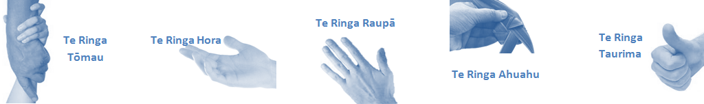

|  |  |  |
| --- | --- | --- |
| **Capabilities** | Capability definition | Achievement Indicators  *(Examples – add/ amend or delete as specific to role using matrix to assist)* |
| **Communication and Personal Interaction**  **Te Ringa Hora**  ***the open hand (denoting someone who is sociable)*** | Operates at a DHB wide level understanding the implications of communications within own service and other services. | * Transfers information effectively verbally and writes clearly, coherently and succinctly. * Shares well thought out, concise and timely information with others using appropriate mediums. * Receives team updates by way of relaying in general terms but more importantly what affect it has on the service and how staff can help where necessary to achieve any requirements. * Facilitates team spirit and resolution of conflict within the team, promotes/protects team reputation, and shows commitment to contributing to the team’s success. * Maintains and promotes high standards of social, ethical and team norms. * Articulates differing perspectives on an issue and can see the merit of alternative points of view. * Works with other members of the team to streamline processes for the best efficiency for the service. * Assists colleagues who have concerns about another team process, a different point of view to consider. |
| Presents clear and articulate messages to all levels of the organisation | * Connects with others, listens, reads people and situations and communicates tactfully. * Gets to know their team members and treats them with respect, valuing their individuality and contributions. |
| **Strategy & Performance**  **Te Ringa Raupā**  ***the roughened hand (symbolising a hard worker)*** | Proactively searches out solutions to problems and makes timely and appropriate decisions. | * Demonstrates effective and timely decision making/problem solving techniques. * Strives for new and improved work processes that will result in greater effectiveness and efficiencies. |
| Understands the implications decisions within the service or individual units have on the wider organisation and other services. | * Aware of the potential impact on other services of decisions on service delivery and consults as appropriate utilising available resources. |
| Works collaboratively with stakeholders to maximise overall effectiveness. | * Provides information to stakeholders before any change occurs. * Seeks feedback from stakeholder groups on service delivery. * Modifies and enhances service delivery in collaboration with stakeholders. |
| **Development and Change**  **Te Ringa Ahuahu**  ***the hand that shapes or fashions something (refers to someone who is innovative)*** | Provides innovative solutions to problems. | * Will change or modify own opinions and will switch to other strategies when necessary. * Continually strives for new and improved work processes that will result in greater effectiveness and efficiencies * Seeks opportunities to improve performance and seeks feedback to measure and improve |
| Supports and guides staff through change. | * Encourages problem solving and solution finding. * Is empathetic and inclusive in finding solutions. * Engages with staff to understand concerns and provide feedback on possible solutions. * Encourages teams to put forward ideas for strategic change. |
| **Personal Accountability**  **Te Ringa Tōmau**  ***the hand that is trustworthy*** | Manages own and encourages others to foster work/life balance. | * Ensures regular breaks are taken and own annual leave accruals are used within the 12 months following accrual. * Ensures employees within their service are taking regular annual leave breaks for the purpose of rest/recreation throughout the year. |
| Actively manages own career aspirations and development. | * Is constantly striving to acquire and maintain knowledge, skills and/or experience. * Has own career development plan and succession planning. * Seeks out development opportunities to expand knowledge and capability. * Engages in projects and activities readily which are above and beyond scope of current role. |
| **Culture and Values**  **Te Ringa Taurima**  ***the hand that nurtures, encourages, supports*** | Inspires team to achieve whilst maintaining DHB values. | * Is proactive and effective when problem solving is required. * Engages with staff member/managers/multi disciplinary team when concerns are raised to best understand their point of view. * Appropriately investigates the concern looking at trends, situation and practices. * Critically examines repeatable risk factors. * Is constantly striving to acquire and maintain knowledge, skills and/or experience. * Demonstrates a commitment to and takes responsibility for going professional development. * Purposeful about where time is invested. * Delivers relevant results within expected timeframes. * Role models expected behaviours and practices. * Treats staff, patients and visitors with dignity and respect. * Uses appropriate empathy to gain organisational objectives. * Is solution focused. * Utilises the Lakes Way philosophy to engage with patients, visitors and multi-disciplinary teams. Works with teams to identify plans for their unit and selves that will contribute to the organisation’s annual plan, vision/mission etc. |

|  |  |  |
| --- | --- | --- |
| **Compulsory Requirements** | Description | Expected Outcomes |
| **Māori Health** | Māori philosophies and values of health are demonstrated in work practice. | * Meaningful relationships are established with Te Huinga Takiora Māori in the planning and delivery of services. * Practices are consistent with Te Tiriti o Waitangi /The Treaty of Waitangi when working with Māori. * Delivery of safe services for Māori are facilitated by ensuring they can access treatment options and are involved in the planning and delivery of their care. * Māori are enabled to access and participate in cultural activities provided by the Lakes DHB. * A commitment to improving the wellbeing of Māori by increasing cultural knowledge in the Lakes DHB is shown. |
| **Te Iti Kahurangi** | The Lakes Way, Our Place Our Culture | * Works within the Te Iti Kahurangi framework and supporting guide document. |
| **Record Keeping** |  | * Complies with the Lakes DHB Corporate Records Management policy to create and maintain full and accurate records. |
| **Quality & Risk** | Patient safety is paramount to the service we deliver at Lakes District Health Board. This is to be achieved in a clinical governance framework that is culturally responsive and identifies and manages risk and opportunities to improve. | * Employees are supported to lead by example and implement a culture of continuous quality improvement. * Risks that may prevent Lakes DHB from achieving their goals are identified, reported, and managed. * Māori patients are provided patient-centred care to achieve positive Māori health outcomes. * Needs of Māori are reviewed and reported in the further development of practice, process and or policy. * Evidence-based methodologies are used to support improvements, e.g. kaupapa Māori methodology. * Quality care is provided to certification standards. |
| **Health & Safety** | Each individual is responsible for ensuring the safety of themselves, their colleagues, patients and their visitors and to comply with all organisational health and safety policies, procedures and guidelines. | * Implementation and reinforcement of a proactive healthy work place culture which reflects relevant Lakes DHB policy and legislative requirements. * Healthy lifestyles are actively promoted and participated in, within the work area. * Employees participate in Health and Safety within areas of work. * Health and Safety activities are appropriately documented within specified timeframes. * Health and Safety policies have been read and understood and are applied in the workplace. * Health and Safety policies are appropriately documented within specified timeframes and incidents are reported immediately. * Any opportunities for improving Health and Safety are reported and acted upon in a timely manner. * All near misses/incident/accidents are reported to the appropriate line manager within 24 hours. |

**Signatures:**

|  |  |
| --- | --- |
| Line Manager:  (position description approved): |  |
| Employee:  (acceptance of position description): |  |

*(Please also initial all other pages to show acceptance of position description.)*

|  |  |  |
| --- | --- | --- |
| **Person Specification** | **Essential:** | **Desirable:** |
| **Education and Qualifications:** | * Registration with the Nursing Council of New Zealand (NCNZ) with appropriate scope of practice and no limiting conditions to practice. * Current Annual Practising Certificate. * A relevant nursing qualification. * Post graduate Certificate ( or working towards) tertiary qualification | * Masters in Nursing * Diploma in Speciality Nursing Practice * Post grad study that includes a research / audit project.. |
| **Experience:** | * Recent hospital clinical practice * Research experience and understanding of Good Clinical Research Practice guidelines * Experience in clinical teaching * Specialty and practice expertise to a minimum Level 4 * Knowledge of quality improvement processes and principles * Knowledge and understanding of the Treaty of Waitangi and implications in nursing and research practice * Knowledge of nursing professional development issues * .. | * .. |
| **Knowledge:** | * Te Tiriti O Waitangi in the provision of health care services and support to Māori. * Te Tiriti O Waitangi in practice, process, policy development and decision making. * Health and Disability Code of Consumer Rights 1996 * Health Information Privacy Code 1994 * Health Practitioners Competency Assurance Act 2003 * Human Rights Act 1993 * Medicines Act 1981 and Medicines Regulation 1984 * Misuse of Drugs Act 1975 and Regulations 1977 * Nursing Council of New Zealand Code of Conduct(current iteration) * Nursing Council of New Zealand Competencies for Scope of Registered Nurse(current iteration) * Treaty of Waitangi Act 1975 and its application to the health setting. | * . Lakes District Health Board Quality Framework (must become conversant with this once employed) * . |
| **Skills:** | * Pronunciation of Te Reo Māori words and names | * Te Reo Māori |
| **Personal Attributes:** | * Contributes positively to the culture of the organisation. * Works well with team members to achieve collective outcomes. * Takes direction positively. * Accounts for own performance. * Demonstrates a caring and compassionate attitude towards clients, whanau and co-workers. * Assesses, plans, implements and evaluates clinical care for patients according to accepted specialist nursing practice and standards; * works in consultation with other health professionals and members of health teams facilitating the care of patients; * provides interventions, treatments and therapies such as medications, and monitors responses to treatment and care plans; * promotes health and assists in preventing ill health by participating in health education and other health promotion activities; * answers questions and providing information to patients and families about treatment and care; * Supervises and co-ordinating the work of enrolled nurses and other health care workers. * Works **indoors** in hospital wards and clinics and other health care facilities in private and public hospitals and medical centres and specialist practices and clinics. * Works in adequately **lit,** **heated, ventilated and clean, well maintained and hygienic** workspaces * **Light to heavy** physical demand. * **Sits** often during patient consultations, briefings, writing reports and at staff meetings. * **Stands and walks** regularly to monitor and examine patients, gather and use equipment, medications and deliver other medical interventions. * **Lifting** up to a heavy demand would be rarely required for moving patients as the majority of work is outpatient based. * Occasional **bending, squatting, crouching, stretching, twisting and reaching** may be required when carrying out nursing procedures. * Regular **contact with body fluid and materials** will necessitate the use of protective clothing and gloves and safety procedures will be adhered to. * Regular computer use will be necessary when using computers and writing notes. Occasional frequent repetitive hand and finger movements * There will be regular **use of surgical and medical equipment and materials** including medicines, medical instruments, blood pressure and temperature taking equipment, medical dressings and sterilising equipment. * **Mental activities** necessary include a high level of cognitive functioning with nursing, observation, evaluation, assessment, communication, interpersonal, organisational, problem solving and decision-making capabilities. * . | * Non-smoker preferred. * . Commitment to on going post graduate education. * Evidence of relevant and accredited training within Gastroenterology; particularly with Chrons disease, ulcerative colitis and Hepatology. * Professional affiliation. |

**ABOUT LAKES DISTRICT HEALTH BOARD**

At Lakes District Health Board we place the highest value on the health and wellbeing of everyone in our community. As such all healthcare workers are expected to play a part in the creation and promotion of an environment which lives the following vision, mission and values:

### VISION

Healthy Communities – Mauriora! In this vision Mauriora refers to the Mauri - being the life essence and the source of well being, and ora - describing the state of wellness.

### STRATEGIC MISSION

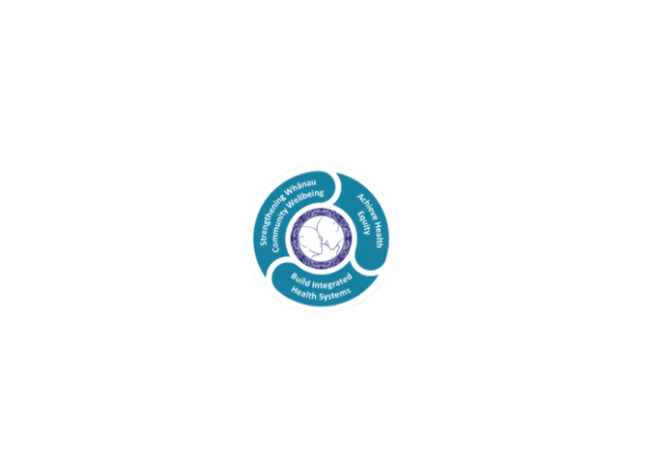

* Achieve equity in Māori health
* Build an Integrated health system
* Strengthen people, whanau & community wellbeing

### THREE CORE VALUES

Manaakitanga respect and acknowledgment of each other’s intrinsic value and contribution

Integrity truthfully and consistently acting collectively for the common good

Accountability collective and individual ownership for clinical and financial outcomes and sustainability

### TE ITI KAHURANGI – THE LAKES WAY, OUR PLACE, OUR CULTURE – WE WILL

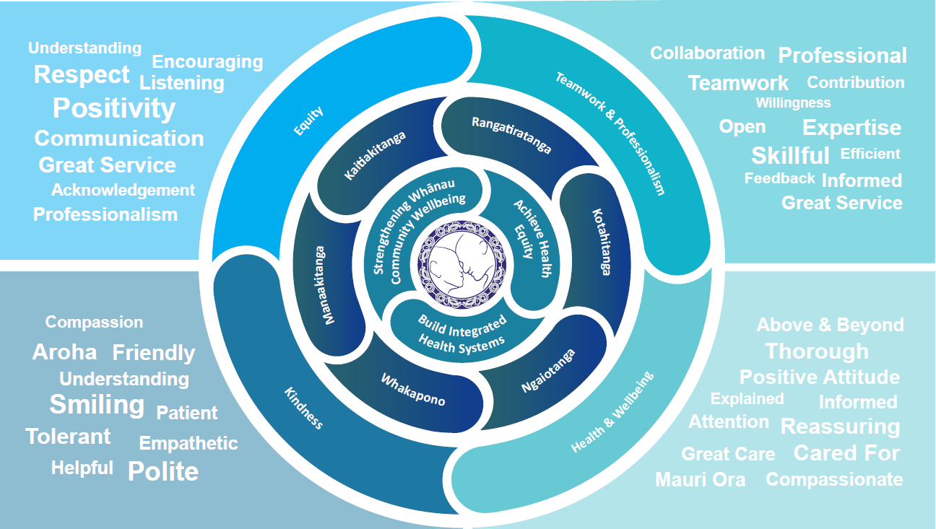

### TE TIRITI O WAITANGI

**Our expression of Te Tiriti o Waitangi**

The text of Te Tiriti, including the preamble and the three articles, along with the Ritenga Māori declaration, are the enduring foundation of our approach to achieving health and independence. Based on these foundations, we will strive to achieve the following four goals, each expressed in terms of mana.

**Mana whakahaere**

Effective and appropriate kaitiakitanga and stewardship over the health and disability system. Mana whakahaere is the exercise of control in accordance with tikanga, kaupapa and kawa Māori. This goes beyond the management of assets and resources and towards enabling Māori aspirations for health and independence.

**Mana motuhake**

Enabling the right for Māori to be Māori (Māori self-determination); to exercise their authority over their lives and to live on Māori terms and according to Māori philosophies, values and practices, including tikanga Māori.

**Mana tangata**

Achieving equity in health and disability outcomes for Māori, enhancing the mana of people across their life course and contributing to the overall health and wellbeing of Māori.

**Mana Māori**

Enabling Ritenga Māori (Māori customary rituals), which are framed by te ao Māori (the Māori world), enacted through tikanga Māori (Māori philosophy and customary practices) and encapsulated within mātauranga Māori (Māori knowledge).

Lakes DHB is committed within the framework of the New Zealand Public Health and Disability Act (2000) to supporting the Crown’s commitment to upholding its Tiriti promises.

### ORGANISATION STRUCTURE

