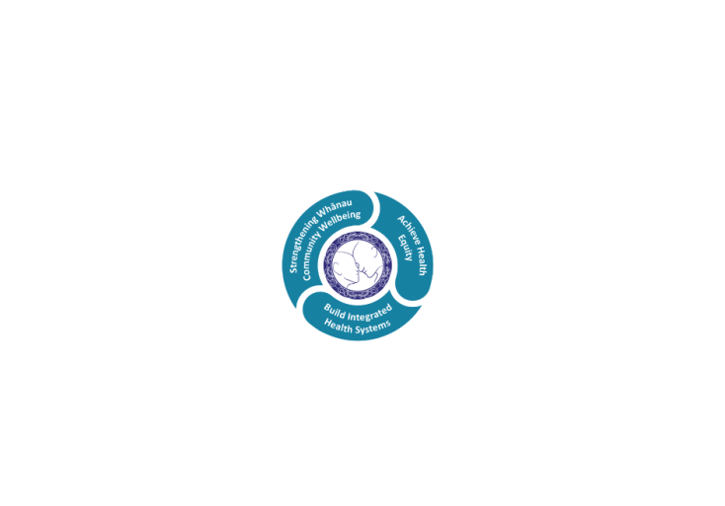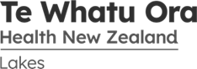

# POSITION DESCRIPTION

|  |  |  |
| --- | --- | --- |
| **Position:** | Mental Health Professional, ART (Acute Response Team), Mental Health & Addictions | |
| **Responsible To:** | Team Leader, Acute Response Team  Clinical (Nurse) Manager, Rotorua Adult Community Mental Health and Addictions  Service Manager Mental Health & Addiction Services | |
| **Direct Reports:** | NIL | |
| **Location:** | Rotorua & Taupo | |
| **Functional Relationships:** | **Internal:** Director of Allied Health  Professional Advisors  Allied Health Staff  Clinical Nurse Director Mental Health  Community Mental Health Nurses  Acute Inpatient Nursing Staff  Consultant Psychiatrists  Nursing Staff  Medical Staff  Administration Staff  Duty Managers  Maori Health Teams  Multi-Disciplinary Teams  Clinical Nurse Educators (CNE)  Clinical Nurse Specialists (CNS)  Other Departments | **External:**  Service Users / Tangata Whaiora  Family, Whanau, Caregivers  Visitors  General Practitioners  Community Agencies  Other Health Providers  Social Services  Non-Government Organisations |
| **Financial Delegations:** | N/A | |
| **Date:** | July 2023 | |

### Primary purpose(s) of the position

The Registered Health Professional is responsible and accountable for the assessment, planning, delivery and evaluation of safe and appropriate care within a crisis setting, with a particular focus on measures that support the psycho-social and welfare elements to promote positive health outcomes.

Provides clinical care based on the relevant scope of practice, competencies, Lakes policies and protocols and current best practice.

Te Whatu Ora Lakes Acute Response Team provides an urgent mental health response service 24 hours per day, 7 days per week throughout the Lakes region. This is within roster shifts which may include an on-call requirement.

The role of Duly Authorised Officer, and associated statutory functions, is a key component.

The role is pivotal in cross agency working to assist tangata whaiora (service users) and their whānau or family to facilitate timely access to specialist help that is easy to navigate, during mental health and addiction crises.

Our model of care asserts that recovery happens when hope is present and therefore service is provided in a way that ensures positive experience for tangata whaiora and their whānau.

Engage with tangata whaiora (service user) and their whānau (families) to provide the right support, information and advice.

This position will be based in Rotorua and will require services across the Lakes catchment area.

The Acute Response Team member will be working within the context of a multi-disciplinary team to provide tangata whaiora and their whānau focussed care in a culturally appropriate manner.

Lakes Acute Response Team will access Te Aka Matua as an active component in ensuring culturally safe engagement.

Best Practice will be achieved through the application of specialist mental health and addiction knowledge and guided by Lakes policies, procedures and values.

Clinical care that is responsive to **Te Ara Tauwhirotanga** - “Pathways that lead us to act with kindness” (Model of Care) to provide the optimal environment and service to effect client’s wellness and recovery.

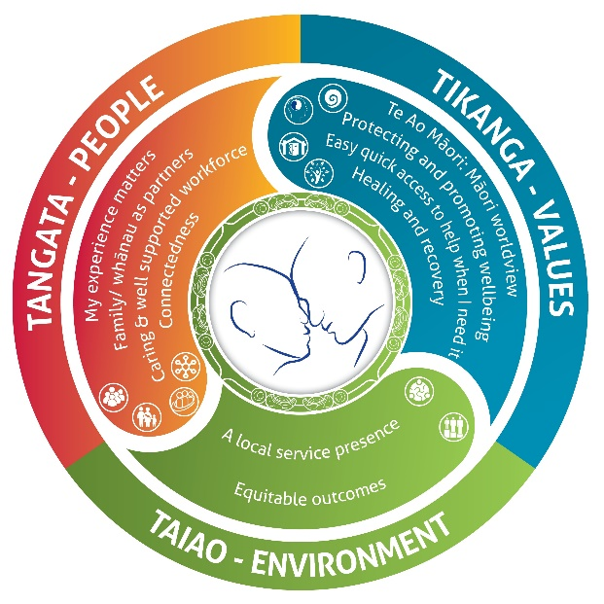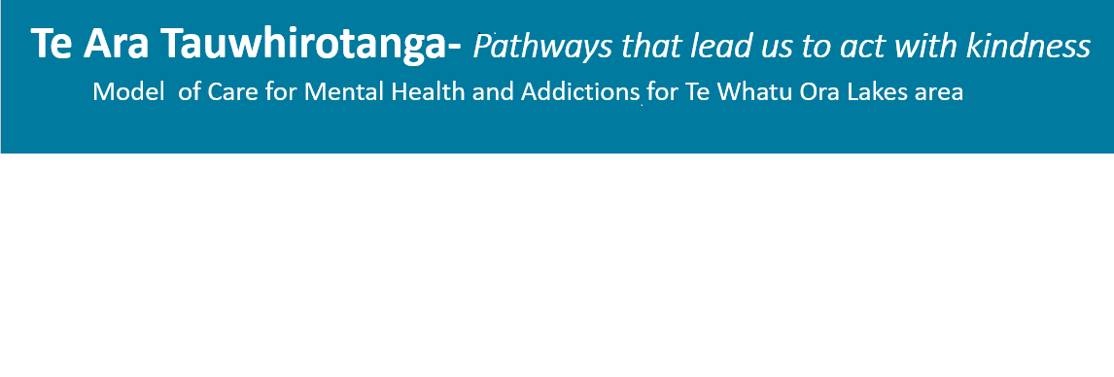

* **Tangata – People**
  + My experience matters
  + Family/Whanau as partners
  + Caring and well supported workforce
  + Connectedness
* **Tikanga –Values**
  + Te Ao Maori: Maori worldview
  + Protecting and promoting wellbeing
  + Easy quick access to help when I need it
  + Healing and recovery
* **Taiao – Environment**
  + A local service presence
  + Equitable outcomes

| **Key Objectives** | **Description** | **Expected Outcomes** |
| --- | --- | --- |
| **Clinical Care in line with Health Professional registration body** | **Social Work**  Effectively utilises the social work process to provide comprehensive social work services to patients and families/whanau in line with registration and current practising certificate competency requirements of the Social Workers Registration Board / Kahui Whakamana Tauwhiro of New Zealand | * Utilises professional discipline knowledge/skills to achieve the best outcomes for tangata whaiora. * Demonstrates continuing achievement through the required attributes, skills and knowledge to of the ten core [competencies](https://swrb.govt.nz/practice/core-competence-standards/) standards of the Social Workers Registration Board / Kahui Whakamana Tauwhiro of New Zealand:      * Maintains currency in organisational core certification as relevant to the clinical area. * Meets the orientation and on-going knowledge and skill requirements for relevant clinical areas. * Must comply with any specific conditions on practice as determined by SWRB. |
| **Occupational Therapy**  Delivers quality occupational therapy in line with registration and current practising certificate competency requirements of the Occupational Therapy Board of New Zealand | Demonstrates continuing achievement of competencies through the required attributes, skills and knowledge within the [five domains](https://www.otboard.org.nz/site/ces/competencies?nav=sidebar) for registration with Occupational Therapy Board of New Zealand.  (Appendix 1)   * Maintains professional e-portfolio demonstrating practice standards in accordance with OTBNZ minimum requirements and must comply with any specific conditions on practice as determined by OTBNZ * Maintains currency in organisational core certification as relevant to the clinical area. * Meets the orientation and on-going knowledge and skill requirements for relevant clinical areas. * Standards of Practice for the Occupational Therapy Process are implemented within the Service area (Referral, Screening, Assessment, Planning, Intervention, Discharge). * Adherence to the World Federation of Occupational Therapists Code of Ethics is maintained.   Applying expert occupational therapy knowledge, skills and values:   * Applying professional and evidence based knowledge to engage with people and communities to enable occupations based on rights, needs, preferences and capacities. * Work within the context of each client’s ecology to optimise their participation and well-being. * Effectively engages in professional supervision or coaching to improve patient outcomes. |
| **Other Health Professional**  Delivers quality care in line with relevant registration and current practising certificate competency requirements | * Demonstrates continuing achievement of competencies through the required attributes, skills and knowledge within the relevant qualification and registration * Maintains currency in organisational core certification as relevant to the clinical area. * Meets the orientation and on-going knowledge and skill requirements for relevant clinical areas. * Must comply with any specific conditions on practice |
| **Te Ara Tauwhirotanga Model of Care** | Follows the principles of the model of care “Te Ara Tauwhirotanga – Pathways that lead us to act with kindness.” | * Utilises Te Ara Tauwhirotanga – “Pathways that lead us to act with kindness” model of care to engage with tamariki, whānau and multidisciplinary teams. * Provides specialist clinical care following the principles of the model of care Te Ara Tauwhirotanga – Pathways that lead us to act with kindness. * Incorporates and follows the principles of the model of care Te Ara Tauwhirotanga – Pathways that lead us to act with kindness into day to day business activities. |
| **Formulation and Planning** | Safe, quality assessment, care and treatment options in accordance with healthcare service user / tangata whaiora needs, professional standards of practice, Lakes policies, guidelines and values | * Safe quality assessment, care and treatment planning including the use of acute alternative facilities or home based treatment options provided in Mental Health or Addictions crisis situations and home based treatment service provision. * Performs confidently and proficiently clinical skills and competencies specific to the area and specific professional discipline requirements * Therapeutic interventions and medications are administered in accordance with Lakes policies. * Demonstrates autonomous establishment of assessments and care treatment planning. * Maintains documentation according to Lakes policies and area standards. * Proficiently plans discharge/transfer of care using MDT and other appropriate resources. * Best Practice is used as a basis for assessment, care and treatment. * Uses a variety of treatment modalities including home based treatment where possible brief intervention talking therapies to meet the needs of consumer / tangata whaiora. * Uses Feedback Informed Treatment as an engagement tool and outcome measure. * Carries out function and duties of a **Duly Authorised Officer** under the general direction of the Director of Area Mental Health Services. |
| **Contribution to Clinical Service Delivery** | Member of the Clinical team, contributing to collaborative team work, and individual responsibility for generating and maintaining accurate data.  Provides support to line manager / CNM in achieving the aims of the department | * Undertakes specific portfolios of responsibilities as agreed with the CNM * Work collaboratively with colleagues and the multidisciplinary team (MDT) to meet patient care and service needs. * Patient care must be actualised for each patient on each shift within the designated time frame. * May be required to work in other units to meet patient care needs. * Is mindful of and responsible for the appropriate and cost effective use of resources in relation to allocated patients within the unit. * Actively facilitates and role models team working and flexibility between clinical and support staff members * Works proactively with medical specialists and other specialists to ensure effective services to patients using the department. |
| **Safety** | Demonstrates clinical, ethical, legal and cultural safety to practice | * The registered health professional promotes that people are entitled to consideration and respectful care without prejudice against gender, ethnic background, lifestyle, education, and religion. * Attends cultural awareness sessions and Treaty of Waitangi workshops as developed by Lakes. * Respects the rights of the person to dignity, privacy and confidentiality in accordance with Lakes' Code of Rights, the Privacy Act and discipline specific codes of practice * Acts in resolving ethical dilemmas and makes ethical decisions within the framework of care and responsibility. * Acts within guidelines of informed consent. * Knows own limitations and seeks help and guidance appropriately. * Challenges established practices that do not fit with best practice principles * Follows up when unsafe/unprofessional behaviour is observed |
| **Professionalism** | Demonstrates accountability and responsibility for professional practice | * Is aware of and upholds the professional standards of practice of their own discipline and Lakes. * On-going Professional Development goals and objectives are set at least annually and there is evidence of progress towards achieving these goals. * Is self-directed at maintaining an advanced level of practice. * Feedback is sought regarding own performance and appropriate improvement demonstrated. * Participates in performance appraisals. * Engages in Clinical Supervision as per Mental Health & Addiction Service Policy. * Provides Clinical supervision if considered appropriate by Service Management, Professional Advisor, and self as per MH&AS Policy. * Acts a role model while promotes professional practice and Lakes vision and values * Maintains own health and wellbeing and refers to relevant support personnel as necessary. * Participates in approved research in area. |
| **Team Communication** | The Health professional will contribute to effective clinical interventions by, and the functioning of, the Multidisciplinary Team (MDT). | * The health professional will be a respected and useful member of the MDT, effectively communicating with other team members and participating in team and service procedures as required. * Demonstrates an understanding and appreciation of the scopes of other disciplines. * Accurately represents discipline specific aspects of clinical care to others. * Provides psycho-social input and opinion to clinical reviews of clients of the MDT. |
| **Clinical Supervision** | Engages in regular clinical supervision, including Cultural Supervision (as appropriate). | * May provide clinical supervision as per Mental Health Service policy. * Receives clinical supervision on a regular basis as per Mental Health Service policy. * Actively participates in Peer Review activities. |
| **Quality** | The Health professional will actively pursue personal, professional, and service focussed Quality Improvement opportunities. | * Participates in development of and adheres to Quality Assurance Policies and Procedures. * Participates in forums that develop Quality Assurance Policies, Procedures and Initiatives appropriate to the appointed role. * Demonstrates commitment to principles of Continuous Improvement. * Documents clinical care provision in accordance with professional Te What Ora Lakes and Mental Health Service standards. * Maintains membership with relevant professional bodies. |
| **Education and Training** | Undertakes teaching and learning activities with consumers, colleagues and students | * Maintains up-to-date knowledge of clinical interventions, psychological therapies and related fields. * Provides in-service training and teaching according to professional abilities. * Develops an annual, personalised Professional Development Plan, and participates in Annual Performance Appraisals. |
| **Other Requirements** | Flexibility | * Lakes is required to provide 24 hour services which at times may require you to change duties or redeploy to another unit/department to ensure safe patient care. * This position description is not exhaustive and you may be requested to perform other reasonable tasks within your scope of practice. |
| **Utilisation of Telehealth** | Provision of patient centric care which will give patients the option of telephone or video appointments where there is no need for an in-person appointment. | * **Allied** - Service provision is in line with the New Zealand Health Strategy and the New Zealand Allied Health Best Practice Guide for Telehealth to provide care “closer to home”. * Advise patients in the use of telemonitoring devices (where appropriate) and provide follow-up care to prevent unnecessary hospital admissions |
| **Research** | The Health professional will participate in and/or support research activities | * May participate in applied and/or theoretical research (as resources permit). * dvice on research design, methodology, statistics and interpretation |
| **Delegated Duties** | The Health professional will perform delegated duties when required. | * Completes any delegated duties from Clinical (Nurse) Manager or Service Manager as related to the function of a Clinical Health professional. |

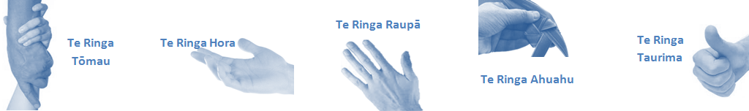

| **Capabilities** | | **Capability Definition** | | **Achievement Indicators** |
| --- | --- | --- | --- | --- |
| **Communication and Personal Interaction**  **Te Ringa Hora**  ***the open hand (denoting someone who is sociable)*** | | Communicates relevant information in a timely manner to those who need to know at a level that is understood. | | * Transfers information effectively verbally and writes clearly, coherently and succinctly. * Shares well thought out, concise and timely information with others using appropriate mediums. * Builds team spirit, facilitates resolution of conflict, promotes/protects team reputation, shows commitment to contributing to the teams’ success. * Maintains and promotes high standards of social, ethical and organisational norms. |
| Fosters a team environment and encourages collaboration between team and departments within Lakes. | | * Articulates differing perspectives on an issue and can see the merit of alternative points of view. * Connects with others, listens, reads people and situations and communicates tactfully. * Gets to know their team members and treats them with respect, valuing their individuality and contributions. |
| Connects with people to build trust and confidence. | |  |
| **Strategy & Performance**  **Te Ringa Raupā**  ***the roughened hand (symbolising a hard worker)*** | | Delegates appropriately within team utilising individual skills to achieve results. | | * Understands individuals’ strengths and weaknesses to utilise or increase skills for those individuals. * Ensures decision making complies with organisational strategies. * Recognises decisions made affect overall results of the service and Te Whatu Ora Lakes. * Works with Service Manager to maximise efficiency |
| Understands the service requirements and the implications of set KPIs or achievements on the overall service delivery. | |  |
| **Development and Change**  **Te Ringa Ahuahu**  ***the hand that shapes or fashions something (refers to someone who is innovative)*** | | Works to include staff in change minimising barriers to implementation. | | * Continually strives for new and improved work processes that will result in greater effectiveness and efficiencies. * Openly broaches concern from the outset asking for ideas and input. * Gives examples of what might help to resolve the issue/concern. * Seeks opportunities to improve performance and seeks feedback to measure and improve. * Encourages participation in possible solution process. * Gives careful consideration of ideas and offers alterations to suggestions where necessary. |
| Articulates decisions and reasoning behind change enable buy-in to results. | | * Informs response to the team including trends, data, process and benefits. * Allows feedback to decisions to enable change process to be actioned where appropriate. |
| **Personal Accountability,** **Integrity and Trust**  **Te Ringa Tōmau**  ***the hand that is trustworthy*** | | Manages own and encourages others to foster work/life balance. | | * Is widely trusted; is seen as a direct, truthful individual; can present the unvarnished truth in an appropriate and helpful manner; keeps confidences; admits mistakes; doesn’t misrepresent him/herself for personal gain; works autonomously but also a team player. * Ensures regular breaks are taken and own annual leave accruals are used within the 12 months following accrual. |
| Actively manages own career aspirations and development. | | * Is constantly striving to acquire and maintain knowledge, skills and/or experience. * Has own career development plan and succession planning. * Seeks out development opportunities to expand knowledge and capability. * Engages in projects and activities readily which are above and beyond scope of current role when requested to. |
| **Culture and Values**  **Te Ringa Taurima**  ***the hand that nurtures, encourages, supports*** | | Makes decisions based on facts and without personal bias. | | * Is proactive and effective when problem solving is required. * Critically examines repeatable risk factors. |
| Engages with mentors and supervisors for personal skill development. | | * Is constantly striving to acquire and maintain knowledge, skills and/or experience. * Demonstrates a commitment to and takes responsibility for going professional development. |
| Plans, prioritises and organises work to deliver on short and long term goals. | | * Purposeful about where time is invested. * Delivers relevant results within expected timeframes. |
| Encourages and promotes Lakes values and expectations. | | * Role models expected behaviours and practices. * Uses appropriate empathy to gain organisational objectives. * Is solution focused. |
| **Compulsory Requirements** | **Description** | | **Expected Outcomes** | |
| **Māori Health** | Māori philosophies and values of health are demonstrated in work practice. | | * Meaningful relationships are established with Te Aka Matua (Rotorua and Taupo Hospitals) and Te Whatu Ora Lakes Maori Health division in the planning and delivery of services. * Practices are consistent with Te Tiriti o Waitangi /The Treaty of Waitangi when working with Māori. * Delivery of safe services for Māori are facilitated by ensuring they can access treatment options and are involved in the planning and delivery of their care. * Māori are enabled to access and participate in cultural activities provided by the Te Whatu Ora Lakes. * A commitment to improving the wellbeing of Māori by increasing cultural knowledge in the Te Whatu Ora Lakes is shown. | |
| **Te Iti Kahurangi** | The Lakes Way, Our Place Our Culture | | * Works within the Te Iti Kahurangi framework and supporting guide document. | |
| **Record Keeping** |  | | * Complies with the Te Whatu Ora Lakes Corporate Records Management policy to create and maintain full and accurate records. | |
| **Quality & Risk** | Patient safety is paramount to the service we deliver at Te Whatu Ora Lakes. This is to be achieved in a clinical governance framework that is culturally responsive and identifies and manages risk and opportunities to improve. | | * Employees are supported to lead by example and implement a culture of continuous quality improvement. * Risks that may prevent Te Whatu Ora Lakes from achieving their goals are identified, reported, and managed. * Māori patients are provided patient-centred care to achieve positive Māori health outcomes. * Needs of Māori are reviewed and reported in the further development of practice, process and or policy. * Evidence-based methodologies are used to support improvements, e.g. kaupapa Māori methodology. * Quality care is provided to certification standards. | |
| **Health & Safety** | Each individual is responsible for ensuring the safety of themselves, their colleagues, patients and their visitors and to comply with all organisational health and safety policies, procedures and guidelines. | | * Implementation and reinforcement of a proactive healthy work place culture which reflects relevant Te Whatu Ora Lakes policy and legislative requirements. * Healthy lifestyles are actively promoted and participated in, within the work area. * Employees participate in Health and Safety within areas of work. * Health and Safety activities are appropriately documented within specified timeframes. * Health and Safety policies have been read and understood and are applied in the workplace. * Health and Safety policies are appropriately documented within specified timeframes and incidents are reported immediately. * Any opportunities for improving Health and Safety are reported and acted upon in a timely manner. * All near misses/incident/accidents are reported to the appropriate line manager within 24 hours. | |

**Signatures:**

|  |  |
| --- | --- |
| Line Manager:  (position description approved): |  |
| Employee:  (acceptance of position description): |  |

*(Please also initial all other pages to show acceptance of position description.)*

|  |  |  |  |  |  |
| --- | --- | --- | --- | --- | --- |
| **Person Specification** | | **Essential:** | | **Desirable:** | |
| **Education and Qualifications:** | | * Full registration with the relevant New Zealand Registration Board. * Treaty of Waitangi training. | | * Post-Graduate training | |
| **Experience:** | | * A minimum of 3 years’ experience in a Mental Health setting | | * Experience in a crisis setting or leadership position | |
| **Health Practitioners Competence Assurance Act 2003** | | * You are required to maintain your current competency based practicing certificate. * You must notify your Manager of any changes to scope or conditions on practice (determined by Regulatory Authority). * You must complete the requirements of any competency programme. * You must notify the employer of concerns relating to the risk of harm to the public of another health practitioner practicing below the required standard of competence. * You are required to know the provisions of the HPCAA as the governing legislation. | |  | |
| **Knowledge:** | | * Relevant Code of Ethics * Mental Health Act (1992) and any amendments * Privacy Act (1993) and its amendments * Health and Disability Code of Consumer Rights 1996 * Health Information Privacy Code 1994 * Health Practitioners Competency Assurance Act 2003 * Human Rights Act 1993 * Misuse of Drugs Act 1975 and Regulations 1977 * Treaty of Waitangi Act 1975 and its application to the health setting. * Medicines Act 1981 and Medicines Regulation 1984 * Misuse of Drugs Act 1975 and Regulations 1977 * Mental Health & Addiction Services Policies, Procedures and Guidelines * Te Tiriti O Waitangi in the provision of health care services and support to Māori. * Te Tiriti O Waitangi in practice, process, policy development and decision making * Other relevant legislation | | * Te Whatu Ora Quality Framework (must become conversant with this once employed) | |
| **Skills:** | | * Pronunciation of Te Reo Māori words and names * Produces and maintains accurate records, notes and other documentation which are clear and up to date. * Basic computer skills * Consumer/Recovery focused | | * Te Reo Māori | |
| **Personal Attributes:** | | * Cultural sensitivity and safety * Able to react appropriately to the unpredictable nature of the work and the workplace * Leadership abilities * Advanced Problem solving abilities * Excellent oral and written communication * Ability to prioritise activities and needs * Professional demeanor * Ability to work independently (self-directed) * Excellent interpersonal skills * Integrity * Good time management and organisational ability. * Team player * Good analytical skills * Ability to work under pressure * Sense of humour | | * Non-smoker preferred | |
| **Other** | | * Full Driver’s License * Covid-19 Vaccinated | |  | |

At Te Whatu Ora Lakes we place the highest value on the health and wellbeing of everyone in our community. As such all healthcare workers are expected to play a part in the creation and promotion of an environment which lives the following vision, mission and values:

### VISION

Healthy Communities – Mauriora! In this vision Mauriora refers to the Mauri - being the life essence and the source of well-being, and ora - describing the state of wellness.

### STRATEGIC MISSION

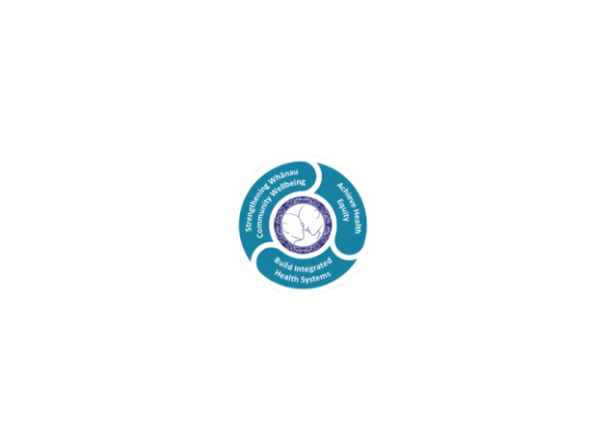

* Achieve equity in Māori health
* Build an Integrated health system
* Strengthen people, whānau & community wellbeing

### THREE CORE VALUES

Manaakitanga respect and acknowledgment of each other’s intrinsic value and contribution

Integrity truthfully and consistently acting collectively for the common good

Accountability collective and individual ownership for clinical and financial outcomes and sustainability

### TE ITI KAHURANGI – THE LAKES WAY, OUR PLACE, OUR CULTURE – WE WILL

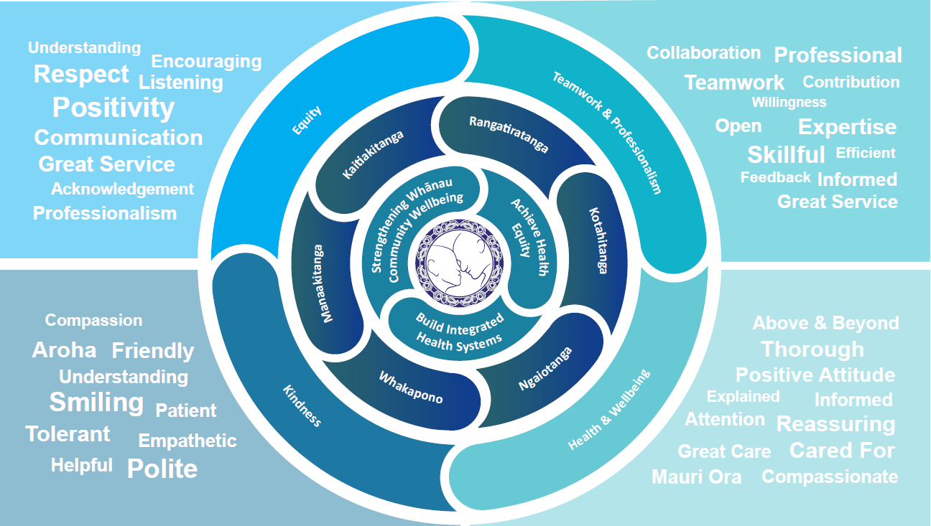

### TE TIRITI O WAITANGI

**Our expression of Te Tiriti o Waitangi**

The text of Te Tiriti, including the preamble and the three articles, along with the Ritenga Māori declaration, are the enduring foundation of our approach to achieving health and independence. Based on these foundations, we will strive to achieve the following four goals, each expressed in terms of mana.

**Mana whakahaere**

Effective and appropriate kaitiakitanga and stewardship over the health and disability system. Mana whakahaere is the exercise of control in accordance with tikanga, kaupapa and kawa Māori. This goes beyond the management of assets and resources and towards enabling Māori aspirations for health and independence.

**Mana motuhake**

Enabling the right for Māori to be Māori (Māori self-determination); to exercise their authority over their lives and to live on Māori terms and according to Māori philosophies, values and practices, including tikanga Māori.

**Mana tangata**

Achieving equity in health and disability outcomes for Māori, enhancing the mana of people across their life course and contributing to the overall health and wellbeing of Māori.

**Mana Māori**

Enabling Ritenga Māori (Māori customary rituals), which are framed by te ao Māori (the Māori world), enacted through tikanga Māori (Māori philosophy and customary practices) and encapsulated within mātauranga Māori (Māori knowledge).

Te Whatu Ora Lakes is committed within the framework of the New Zealand Public Health and Disability Act (2000) to supporting the Crown’s commitment to upholding its Tiriti promises.

### ORGANISATION STRUCTURE

