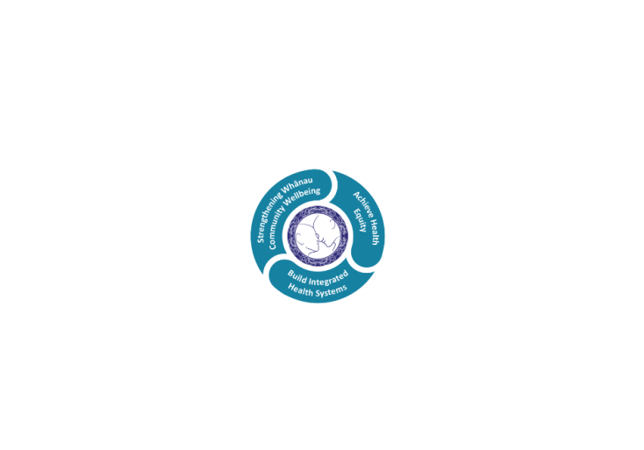

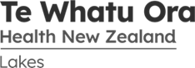

# POSITION DESCRIPTION

|  |  |  |
| --- | --- | --- |
| **Position**: | Mental Health Cultural Peer Support Worker, Te Toki Haumanu Closer to Home Services. | |
| **Responsible to:** | Clinical Nurse Manager *with support from Team Coach*]  Dotted reporting line to Service Manager, Te Aka Matua  Service Manager Mental Health & Addiction Services. | |
| **Direct Reports:** | Nil. | |
| **Location:** | Rotorua & Taupō | |
| **Functional relationships:** | **Internal:**  Clerical Staff  Nursing Staff  Allied Health Staff  Medical Staff  Clerical/Admin Staff  Mental Health & Addiction Multi-disciplinary Teams and services  Te Aka Matua Kaupapa Service  Other Departments | **External**:  Service Uses, Caregivers, Family/Whanau, Iwi Representatives.  Consumer & Family/Whanau  Peer Support Lead  Representatives Non-Governmental Organisations  Primary Health Organisation personnel  General Practitioners (GP’s) & Practice Nurses - Designated Primary Care Practices. |
| **Financial delegations:** | Nill | |
| **Date**: | August 2023. | |

### 

### Primary purpose(s) of the position

Te Toki Haumanu is a two-tiered community-based acute alternative framework that enables person-directed and whānau & family inclusive care and seeks to simplify the care pathways for the people using these services to provide more effective care.

* + - 1. The primary purpose of the position is to provide individualised support with the goal of recovery by role-modelling of hope, encouraging self-awareness and self-determination, including the development of participation with natural supports within the person’s own community.

1. The Cultural Peer Support worker bring a unique cultural perspective to the role and supports the Clinical (Nurse) Manager and the team to appropriately provide navigation, cultural advice, care and specifically (although not exclusively) support Maori tangata whaiora and their whanau
2. Cultural Peer Support Workers (CPSW) are members of the Te Toki Haumanu multi-disciplinary team (MDT) and works under the direction and delegation of the registered health professionals.
3. As Peer Support Workers the CPSW may share personal experience of recovery in a way that inspires hope and encourages people to recognise that they are able to determine their own wellbeing. The CPSW relationship is based on mutual respect, through shared experience and understanding.
4. CPSW work to enable service users to be partners in their care. The role necessitates the development of strong supportive relationships based on mutual respect and shared understanding.
5. Cultural Peer Support Workers work within an agreed model of practice. CPSW share wellness skills and strategies that may support people to achieve their recovery and wellbeing goals.
6. CPSW is a unique role with specific training and workforce infrastructure, including supervision and on-going professional development.
7. Within the framework of Te Toki Haumanu, the role includes an on-call function to ensure support can be offered to Tangata Whai Ora (Service Users) at their most vulnerable times, such as crisis assessment or admission to the in-patient unit

* **Te Ara Tauwhirotanga - “Pathways that lead us to act with kindness”** (Model of Care) to provide the optimal environment and service to effect client’s wellness and recovery.

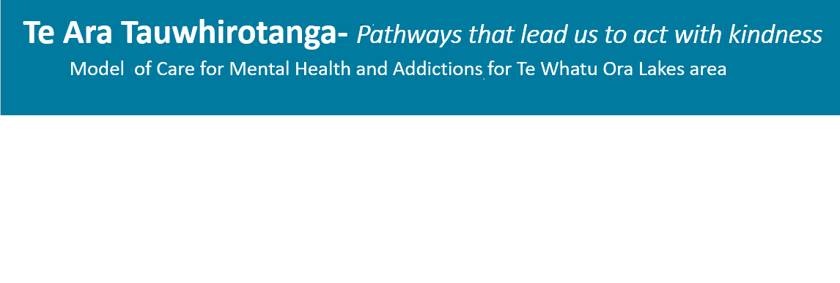



* **Tangata – People**
  + My experience matters
  + Family/Whanau as partners
  + Caring and well supported workforce
  + Connectedness
* **Tikanga –Values**
  + Te Ao Maori: Maori worldview
  + Protecting and promoting wellbeing
  + Easy quick access to help when I need it
  + Healing and recovery
* **Taiao – Environment**
  + A local service presence
  + Equitable outcomes

|  |  |  |
| --- | --- | --- |
| **Key Objectives** | Description | Expected Outcomes |
| **Recovery Coaching** | To be a positive role model for hope by using own life stories. Ensure people become more active participants in their own recovery process | * Demonstrating the five Pathways to Recovery when utilising the peer support approach:   + Hope   + Choice   + Empowerment & Self-determination   + Recovery environment   + Spirituality, meaning & purpose   + Provide direct peer support to peers and connecting with peers by sharing own personal experience of recovery in a way that inspires hope, motivation, self- determination and empowerment; * Assist peers with developing personal recovery plans * Support peers in developing their own natural supports that will enable them to increase their resilience, confidence and engagement in community activities. |
| **Cultural guidance** | Provide cultural support and guidance for Maori and their whanau who are in receipt of care from Te Whatu Ora Lakes in-patient Mental Health & Addiction Services | * The Cultural Peer Support Worker may provide specialist advice, guidance and/or support (if appropriate) in the facilitation of whanau engagement with CMHS staff e.g. pohiri, engagement and liaison with staff to whanau, whanau to staff as appropriate and requested by whānau. * Processes are in accordance with the tikanga and kawa of Te Arawa or Tuwharetoa as appropriate * Maintains connections with Lakes Te Aka Matua Kaupapa service * Recognise cultural differences and adapt communication or interaction where appropriate. Examples of different cultural groups may be as a result of age difference, ethnic difference, gender or religious difference and so on. If unsure always ask. |
| **Consumer Support** | To provide support to tangata whaiora and their immediate whānau under the direction of the clinical team. | * Assist and guide tangata whaiora to access relevant community services and supports to help them with their recovery. * Assist and support tangata whaiora in attending clinical appointments and ensures a Maori worldview is considered within formulation and care plans. * Work under the direction of the clinical team to maintain observations or community support and reporting to the clinical team with regards any changes, issues or concerns for individual tangata whaiora and their immediate whānau where relevant. * Assist the clinical and administration team to maintain a safe and welcoming environment * Other activities as requested by the clinical team within the relevant scope of practice and responsibility e.g. relationship building and networking. * Maintain a positive disposition and encourage hope and optimism towards tangata whaiora and families. * Demonstrate active listening skills. * Assist with independent cultural assessment as required within the Mental Health Act process. |
| **Teamwork** | Act as a member of the MDT & facilitates Māori perspectives and connections between individual Māori, whānau, and staff of Lakes specialist Community Mental Health & Addiction services | * Collaboratively works within the CMHS and other agreed service settings * Understands and is able to articulate the scope of the cultural peer support worker role. * Maintains positive and effective working relationships with other team members within the MDT (multidisciplinary team) * Participates in team meetings and team processes. * Resolves any conflict or tensions in a positive manner or elevates to Clinical (Nurse) Manager (CNM) if assistance required * Uses any equipment or supplies resourcefully and responsibly and reports any faulty or damaged equipment to the CNM or a senior staff member. * Works with Service Manager to maximise the cultural peer support service efficiency. |
| **Personal Development** | To take responsibility for personal and professional education and development within the Peer Support Worker role. | * Complete any relevant follow-up peer support and recovery training (e.g. WRAP) on a regular basis. * Participate in regular and ongoing peer support supervision, both individual and group and participate in coaching supervision as required. * Attend relevant training or educational programmes to update own knowledge. * Gain further skills as required by Lakes including mandatory annual Mental Health & Addiction Services training. * Participating in ongoing individual performance reviews by identifying own learning needs, and setting professional development goals to meet these. * Demonstrate personal well-being and resilience. |
| **Utilisation of Telehealth** | Health care is delivered using digital technology where participants may be separated by time and/or distance | ALLIED STAFF   * Service provision is in line with the New Zealand Health Strategy and the New Zealand Allied Health Best Practice Guide for Telehealth to provide care “closer to home”. * Person centric care which will give tangata whaiora the option of telephone or video appointments where there is no need for an in-person appointment. |
| **Model of Care** | Follows the principles of the model of care “Te Ara Tauwhirotanga – Pathways that lead us to act with kindness.” | * Utilises Te Ara Tauwhirotanga – “Pathways that lead us to act with kindness” model of care to engage with service users / whaiora, visitors and multidisciplinary teams. * Incorporates and follows the principles of the model of care Te Ara Tauwhirotanga – Pathways that lead us to act with kindness into day to day business activities. |

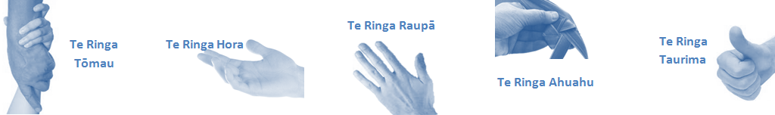

|  |  |  |
| --- | --- | --- |
| **Capabilities** | Capability definition | Achievement Indicators  *)* |
| **Communication and Personal Interaction**  **Te Ringa Hora**  ***the open hand (denoting someone who is sociable)*** | Communicates relevant information in a timely manner to those who need to know at a level that is understood. | * Transfers information effectively verbally and writes clearly, coherently and succinctly. * Shares well thought out, concise and timely information with others using appropriate mediums. * Organisational updates are provided to staff by way of relaying in general terms but more importantly what affect it has on the unit and how staff can help where necessary to achieve any requirements. * Builds team spirit, facilitates resolution of conflict within the team, promotes/protects team reputation, shows commitment to contributing to the teams success. * Maintains and promotes high standards of social, ethical and organisational norms. |
| Fosters a team environment and encourages collaboration between team and departments within Lakes.. | * Articulates differing perspectives on an issue and can see the merit of alternative points of view. * Works with other managers and teams to streamline processes for the best efficiency for both teams. * Provides staff who have concerns about another team process, a different point of view to consider. |
| Connects with people to build trust and confidence. | * Connects with others, listens, reads people and situations and communicates tactfully. * Gets to know their team members and treats them with respect, valuing their individuality and contributions. |
| **Strategy & Performance**  **Te Ringa Raupā**  ***the roughened hand (symbolising a hard worker)*** | Delegates appropriately within team utilising individual skills to achieve results. | * Understands individual’s strengths and weaknesses to utilise or increase skills for those individuals. * Assigns and sub-delegates staff to teams to allow for development and succession planning. |
| Understands the mental health & addiction service requirements and the implications of achievements on the overall service delivery. | * Ensures decision making complies with organisational strategies. * Recognises decisions made within the MHAS affect overall results of the service and Lakes. * Works with Service Manager to maximise unit efficiency |
| **Development and Change**  **Te Ringa Ahuahu**  ***the hand that shapes or fashions something (refers to someone who is innovative)*** | Works to include staff in change minimising barriers to implementation. | * Questions traditional ways of doing things when choosing a course of action or finds new combinations of old elements to form an innovative solution. * Continually strives for new and improved work processes that will result in greater effectiveness and efficiencies. * Openly broaches concern with staff from the outset asking for their ideas and input. * Gives examples of what might help to resolve the issue/concern. * Seeks opportunities to improve performance and seeks feedback to measure and improve. * Encourages staff participation in possible solution process. * Allows staff input to possible solutions to concern. * Gives careful consideration to staff ideas and offers alterations to suggestions where necessary. |
| Articulates decisions and reasoning behind change enable buy-in to results. | * Develops an informative response to the team including trends, data, process and benefits of the decided process/change. * Allows feedback to decision to enable ‘tinkering’ to be made where appropriate. |
| **Personal Accountability**  **Te Ringa Tōmau**  ***the hand that is trustworthy*** | Manages own and encourages others to foster work/life balance. | * Ensures regular breaks are taken and own annual leave accruals are used within the 12 months following accrual. * Ensures employees within their service are taking regular annual leave breaks for the purpose of rest/recreation throughout the year. |
| Actively manages own career aspirations and development. | * Is constantly striving to acquire and maintain knowledge, skills and/or experience. * Has own career development plan and succession planning. * Seeks out development opportunities to expand knowledge and capability. * Engages in projects and activities readily which are above and beyond scope of current role. |
| **Culture and Values**  **Te Ringa Taurima**  ***the hand that nurtures, encourages, supports*** | Makes decisions based on facts and without personal bias. | * Is proactive and effective when problem solving is required. * Engages with staff member/managers/multi-disciplinary team when concerns are raised to best understand their point of view. * Appropriately investigates the concern looking at trends, situation and practices. * Critically examines repeatable risk factors. |
| Engages with mentors and supervisors for personal skill development. | * Is constantly striving to acquire and maintain knowledge, skills and/or experience. * Demonstrates a commitment to and takes responsibility for going professional development. |
| Plans, prioritises and organises work to deliver on short and long term goals. | * Purposeful about where time is invested. * Delivers relevant results within expected timeframes. |
| Encourages and promotes Te Whatu Ora Lakes values and expectations. | * Role models expected behaviours and practices. * Treats staff, tangata whaiora and visitors with dignity and respect. * Uses appropriate empathy to gain organisational objectives. * Is solution focused. |

|  |  |  |
| --- | --- | --- |
| **Compulsory Requirements** | Description | Expected Outcomes |
| **Māori Health** | Māori philosophies and values of health are demonstrated in work practice. | * Meaningful relationships are established with Te Aka Matua (Rotorua and Taupo Hospitals) Te Whatu Ora Lakes Maori Health division in the planning and delivery of services. * Practices are consistent with Te Tiriti o Waitangi /The Treaty of Waitangi when working with Māori. * Delivery of safe services for Māori are facilitated by ensuring they can access treatment options and are involved in the planning and delivery of their care. * Māori are enabled to access and participate in cultural activities provided by the Te Whatu Ora Lakes. * A commitment to improving the wellbeing of Māori by increasing cultural knowledge in the Te Whatu Ora Lakes is shown. |
| **Te Iti Kahurangi** | The Lakes Way, Our Place Our Culture | * Works within the Te Iti Kahurangi framework and supporting guide document. |
| **Record Keeping** |  | * Complies with the Te Whatu Ora Lakes Corporate Records Management policy to create and maintain full and accurate records. |
| **Quality & Risk** | Patient safety is paramount to the service we deliver at Te Whatu Ora Lakes. This is to be achieved in a clinical governance framework that is culturally responsive and identifies and manages risk and opportunities to improve. | * Employees are supported to lead by example and implement a culture of continuous quality improvement. * Risks that may prevent Te Whatu Ora Lakes from achieving their goals are identified, reported, and managed. * Māori tangata whaiora are provided patient-centred care to achieve positive Māori health outcomes. * Needs of Māori are reviewed and reported in the further development of practice, process and or policy. * Evidence-based methodologies are used to support improvements, e.g. kaupapa Māori methodology. * Quality care is provided to certification standards. |
| **Health & Safety** | Each individual is responsible for ensuring the safety of themselves, their colleagues, tangata whaiora and their visitors and to comply with all organisational health and safety policies, procedures and guidelines. | * Implementation and reinforcement of a proactive healthy work place culture which reflects relevant Te Whatu Ora Lakes policy and legislative requirements. * Healthy lifestyles are actively promoted and participated in, within the work area. * Employees participate in Health and Safety within areas of work. * Health and Safety activities are appropriately documented within specified timeframes. * Health and Safety policies have been read and understood and are applied in the workplace. * Health and Safety policies are appropriately documented within specified timeframes and incidents are reported immediately. * Any opportunities for improving Health and Safety are reported and acted upon in a timely manner. * All near misses/incident/accidents are reported to the appropriate line manager within 24 hours. |

**Signatures:**

|  |  |
| --- | --- |
| Line Manager:  (position description approved): |  |
| Employee:  (acceptance of position description): |  |

*(Please also initial all other pages to show acceptance of position description.)*

|  |  |  |
| --- | --- | --- |
| **Person Specification** | **Essential:** | **Desirable:** |
| **Education and Qualifications:** | * Current clean drivers license | * Accredited Peer Support training * Level 4 Mental Health Support worker * .. |
| **Experience:** | * Whanau, hapu, iwi and marae and/or working with other Indigenous peoples * Mature adult with well-established interpersonal skills * Previous work experience in the field of mental health and addiction and/or in similar roles. | * Mental health or addiction lived experience * Experience in a health and/or social services environment.. |
| **Knowledge:** | * Growing Cultural knowledge and understanding of the cultural and spiritual norms of the whanau * Has a working knowledge of Maaori communities, whānau, hapu and iwi within the Lakes community * Knowledge of Māori providers * Te Tiriti O Waitangi in the provision of health care services and support to Māori. * Te Tiriti O Waitangi in practice, process, policy development and decision making. * Te Whatu Ora Lakes is a Reorua organisation knowledge and understanding of Te Reo/ Correct pronunciation. * Is aware of legislation that impacts on mental health care delivery and practices within legal boundaries. This is to include the Mental Health (Compulsory Assessment and Treatment) Act 1992, the Privacy Act 1993 (Health Information Privacy Code 1994 and the Health and Disability Act. * Health Records Act.. | * .. |
| **Skills:** | * Pronunciation of Te Reo Māori words and names * Knowledge of powhiri, karakia, whaikorero, whakapapa or a commitment to learn * Personal commitment to delivering a high standard of customer service/care * Sound communication skills with empathy for people with mental health and addiction problems * Effective written communication skills including computer literacy * Ability to relate to a wide range of people respectfully * Demonstrated ability to remain calm in difficult situations. * A positive can do attitude * Willingness and ability to take direction and contribute positively to the team culture * A clean drivers licence – Class 1 * Flexible and ability to multi-task * Willing to undertake mandatory and other appropriate training. * Ability to work rostered shifts 24 hour/7 day a week * Good personal time management and ability to prioritise * Ability to manage your own stress and cope under pressure * Maintain the code of conduct * Honest, trustworthy and reliable * Physically able to attend personal restraint training. | * Te Reo Māori * Has good knowledge of engaging with all nationalities and ethnic groups. * Competent in Māori models of Practice Competent in Maori models/service delivery e.g. Te Whare Tapa Wha, Pohiri and other models |
| **Personal Attributes:** | * Contributes positively to the culture of the organisation, is a team player, takes direction and accounts for performance. Demonstrate a caring and compassionate attitude towards clients, whānau and co-workers. * Able to relate with people from all walks of life.. | * Non-smoker preferred. * A sense of humour * Conflict resolution skills * De-escalation skills * Knowledge of the principles of recovery. |

**ABOUT TE WHATU ORA LAKES**

At Te Whatu Ora Lakes we place the highest value on the health and wellbeing of everyone in our community. As such all healthcare workers are expected to play a part in the creation and promotion of an environment which lives the following vision, mission and values:

### VISION

Healthy Communities – Mauriora! In this vision Mauriora refers to the Mauri - being the life essence and the source of well being, and ora - describing the state of wellness.

### STRATEGIC MISSION

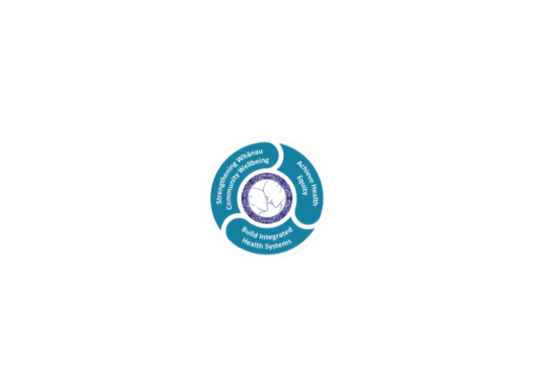

* Achieve equity in Māori health
* Build an Integrated health system
* Strengthen people, whanau & community wellbeing

### THREE CORE VALUES

Manaakitanga respect and acknowledgment of each other’s intrinsic value and contribution

Integrity truthfully and consistently acting collectively for the common good

Accountability collective and individual ownership for clinical and financial outcomes and sustainability

### TE ITI KAHURANGI – THE LAKES WAY, OUR PLACE, OUR CULTURE – WE WILL

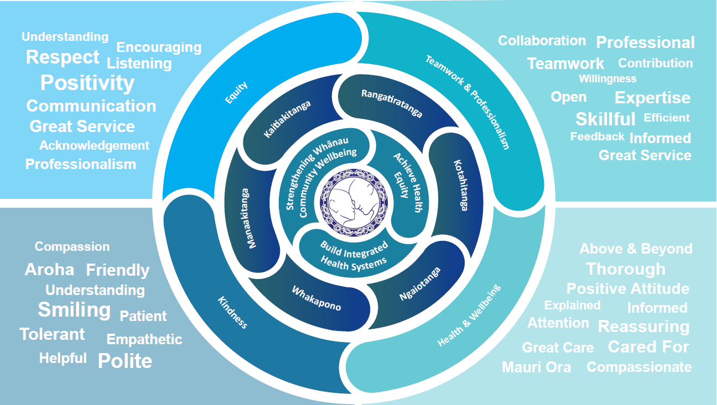

### TE TIRITI O WAITANGI

**Our expression of Te Tiriti o Waitangi**

The text of Te Tiriti, including the preamble and the three articles, along with the Ritenga Māori declaration, are the enduring foundation of our approach to achieving health and independence. Based on these foundations, we will strive to achieve the following four goals, each expressed in terms of mana.

**Mana whakahaere**

Effective and appropriate kaitiakitanga and stewardship over the health and disability system. Mana whakahaere is the exercise of control in accordance with tikanga, kaupapa and kawa Māori. This goes beyond the management of assets and resources and towards enabling Māori aspirations for health and independence.

**Mana motuhake**

Enabling the right for Māori to be Māori (Māori self-determination); to exercise their authority over their lives and to live on Māori terms and according to Māori philosophies, values and practices, including tikanga Māori.

**Mana tangata**

Achieving equity in health and disability outcomes for Māori, enhancing the mana of people across their life course and contributing to the overall health and wellbeing of Māori.

**Mana Māori**

Enabling Ritenga Māori (Māori customary rituals), which are framed by te ao Māori (the Māori world), enacted through tikanga Māori (Māori philosophy and customary practices) and encapsulated within mātauranga Māori (Māori knowledge).

Te Whatu Ora Lakes is committed within the framework of the New Zealand Public Health and Disability Act (2000) to supporting the Crown’s commitment to upholding its Tiriti promises.

### ORGANISATION STRUCTURE

