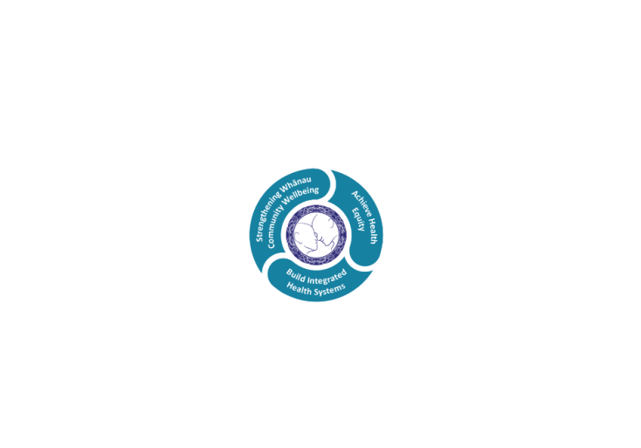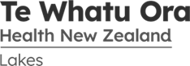

# POSITION DESCRIPTION

|  |  |  |
| --- | --- | --- |
| **Position:** | Radiology Receptionist and Administration Support | |
| **Responsible To:** | Administration Team Leader | |
| **Direct Reports:** | Nil | |
| **Location:** | Rotorua & Taupō | |
| **Functional Relationships:** | **Internal:**  Administrative Staff  Nursing Staff  MRTs  Sonographers  Radiologist  Allied Health Staff  Medical Staff  Other Departments | **External**:  Patients/Clients  Family/Whanau  Mokoia Imaging  TRG  Midland MRI  All DHBs |
| **Financial Delegations:** | Nil | |
| **Date:** | October 2022 | |

### Primary purpose(s) of the position

* To provide a competent, high quality Reception service with a customer focuses.
* To co-ordinate the scheduling of all Radiology procedures and requests in a timely manner in accordance with referrer’s requirements, Grade/Radiologist prioritising and Ministry of Health requirements.
* To electronically maintain and manage modality waitlists.
* To communicate effectively with internal and external parties to ensure scheduling outcomes for referrers and patients are met.
* Provide administration support for colleagues and cross- cover where needed for other administrators within the department.

|  |  |  |
| --- | --- | --- |
| **Key Objectives** | **Description** | **Expected Outcomes** |
| **Reception** | **To provide a high quality reception service with customer focuses** | * **Patient’s arrival is registered in the RIS and patients are directed to appropriate waiting areas within the department.** * **Outpatient walk in procedures are scheduled according to department policy as required.** * **Appropriate areas notified of patient arrival into department.** * **The telephone is answered promptly and in a courteous manner.** * **Mail is received and distributed** * **Outgoing reports and mail are sent within set time frame.** * **Radiology images are retrieved, tracked and sent using the Picture Archiving and Communication System (PACS) on request.** * **Patients presenting at the radiology reception counter are welcomed and attended to as required** * **All enquires or requests are attended to in a courteous and helpful manner, ensuring customer satisfaction at all times.** * **Patient’s information is confirmed and any necessary changes loaded onto the local and national computer system.** * **Scheduling and wait list enquiries are answered as necessary.** * **Send radiology reports by fax/HL7 as requested.** |
| **Scheduling** | **Scheduling and co-ordination of all Radiology procedures and requests.**  **Maintain and manage waitlists**  **Communicate effectively with internal and external parties to ensure scheduling outcomes for referrers and patients are met.** | * **Referral information is received and entered onto the Radiology Information System (RIS).** * **Referrals are responded to within the guidelines provided by the Radiology Manager or delegated representative(s).** * **All outpatient/inpatient Radiology modality procedures are scheduled to fit into the radiology scheduling system, including urgent requests.** * **Confirmation of appointments are received and recorded.** * **Scheduling of procedures are arranged with the patient/ ward/ outpatient/ private provider to best fit within the time frames required.** * **Appointments are re-scheduled if necessary and as required whilst maintaining targets wherever possible and timely communication is made to relevant parties when these targets are exceeded.** * **Scheduling of procedures requiring prior preparation is arranged with patient/ ward/ to ensure that patients/ward staff receive correct preparation products, instructions, prescriptions, laboratory request forms, and have full understanding of the appointment details and preparation required.** * **Scheduler liaises with Patients and/or their representatives, Radiology staff and Medical staff, both internally and externally, regarding appropriate scheduling of procedures and preparations according to patient conditions and requirements to ensure scheduling runs smoothly, and best outcome is achieved for patients.** * **Scheduler liaises with other hospital departments and Radiology modalities to co-ordinate interdependent appointments and minimise travel for patients wherever possible.** * **All cases are arranged within the set time frame for weekly radiology conferences and organisational MDM meetings.** * **Admissions and pre-admission requirements are arranged and communicated to all relevant parties ensuring all necessary resources are available and co-ordinated for a smooth transition for patients between departments and wards as appropriate.** * **Requests for procedures not relevant to this DHB Radiology department are re-directed as necessary.** * **Referrals are processed accurately and timely so that systems are maintained to provide scheduling and waiting list information as required.** * **Patient’s information is confirmed and any necessary changes loaded onto the local and national computer system to ensure patient information is current and correct.** * **Wait lists are monitored daily and appointments scheduled as appropriate.** * **Expected wait times are notified to patient and referrer as required.** * **Senior staff are advised and problem solving occurs between all staff concerned when wait lists become too long and are likely to exceed targets** * **All scheduling and wait list enquiries via telephone, email, fax and in person are dealt with as necessary.** * **All changes in scheduling are communicated promptly and confirmed with patients and all relevant parties.** * **All additional information received that relates to a patient’s appointment, including re-scheduling notes are recorded in RIS to ensure all staff have relevant information readily available.** * **Senior MRT advice is sought where appointments are not readily available for urgent cases and problem solving is required using in-patient or after hours appointment times.** * **Relevant senior MRTs are notified in a timely manner when wait lists exceed MOH and departmental targets. Solutions are discussed and implemented as required.** * **Outsourced procedures have purchase orders requested and relevant information delivered/received in a timely manner.** * **Continual review, discussion and updates in workflow occur as required to ensure a high standard of service is provided at all times.** * **Complaints procedures are followed in accordance with Lakes DHB policies** |

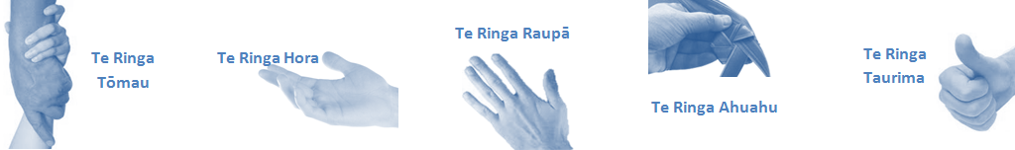

|  |  |  |
| --- | --- | --- |
| **Capabilities** | Capability definition | Achievement Indicators |
| **Communication and Personal Interaction**  **Te Ringa Hora**  ***the open hand (denoting someone who is sociable)*** | Openly communicates and cooperates with all levels of DHB employees, patients and visitors. | * Listens actively, absorbs message and responds appropriately. * Builds effective working relationships. * Establishes rapport with others and gains their respect while being adaptive in relating to different types of people and situation. * Openly and constructively participates in conversations with md team, patients, managers and visitors * Informs Administration team leader when workload becomes excessive and help is required to meet turnaround times. * Liaise with the Administration team leader on application for leave. * Patients and visitors are appropriately welcomed and treated while within the DHB * Collegiality with team mates and md teams * Accepts differences of opinion can occur but these happen respectfully and without any continued animosity |
| **Strategy & Performance**  **Te Ringa Raupā**  ***the roughened hand (symbolising a hard worker)*** | Spends energy on delivering role requirements and meeting objectives | * Has an energetic approach to work and is self-motivated. * Accepts direction and instruction of manager but is able to work effectively without direction or guidance. * Organises time and resources effectively. * Understands and work towards achievement of the organisation’s goals. * On shift is busy completing shift duties. |
| Organises own time to deliver on required tasks and duties | * Utilises effective time management strategies to meet shift duties and works towards achieving objectives in any spare moments. |
| **Development and Change**  **Te Ringa Ahuahu**  ***the hand that shapes or fashions something (refers to someone who is innovative)*** | Accepts change in day to day practices and contributes to decision making of the team. | * Can adjust behaviour to the demands of the work environment in order to remain productive through periods of transition, ambiguity, uncertainty and stress |
| Makes suggestions to increase efficiency of the unit. | * Works with managers and team to make any changes within practices work * Contributes to change processes, offering solution based ideas * Constructively makes suggestions to improve process or practices and gain efficiencies * Accepts when ideas are not accepted for implementation |
| **Personal Accountability**  **Te Ringa Tōmau**  ***the hand that is trustworthy*** | Is open with manager and colleagues and open to accepting feedback and critique to improve upon practice. | * Offers constructive criticism and accepts feedback. * Establishes rapport with others and gains their respect while being adaptive in relating to different types of people and situations, to allow improvements to be made. * Accepts all feedback and participates in feedback discussions appropriately * Responds and queries how improvements can be made * Advises manager wherever issues may be impacting on performance |
| Looks for and undertakes development activities appropriate for role and career development. | * Recognises areas that could be improved in own practice * Requests learning and development opportunities to enhance practice in role and/ or to assist where improvements can be made * Recognises and facilitates the rights of Māori clients and their whanau to participate in cultural activities. * Has a working knowledge of the Lakes DHB Māori communities. |
| **Culture and Values**  **Te Ringa Taurima**  ***the hand that nurtures, encourages, supports*** | Operates in line with DHB values and expectations and professional codes of conduct. | * Demonstrates a commitment to cultural safety by meeting and exceeding the cultural needs of clients/ customers/ colleagues. * Incorporates the Lakes Way into day to day business activities * Shows respect for patients, colleagues, * managers, md teams * Utilises the Lakes Way philosophy to engage with patients, visitors and md teams |

| **Compulsory Requirements** | **Description** | **Expected Outcomes** |
| --- | --- | --- |
| **Māori Health** | Māori philosophies and values of health are demonstrated in work practice. | * Meaningful relationships are established with Te Aka Matua (Rotorua and Taupo Hospitals) and Te Whatu Ora Lakes Maori Health division in the planning and delivery of services. * Practices are consistent with Te Tiriti o Waitangi /The Treaty of Waitangi when working with Māori. * Delivery of safe services for Māori are facilitated by ensuring they can access treatment options and are involved in the planning and delivery of their care. * Māori are enabled to access and participate in cultural activities provided by the Te Whatu Ora Lakes. * A commitment to improving the wellbeing of Māori by increasing cultural knowledge in the Te Whatu Ora Lakes is shown. |
| **Te Iti Kahurangi** | The Lakes Way, Our Place Our Culture | * Works within the Te Iti Kahurangi framework and supporting guide document. |
| **Record Keeping** |  | * Complies with the Te Whatu Ora Lakes Corporate Records Management policy to create and maintain full and accurate records. |
| **Quality & Risk** | Patient safety is paramount to the service we deliver at Te Whatu Ora Lakes. This is to be achieved in a clinical governance framework that is culturally responsive and identifies and manages risk and opportunities to improve. | * Employees are supported to lead by example and implement a culture of continuous quality improvement. * Risks that may prevent Te Whatu Ora Lakes from achieving their goals are identified, reported, and managed. * Māori patients are provided patient-centred care to achieve positive Māori health outcomes. * Needs of Māori are reviewed and reported in the further development of practice, process and or policy. * Evidence-based methodologies are used to support improvements, e.g. kaupapa Māori methodology. * Quality care is provided to certification standards. |
| **Health & Safety** | Each individual is responsible for ensuring the safety of themselves, their colleagues, patients and their visitors and to comply with all organisational health and safety policies, procedures and guidelines. | * Implementation and reinforcement of a proactive healthy work place culture which reflects relevant Te Whatu Ora Lakes policy and legislative requirements. * Healthy lifestyles are actively promoted and participated in, within the work area. * Employees participate in Health and Safety within areas of work. * Health and Safety activities are appropriately documented within specified timeframes. * Health and Safety policies have been read and understood and are applied in the workplace. * Health and Safety policies are appropriately documented within specified timeframes and incidents are reported immediately. * Any opportunities for improving Health and Safety are reported and acted upon in a timely manner. * All near misses/incident/accidents are reported to the appropriate line manager within 24 hours. |

**Signatures:**

|  |  |
| --- | --- |
| Line Manager:  (position description approved): |  |
| Employee:  (acceptance of position description): |  |

*(Please also initial all other pages to show acceptance of position description.)*

|  |  |  |
| --- | --- | --- |
| **Person Specification** | **Essential:** | **Desirable:** |
| **Education and Qualifications:** | * Effective communication and interpersonal skills. * Excellent computer skills. * Good interpersonal and communication skills. * Demonstrate the ability to effectively work as a member of a team. * Self-motivated and can use initiative. * Proven ability to be flexible and set priorities. * Ability to maintain a calm disposition under stress. * Ability to work under pressure and prioritise workloads effectively to meet |  |
| **Experience:** |  |  |
| **Knowledge:** | * Te Tiriti O Waitangi in the provision of health care services and support to Māori. * Te Tiriti O Waitangi in practice, process, policy development and decision making. |  |
| **Skills:** | * Pronunciation of Te Reo Māori words and names | * Te Reo Māori |
| **Personal Attributes:** |  | * Non-smoker preferred. |

**ABOUT TE WHATU ORA LAKES**

At Te Whatu Ora Lakes we place the highest value on the health and wellbeing of everyone in our community. As such all healthcare workers are expected to play a part in the creation and promotion of an environment which lives the following vision, mission and values:

### VISION

Healthy Communities – Mauriora! In this vision Mauriora refers to the Mauri - being the life essence and the source of well-being, and ora - describing the state of wellness.

### STRATEGIC MISSION

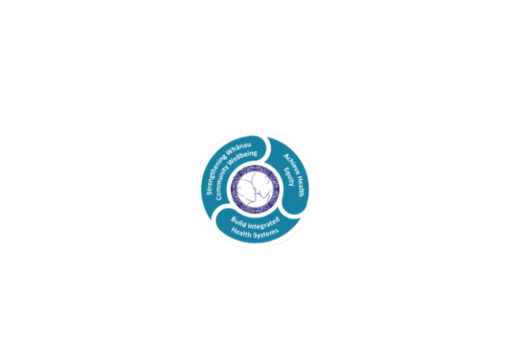

* Achieve equity in Māori health
* Build an Integrated health system
* Strengthen people, whanau & community wellbeing

### THREE CORE VALUES

Manaakitanga respect and acknowledgment of each other’s intrinsic value and contribution

Integrity truthfully and consistently acting collectively for the common good

Accountability collective and individual ownership for clinical and financial outcomes and sustainability

### TE ITI KAHURANGI – THE LAKES WAY, OUR PLACE, OUR CULTURE – WE WILL

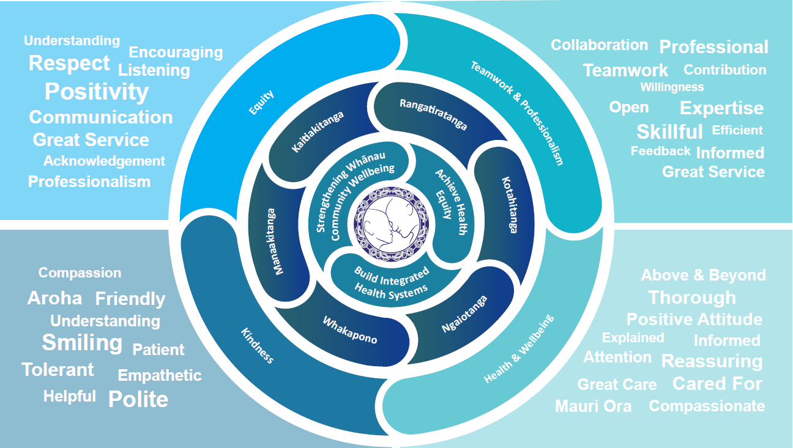

### TE TIRITI O WAITANGI

**Our expression of Te Tiriti o Waitangi**

The text of Te Tiriti, including the preamble and the three articles, along with the Ritenga Māori declaration, are the enduring foundation of our approach to achieving health and independence. Based on these foundations, we will strive to achieve the following four goals, each expressed in terms of mana.

**Mana whakahaere**

Effective and appropriate kaitiakitanga and stewardship over the health and disability system. Mana whakahaere is the exercise of control in accordance with tikanga, kaupapa and kawa Māori. This goes beyond the management of assets and resources and towards enabling Māori aspirations for health and independence.

**Mana motuhake**

Enabling the right for Māori to be Māori (Māori self-determination); to exercise their authority over their lives and to live on Māori terms and according to Māori philosophies, values and practices, including tikanga Māori.

**Mana tangata**

Achieving equity in health and disability outcomes for Māori, enhancing the mana of people across their life course and contributing to the overall health and wellbeing of Māori.

**Mana Māori**

Enabling Ritenga Māori (Māori customary rituals), which are framed by te ao Māori (the Māori world), enacted through tikanga Māori (Māori philosophy and customary practices) and encapsulated within mātauranga Māori (Māori knowledge).

Te Whatu Ora Lakes is committed within the framework of the New Zealand Public Health and Disability Act (2000) to supporting the Crown’s commitment to upholding its Tiriti promises.

### ORGANISATION STRUCTURE

