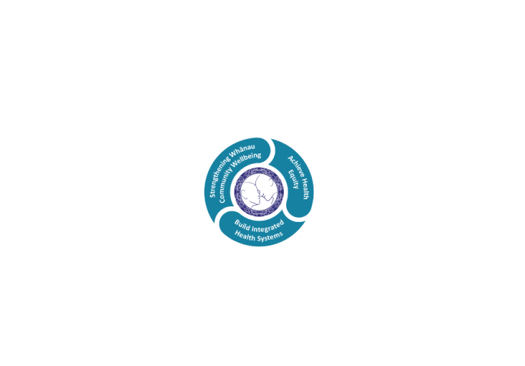

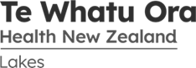

# POSITION DESCRIPTION

|  |  |  |
| --- | --- | --- |
| **Position**: | Health Care Assistant – (Medical Unit) | |
| **Responsible to:** | Clinical Nurse Manager | |
| **Direct Reports:** | Nil | |
| **Location:** | Rotorua & Taupō | |
| **Functional relationships:** | **Internal:**  Clients  Family, whanau, caregivers  Nursing Staff  Clerical Staff  Multidisciplinary team  Clinical Nurse Educators  Clinical Nurse Directors  Other Departments | **External**:  Community agencies  Other health providers |
| **Financial delegations:** | Nil | |
| **Date**: | December 2020 | |

### Primary purpose(s) of the position

To provide support within the ward or department as a member of the health care team under the direction and delegation of a Registered Nurse/Midwife. The support provided may include clinical and non clinical tasks.

|  |  |  |
| --- | --- | --- |
| **Key Objectives** | Description | Expected Outcomes |
| **Patient care** | Supports nursing and midwifery staff in the provision of patient care | * Under the delegation and direction of RN/RM provides patient care such as personal hygiene, * moving and handling, positioning, pressure area care, making beds and assist with meals. * Under direction of RN/RM provides direct support and close observation, to ensure the safety of vulnerable patients. * Answers call bells promptly and acts on requests for assistance e.g. bed pans, fluids. * Informs RN/RM promptly of needs and reports any changes in patient condition to the RN/RM. * Communicates in a friendly courteous manner with patients, family, whanau and members of the health care team. * Maintains an awareness of patient safety and takes measures to prevent any injury. * Has a key role in contributing to frequent patient rounding to ensure patient safety and comfort. * Takes responsibility for ensuring the immediate patient environment is suitable to patient needs and patients have access to essential items such as call bell, beverages etc. * Follows organisational policies and infection control procedures. * Knows own limitations and seeks help and guidance when required. * Only undertakes tasks they are trained to do. * Maintains confidentiality of information. * Demonstrates sensitivity to patient privacy. |
| **Non clinical support of unit** | Assist with the provision of a clean, tidy, efficient, safe  unit and service | * Carry out assigned tasks such as cleaning, restocking, tidying and checking of equipment. * Contributes to the maintenance of supplies by ordering, processing and monitoring of stock levels. * Supports clinical team with administration requirements such as answering the phone and providing reception duties. * Reports faulty or damaged equipment and maintenance required within the unit. |
| **Utilisation of Telehealth** | Provision of patient centric care which will give patients the option of telephone or video appointments where there is no need for an in-person appointment. | * Assist doctors and nurse practitioners to deliver care via video and phone as requested. |
|  |  |  |

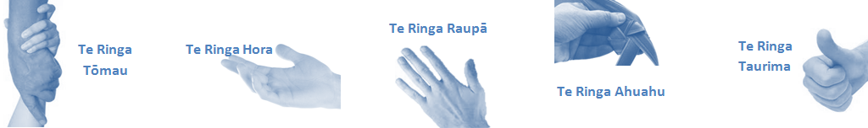

|  |  |  |
| --- | --- | --- |
| **Capabilities** | Capability definition | Achievement Indicators |
| **Communication and Personal Interaction**  **Te Ringa Hora**  ***the open hand (denoting someone who is sociable)*** | Openly communicates and cooperates with all levels of DHB employees, patients and visitors. | * Builds effective working relationships. * Accepts differences of opinion can occur but these happen respectfully and without animosity. |
| **Strategy & Performance**  **Te Ringa Raupā**  ***the roughened hand (symbolising a hard worker)*** | Spends energy on delivering role requirements and meeting objective | * Has an energetic approach to work and is self motivated. * Accepts direction and instruction and seeks guidance as required. |
| Organises own time to deliver on required tasks and duties | * Organises time and resources effectively. * Maintains focus and completes required duties throughout the shift. |
| **Development and Change**  **Te Ringa Ahuahu**  ***the hand that shapes or fashions something (refers to someone who is innovative)*** | Accepts change in day to day practices and contributes to decision making of the team. | * Works with the team and managers to make any changes within practices work. * Contributes positively to change processes and improvement initiatives. |
| Makes suggestions to increase efficiency of the unit. |  |
| **Personal Accountability**  **Te Ringa Tōmau**  ***the hand that is trustworthy*** | Is open with manager and colleagues and open to accepting feedback and critique to improve upon practice. | * Offers and accepts constructive feedback. * Shows respect and establishes rapport when responding to the different needs of people and practice situations. * Advises manager wherever issues may be impacting on performance. |
| Looks for and undertakes development activities appropriate for role and career development. | * Recognises areas that could be improved in own practice. |
| **Culture and Values**  **Te Ringa Taurima**  ***the hand that nurtures, encourages, supports*** | Operates in line with DHB values and expectations and professional codes of conduct. | * Demonstrates a commitment to cultural safety by meeting the cultural needs of clients / customers / colleagues. * Incorporates the Lakes Way into day to day business activities. * Shows respect for patients, colleagues, managers, multidisciplinary team and others |

|  |  |  |
| --- | --- | --- |
| **Compulsory Requirements** | Description | Expected Outcomes |
| **Māori Health** | Māori philosophies and values of health are demonstrated in work practice. | * Meaningful relationships are established with Te Aka Matua (Rotorua and Taupo Hospitals) and Lakes DHB Maori Health division in the planning and delivery of services. * Practices are consistent with Te Tiriti o Waitangi /The Treaty of Waitangi when working with Māori. * Delivery of safe services for Māori are facilitated by ensuring they can access treatment options and are involved in the planning and delivery of their care. * Māori are enabled to access and participate in cultural activities provided by the Lakes DHB. * A commitment to improving the wellbeing of Māori by increasing cultural knowledge in the Lakes DHB is shown. |
| **Te Iti Kahurangi** | The Lakes Way, Our Place Our Culture | * Works within the Te Iti Kahurangi framework and supporting guide document. |
| **Record Keeping** |  | * Complies with the Lakes DHB Corporate Records Management policy to create and maintain full and accurate records. |
| **Quality & Risk** | Patient safety is paramount to the service we deliver at Lakes District Health Board. This is to be achieved in a clinical governance framework that is culturally responsive and identifies and manages risk and opportunities to improve. | * Employees are supported to lead by example and implement a culture of continuous quality improvement. * Risks that may prevent Lakes DHB from achieving their goals are identified, reported, and managed. * Māori patients are provided patient-centred care to achieve positive Māori health outcomes. * Needs of Māori are reviewed and reported in the further development of practice, process and or policy. * Evidence-based methodologies are used to support improvements, e.g. kaupapa Māori methodology. * Quality care is provided to certification standards. |
| **Health & Safety** | Each individual is responsible for ensuring the safety of themselves, their colleagues, patients and their visitors and to comply with all organisational health and safety policies, procedures and guidelines. | * Implementation and reinforcement of a proactive healthy work place culture which reflects relevant Lakes DHB policy and legislative requirements. * Healthy lifestyles are actively promoted and participated in, within the work area. * Employees participate in Health and Safety within areas of work. * Health and Safety activities are appropriately documented within specified timeframes. * Health and Safety policies have been read and understood and are applied in the workplace. * Health and Safety policies are appropriately documented within specified timeframes and incidents are reported immediately. * Any opportunities for improving Health and Safety are reported and acted upon in a timely manner. * All near misses/incident/accidents are reported to the appropriate line manager within 24 hours. |

**Signatures:**

|  |  |
| --- | --- |
| Line Manager:  (position description approved): |  |
| Employee:  (acceptance of position description): |  |

*(Please also initial all other pages to show acceptance of position description.)*

|  |  |  |
| --- | --- | --- |
| **Person Specification** | **Essential:** | **Desirable:** |
| **Education and Qualifications:** | * Achieved NCEA level 1 or equivalent. * English as a second language has met IELTS level 5. | * A relevant qualification as an HCA such as NZQA/Career Force/other approved   programmes |
| **Experience:** | * Previous work in a health care setting or related health or consumer focused service e.g. hospitality | * Recent experience as a health care assistant |
| **Knowledge:** | * Te Tiriti O Waitangi in the provision of health care services and support to Māori. * Te Tiriti O Waitangi in practice, process, policy development and decision making. * Lakes DHB is a Reorua organisation knowledge and understanding of Te Reo/ Correct pronunciation. |  |
| **Skills:** | * Pronunciation of Te Reo Māori words and names * Effective communication and interpersonal skills * Flexible and able to adjust to changing needs and priorities | * Te Reo Māori * Computer competent * Organisation skills |
| **Personal Attributes:** | * Self motivated and uses initiative * Honest and reliable * Ability to work in a team environment * Ability to work under pressure and adapt to changes in a demanding work environment * Ability to maintain a calm disposition under pressure * Ability to escalate concerns and seek assistance * Accepts direction and delegation | * Non-smoker preferred. |

**ABOUT LAKES DISTRICT HEALTH BOARD**

At Lakes District Health Board we place the highest value on the health and wellbeing of everyone in our community. As such all healthcare workers are expected to play a part in the creation and promotion of an environment which lives the following vision, mission and values:

### VISION

Healthy Communities – Mauriora! In this vision Mauriora refers to the Mauri - being the life essence and the source of well being, and ora - describing the state of wellness.

### STRATEGIC MISSION

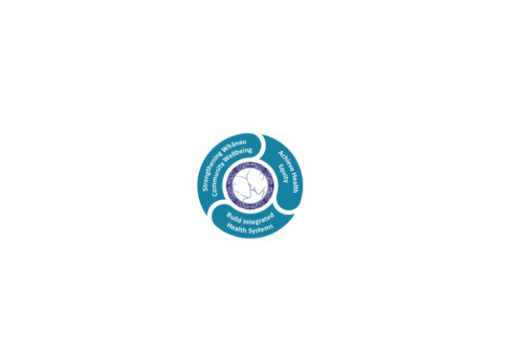

* Achieve equity in Māori health
* Build an Integrated health system
* Strengthen people, whanau & community wellbeing

### THREE CORE VALUES

Manaakitanga respect and acknowledgment of each other’s intrinsic value and contribution

Integrity truthfully and consistently acting collectively for the common good

Accountability collective and individual ownership for clinical and financial outcomes and sustainability

### TE ITI KAHURANGI – THE LAKES WAY, OUR PLACE, OUR CULTURE – WE WILL

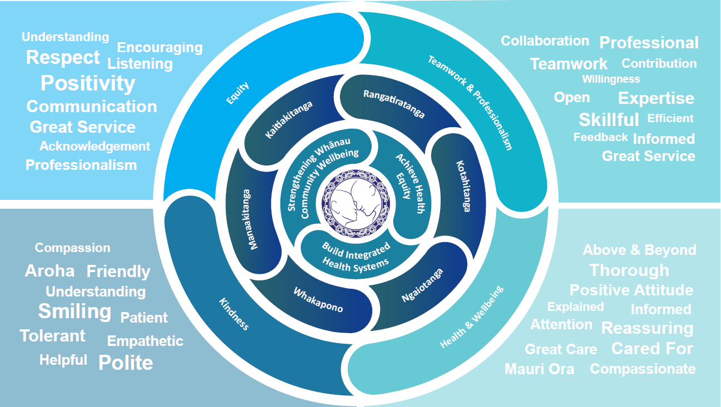

### TE TIRITI O WAITANGI

**Our expression of Te Tiriti o Waitangi**

The text of Te Tiriti, including the preamble and the three articles, along with the Ritenga Māori declaration, are the enduring foundation of our approach to achieving health and independence. Based on these foundations, we will strive to achieve the following four goals, each expressed in terms of mana.

**Mana whakahaere**

Effective and appropriate kaitiakitanga and stewardship over the health and disability system. Mana whakahaere is the exercise of control in accordance with tikanga, kaupapa and kawa Māori. This goes beyond the management of assets and resources and towards enabling Māori aspirations for health and independence.

**Mana motuhake**

Enabling the right for Māori to be Māori (Māori self-determination); to exercise their authority over their lives and to live on Māori terms and according to Māori philosophies, values and practices, including tikanga Māori.

**Mana tangata**

Achieving equity in health and disability outcomes for Māori, enhancing the mana of people across their life course and contributing to the overall health and wellbeing of Māori.

**Mana Māori**

Enabling Ritenga Māori (Māori customary rituals), which are framed by te ao Māori (the Māori world), enacted through tikanga Māori (Māori philosophy and customary practices) and encapsulated within mātauranga Māori (Māori knowledge).

Lakes DHB is committed within the framework of the New Zealand Public Health and Disability Act (2000) to supporting the Crown’s commitment to upholding its Tiriti promises.

.

### ORGANISATION STRUCTURE

