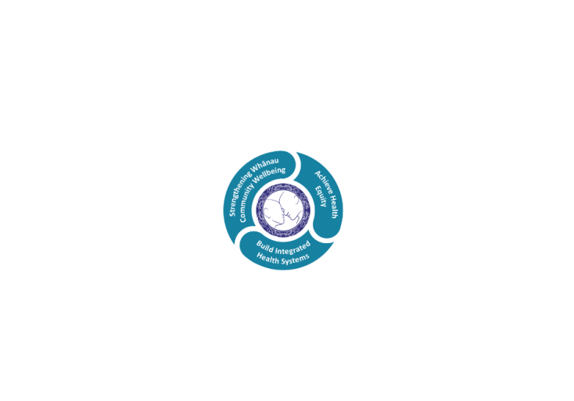



# POSITION DESCRIPTION

|  |  |  |
| --- | --- | --- |
| **Position**: | Psychologist. | |
| **Responsible to:** | Clinical Nurse Manager - Infant, Child and Adolescent Mental Health Services (iCAMHS)  Service Manager - Mental Health & Addiction Services. | |
| **Direct Reports:** | Nil. | |
| **Location:** | Rotorua & Taupō | |
| **Functional relationships:** | **Internal:**  Professional Advisor – Psychology  Acute Response Team (ART)  Psychology Team  Te Aka Matua Services  Clerical Staff  Nursing Staff  Allied Health Staff  Medical Staff  Other Departments | **External**:  Clients  Family/Whanau/Caregivers  Community groups/agencies  Consumer Advisors  Local/Regional Psychology Collectives  Multidisciplinary Team(s)  NZPsS and/or NZCCP  Other health professionals. |
| **Financial delegations:** | Nill | |
| **Date**: | .August 2022 | |

**Primary purpose(s) of the position**

1. To provide an effective psychological outpatient assessment and treatment service to the target population.
2. To provide consultation, education, and supervision *(where appropriate)* to other Mental Health Services’ staff and community contacts.
3. To fulfil the role and responsibilities of Keyworker when and as required.
4. To provide leadership in the development of Mental Health Services*.*
5. To facilitate the delivery of effective clinical services ensuring quality patient care and a safe journey across the care continuum.

***Employees of Te Whatu Ora Lakes must adhere to all relevant Policies and Procedures in the performance of their duties***

* **Te Ara Tauwhirotanga - “Pathways that lead us to act with kindness”** (Model of Care) to provide the optimal environment and service to effect client’s wellness and recovery.

**TE ARA TAUWHIROTANGA – PATHWAYS THAT LEAD US TO ACT WITH KINDNESS**

* **Tangata – People**
  + My experience matters
  + Family/Whanau as partners
  + Caring and well supported workforce
  + Connectedness
* **Tikanga –Values**
  + Te Ao Maori: Maori worldview
  + Protecting and promoting wellbeing
  + Easy quick access to help when I need it
  + Healing and recovery
* **Taiao – Environment**
  + A local service presence
  + Equitable outcomes

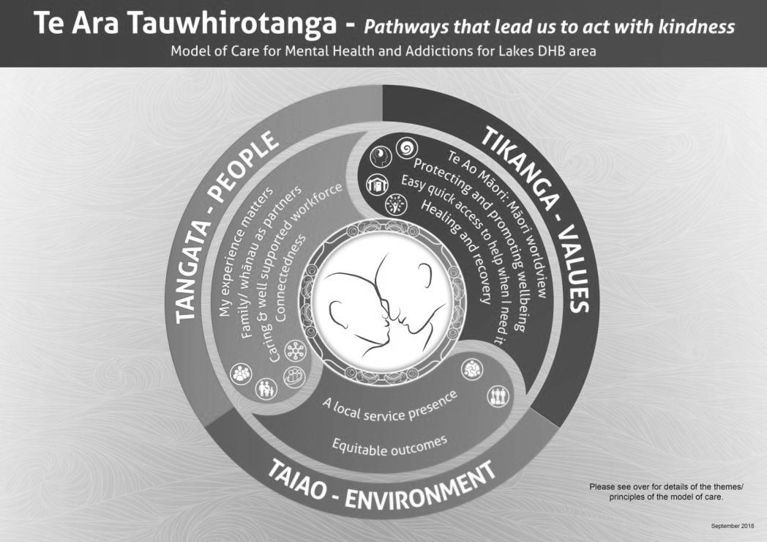

|  |  |  |  |  |  |
| --- | --- | --- | --- | --- | --- |
| **Key Objectives** | | Description | | Expected Outcomes | |
| **Psychological Assessment** | | The Psychologist will obtain and review relevant information, orientate client(s) / whanau, obtain any necessary consents, conduct and document initial and ongoing assessment. | | * Selects and utilises appropriate psychological tests, instruments, interviews and procedures to assess cognitive, personality and relational functioning. * Considers biological, psychological, occupational, and ecological factors. * Tailors assessment to the developmental stage and unique needs of the client. * Conducts informing interviews and writes psychological reports. * Maintains standards consistent with the NZ Psychologist’s Board Code of Ethics regarding use, administration, access and release of data and reports. * Seeks consent and appropriately follows Te Whatu Ora Lakes and Mental Health & Addiction Service policy and procedures. | |
| **Formulation and Planning** | | The Psychologist will collaborate (as possible) with the client (and others) to identify and prioritise areas for potential intervention, set goals, plan intervention(s), renew consent(s) (as required), and document an Individual Care Plan (ICP). | | * Assesses individuals and/or systems to establish appropriate diagnoses and formulations. * Utilises the current edition of “Diagnostic and Statistical Manual of Mental Disorders” to establish Psychiatric diagnoses. Seeks advice and consults with fellow colleagues where appropriate. * Documents process and decision making. * Psycho-diagnostic work demonstrates relevance to understanding and treatment planning. * Consults as required. * Collaborates/contracts with client (whenever appropriate). | |
| **Psychotherapy and Clinical Intervention** | | The Psychologist will implement the ICP, including ongoing assessment / evaluation, and will document progress and outcomes. | | * Provides psychological interventions. * Provides psychotherapy to individuals, families and groups. * Psychotherapy and interventions are consistent with generally accepted theories and techniques, and adhere to the Code of Ethics currently endorsed by the NZ Psychologists Board. | |
| **Key worker** | | | The psychologist will fulfil the role and responsibilities of keyworker when assigned. | * Co-ordinates Care Plan implementation. * Serves as first point of contact for the client * Ensures assertive follow-up occurs when needed. * Provides ongoing input into clinical decisions regarding the range of interventions for the client including regular communication with the Responsible Clinician / Consultant Psychiatrist. * Co-ordinates and ensures involvement of the client and caregivers in decisions relating to care; reviews those decisions and renegotiates them when necessary. * Completes all relevant documentation according to Te Whatu Ora Lakes policy and professional standards. * Ensures the client has all the relevant information. |
| **Consultation and Liaison** | | | The Psychologist will provide expert consultation, and will maintain excellent working relationships with internal and external services/agencies. | * Provides clinical psychological consultation to Mental Health & Addiction Service staff and clinical programmes as required. * Provides professional, clinical psychological consultation to other services within Te Whatu Ora Lakes as required. * Provides liaison with designated community agencies and provides consultative services as required. * Ensures all consultations are clinically sound, safe, and well grounded. |
| **Family Consultation** | | | The Psychologist will consult with family / whanau as appropriate | * Regularly incorporates work with families / whanau into assessment and treatment of clients |
| **Team Communication** | | | The Psychologist will contribute to effective clinical interventions by, and the functioning of, the Multidisciplinary Team (MDT). | * That the psychologist will be a respected and useful member of the MDT, effectively communicating with other team members and participating in team and service procedures as required. * Demonstrates an understanding and appreciation of the scopes of other disciplines. * Accurately represents discipline of Clinical Psychology to others. * Provides psychological input and opinion to clinical reviews of clients of the MDT. |
| **Clinical Supervision** | | | The Psychologist will engage in regular clinical supervision, including Cultural Supervision (as appropriate). | * May provide clinical supervision as per Mental Health Service policy. * Receives clinical supervision on a regular basis as per Mental Health Service policy. * Actively participates in Peer Review activities. |
| **Quality** | | | The Psychologist will actively pursue personal, professional, and service focussed Quality Improvement opportunities. | * Participates in development of and adheres to Quality Assurance Policies and Procedures. * Participates in forums that develop Quality Assurance Policies, Procedures and Initiatives appropriate to the appointed role. * Demonstrates commitment to principles of Continuous Improvement. * Documents clinical care provision in accordance with professional Te Whatu Ora Lakes and Mental Health Service standards. * Maintains membership in either the NZ Psychological Society or the NZ College of Clinical Psychologists. |
| **Education and Training** | | | The Psychologist will collaborate to identify and meet their learning / development needs, and will contribute to meeting the needs of other clinicians. | * Maintains up-to-date knowledge of clinical psychology and related fields. * Provides Inservice training and teaching according to professional abilities. * Develops an annual, personalised Professional Development Plan, and participates in Annual Performance Appraisals |
| **Research** | | | The Psychologist will participate in and/or support research activities | * Conducts applied and/or theoretical research (as resources permit). * Publishes research (as practicable). * Provides advice on research design, methodology, statistics and interpretation. |
| **Delegated Duties** | | | The Psychologist will perform delegated duties when required | * Completes any delegated duties from Line Manager as related to the function of a Clinical Psychologist in the Infant, Child & Adolescent Mental Health Services. |
| **Model of Care** | Follows the principles of the model of care “**Te Ara Tauwhirotanga – Pathways that lead us to act with kindness**.” | | | * Utilises **Te Ara Tauwhirotanga – “Pathways that lead us to act with kindness”** model of care to engage with patients, visitors and multidisciplinary teams. * Incorporates and follows the principles of the model of care **Te Ara Tauwhirotanga – Pathways that lead us to act with kindness** into day to day business activities. | | |
| **Utilisation of Telehealth** | | Health care is delivered using digital technology where participants may be separated by time and/or distance | | * ALLIED STAFF * Service provision is in line with the New Zealand Health Strategy and the New Zealand Allied Health Best Practice Guide for Telehealth to provide care “closer to home”. * Patient centric care which will give patients the option of telephone or video appointments where there is no need for an in-person appointment. | |

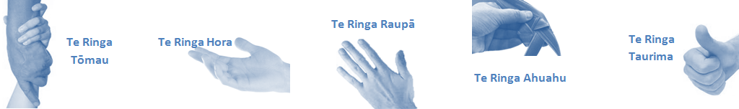

|  |  |  |
| --- | --- | --- |
| **Capabilities** | Capability definition | Achievement Indicators  *)* |
| **Communication and Personal Interaction**  **Te Ringa Hora**  ***the open hand (denoting someone who is sociable)*** | Communicates relevant information in a timely manner to those who need to know at a level that is understood. | * Transfers information effectively verbally and writes clearly, coherently and succinctly. * Shares well thought out, concise and timely information with others using appropriate mediums. * Organisational updates are provided to staff by way of relaying in general terms but more importantly what affect it has on the unit and how staff can help where necessary to achieve any requirements. * Builds team spirit, facilitates resolution of conflict within the team, promotes/protects team reputation, shows commitment to contributing to the teams success. * Maintains and promotes high standards of social, ethical and organisational norms. |
| Fosters a team environment and encourages collaboration between team and departments within the DHB. | * Articulates differing perspectives on an issue and can see the merit of alternative points of view. * Works with other managers and teams to streamline processes for the best efficiency for both teams. * Provides staff who have concerns about another team process, a different point of view to consider. |
| Connects with people to build trust and confidence. | * Connects with others, listens, reads people and situations and communicates tactfully. * Gets to know their team members and treats them with respect, valuing their individuality and contributions. |
| **Strategy & Performance**  **Te Ringa Raupā**  ***the roughened hand (symbolising a hard worker)*** | Delegates appropriately within team utilising individual skills to achieve results. | * Understands individuals strengths and weaknesses to utilise or increase skills for those individuals. * Assigns and sub-delegates staff to teams to allow for development and succession planning. |
| Understands the unit requirements and the implications of the units achievements on the overall service delivery. | * Ensures decision making complies with organisational strategies. * Recognises decisions made within the unit affect overall results of the service and the DHB. * Works with Service Manager to maximise unit efficiency. |
| **Development and Change**  **Te Ringa Ahuahu**  ***the hand that shapes or fashions something (refers to someone who is innovative)*** | Works to include staff in change minimising barriers to implementation. | * Questions traditional ways of doing things when choosing a course of action or finds new combinations of old elements to form an innovative solution. * Continually strives for new and improved work processes that will result in greater effectiveness and efficiencies. * Openly broaches concern with staff from the outset asking for their ideas and input. * Gives examples of what might help to resolve the issue/concern. * Seeks opportunities to improve performance and seeks feedback to measure and improve. * Encourages staff participation in possible solution process. * Allows staff input to possible solutions to concern. * Gives careful consideration to staff ideas and offers alterations to suggestions where necessary. |
| Articulates decisions and reasoning behind change enable buy-in to results. | * Develops an informative response to the team including trends, data, process and benefits of the decided process/change. * Allows feedback to decision to enable ‘tinkering’ to be made where appropriate. |
| **Personal Accountability**  **Te Ringa Tōmau**  ***the hand that is trustworthy*** | Manages own and encourages others to foster work/life balance. | * Ensures regular breaks are taken and own annual leave accruals are used within the 12 months following accrual. * Ensures employees within their service are taking regular annual leave breaks for the purpose of rest/recreation throughout the year. |
| Actively manages own career aspirations and development. | * Is constantly striving to acquire and maintain knowledge, skills and/or experience. * Has own career development plan and succession planning. * Seeks out development opportunities to expand knowledge and capability. * Engages in projects and activities readily which are above and beyond scope of current role. |
| **Culture and Values**  **Te Ringa Taurima**  ***the hand that nurtures, encourages, supports*** | Makes decisions based on facts and without personal bias. | * Is proactive and effective when problem solving is required. * Engages with staff member/managers/multi disciplinary team when concerns are raised to best understand their point of view. * Appropriately investigates the concern looking at trends, situation and practices. * Critically examines repeatable risk factors. |
| Engages with mentors and supervisors for personal skill development. | * Is constantly striving to acquire and maintain knowledge, skills and/or experience. * Demonstrates a commitment to and takes responsibility for going professional development. |
| Plans, prioritises and organises work to deliver on short and long term goals. | * Purposeful about where time is invested. * Delivers relevant results within expected timeframes. |
| Encourages and promotes DHB values and expectations. | * Role models expected behaviours and practices. * Treats staff, patients and visitors with dignity and respect. * Uses appropriate empathy to gain organisational objectives. * Is solution focused. |

|  |  |  |
| --- | --- | --- |
| **Compulsory Requirements** | Description | Expected Outcomes |
| **Māori Health** | Māori philosophies and values of health are demonstrated in work practice. | * Meaningful relationships are established with Te Aka Matua (Rotorua and Taupo Hospitals) and Te Whatu Ora Lakes Maori Health division in the planning and delivery of services. * Practices are consistent with Te Tiriti o Waitangi /The Treaty of Waitangi when working with Māori. * Delivery of safe services for Māori are facilitated by ensuring they can access treatment options and are involved in the planning and delivery of their care. * Māori are enabled to access and participate in cultural activities provided by the Te Whatu Ora Lakes. * A commitment to improving the wellbeing of Māori by increasing cultural knowledge in the Te Whatu Ora Lakes is shown. |
| **Te Iti Kahurangi** | The Lakes Way, Our Place Our Culture | * Works within the Te Iti Kahurangi framework and supporting guide document. |
| **Record Keeping** |  | * Complies with the Te Whatu Ora Lakes Corporate Records Management policy to create and maintain full and accurate records. |
| **Quality & Risk** | Patient safety is paramount to the service we deliver at Te Whatu Ora Lakes. This is to be achieved in a clinical governance framework that is culturally responsive and identifies and manages risk and opportunities to improve. | * Employees are supported to lead by example and implement a culture of continuous quality improvement. * Risks that may prevent Te Whatu Ora Lakes from achieving their goals are identified, reported, and managed. * Māori patients are provided patient-centred care to achieve positive Māori health outcomes. * Needs of Māori are reviewed and reported in the further development of practice, process and or policy. * Evidence-based methodologies are used to support improvements, e.g. kaupapa Māori methodology. * Quality care is provided to certification standards. |
| **Health & Safety** | Each individual is responsible for ensuring the safety of themselves, their colleagues, patients and their visitors and to comply with all organisational health and safety policies, procedures and guidelines. | * Implementation and reinforcement of a proactive healthy work place culture which reflects relevant Te Whatu Ora Lakes policy and legislative requirements. * Healthy lifestyles are actively promoted and participated in, within the work area. * Employees participate in Health and Safety within areas of work. * Health and Safety activities are appropriately documented within specified timeframes. * Health and Safety policies have been read and understood and are applied in the workplace. * Health and Safety policies are appropriately documented within specified timeframes and incidents are reported immediately. * Any opportunities for improving Health and Safety are reported and acted upon in a timely manner. * All near misses/incident/accidents are reported to the appropriate line manager within 24 hours. |

**Signatures:**

|  |  |
| --- | --- |
| Line Manager:  (position description approved): |  |
| Employee:  (acceptance of position description): |  |

*(Please also initial all other pages to show acceptance of position description.)*

|  |  |  |
| --- | --- | --- |
| **Person Specification** | **Essential:** | **Desirable:** |
| **Education and Qualifications:** | * Full registration with the New Zealand Psychologists Board. * Full member of either the New Zealand Psychological Society or the New Zealand College of Clinical Psychologists. * Masters Degree (Clinical Psychology) and Post-Graduate Diploma in Clinical Psychology (or equivalent). * Treaty of Waitangi training.. | * If NZPsS member, also a full member of the Institute of Clinical Psychology. * If PhD, additional “experience” may be credited. |
| **Experience:** | * 1 year experience in a Mental Health setting or Accredited Internship program.. | * 2 years progressive experience as a Clinical Psychologist in a Mental Health setting. |
| **Health Practitioners Competence Assurance Act 2003** | * + You are required to maintain your current competency based practicing certificate.   + You must notify your Manager of any changes to scope or conditions on practice (determined by Regulatory Authority).   + You must complete the requirements of any competency programme.   + You must notify the employer of concerns relating to the risk of harm to the public of another health practitioner practicing below the required standard of competence.   + You are required to know the provisions of the HPCAA as the governing legislation. |  |
| **Knowledge:** | * Te Tiriti O Waitangi in the provision of health care services and support to Māori. * Te Tiriti O Waitangi in practice, process, policy development and decision making. * Te Whatu Ora Lakes is a Reorua organisation knowledge and understanding of Te Reo/ Correct pronunciation. * Psychologists Act (1981) * Code of Ethics as adopted by the New Zealand Psychologists Board * Mental Health Act (1992) and any amendments * Privacy Act (1993) and its amendments * Health and Disability Code of Consumer Rights 1996 * Health Information Privacy Code 1994 * Health Practitioners Competency Assurance Act 2003 * Human Rights Act 1993 * Misuse of Drugs Act 1975 and Regulations 1977 * Treaty of Waitangi Act 1975 and its application to the health setting. * Medicines Act 1981 and Medicines Regulation 1984 * Misuse of Drugs Act 1975 and Regulations 1977 * Mental Health & Addiction Services Policies, Procedures and Guidelines   Other relevant legislation | * Te Whatu Ora Lakes Quality Framework (must become conversant with this once employed) * . |
| **Skills:** | * Pronunciation of Te Reo Māori words and names * Produces and maintains accurate records, notes and other documentation which are clear and up to date. * Basic computer skills * Consumer/Recovery focussed.. | * Te Reo Māori * .. |
| **Personal Attributes:** | * Cultural sensitivity and safety * Able to react appropriately to the unpredictable nature of the work and the workplace * Leadership abilities * Advanced Problem solving abilities * Excellent oral and written communication * Ability to prioritise activities and needs * Professional demeanour * Ability to work independently (self-directed) * Excellent interpersonal skills * Integrity * Good time management and organisational ability. * Team player * Good analytical skills * Ability to work under pressure * Sense of humour. | * Non-smoker preferred. * .. |

**Core competencies for the psychologist –**

**(as outlined in Te Whatu Ora Lakes Core Competencies booklet)**

|  |  |
| --- | --- |
|  |  |
| **SPECIALIST COMPETENCIES** | As recognised by the Mental Health Workforce Development Co-ordinating Committee (1999), Psychologists function at a Specialist level of expertise, and will therefore demonstrate Specialist competencies |
| **Interpersonal Relationships** | **Definition** – Psychologists normally do their work in the context of interpersonal relationships. They must therefore be able to establish and maintain a constructive working alliance with their clients, and possess adequate cultural competency.  **Knowledge –**  Knowledge of theories and empirical data on the professional relationship, such as:   * Developmental stages and considerations * Interpersonal relationships * Power relationships * Therapeutic alliance * Interface with social psychology * More specific knowledge of the fluctuations of the therapeutic/professional relationship as a function of intervention setting   Knowledge of self, such as:   * Motivation * Resources * Values * Personal biases/vulnerabilities (e.g. to secondary victimisation) * Factors that may influence the professional relationship (e.g., boundary issues)   Knowledge of others, such as:   * Macro-environment in which the person functions (work, national norms, etc.) * Micro-environment (personal differences, family, gender differences, etc.)   **Skills –**   * Effective communication * Establishment and maintenance of rapport * Sensitive to the vulnerabilities of the target population * Establishment and maintenance of trust and respect in the professional relationship * Conflict management * Self care |
| **Assessment and evaluation** | **Definition** -- A competent Clinical Psychologist draws upon a thorough understanding of varied and complex Psychological theories and diverse methods of evaluation, and has the ability to apply these to new problems to generate tailored interventions. The appropriate subject of evaluation in many instances is not an individual person but a couple, family, organisation, or system at some other level of organisation. The skills required for assessment can and should be applied to many situations other than initial evaluation, including, for example, crisis assessment/intervention, treatment outcome, and program evaluation. The primary purpose of psychological assessment is to provide an understanding that informs a practical plan of action. It may result in a diagnostic classification or in the identification of strengths or competencies.  **Knowledge of –**   * Assessment methods (including interview, observation, psychometrics etc.) * Populations served * Human development * Diagnosis   **Skills –**   * Formulation/Clarification of a referral question * Selection of assessment methods * Information collection and processing * Psychometric methods (and integration of results) * Formulation of hypotheses and making a diagnosis when appropriate * Report writing and communication with clients * Formulation of an intervention/treatment plan * Ongoing assessment/evaluation, and adaptation to findings |
| **Intervention** | Definition – The intervention competency is conceptualised as activities that promote, restore, sustain, and/or enhance positive functioning and a sense of well being in clients through preventive, developmental and/or remedial services. A broad, comprehensive vision of the intervention competency should explicitly include theory as well as the following knowledge and skills:  **Knowledge –**   * The learning of an array of varied interventions with individuals and systems (eg. couples, families, groups and organisations) * Relationship of family dynamics to psychological disorders * A respect for the positive aspects of all major approaches, which should reflect an openness to varied viewpoints and methods * Awareness of when to make appropriate referrals and consult * Awareness of context and diversity (including cultural) * Knowledge of interventions that promote health and wellness * Knowledge of specific interventions for specific issues/diagnoses   **Skills –**   * Establish and maintain professional relationships with clients from all populations served * Establish and maintain appropriate interdisciplinary relationships with colleagues * Gather information about the nature and severity of problems and formulate hypotheses about the factors that are contributing to the problem through qualitative and quantitative means * Select appropriate intervention methods (including Motivational Interviewing) and timeframes * Analyse the information, develop a conceptual framework, and communicate this to the client |
| **Research** | **Definition** – Clinical Psychologists will have completed research training such that they will demonstrate:   * A basic understanding of and respect for the scientific under-pinning of the discipline * Knowledge of methods so as to be good consumers of the products of scientific knowledge * Sufficient skills in the conduct of research to be able to develop and carry out projects in a professional context and, in certain cases, in an academic context with the aid of specialised consultants (e.g. statisticians)   **Knowledge –**   * Basic knowledge of research methods and of the applications of scientific research, including * Applied statistics and measurement theory * The logic of different models of scientific research (from laboratory experimentation to quasi-experimental and field research); Qualitative research methods (including observation and interviewing), etc., particularly with respect to the nature of reliability and validity in the gathering and interpretation of qualitative data   **Skills –**   * Critical reasoning skills * Applications of various research approaches to social systems * Ability to write professional reports |
| **Ethics and standards** | **Definition** – Professionals accept their obligations, are sensitive to others, and conduct themselves in an ethical manner. They establish professional relationships within the applicable constraints and standards.  **Knowledge –**   * Ethical principles * Standards of professional conduct * Responsibilities to clients, society, the profession, and colleagues * Awareness of potentially conflicting principles * Standards for psychological tests and measurements * Standards for conducting psychological research * Jurisprudence/Legislation and local knowledge   **Skills –**   * Ethical decision-making process * Proactive identification of potential ethical dilemmas * Resolution of ethical dilemmas |
| **Supervision** | **Definition** – A quality improvement/assurance activity that involves developing or enhancing the competence of the person being supervised. Supervision is a preferred vehicle for the integration of practice, theory and research.  **Knowledge –**   * Models for the acquisition of competencies under supervision * Methods and techniques of supervision * Available technical resources * Power relationships as well as cultural, gender issues and ethnic differences   **Skills –**   * Sensitivity to power, cultural, sex, and ethnic issues * Articulation of clear learning objectives * Creating an open and participatory climate * Learning to be a good supervisee (open to supervision, well prepared, able to use time efficiently, non-defensive, aware of limits, etc.) * Being able to differentiate between supervision and therapy * Integration of knowledge * Awareness of one’s own strengths and limitations as supervisor |

**ABOUT TE WHATU ORA LAKES**

At Te Whatu Ora Lakes we place the highest value on the health and wellbeing of everyone in our community. As such all healthcare workers are expected to play a part in the creation and promotion of an environment which lives the following vision, mission and values:

### VISION

Healthy Communities – Mauriora! In this vision Mauriora refers to the Mauri - being the life essence and the source of well being, and ora - describing the state of wellness.

### STRATEGIC MISSION

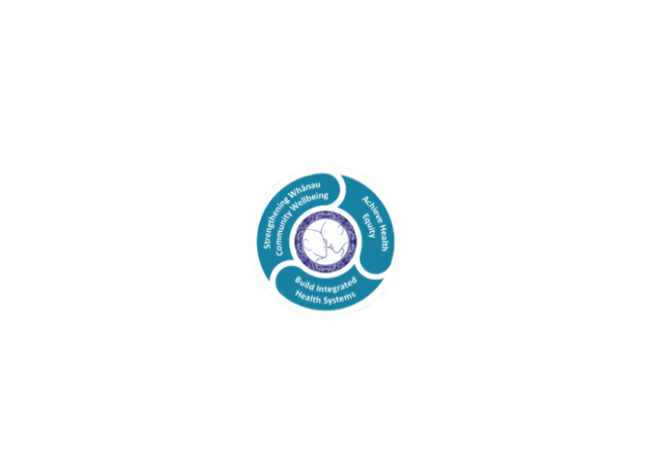

* Achieve equity in Māori health
* Build an Integrated health system
* Strengthen people, whanau & community wellbeing

### THREE CORE VALUES

Manaakitanga respect and acknowledgment of each other’s intrinsic value and contribution

Integrity truthfully and consistently acting collectively for the common good

Accountability collective and individual ownership for clinical and financial outcomes and sustainability

### TE ITI KAHURANGI – THE LAKES WAY, OUR PLACE, OUR CULTURE – WE WILL

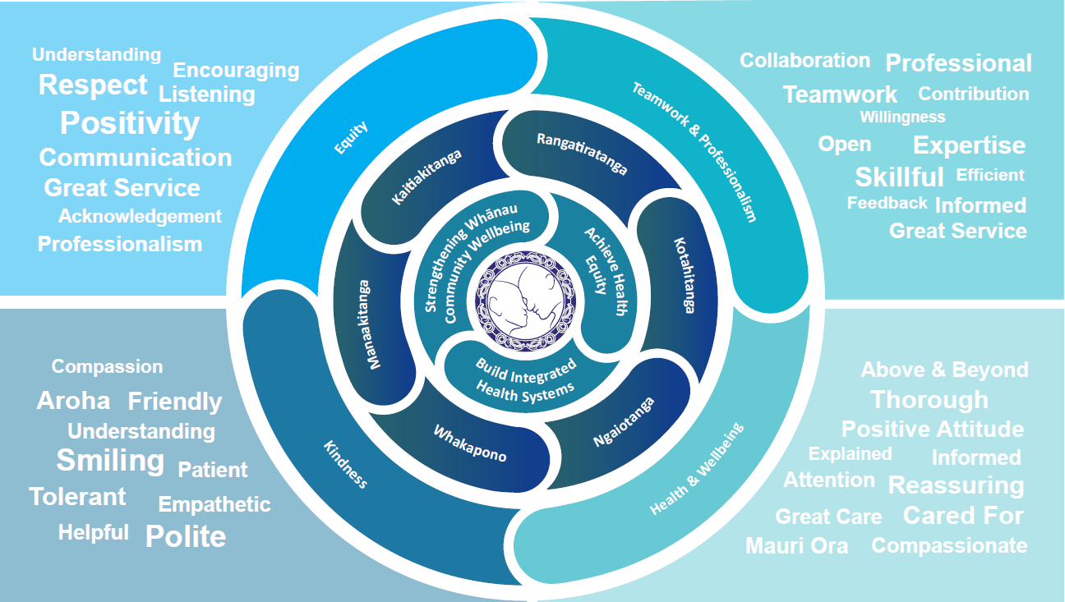

### TE TIRITI O WAITANGI

**Our expression of Te Tiriti o Waitangi**

The text of Te Tiriti, including the preamble and the three articles, along with the Ritenga Māori declaration, are the enduring foundation of our approach to achieving health and independence. Based on these foundations, we will strive to achieve the following four goals, each expressed in terms of mana.

**Mana whakahaere**

Effective and appropriate kaitiakitanga and stewardship over the health and disability system. Mana whakahaere is the exercise of control in accordance with tikanga, kaupapa and kawa Māori. This goes beyond the management of assets and resources and towards enabling Māori aspirations for health and independence.

**Mana motuhake**

Enabling the right for Māori to be Māori (Māori self-determination); to exercise their authority over their lives and to live on Māori terms and according to Māori philosophies, values and practices, including tikanga Māori.

**Mana tangata**

Achieving equity in health and disability outcomes for Māori, enhancing the mana of people across their life course and contributing to the overall health and wellbeing of Māori.

**Mana Māori**

Enabling Ritenga Māori (Māori customary rituals), which are framed by te ao Māori (the Māori world), enacted through tikanga Māori (Māori philosophy and customary practices) and encapsulated within mātauranga Māori (Māori knowledge).

Te Whatu Ora Lakes is committed within the framework of the New Zealand Public Health and Disability Act (2000) to supporting the Crown’s commitment to upholding its Tiriti promises.

### ORGANISATION STRUCTURE

