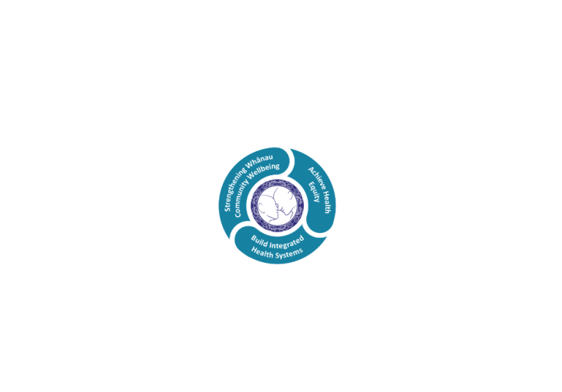

# **POSITION DESCRIPTION**

|  |  |  |
| --- | --- | --- |
| **Position:** | **Paediatric Liaison Nurse** | |
| **Responsible to:** | Rotorua Emergency Department - Clinical Nurse Manager | |
| **Direct Reports:** | Nil | |
| **Location:** | Rotorua | |
| **Functional Relationships:** | **Internal:**  Administration Staff  Allied Health Staff  Clinical Director ED  Clinical Nurse Directors  Clinical Nurse Educators  Clinical Nurse Specialists  Duty Nurse Managers  Medical Staff  Multidisciplinary Teams  Nursing Staff  Other Departments | **External:**  Clients  Family, Whanau, Caregivers  Community Agencies  Other Health Providers  Social Services |
| **Financial Delegations:** | Nil | |
| **Date:** | June 2022 | |



### Primary Purpose(s) of the Position

The Registered Nurse is responsible and accountable for the assessment, planning, delivery and evaluation of safe and appropriate nursing care.

* Provides nursing care based on the RN scope of practice, NCNZ competencies, LDHB policies and protocols and current best practice.
* Works collaboratively within the multidisciplinary team ensuring quality patient care and a safe client journey across the care continuum.

The Paediatric Liaison Nurse (PLN) role is responsible for providing nursing care and expertise both in direct care delivery and provision of nursing expertise and guidance to nursing and medical colleagues across the Emergency Department and Children’s Ward. As a member of the nursing leadership team the PLN has a key resource role in supporting and enhancing timely, effective care to all patients presenting to the Emergency Department.

The PLN is required to facilitate multidisciplinary care for complex presentations and promote evidence based principles and promote access to appropriate services.

As a senior nurse, this role also has a responsibility for improving the quality of professional nursing practice and safe guarding high standards of care in Lakes District Health Board through research, evaluating, developing and implementing standards of nursing practice in the specific area of practice and supporting an environment in which excellence in clinical care can flourish.

| **Key Objectives** | **Description** | **Expected Outcomes** |
| --- | --- | --- |
| **Nursing Practice** | The Registered Nurse provides safe effective client care using professional knowledge and skills in accordance with the Registered Nurse Scope of Practice and Nursing Council of New Zealand competency requirements. | * Demonstrates continuing achievement of competencies within the four domains for a Registered Nurse with Nursing Council of New Zealand: (<http://www.nursingcouncil.org.nz/content/download/263/1205/file/Nursing%20comp%20for%20RN.pdf>) * Professional Responsibility * Management of nursing care * Interpersonal relationships * Inter-professional health care and quality improvement * Maintains NCNZ requirements of an annual practicing certificate. * Meets the orientation and ongoing knowledge and skill requirements for relevant clinical areas. * Maintains currency in organisational core certification as relevant to the clinical area. * Notify your manager of any changes to your scope of practice or conditions on practice (determined by NCNZ). * Comply with any specific conditions on practice as determined by NCNZ. * Maintains knowledge of and practices within the HPCA Act, code of conduct NCNZ and other governing legislation relevant to the nursing role. * Practices within LDHB policies, protocols and Nursing Practice Standards. |
| **Contribution to Service Delivery** | Member of the Nursing team, contributing to collaborative team work, and individual responsibility for generating and maintaining accurate TrendCare data. | * May be responsible for a portfolio within the unit i.e. infection control, H&S. * Provides support to colleagues and the multidisciplinary team to meet patient care and service needs. * Must ensure the correct type and predictions are completed for each patient on the morning shift for the next 24 hours, or for the remaining shifts if admitted in the afternoon/night. * Patient care must be actualised for each patient on each shift within the designated time frame. * New patients must have correct patient type and care predicted within 30 minutes of admission. * Ensure allocate staff screen reflects any worked hours not available to provide inpatient care. * With CNM or colleague’s reviews and adapts workload allocation in response to clinical demand and nursing resource, utilising Trendcare data. * May be required to work in other units to meet patient care needs. * May take the leadership role by coordinating the shift. * Is mindful of and responsible for the appropriate and cost effective use of resources in relation to allocated patients within the unit. * Acts as liaison and advocate for infants, children and adolescents requiring admission to the Children’s Unit, ICU, or other in-patient departments. * Actively facilitates and role models team working and flexibility between clinical and support staff members. * Works proactively with medical specialists and nurse specialists to ensure effective services to patients using the department. * Provides care which enables timely and effective patient journeys through the care continuum. * Works collaboratively with ward staff to achieve appropriate, safe and timely transfer between departments. * Apply best available evidence to their practice. * Monitors patient journeys from ED to receiving areas, conducting periodic audits of activity and participates in Datix and other reviews relating to effective care delivery to infants, children and adolescents. * Provide advocacy and leadership in facilitating choice and patient centred decisions in the management of care. |
| **Other Requirements** |  | * The Lakes District Health Board is required to provide 24 hour services which at times may require you to change duties or redeploy to another unit/department to ensure safe patient care. * This position description is not exhaustive and you may be requested to perform other reasonable tasks within your scope of practice. |
| **Utilisation of Telehealth** | Provision of patient centric care which will give patients the option of telephone or video appointments where there is no need for an in-person appointment. | * Service provision is in line with the New Zealand Health Strategy and the Nurse Executives of New Zealand Telehealth Position statement to provide care “closer to home”. * Assist doctors and nurse practitioners to deliver care via video and phone. * Advise patients in the use of tele-monitoring devices (where appropriate) and provide follow-up care to prevent unnecessary hospital admissions. |
| **Patient Centred Care Coordination** | Management of individual patient and whanau care. | * Assesses, plans, implements and evaluates nursing care for patients according to accepted nursing practice and standards. * Works in consultation with other health professionals and members of health teams, in co-ordinating the care of patients. * Provides interventions, treatments and therapies such as medications, and monitors responses to treatment. * Promotes health and assists in preventing ill health by participating in health education and other health promotion activities. * Answers questions and provides information to patients and families about treatment and care. * Completes all required electronic and paper clinical documentation, accurately and in a timely fashion. * Uses advanced knowledge research and skills to provide direct nursing care/interventions for patients in the department to achieve specific outcomes. * Fosters the provision of positive patient/client outcomes and person centred care. * Implements evidenced based practice with the intention of integrating medical and nursing skills to promote excellence in patient care. * Assess client family level of understanding and delivers adjusted, appropriate education to improve knowledge of treatment, prevention of complications and to promote well-being. |
| **Senior Nursing and Professional Leadership** | Provide advice/education to other nurses and health professionals | * Demonstrates advanced clinical judgement and decision making, role modelling best practice. * Acts as a resource for other staff in relation to needs of infants, children and adolescents. * Support development of appropriate paediatric skills to support emergency department and children’s unit nursing care requirements. * Supports and contributes to specific paediatric educational initiatives in partnership with the CNEs of ED and CU. * Provides coaching and peer support to nurses providing direct care to infants, children and adolescents. |
| **Ongoing Professional Development** |  | * Participates in case reviews and on-going activities as required. * Identifies own learning needs and is proactive in seeking access to continuing education and personal development. * Completes practice reflection and regular performance review with the CNMs/CNDs. |

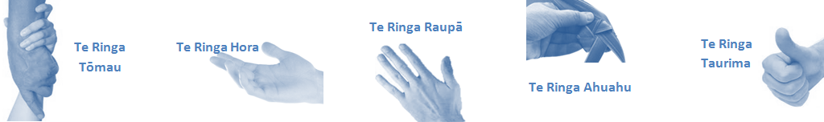

| **Capabilities** | **Capability Definition** | **Achievement Indicators** |
| --- | --- | --- |
| **Communication and Personal Interaction**  **Te Ringa Hora**  ***the open hand (denoting someone who is sociable)*** | Openly communicates and cooperates with all levels of DHB employees, patients and visitors. | * Builds and maintains open respectful relationships. * Openly and constructively participates in conversations with multidisciplinary team, patients, managers and visitors. * Accepts differences of opinion can occur but these happen respectfully. |
| **Strategy & Performance**  **Te Ringa Raupā**  ***the roughened hand (symbolising a hard worker)*** | Spends energy on delivering role requirements and meeting objectives. | * Has an energetic approach to work and is self-motivated. |
| Organises own time to deliver on required tasks and duties. | * Accepts direction and instruction of manager but is able to work effectively without direct guidance. * Maintains expected productivity in line with assigned duties. |
| **Development and Change**  **Te Ringa Ahuahu**  ***the hand that shapes or fashions something (refers to someone who is innovative)*** | Accepts change in day to day practices and contributes to decision making of the team. | * Constructively makes suggestions to improve process or practices and gain efficiencies. |
| Makes suggestions to increase efficiency of the unit. | * Demonstrates positive attitude and responsiveness to opportunities for improvement. * Is solution focused. * Undertakes and manages a specific portfolio of responsibilities as agreed with the CNM. |
| **Personal Accountability**  **Te Ringa Tōmau**  ***the hand that is trustworthy*** | Is open with manager and colleagues and open to accepting feedback and critique to improve upon practice. | * Offers and receives constructive critique of practice and self. * Shows respect and establishes rapport when responding to the different needs of people and practice situations. * Advises manager whenever issues may be impacting on performance. |
| Looks for and undertakes development activities appropriate for role and career development. | * Recognises areas that could be improved in own practice and takes action to address those needs. |
| **Culture and Values**  **Te Ringa Taurima**  ***the hand that nurtures, encourages, supports*** | Operates in line with DHB values and expectations and professional codes of conduct. | * Demonstrates manaakitanga, respect, integrity and accountability in every day performance. * Incorporates the Lakes Way into day to day business activities. * Demonstrates the culture and the agreed behaviours of Te iti Kahurangi. * Shows respect for patients, colleagues, managers, Multi-disciplinary team and others. |

| **Compulsory Requirements** | **Description** | **Expected Outcomes** |
| --- | --- | --- |
| **Māori Health** | Māori philosophies and values of health are demonstrated in work practice. | * Meaningful relationships are established with Te Aka Matua (Rotorua and Taupo Hospitals) and Lakes DHB Maori Health division in the planning and delivery of services. * Practices are consistent with Te Tiriti o Waitangi /The Treaty of Waitangi when working with Māori. * Delivery of safe services for Māori are facilitated by ensuring they can access treatment options and are involved in the planning and delivery of their care. * Māori are enabled to access and participate in cultural activities provided by the Lakes DHB. * A commitment to improving the wellbeing of Māori by increasing cultural knowledge in the Lakes DHB is shown. |
| **Te Iti Kahurangi** | The Lakes Way, Our Place Our Culture. | * Works within the Te Iti Kahurangi framework and supporting guide document. |
| **Record Keeping** |  | * Complies with the Lakes DHB Corporate Records Management policy to create and maintain full and accurate records. |
| **Quality & Risk** | Patient safety is paramount to the service we deliver at Lakes District Health Board. This is to be achieved in a clinical governance framework that is culturally responsive and identifies and manages risk and opportunities to improve. | * Employees are supported to lead by example and implement a culture of continuous quality improvement. * Risks that may prevent Lakes DHB from achieving their goals are identified, reported, and managed. * Māori patients are provided patient-centred care to achieve positive Māori health outcomes. * Needs of Māori are reviewed and reported in the further development of practice, process and or policy. * Evidence-based methodologies are used to support improvements, e.g. kaupapa Māori methodology. * Quality care is provided to certification standards. |
| **Health & Safety** | Each individual is responsible for ensuring the safety of themselves, their colleagues, patients and their visitors and to comply with all organisational health and safety policies, procedures and guidelines. | * Implementation and reinforcement of a proactive healthy work place culture which reflects relevant Lakes DHB policy and legislative requirements. * Healthy lifestyles are actively promoted and participated in, within the work area. * Employees participate in Health and Safety within areas of work. * Health and Safety activities are appropriately documented within specified timeframes. * Health and Safety policies have been read and understood and are applied in the workplace. * Health and Safety policies are appropriately documented within specified timeframes and incidents are reported immediately. * Any opportunities for improving Health and Safety are reported and acted upon in a timely manner. * All near misses/incident/accidents are reported to the appropriate line manager within 24 hours. |

**Signatures:**

|  |  |
| --- | --- |
| Line Manager:  (position description approved): |  |
| Employee:  (acceptance of position description): |  |

(Please also initial all other pages to show acceptance of position description.)

|  |  |  |
| --- | --- | --- |
| **Person Specification** | **Essential** | **Desirable** |
| **Education and Qualifications:** | * Registered Nurse with a current Nursing Council of New Zealand (NCNZ) practising certificate in the appropriate scope. * Commitment to ongoing post graduate education. * Evidence of relevant professional development in speciality clinical knowledge and skills. * Postgraduate certificate in Nursing with paediatric or acute care focus. | * Working towards postgraduate diploma with relevant nursing/health focus. * Current drivers’ license. |
| **Experience:** | * Meets competent level or higher on the Professional Development and Recognition Programme. * Nursing experience – minimum 5 years paediatric experience in acute setting. |  |
| **Knowledge:** | * Te Tiriti O Waitangi in the provision of health care services and support to Māori. * Te Tiriti O Waitangi in practice, process, policy development and decision making. * Lakes DHB is a Reorua organisation knowledge and understanding of Te Reo/ Correct pronunciation. * Health and Disability Code of Consumer Rights 1996 * Health Information Privacy Code 1994 * Health Practitioners Competency Assurance Act 2003 * Human Rights Act 1993 * Medicines Act 1981 and Medicines Regulation 1984 * Misuse of Drugs Act 1975 and Regulations 1977 * Nursing Council of New Zealand Code of Conduct(current iteration) * Nursing Council of New Zealand Competencies for Scope of Registered Nurse(current iteration) | * Proficiency in tikanga and te reo. * Knowledge of Disability Support sector networks, Rehabilitation Sector and Maori systems and networks. * Have an awareness of Iwi and Hapu within the boundaries of region. * Lakes District Health Board Quality Framework (must become conversant with this once employed). |
| **Skills:** | * Pronunciation of Te Reo Māori words and names. | * Te Reo Māori. |
| **Personal Attributes:** | * Caring and compassionate attitude towards clients, whanau and co-workers. * Motivated and self-directed. * Excellent interpersonal skills. * Adaptability and flexibility. * Prioritisation, time and workload management skills. * Works well within team to achieve collective outcomes. | * Non-smoker preferred. * Flexibility and lateral thinking. * Commitment to on-going post graduate education. * Professional affiliation. |

**ABOUT LAKES DISTRICT HEALTH BOARD**

At Lakes District Health Board we place the highest value on the health and wellbeing of everyone in our community. As such all healthcare workers are expected to play a part in the creation and promotion of an environment which lives the following vision, mission and values:

### VISION

Healthy Communities – Mauriora! In this vision Mauriora refers to the Mauri - being the life essence and the source of well being, and ora - describing the state of wellness.

### STRATEGIC MISSION

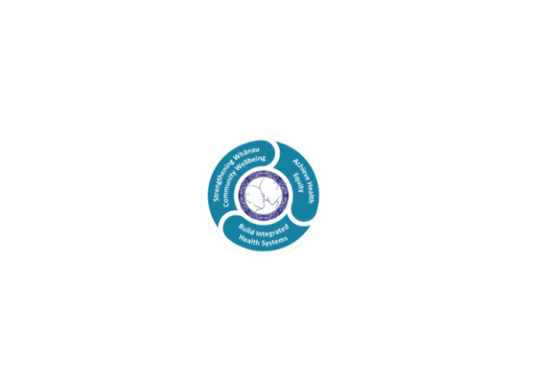

* Achieve equity in Māori health
* Build an Integrated health system
* Strengthen people, whanau & community wellbeing

### THREE CORE VALUES

Manaakitanga respect and acknowledgment of each other’s intrinsic value and contribution

Integrity truthfully and consistently acting collectively for the common good

Accountability collective and individual ownership for clinical and financial outcomes and sustainability

### TE ITI KAHURANGI – THE LAKES WAY, OUR PLACE, OUR CULTURE – WE WILL

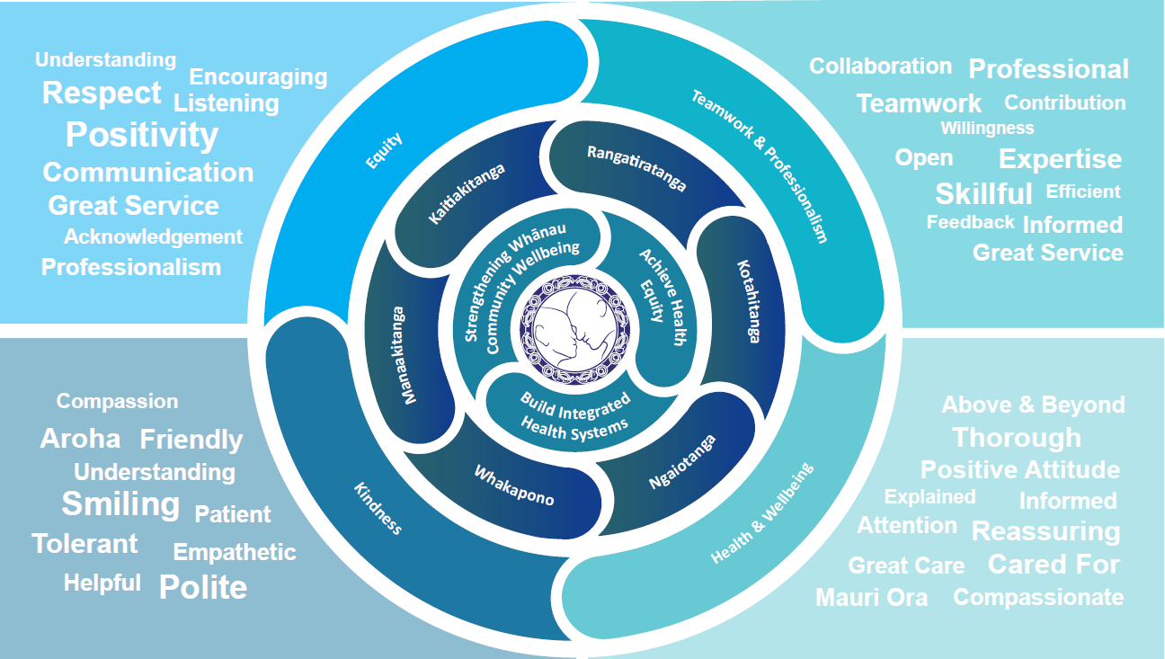

### TE TIRITI O WAITANGI

**Our expression of Te Tiriti o Waitangi**

The text of Te Tiriti, including the preamble and the three articles, along with the Ritenga Māori declaration, are the enduring foundation of our approach to achieving health and independence. Based on these foundations, we will strive to achieve the following four goals, each expressed in terms of mana.

**Mana whakahaere**

Effective and appropriate kaitiakitanga and stewardship over the health and disability system. Mana whakahaere is the exercise of control in accordance with tikanga, kaupapa and kawa Māori. This goes beyond the management of assets and resources and towards enabling Māori aspirations for health and independence.

**Mana motuhake**

Enabling the right for Māori to be Māori (Māori self-determination); to exercise their authority over their lives and to live on Māori terms and according to Māori philosophies, values and practices, including tikanga Māori.

**Mana tangata**

Achieving equity in health and disability outcomes for Māori, enhancing the mana of people across their life course and contributing to the overall health and wellbeing of Māori.

**Mana Māori**

Enabling Ritenga Māori (Māori customary rituals), which are framed by te ao Māori (the Māori world), enacted through tikanga Māori (Māori philosophy and customary practices) and encapsulated within mātauranga Māori (Māori knowledge).

Lakes DHB is committed within the framework of the New Zealand Public Health and Disability Act (2000) to supporting the Crown’s commitment to upholding its Tiriti promises.

### ORGANISATION STRUCTURE

