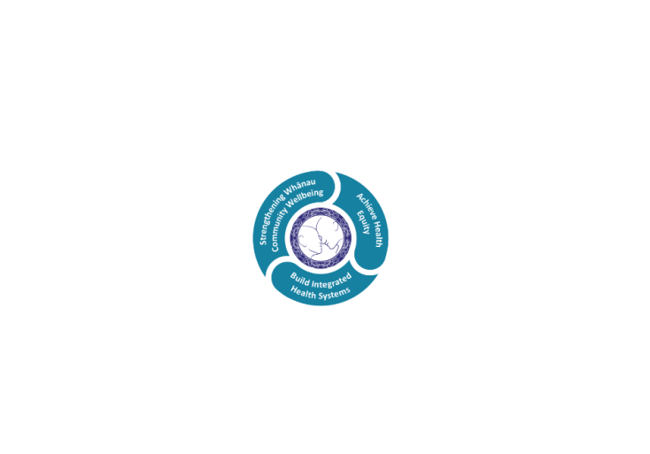



# POSITION DESCRIPTION

|  |  |  |
| --- | --- | --- |
| **Position**: | Registered Nurse Childrens Unit | |
| **Responsible to:** | Clinical Nurse Manager | |
| **Direct Reports:** | Nil | |
| **Location:** | Rotorua & Taupō | |
| **Functional relationships:** | **Internal:**  Clinical Nurse Directors  Clients  Family, whanau, caregivers  Nursing Staff  Clinical Nurse Educators  Clinical Nurse Specialists  Duty Nurse Managers  Clerical Staff  Multidisciplinary team  Other Departments | **External**:  Community agencies  Other health providers Social services |
| **Financial delegations:** | Nill | |
| **Date**: | July 2021Paediatric | |

### Primary purpose(s) of the position

The Registered Nurse is responsible and accountable for the assessment, planning, delivery and evaluation of safe and appropriate nursing care.

* Provides nursing care based on the RN scope of practice, NCNZ competencies, LDHB policies and protocols and current best practice.
* Works collaboratively within the multidisciplinary team ensuring quality patient care and a safe client journey across the care continuum.

|  |  |  |
| --- | --- | --- |
| **Key Objectives** | Description | Expected Outcomes |
| **Nursing Practice** | The Registered Nurse provides safe effective client care using professional knowledge and skills in accordance with the Registered Nurse Scope of Practice and Nursing Council of New Zealand competency requirements. | * Demonstrates continuing achievement of competencies within the four domains for registration with Nursing Council of New Zealand (<http://www.nursingcouncil.org.nz/content/download/263/1205/file/Nursing%20comp%20for%20RN.pdf>)  1. Professional Responsibility 2. Management of nursing care 3. Interpersonal relationships 4. Inter-professional health care and quality improvement  * Meets practice and educational hours in accordance with NCNZ minimum requirements. * Maintains currency in organisational core certification as relevant to the clinical area. * Meets the orientation and ongoing knowledge and skill requirements for relevant clinical areas. * Maintains knowledge of and works within scope of practice as defined at any given time by New Zealand Nursing Council and as required to maintain registration. (http://www.nursingcouncil.org.nz/Nurses/Scopes-of-practice/Registered-nurse) * Must comply with any specific conditions on practice as determined by NCNZ |
| **Contribution to**  **Service delivery** | Member of the Nursing team, contributing to collaborative team work, and individual responsibility for generating and maintaining accurate TrendCare data. | * May be responsible for a portfolio within the unit i.e. infection control, H&S. * Provides support to colleagues and the multidisciplinary team to meet patient care and service needs. * Must ensure the correct type and predictions are completed for each patient on the morning shift for the next 24 hours, or for the remaining shifts if admitted in the afternoon/night. * Patient care must be actualized for each patient on each shift within the designated time frame. * New patients must have correct patient type and care predicted within 30minutes of admission. * Ensure allocate staff screen reflects any worked hours not available to provide inpatient care. * With CNM or colleagues reviews and adapts workload allocation in response to clinical demand and nursing resource, utilising trendcare data. * May be required to work in other units to meet patient care needs. * May take the leadership role by coordinating the shift. * Is mindful of and responsible for the appropriate and cost effective use of resources in relation to allocated patients within the unit. |
| **Other requirements** |  | * The Lakes District Health Board is required to provide 24 hour services which at times may require you to change duties or redeploy to another unit/department to ensure safe patient care. * This position description is not exhaustive and you may be requested to perform other reasonable tasks within your scope of practice. |

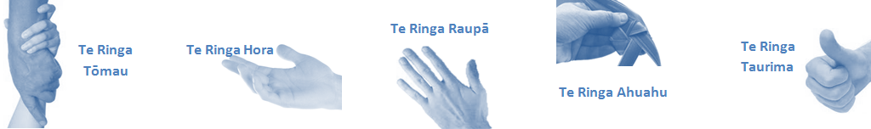

|  |  |  |
| --- | --- | --- |
| **Capabilities** | Capability definition | Achievement Indicators |
| **Communication and Personal Interaction**  **Te Ringa Hora**  ***the open hand (denoting someone who is sociable)*** | Openly communicates and cooperates with all levels of DHB employees, patients and visitors. | * Builds and maintains open respectful relationships. * Openly and constructively participates in conversations with multidisciplinary team, patients, managers and visitors. * Accepts differences of opinion can occur but these happen respectfully. |
| **Strategy & Performance**  **Te Ringa Raupā**  ***the roughened hand (symbolising a hard worker)*** | Spends energy on delivering role requirements and meeting objectives | * Has an energetic approach to work and is self motivated. |
| Organises own time to deliver on required tasks and duties | * Accepts direction and instruction of manager but is able to work effectively without direct guidance. * Maintains expected productivity in line with assigned duties. |
| **Development and Change**  **Te Ringa Ahuahu**  ***the hand that shapes or fashions something (refers to someone who is innovative)*** | Accepts change in day to day practices and contributes to decision making of the team. | * Constructively makes suggestions to improve process or practices and gain efficiencies. |
| Makes suggestions to increase efficiency of the unit. | * Demonstrates positive attitude and responsiveness to opportunities for improvement. * Is solution focused. * Undertakes and manages a specific portfolio of responsibilities as agreed with the CNM. |
| **Personal Accountability**  **Te Ringa Tōmau**  ***the hand that is trustworthy*** | Is open with manager and colleagues and open to accepting feedback and critique to improve upon practice. | * Offers and receives constructive critique of practice and self. * Shows respect and establishes rapport when responding to the different needs of people and practice * situations. * Advises manager whenever issues may be impacting on performance. |
| Looks for and undertakes development activities appropriate for role and career development. | * Recognises areas that could be improved in own practice and takes action to address those needs. |
| **Culture and Values**  **Te Ringa Taurima**  ***the hand that nurtures, encourages, supports*** | Operates in line with DHB values and expectations and professional codes of conduct. | * Demonstrates manaakitanga, respect, integrity and accountability in every day performance. * Incorporates the Lakes Way into day to day business activities. * Demonstrates the culture and the agreed behaviours of Te iti Kahurangi. * Shows respect for patients, colleagues, managers, Multi-disciplinary team and others. |

|  |  |  |
| --- | --- | --- |
| **Compulsory Requirements** | Description | Expected Outcomes |
| **Māori Health** | Māori philosophies and values of health are demonstrated in work practice. | * Meaningful relationships are established with Te Huinga Takiora Māori in the planning and delivery of services. * Practices are consistent with Te Tiriti o Waitangi /The Treaty of Waitangi when working with Māori. * Delivery of safe services for Māori are facilitated by ensuring they can access treatment options and are involved in the planning and delivery of their care. * Māori are enabled to access and participate in cultural activities provided by the Lakes DHB. * A commitment to improving the wellbeing of Māori by increasing cultural knowledge in the Lakes DHB is shown. |
| **Te Iti Kahurangi** | The Lakes Way, Our Place Our Culture | * Works within the Te Iti Kahurangi framework and supporting guide document. |
| **Record Keeping** |  | * Complies with the Lakes DHB Corporate Records Management policy to create and maintain full and accurate records. |
| **Quality & Risk** | Patient safety is paramount to the service we deliver at Lakes District Health Board. This is to be achieved in a clinical governance framework that is culturally responsive and identifies and manages risk and opportunities to improve. | * Employees are supported to lead by example and implement a culture of continuous quality improvement. * Risks that may prevent Lakes DHB from achieving their goals are identified, reported, and managed. * Māori patients are provided patient-centred care to achieve positive Māori health outcomes. * Needs of Māori are reviewed and reported in the further development of practice, process and or policy. * Evidence-based methodologies are used to support improvements, e.g. kaupapa Māori methodology. * Quality care is provided to certification standards. |
| **Health & Safety** | Each individual is responsible for ensuring the safety of themselves, their colleagues, patients and their visitors and to comply with all organisational health and safety policies, procedures and guidelines. | * Implementation and reinforcement of a proactive healthy work place culture which reflects relevant Lakes DHB policy and legislative requirements. * Healthy lifestyles are actively promoted and participated in, within the work area. * Employees participate in Health and Safety within areas of work. * Health and Safety activities are appropriately documented within specified timeframes. * Health and Safety policies have been read and understood and are applied in the workplace. * Health and Safety policies are appropriately documented within specified timeframes and incidents are reported immediately. * Any opportunities for improving Health and Safety are reported and acted upon in a timely manner. * All near misses/incident/accidents are reported to the appropriate line manager within 24 hours. |

**Signatures:**

|  |  |
| --- | --- |
| Line Manager:  (position description approved): |  |
| Employee:  (acceptance of position description): |  |

*(Please also initial all other pages to show acceptance of position description.)*

|  |  |  |
| --- | --- | --- |
| **Person Specification** | **Essential:** | **Desirable:** |
| **Education and Qualifications:** | * Registered Nurse with a current Nursing * Council of New Zealand (NCNZ) practising certificate in the appropriate scope * Commitment to ongoing post graduate education. | * Qualification relating to area of practice * Current drivers license |
| **Experience:** | * Meets competent level or higher on the Professional Development and Recognition Programme * Nursing experience – at least 2 years post graduate | * Paediatric nursing experience |
| **Knowledge:** | * Te Tiriti O Waitangi in the provision of health care services and support to Māori. * Te Tiriti O Waitangi in practice, process, policy development and decision making.. |  |
| **Skills:** | * Pronunciation of Te Reo Māori words and names | * Te Reo Māori |
| **Personal Attributes:** | * Caring and compassionate attitude towards clients, whanau and co-workers * Motivated and self directed * Excellent interpersonal skills * Adaptability and flexibility * Prioritisation, time and workload management skills * Works well within team to achieve collective outcomes. | * Non-smoker preferred. |

**ABOUT LAKES DISTRICT HEALTH BOARD**

At Lakes District Health Board we place the highest value on the health and wellbeing of everyone in our community. As such all healthcare workers are expected to play a part in the creation and promotion of an environment which lives the following vision, mission and values:

### VISION

Healthy Communities – Mauriora! In this vision Mauriora refers to the Mauri - being the life essence and the source of well being, and ora - describing the state of wellness.

### STRATEGIC MISSION

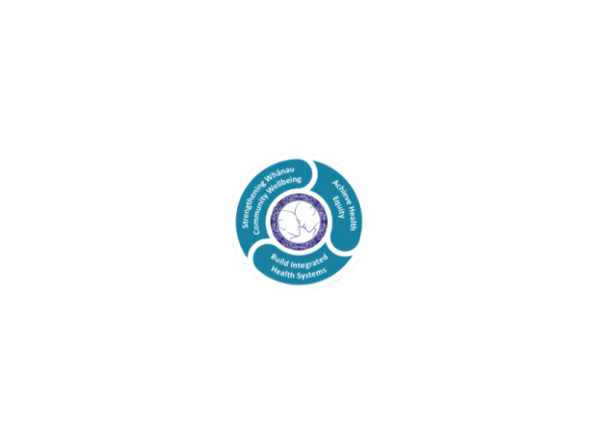

* Achieve equity in Māori health
* Build an Integrated health system
* Strengthen people, whanau & community wellbeing

### THREE CORE VALUES

Manaakitanga respect and acknowledgment of each other’s intrinsic value and contribution

Integrity truthfully and consistently acting collectively for the common good

Accountability collective and individual ownership for clinical and financial outcomes and sustainability

### TE ITI KAHURANGI – THE LAKES WAY, OUR PLACE, OUR CULTURE – WE WILL

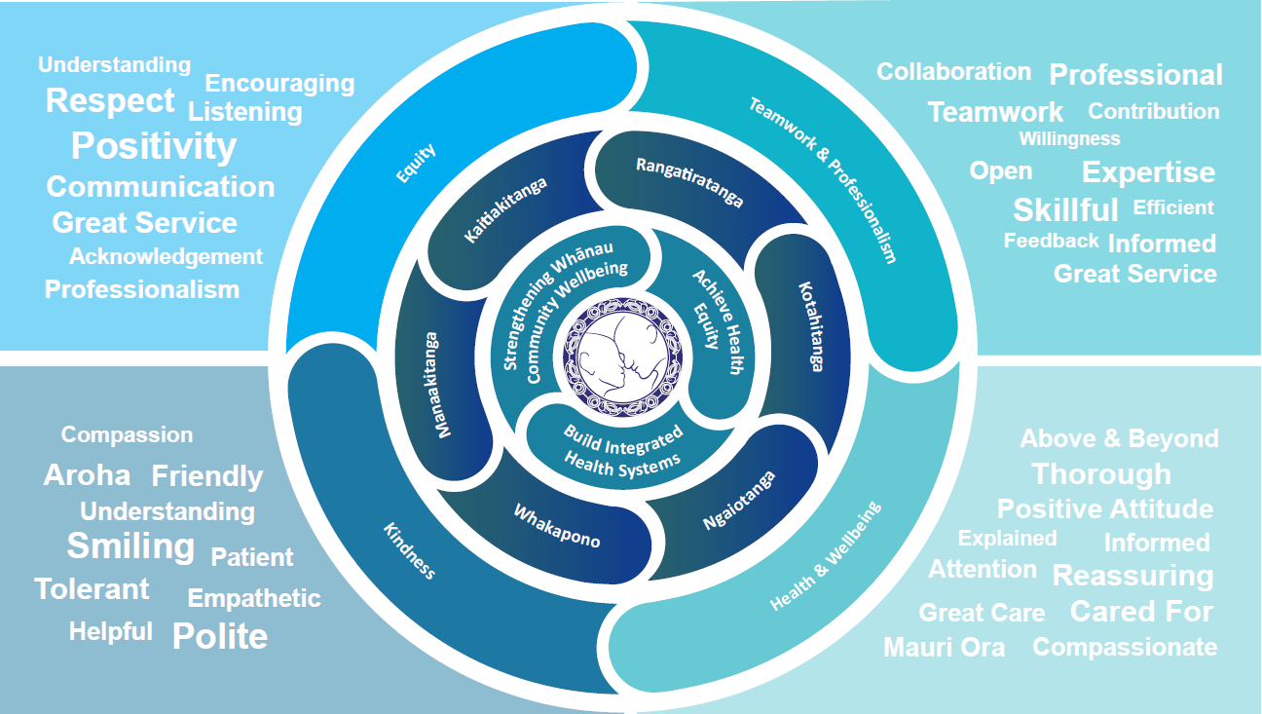

### TE TIRITI O WAITANGI

**Our expression of Te Tiriti o Waitangi**

The text of Te Tiriti, including the preamble and the three articles, along with the Ritenga Māori declaration, are the enduring foundation of our approach to achieving health and independence. Based on these foundations, we will strive to achieve the following four goals, each expressed in terms of mana.

**Mana whakahaere**

Effective and appropriate kaitiakitanga and stewardship over the health and disability system. Mana whakahaere is the exercise of control in accordance with tikanga, kaupapa and kawa Māori. This goes beyond the management of assets and resources and towards enabling Māori aspirations for health and independence.

**Mana motuhake**

Enabling the right for Māori to be Māori (Māori self-determination); to exercise their authority over their lives and to live on Māori terms and according to Māori philosophies, values and practices, including tikanga Māori.

**Mana tangata**

Achieving equity in health and disability outcomes for Māori, enhancing the mana of people across their life course and contributing to the overall health and wellbeing of Māori.

**Mana Māori**

Enabling Ritenga Māori (Māori customary rituals), which are framed by te ao Māori (the Māori world), enacted through tikanga Māori (Māori philosophy and customary practices) and encapsulated within mātauranga Māori (Māori knowledge).

Lakes DHB is committed within the framework of the New Zealand Public Health and Disability Act (2000) to supporting the Crown’s commitment to upholding its Tiriti promises.

### ORGANISATION STRUCTURE

