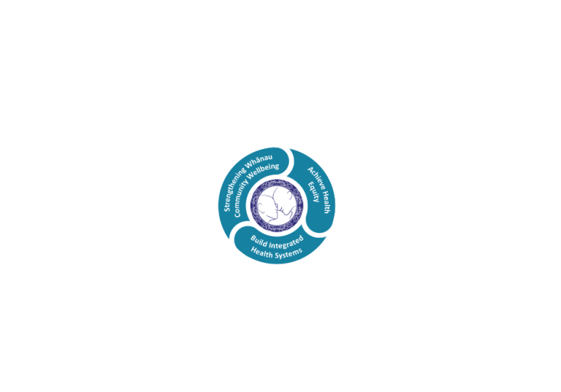



# POSITION DESCRIPTION

|  |  |  |
| --- | --- | --- |
| **Position**: | Physiotherapist Rotational | |
| **Responsible to:** | Team Leader | |
| **Direct Reports:** | Nil | |
| **Location:** | Rotorua | |
| **Functional relationships:** | **Internal:**  Physiotherapy staff  Clerical staff  Nursing Staff  Allied Health Staff  Medical Staff  Other Departments | **External**:  .Patients/carers/family/whanau  District Nursing Service  General Medical Practitioners  Private Hospitals & Residential Care Facilities  Community Agencies |
| **Financial delegations:** | Nill | |
| **Date**: | January 2021 | |

### Primary purpose(s) of the position

To provide a high standard and effective physiotherapy service to patients within Rotorua Hospital and lakes DHB.

|  |  |  |
| --- | --- | --- |
| **Key Objectives** | **Description** | **Expected Outcomes** |
| To treat patients safely and appropriately to standards of practice as set by the Physiotherapy Department, Rotorua Hospital. | Professional Standards of practice for physiotherapy therapy.  Own workload management.  Client/patient rights | Appropriate assessment of patients, treatment planning and evaluation of outcomes   * documentation of all assessment and treatment using the problem orientated medical recording system * feedback to referrer as appropriate * correct use and care of equipment * Management of work and organisation of work load. Workload priorities are established and maintained. * Efficient time management. * acceptance of responsibility as directed * instruction of Assistants, Attendant * follow Physiotherapy Department procedures. * follow Hospital protocols (eg form filling) * report any damages/losses to Professional Advisor * attendance at Ward rounds and Ward meetings as necessary and as directed by senior physiotherapists * issue of walking aids in accordance with departmental and Equipment Management Services policies * keep accurate daily statistics * complete incident forms for any accidents, incidents or near misses * compliance with relevant legislation eg: * Health and Disability patient code of rights * Health practitioners competency Act * Privacy Act * Health and Safety in Employment * Consumer Guarantees Act   Control Information:   * Audit of patient care records * problem orientated medical recording * on the job observation and appraisal / professional development plan * feedback from wards and departments * department records/computer records * client satisfaction surveys. |
| To ensure communication is established at all levels to achieve departmental objectives | Communication regarding provision of Physiotherapy  Services | * Appropriate written and verbal communication with medical staff, patients, care givers, colleagues, aides, attendants etc * follow recommended procedures by accurate, legible, prompt recording * attendance at relevant team meetings. * Check and action messages left in a timely manner   Control Information:   * Record keeping audits * observation and appraisal * feedback |
| To maintain professional development of self and contribute to professional development of others | Professional development of self .professional development of other staff.  Present and participate in departmental and hospital in-service education. | * Attendance at weekly in-service education * Present at in-service and provide appropriate documentation. * development of own skills - on-going learning * orientation of new staff, nurses etc * education of other staff as directed eg nurses, attendants etc * attendance at individual service 'in-service' and peer reviews.  Control Information:  * Attendance and contribution to departmental and service in-service education sessions * In-service plan, evaluation and record of attendance completed * observation and appraisal * completion of education checklist - Professional Development Plan |
| To participate in the development and growth of the Physiotherapy Department. | Participate in quality and staff meetings | * Active participation in drafting of departmental policies, procedures and standards * active participation in departmental decisions * daily completion of statistics.   Control Information:   * Attendance at staff meetings and administration meetings as requested |
| To uphold the standing of the Physiotherapy Department. | Representation of Physiotherapy and maintain professional standards. | * Promotion of professional standards by appearance, initiative, versatility, competence and manner * continued professional development through education * compliance with uniform standards, compliance with staff conduct standards.   Control Information:   * Appraisal * on the job observation * audits |
| To be prepared to work in any area of Physiotherapy at short notice and to participate in the on call and weekend roster | Adaptability to work where required. | * Participation in on-call and weekend roster. * treatment of patients in areas short-staffed by sick/annual leave etc as directed by the Professional Advisor, and Senior Physiotherapists. * Assist with physiotherapy students as directed. * rotation to other wards/services as directed by the Professional Advisor, and Senior Physiotherapists.   Control Information:   * On-call record keeping audits * observation and appraisal * feedback from wards etc * on-call competency appraisal |

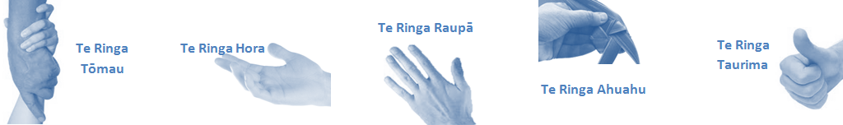

|  |  |  |
| --- | --- | --- |
| **Capabilities** | Capability definition | Achievement Indicators  *(Examples – add/ amend or delete as specific to role using matrix to assist)* |
| **Communication and Personal Interaction**  **Te Ringa Hora**  ***the open hand (denoting someone who is sociable)*** | Openly communicates and cooperates with all levels of DHB employees, patients and visitors. | * Listens actively, absorbs message and responds appropriately. * Builds effective working relationships. * Establishes rapport with others and gains their respect while being adaptive in relating to different types of people and situation. * Openly and constructively participates in conversations with md team, patients, managers and visitors * Patients and visitors are appropriately welcomed and treated while within the DHB * Collegiality with team mates and md teams * Accepts differences of opinion can occur but these happen respectfully and without any continued animosity |
| **Strategy & Performance**  **Te Ringa Raupā**  ***the roughened hand (symbolising a hard worker)*** | Spends energy on delivering role requirements and meeting objectives | * Has an energetic approach to work and is self motivated. * Accepts direction and instruction of manager but is able to work effectively without direction or guidance. * Organises time and resources effectively. * Understands and work towards achievement of the organisation’s goals. * On shift is busy completing shift duties. |
| Organises own time to deliver on required tasks and duties | * Utilises effective time management strategies to meet shift duties and works towards achieving objectives in any spare moments. |
| **Development and Change**  **Te Ringa Ahuahu**  ***the hand that shapes or fashions something (refers to someone who is innovative)*** | Accepts change in day to day practices and contributes to decision making of the team. | * Can adjust behaviour to the demands of the work environment in order to remain productive through periods of transition, ambiguity, uncertainty and stress |
| Makes suggestions to increase efficiency of the unit. | * Works with managers and team to make any changes within practices work * Contributes to change processes, offering solution based ideas * Constructively makes suggestions to improve process or practices and gain efficiencies * Accepts when ideas are not accepted for implementation |
| **Personal Accountability**  **Te Ringa Tōmau**  ***the hand that is trustworthy*** | Is open with manager and colleagues and open to accepting feedback and critique to improve upon practice. | * Offers constructive criticism and accepts feedback. * Establishes rapport with others and gains their respect while being adaptive in relating to different types of people and situations, to allow improvements to be made. * Accepts all feedback and participates in feedback discussions appropriately * Responds and queries how improvements can be made * Advises manager wherever issues may be impacting on performance |
| Looks for and undertakes development activities appropriate for role and career development. | * Recognises areas that could be improved in own practice * Requests learning and development opportunities to enhance practice in role and/ or to assist where improvements can be made * Recognises and facilitates the rights of Māori clients and their whanau to participate in cultural activities. * Has a working knowledge of the Lakes DHB Māori communities. |
| **Culture and Values**  **Te Ringa Taurima**  ***the hand that nurtures, encourages, supports*** | Operates in line with DHB values and expectations and professional codes of conduct. | * Demonstrates a commitment to cultural safety by meeting and exceeding the cultural needs of clients/ customers/ colleagues. * Incorporates the Lakes Way into day to day business activities * Shows respect for patients, colleagues, * managers, md teams * Utilises the Lakes Way philosophy to engage with patients, visitors and multi-disciplinary teams |

|  |  |  |
| --- | --- | --- |
| **Compulsory Requirements** | Description | Expected Outcomes |
| **Māori Health** | Māori philosophies and values of health are demonstrated in work practice. | * Meaningful relationships are established with Te Huinga Takiora Māori in the planning and delivery of services. * Practices are consistent with Te Tiriti o Waitangi /The Treaty of Waitangi when working with Māori. * Delivery of safe services for Māori are facilitated by ensuring they can access treatment options and are involved in the planning and delivery of their care. * Māori are enabled to access and participate in cultural activities provided by the Lakes DHB. * A commitment to improving the wellbeing of Māori by increasing cultural knowledge in the Lakes DHB is shown. |
| **Te Iti Kahurangi** | The Lakes Way, Our Place Our Culture | * Works within the Te Iti Kahurangi framework and supporting guide document. |
| **Record Keeping** |  | * Complies with the Lakes DHB Corporate Records Management policy to create and maintain full and accurate records. |
| **Quality & Risk** | Patient safety is paramount to the service we deliver at Lakes District Health Board. This is to be achieved in a clinical governance framework that is culturally responsive and identifies and manages risk and opportunities to improve. | * Employees are supported to lead by example and implement a culture of continuous quality improvement. * Risks that may prevent Lakes DHB from achieving their goals are identified, reported, and managed. * Māori patients are provided patient-centred care to achieve positive Māori health outcomes. * Needs of Māori are reviewed and reported in the further development of practice, process and or policy. * Evidence-based methodologies are used to support improvements, e.g. kaupapa Māori methodology. * Quality care is provided to certification standards. |
| **Health & Safety** | Each individual is responsible for ensuring the safety of themselves, their colleagues, patients and their visitors and to comply with all organisational health and safety policies, procedures and guidelines. | * Implementation and reinforcement of a proactive healthy work place culture which reflects relevant Lakes DHB policy and legislative requirements. * Healthy lifestyles are actively promoted and participated in, within the work area. * Employees participate in Health and Safety within areas of work. * Health and Safety activities are appropriately documented within specified timeframes. * Health and Safety policies have been read and understood and are applied in the workplace. * Health and Safety policies are appropriately documented within specified timeframes and incidents are reported immediately. * Any opportunities for improving Health and Safety are reported and acted upon in a timely manner. * All near misses/incident/accidents are reported to the appropriate line manager within 24 hours. |

**Signatures:**

|  |  |
| --- | --- |
| Line Manager:  (position description approved): |  |
| Employee:  (acceptance of position description): |  |

*(Please also initial all other pages to show acceptance of position description.)*

|  |  |  |
| --- | --- | --- |
| **Person Specification** | **Essential:** | **Desirable:** |
| **Education and Qualifications:** | * . New Zealand Registered Physiotherapist * Current Annual Practising Certificate * New Zealand drivers Licence | * Accredited assessor (mobility) or eligible to be one * Member of Physiotherapy New Zealand |
| **Experience:** | * . | * General clinical experience in Physiotherapy |
| **Knowledge:** | * Te Tiriti O Waitangi in the provision of health care services and support to Māori. * Te Tiriti O Waitangi in practice, process, policy development and decision making. * Relevant legislation and regulations including * Privacy act and health information privacy code * Health and safety in Employment Act * Codes of safe Practice * Health practitioners competency act * Health and disability commissioner act and code of health and disability consumer rights | * .. |
| **Skills:** | * Pronunciation of Te Reo Māori words and names * Ability to learn and apply new skills demonstrated effectiveness in managing workload. | * Te Reo Māorii |
| **Personal Attributes:** | * .. | * Non-smoker preferred. * .. |

**Limitations of authority**

* Order all goods and equipment through Team leader / Professional Advisor.
* Implementation of changes in procedure or policy in Physiotherapy services must be authorised by Team Leader/ Professional Advisor.
* Enquiries for patient information must be directed through the Team Leader/ Professional Advisor to the Privacy Officer.

**ABOUT LAKES DISTRICT HEALTH BOARD**

At Lakes District Health Board we place the highest value on the health and wellbeing of everyone in our community. As such all healthcare workers are expected to play a part in the creation and promotion of an environment which lives the following vision, mission and values:

### VISION

Healthy Communities – Mauriora! In this vision Mauriora refers to the Mauri - being the life essence and the source of well being, and ora - describing the state of wellness.

### STRATEGIC MISSION

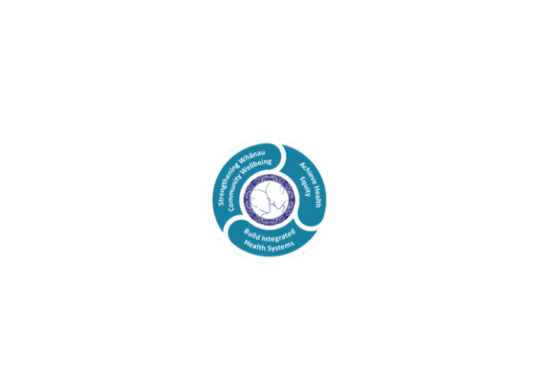

* Achieve equity in Māori health
* Build an Integrated health system
* Strengthen people, whanau & community wellbeing

### THREE CORE VALUES

Manaakitanga respect and acknowledgment of each other’s intrinsic value and contribution

Integrity truthfully and consistently acting collectively for the common good

Accountability collective and individual ownership for clinical and financial outcomes and sustainability

### TE ITI KAHURANGI – THE LAKES WAY, OUR PLACE, OUR CULTURE – WE WILL

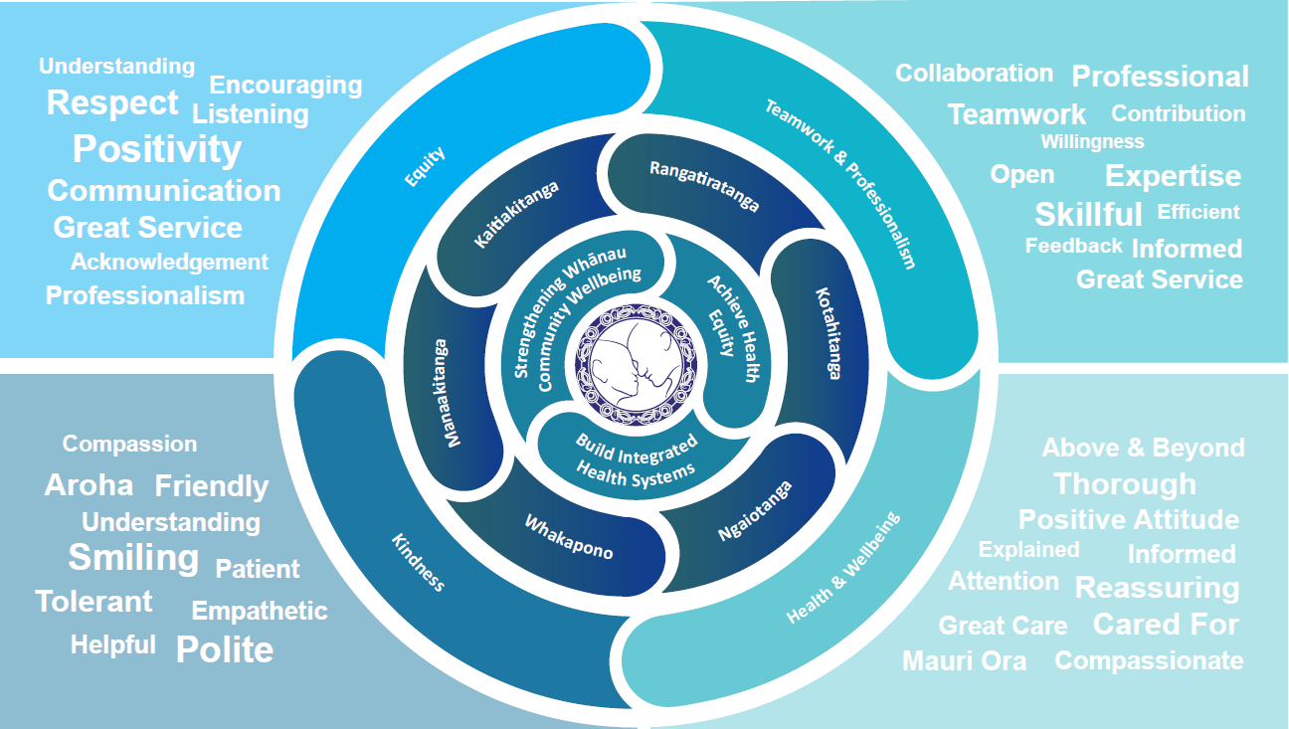

### TE TIRITI O WAITANGI

**Our expression of Te Tiriti o Waitangi**

The text of Te Tiriti, including the preamble and the three articles, along with the Ritenga Māori declaration, are the enduring foundation of our approach to achieving health and independence. Based on these foundations, we will strive to achieve the following four goals, each expressed in terms of mana.

**Mana whakahaere**

Effective and appropriate kaitiakitanga and stewardship over the health and disability system. Mana whakahaere is the exercise of control in accordance with tikanga, kaupapa and kawa Māori. This goes beyond the management of assets and resources and towards enabling Māori aspirations for health and independence.

**Mana motuhake**

Enabling the right for Māori to be Māori (Māori self-determination); to exercise their authority over their lives and to live on Māori terms and according to Māori philosophies, values and practices, including tikanga Māori.

**Mana tangata**

Achieving equity in health and disability outcomes for Māori, enhancing the mana of people across their life course and contributing to the overall health and wellbeing of Māori.

**Mana Māori**

Enabling Ritenga Māori (Māori customary rituals), which are framed by te ao Māori (the Māori world), enacted through tikanga Māori (Māori philosophy and customary practices) and encapsulated within mātauranga Māori (Māori knowledge).

Lakes DHB is committed within the framework of the New Zealand Public Health and Disability Act (2000) to supporting the Crown’s commitment to upholding its Tiriti promises.

### ORGANISATION STRUCTURE

