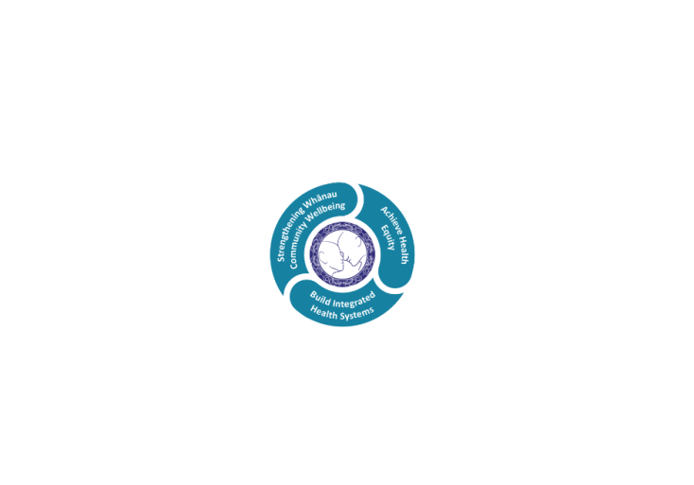

# POSITION DESCRIPTION

|  |  |  |
| --- | --- | --- |
| **Position**: | Visiting Neurodevelopmental Therapist (VNT),  Child Development Team | |
| **Responsible to:** | Team Leader, Child Development Team | |
| **Direct Reports:** | Nil | |
| **Location:** | Rotorua & Taupō | |
| **Functional relationships:** | **Internal:**  Clerical Staff  Nursing Staff  Allied Health Staff  Medical Staff  Other Departments  Paediatricians and Orthopaedic Consultants  Woman, Child & Family Paediatric Staff  Infant, Child, & Adolescent Mental Health Service  Public Health Nursing  Professional Advisors Occupational Therapy and Physiotherapy  Needs Assessment Co–ordination Services (NASC) - Support Net. | **External:**  Orthotic Department, QE Health  Children’s Team  Community Living Trust  Seating to Go  Ministry Of Education - Learning Support (MOE)  Enable Funding  Oranga Tamariki  Accident Compensation Corporation (ACC)  Early childhood centres and schools  Explore  All agencies both primary and tertiary supporting children with developmental needs. |
| **Financial delegations:** |  | |
| **Date**: |  | |

### Primary purpose(s) of the position

The VNT forms part of a multidisciplinary Child Development Team providing service in Lakes District Health Board under the Disability Support Services umbrella.

The Child Development Team (CDT) provides assessment and therapy service for children aged 0 – 15 (inclusive) who have a physical, sensory or intellectual disability and those with, or at risk of, developmental delay. Our service provides therapy, management, information and support in the home and community in partnership with caregivers.

|  |  |  |  |  |
| --- | --- | --- | --- | --- |
| **Key Objectives** | **Description** | | **Expected Outcomes** | |
| **Neurodevelopmental Therapy Service** | | To provide a Neurodevelopmental Therapy Service to clientele within a designated geographical area. | * That a rapport is established with the family through regular home visiting, attendance at a centre, or through telephone contact. * The child's overall development is assessed using standardised assessments within the home setting or at a place of the family / whānau / caregiver’s choice. * Therapists in partnership with family / whānau / caregivers inform, guide and up skill in the management of the child in order to facilitate and stimulate the next stage of development. * Individual holistic programmes are set up in conjunction with families and caregivers, culturally sensitive to their needs and in line with current therapeutic and behavioural best practice. * Ongoing assessment of children and evaluation of their programmes, liaison with MOE and other professionals as appropriate. * That progress is recorded and documented, and made available to appropriate personnel with family / whānau / caregivers' approval. * That family have access to information about the child's condition as well as current supportive agencies within the community e.g. appropriate benefits and funding supports. * That assessment and arrangement for provision of specialised equipment, orthopaedic aids, wheelchairs, housing modifications, technical and functional aids within the home and school are carried out in accordance with Lakes DHB policies, Work and Income New Zealand (WINZ), Enable, ACC, NASC, and other funding agencies. * Family / whānau / caregivers are supported and guided in order that they are able to take primary responsibility for the ongoing management and care of their child within the family unit. |
| **Liaison** | Liaison with other professional, educational, statutory, community and voluntary agencies. | | * Work as part of the Paediatric Team liaising with: Paediatricians; Specialists; General Practitioners; Child Development Team; Infant, Child and Adolescent Mental Health Service; Community Outreach Nurses; Woman, Child & Family Paediatric Staff; Social Workers; Well Child Providers; Community Health and others working within the area of paediatrics. * Work in co–operation with the MOE staff making appropriate joint visits in the home and educational settings. Involvement with Individual Education Planning for children on caseload. * Attend liaison meetings as appropriate. * Liaison with educational facilities such as Early Childhood Centres, Schools, Voluntary Agencies; and statutory bodies such as NASC, WINZ, Oranga Tamariki. | |
| **Service Development** |  | | * Active involvement in service planning and development through reflection and quality projects. * Service developed appropriately to current needs. Planning of ongoing service development with Management, Paediatricians and other relevant professionals. | |
| **Administration** |  | | * Organisation of case load. * Accurate records and statistics maintained. * Responding to patient and agency queries and requests. | |
| **Utilisation of Telehealth** | Provision of patient centric care which will give patients the option of telephone or video appointments where there is no need for an in-person appointment. | | ALLIED STAFF   * Service provision is in line with the New Zealand Health Strategy and the New Zealand Allied Health Best Practice Guide for Telehealth to provide care “closer to home”. | |

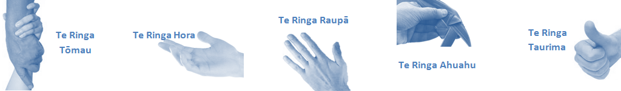

|  |  |  |
| --- | --- | --- |
| **Capabilities** | **Capability definition** | **Achievement Indicators** |
| **Communication and Personal Interaction**  **Te Ringa Hora**  ***the open hand (denoting someone who is sociable)*** | Openly communicates and cooperates with all levels of DHB employees, patients and visitors. | * Listens actively, absorbs message and responds appropriately. * Builds effective working relationships. * Establishes rapport with others and gains their respect while being adaptive in relating to different types of people and situation. * Openly and constructively participates in conversations with md team, patients, managers and visitors * Patients and visitors are appropriately welcomed and treated while within the DHB * Collegiality with team mates and md teams * Accepts differences of opinion can occur but these happen respectfully and without any continued animosity |
| **Strategy & Performance**  **Te Ringa Raupā**  ***the roughened hand (symbolising a hard worker)*** | Spends energy on delivering role requirements and meeting objectives | * Has an energetic approach to work and is self-motivated. * Accepts direction and instruction of manager but is able to work effectively without direction or guidance. * Organises time and resources effectively. * Understands and work towards achievement of the organisation’s goals. |
| Organises own time to deliver on required tasks and duties | * Utilises effective time management strategies to meet shift duties and works towards achieving objectives in any spare moments. |
| **Development and Change**  **Te Ringa Ahuahu**  ***the hand that shapes or fashions something (refers to someone who is innovative)*** | Accepts change in day to day practices and contributes to decision making of the team. | * Can adjust behaviour to the demands of the work environment in order to remain productive through periods of transition, ambiguity, uncertainty and stress |
| Makes suggestions to increase efficiency of the unit. | * Works with managers and team to make any changes within practices work * Contributes to change processes, offering solution based ideas * Constructively makes suggestions to improve process or practices and gain efficiencies * Accepts when ideas are not accepted for implementation |
| **Personal Accountability**  **Te Ringa Tōmau**  ***the hand that is trustworthy*** | Is open with manager and colleagues and open to accepting feedback and critique to improve upon practice. | * Offers constructive criticism and accepts feedback. * Establishes rapport with others and gains their respect while being adaptive in relating to different types of people and situations, to allow improvements to be made. * Accepts all feedback and participates in feedback discussions appropriately * Responds and queries how improvements can be made * Advises manager wherever issues may be impacting on performance |
| Looks for and undertakes development activities appropriate for role and career development. | * Recognises areas that could be improved in own practice * Requests learning and development opportunities to enhance practice in role and/ or to assist where improvements can be made * Recognises and facilitates the rights of Māori clients and their whānau to participate in cultural activities. * Has a working knowledge of the Lakes DHB Māori communities. |
| **Culture and Values**  **Te Ringa Taurima**  ***the hand that nurtures, encourages, supports*** | Operates in line with DHB values and expectations and professional codes of conduct. | * Demonstrates a commitment to cultural safety by meeting and exceeding the cultural needs of clients/ customers/ colleagues. * Incorporates the Lakes Way into day to day business activities * Shows respect for patients, colleagues, * managers, MDT teams * Utilises the Lakes Way philosophy to engage with patients, visitors and multi-disciplinary teams |

|  |  |  |
| --- | --- | --- |
| **Compulsory Requirements** | **Description** | **Expected Outcomes** |
| **Māori Health** | Māori philosophies and values of health are demonstrated in work practice. | * Meaningful relationships are established with Te Huinga Takiora Māori in the planning and delivery of services. * Practices are consistent with Te Tiriti o Waitangi /The Treaty of Waitangi when working with Māori. * Delivery of safe services for Māori are facilitated by ensuring they can access treatment options and are involved in the planning and delivery of their care. * Māori are enabled to access and participate in cultural activities provided by the Lakes DHB. * A commitment to improving the wellbeing of Māori by increasing cultural knowledge in the Lakes DHB is shown. |
| **Te Iti Kahurangi** | The Lakes Way, Our Place Our Culture | * Works within the Te Iti Kahurangi framework and supporting guide document. |
| **Record Keeping** |  | * Complies with the Lakes DHB Corporate Records Management policy to create and maintain full and accurate records. |
| **Quality & Risk** | Patient safety is paramount to the service we deliver at Lakes District Health Board. This is to be achieved in a clinical governance framework that is culturally responsive and identifies and manages risk and opportunities to improve. | * Employees are supported to lead by example and implement a culture of continuous quality improvement. * Risks that may prevent Lakes DHB from achieving their goals are identified, reported, and managed. * Māori patients are provided patient-centred care to achieve positive Māori health outcomes. * Needs of Māori are reviewed and reported in the further development of practice, process and or policy. * Evidence-based methodologies are used to support improvements, e.g. kaupapa Māori methodology. * Quality care is provided to certification standards. |
| **Health & Safety** | Each individual is responsible for ensuring the safety of themselves, their colleagues, patients and their visitors and to comply with all organisational health and safety policies, procedures and guidelines. | * Implementation and reinforcement of a proactive healthy work place culture which reflects relevant Lakes DHB policy and legislative requirements. * Healthy lifestyles are actively promoted and participated in, within the work area. * Employees participate in Health and Safety within areas of work. * Health and Safety activities are appropriately documented within specified timeframes. * Health and Safety policies have been read and understood and are applied in the workplace. * Health and Safety policies are appropriately documented within specified timeframes and incidents are reported immediately. * Any opportunities for improving Health and Safety are reported and acted upon in a timely manner. * All near misses/incident/accidents are reported to the appropriate line manager within 24 hours. |

**Signatures:**

|  |  |
| --- | --- |
| Line Manager:  (position description approved): |  |
| Employee:  (acceptance of position description): |  |

*(Please also initial all other pages to show acceptance of position description.)*

|  |  |  |
| --- | --- | --- |
| **Person Specification** | **Essential:** | **Desirable:** |
| Education and Qualifications: | * New Zealand Diploma of Physiotherapy or Occupational Therapy, or recognised equivalent. * Current New Zealand Practising Certificate. * Current New Zealand Driving Licence. * Knowledge of Health & Disability Act. * Knowledge of the Privacy Act. * Knowledge of the Treaty of Waitangi. * Excellent interpersonal skills with a wide variety of families and professionals. * Effective verbal and written skills. * Self-management skills. * Ability to work effectively in a trans-disciplinary or an interdisciplinary team and inter–agency. * Good listening skills. * Ability to be responsive to Maori practices and beliefs in relation to disability. * Ability to work in multicultural settings. * Adaptive, innovative, able to problem–solve. * Ability to work on one's own... | * + At least three years post graduate experience, some of which must have been in paediatrics or community disability services.   + Knowledge of child development, normal and atypical.   + Knowledge of Accident Compensation Corporation Act, and ACC contracts.   + Knowledge of Maori Health Providers for children and caregivers.   + Knowledge of different theories supporting Paediatric Therapies.   + Knowledge of Community and Government Agencies. * Able to be an Accredited Assessor in the areas of Housing Alterations, Personal Care and Household Management, Mobility and Standing, Seating and Lying. |
| **Knowledge**: | * Te Tiriti O Waitangi in the provision of health care services and support to Māori. * Te Tiriti O Waitangi in practice, process, policy development and decision making. |  |
| **Skills:** | * Pronunciation of Te Reo Māori words and names. | * Te Reo Māori |
| **Personal Attributes:** |  | * Non-smoker preferred |

**ABOUT LAKES DISTRICT HEALTH BOARD**

At Lakes District Health Board we place the highest value on the health and wellbeing of everyone in our community. As such all healthcare workers are expected to play a part in the creation and promotion of an environment which lives the following vision, mission and values:

### VISION

Healthy Communities – Mauriora! In this vision Mauriora refers to the Mauri - being the life essence and the source of well being, and ora - describing the state of wellness.

### STRATEGIC MISSION

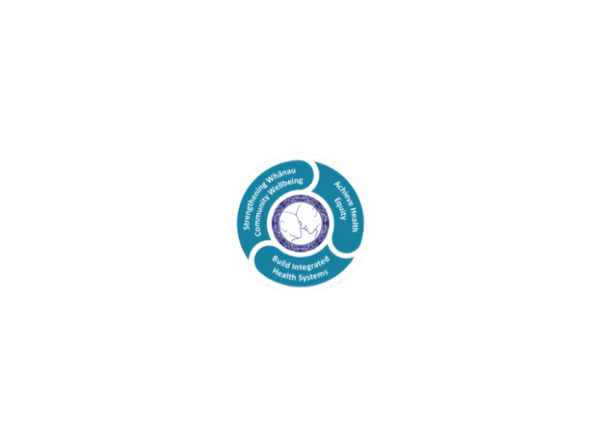

* Achieve equity in Māori health
* Build an Integrated health system
* Strengthen people, whanau & community wellbeing

### THREE CORE VALUES

Manaakitanga respect and acknowledgment of each other’s intrinsic value and contribution

Integrity truthfully and consistently acting collectively for the common good

Accountability collective and individual ownership for clinical and financial outcomes and sustainability

### TE ITI KAHURANGI – THE LAKES WAY, OUR PLACE, OUR CULTURE – WE WILL

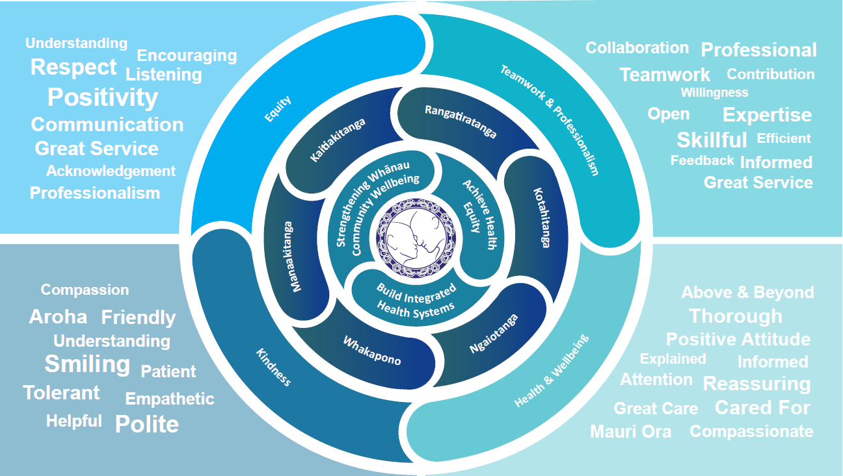

### TE TIRITI O WAITANGI

**Our expression of Te Tiriti o Waitangi**

The text of Te Tiriti, including the preamble and the three articles, along with the Ritenga Māori declaration, are the enduring foundation of our approach to achieving health and independence. Based on these foundations, we will strive to achieve the following four goals, each expressed in terms of mana.

**Mana whakahaere**

Effective and appropriate kaitiakitanga and stewardship over the health and disability system. Mana whakahaere is the exercise of control in accordance with tikanga, kaupapa and kawa Māori. This goes beyond the management of assets and resources and towards enabling Māori aspirations for health and independence.

**Mana motuhake**

Enabling the right for Māori to be Māori (Māori self-determination); to exercise their authority over their lives and to live on Māori terms and according to Māori philosophies, values and practices, including tikanga Māori.

**Mana tangata**

Achieving equity in health and disability outcomes for Māori, enhancing the mana of people across their life course and contributing to the overall health and wellbeing of Māori.

**Mana Māori**

Enabling Ritenga Māori (Māori customary rituals), which are framed by te ao Māori (the Māori world), enacted through tikanga Māori (Māori philosophy and customary practices) and encapsulated within mātauranga Māori (Māori knowledge).

Lakes DHB is committed within the framework of the New Zealand Public Health and Disability Act (2000) to supporting the Crown’s commitment to upholding its Tiriti promises.

### ORGANISATION STRUCTURE



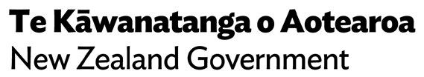

**TeWhatuOra.govt.nz**

Private Bag 3023, Rotorua Mail Centre, Rotorua 3046

Waea pūkoro: +64 7 3481199