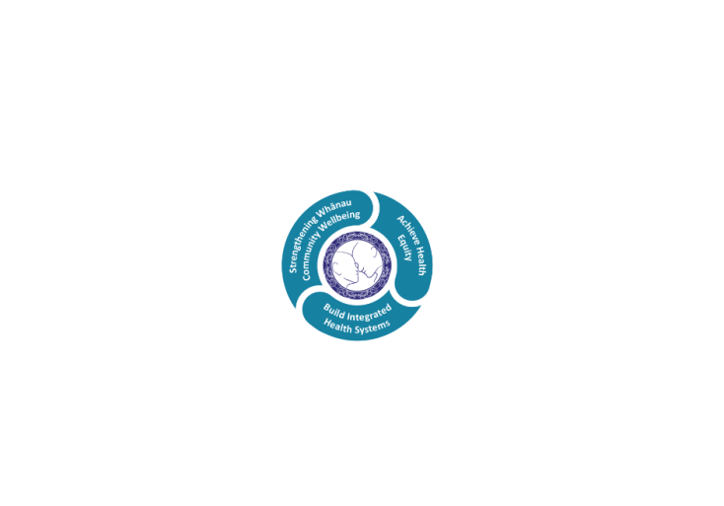

# POSITION DESCRIPTION

|  |  |  |
| --- | --- | --- |
| **Position:** | Waiariki Mana Ake Wayfinder | |
| **Responsible To:** | Clinical Team Lead, Waiariki Mana Ake  Clinical Manager, Waiariki Mana Ake  Service Manager, Mental Health & Addiction Services | |
| **Direct Reports:** | N/A | |
| **Location:** | Waiariki | |
| **Functional Relationships:** | **Internal:**  Programme Lead  Project Team  Clinical Services  Hospital and Specialist Services  Learning Support Co-ordinators  Kahui Hauora Lead / Clinician  CAMHS  Professional Advisors  Te Whatu Ora Lakes and Hauora a Toi Bay of Plenty | **External:**  Primary Health  Intersectoral agencies  Ministry of Education  Principals  Kaupapa Māori Kura  School / Kura Learning Support Team  Non-Government Organisations  Iwi, including IMPB |
| **Financial Delegations:** | N/A | |
| **Date:** | September 2023 | |

Professional Advisor

(Nursing; Psychology; Allied Health (Social Worker; Occupational Therapist; others))

### Primary purpose(s) of the position

This role will be responsible for delivering early interventional health and wellbeing guidance, support and service within Primary and Intermediate schools within the Waiariki area. The Mana Ake service is led by health but delivered in collaboration with education, enabling the delivery of support where initial discovery of wellbeing need is often identified in a community setting.

The Mana Ake workforce is made up of both registered clinical and non-registered kaimahi with an aim to deliver evidence informed individual, group and whole of class/school wellbeing programmes and interventions, targeted at tamariki with low level issues. The goal of Mana Ake is to address issues early, thereby minimising the need for escalation to more intensive specialist services.

The Wayfinder will work closely with the clinical team to provide interventions in kura and schools. The Wayfinder will provide a link between the clinical team, kura, schools, and wider whānau / community. The Wayfinder will walk alongside whānau and tamariki on their wellbeing journey to support the delivery of strategies.

The Mana Ake service supports Te Ara Tauwhirotanga- “pathways that lead us to act with kindness” Model of Care, enabling an optimal environment and service to effect a service users wellness and recovery.

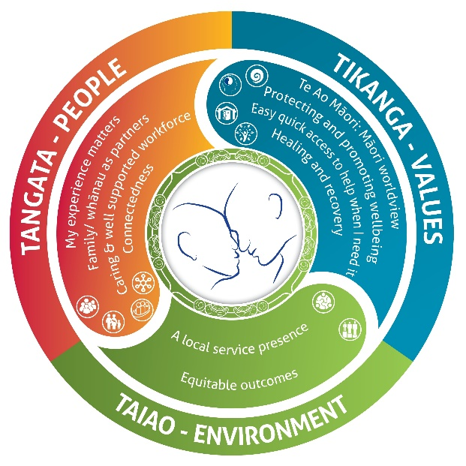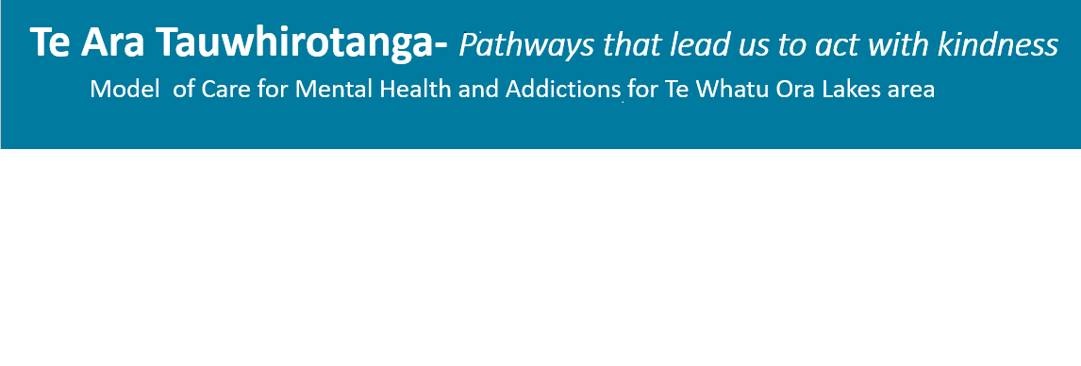

* **Tangata – People**
  + My experience matters
  + Family/Whanau as partners
  + Caring and well supported workforce
  + Connectedness
* **Tikanga –Values**
  + Te Ao Maori: Maori worldview
  + Protecting and promoting wellbeing
  + Easy quick access to help when I need it
  + Healing and recovery
* **Taiao – Environment**
  + A local service presence
  + Equitable outcomes

| **Key Objectives** | **Description** | **Expected Outcomes** |
| --- | --- | --- |
| **Wellbeing Care** | Provide assessment, intervention and support that reflects mana enhancing, empowering and strengths-based practice under the supervision and guidance of clinical team members. | * Provides timely, accessible, responsive support to tamariki, whānau and schools, empowering and enhancing community connections. * The Wayfinder will: * work in accordance with Mana Ake practice guidance and conduct themselves in a way that upholds the integrity of the Mana Ake initiative * be led by school and whānau priorities and aspirations * be known in the communities they support * seek to add value by identifying opportunities to enhance wellbeing outcomes * ensure culturally, and linguistically diverse populations are supported in a culturally appropriate manner with a focus on attaining equitable outcomes * identify and build on client and whānau strengths * share skills and strategies with whānau so that caregivers are empowered to support clients in their home environment * share skills and strategies with schools so that school staff are empowered to support clients in the school environment. * Conduct assessment, formulation, and risk management, including escalation as required, supported by clinican team members. * Develop and document clear and appropriate individual referral pathways. * Apply interventions and programmes in a competent and safe way. * Evaluate progress and outcomes against treatment goals. * Participates in regular Performance Reviews and contributes to peer review * Other activities as requested by the Clinician within the relevant scope of practice and responsibility. |
| **Te Ara Tauwhirotanga Model of Care** | Follows the principles of the model of care “Te Ara Tauwhirotanga – Pathways that lead us to act with kindness.” | * Utilises Te Ara Tauwhirotanga – “Pathways that lead us to act with kindness” model of care to engage with tamariki, whānau and multidisciplinary teams. * Provides care following the principles of the model of care Te Ara Tauwhirotanga – Pathways that lead us to act with kindness. * Incorporates and follows the principles of the model of care Te Ara Tauwhirotanga – Pathways that lead us to act with kindness into day to day business activities. |
| **Relationship management** | Relationships are developed and supported effectively and in a professional and timely manner. | * The Wayfinder will establish and proactively maintain positive communication and relationships. * Provide support and guidance to cross sectorial members seeking advice to establish an appropriate pathway of support for the child or young person. |
| **Confidentiality and privacy** | Ensure confidentiality and privacy for all tamariki, whānau and agency information | * Ensure documentation is current, accurate, timely and maintain confidentiality within legal, organisational and ethical requirements. * Ensure that conversations regarding individuals or whānau held in all settings are conducted in a way that maintains confidentiality and privacy. |
| **Teamwork** | Attitude and work ethic promotes effective teamwork. | * Participate as a member of the team and display commitment to achieving the vision and goals of the Waiariki Mana Ake programme. * Work in a constructive way to build a “one entity” organisation, having a flexible and team approach to the total organisation in the achievement of outcomes. * Share information and communicate in an open and honest manner. |
| **Supervison/Coaching** | Engages in regular, structured and reflective coaching | * Accountable for participating in supervision/coaching on a monthly basis. * Use a formal evaluation process with supervisor to capture the experience and gains from supervision/coaching. |

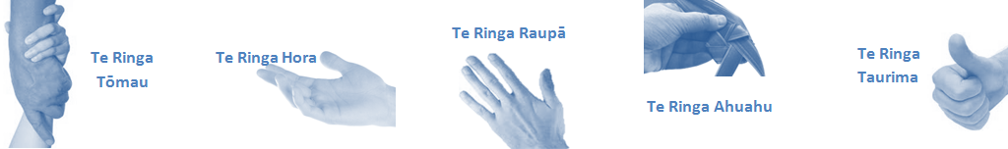

| **Capabilities** | | **Capability Definition** | | **Achievement Indicators** |
| --- | --- | --- | --- | --- |
| **Communication and Personal Interaction**  **Te Ringa Hora**  ***the open hand (denoting someone who is sociable)*** | | Communicates relevant information in a timely manner to those who need to know at a level that is understood. | | * Transfer information effectively verbally and writes clearly, coherently and succinctly. * Share well thought out, concise and timely information with others using appropriate mediums. * Build team spirit, promote/protect team reputation, show commitment to contributing to the teams’ success. * Maintain and promote high standards of social, ethical and organisational norms. |
| Fosters a team environment and encourages collaboration between team and departments within Lakes. | | * Articulate differing perspectives on an issue and can see the merit of alternative points of view. |
| Connects with people to build trust and confidence. | | * Connect with others, listen, reads people and situations and communicates tactfully. * Get to know their team members and treats them with respect, valuing their individuality and contributions |
| **Strategy & Performance**  **Te Ringa Raupā**  ***the roughened hand (symbolising a hard worker)*** | | Spends energy on delivering role requirements and meeting objectives. Organises own time to deliver on required tasks and duties | | * Has an energetic approach to work and is self motivated. * Accepts direction and instruction of manager but is able to work effectively without direction or guidance. * Organises time and resources effectively. * Understands and works towards achievement of the organisation’s goals. |
|  | |  |
| **Development and Change**  **Te Ringa Ahuahu**  ***the hand that shapes or fashions something (refers to someone who is innovative)*** | | Has an energetic approach to work and is self motivated.  Accepts direction and instruction of manager but is able to work effectively without direction or guidance.  Organises time and resources effectively.  Understands and work towards achievement of the organisation’s goals. | | * Can adjust behaviour to the demands of the work environment in order to remain productive through periods of transition, ambiguity, uncertainty and stress * Continually strives for new and improved work processes that will result in greater effectiveness and efficiencies. * Is solution focused. * Seeks opportunities to improve performance and seeks feedback to measure and improve. * Encourages team participation in solution development process. |
| **Personal Accountability,** **Integrity and Trust**  **Te Ringa Tōmau**  ***the hand that is trustworthy*** | | Manages own and encourages others to foster work/life balance. Actively manages own career aspirations and development. | | * Offers constructive criticism and accepts feedback. * Establishes rapport with others and gains their respect while being adaptive in relating to different types of people and situations, to allow improvements to be made. * Advises manager wherever issues may be impacting on performance * Is widely trusted; is seen as a direct, truthful individual; can present the unvarnished truth in an appropriate and helpful manner; keeps confidences; admits mistakes; doesn’t misrepresent him/herself for personal gain; works autonomously but also a team player. * Ensures regular breaks are taken and own annual leave accruals are used within the 12 months following accrual. |
|  | | * Is constantly striving to acquire and maintain knowledge, skills and/or experience. * Manages own career development plan. * Seeks out development opportunities to expand knowledge and capability. |
| **Culture and Values**  **Te Ringa Taurima**  ***the hand that nurtures, encourages, supports*** | | Makes decisions based on facts and without personal bias. | | * Demonstrates a commitment to cultural safety by meeting and exceeding the cultural needs of tamariki and whānau. * Is proactive and effective when problem solving is required. |
| Engages with mentors and supervisors for personal skill development. | | * Is constantly striving to acquire and maintain knowledge, skills and/or experience. * Demonstrates a commitment to and takes responsibility for going professional development. |
| Plans, prioritises and organises work to deliver on short and long term goals. | | * Purposeful about where time is invested. * Delivers relevant results within expected timeframes. |
| Encourages and promotes Lakes values and expectations. | | * Role models expected behaviours and practices. * Treats people with dignity and respect. * Uses appropriate empathy to gain organisational objectives. * Is solution focused. |
| **Compulsory Requirements** | **Description** | | **Expected Outcomes** | |
| **Māori Health** | Māori philosophies and values of health are demonstrated in work practice. | | * Meaningful relationships are established with Te Whatu Ora Lakes Maori Health division in the planning and delivery of services. * Practices are consistent with Te Tiriti o Waitangi /The Treaty of Waitangi when working with Māori. * Delivery of safe services for Māori are facilitated by ensuring they can access treatment options and are involved in the planning and delivery of their care. * Māori are enabled to access and participate in cultural activities provided by the Te Whatu Ora Lakes. * A commitment to improving the wellbeing of Māori by increasing cultural knowledge in the Te Whatu Ora Lakes is shown. | |
| **Te Iti Kahurangi** | The Lakes Way, Our Place Our Culture | | * Works within the Te Iti Kahurangi framework and supporting guide document. | |
| **Record Keeping** |  | | * Complies with the Te Whatu Ora Lakes Corporate Records Management policy to create and maintain full and accurate records. * Ensures documentation is current, accurate, timely and maintains confidentiality within legal, organisational and ethical requirements. * Demonstrates computer skills necessary to organise data for essential care delivery and to report on data as required. * Maintains accurate data recording and meet reporting requirements. | |
| **Quality & Risk** | Patient safety is paramount to the service we deliver at Te Whatu Ora Lakes. This is to be achieved in a clinical governance framework that is culturally responsive and identifies and manages risk and opportunities to improve. | | * Employees are supported to lead by example and implement a culture of continuous quality improvement. * Risks that may prevent Te Whatu Ora Lakes from achieving their goals are identified, reported, and managed. * Māori patients are provided patient-centred care to achieve positive Māori health outcomes. * Needs of Māori are reviewed and reported in the further development of practice, process and or policy. * Evidence-based methodologies are used to support improvements, e.g. kaupapa Māori methodology. * Quality care is provided to certification standards. | |
| **Health & Safety** | Each individual is responsible for ensuring the safety of themselves, their colleagues, patients and their visitors and to comply with all organisational health and safety policies, procedures and guidelines. | | * Implementation and reinforcement of a proactive healthy work place culture which reflects relevant Te Whatu Ora Lakes policy and legislative requirements. * Healthy lifestyles are actively promoted and participated in, within the work area. * Employees participate in Health and Safety within areas of work. * Health and Safety activities are appropriately documented within specified timeframes. * Health and Safety policies have been read and understood and are applied in the workplace. * Health and Safety policies are appropriately documented within specified timeframes and incidents are reported immediately. * Any opportunities for improving Health and Safety are reported and acted upon in a timely manner. * All near misses/incident/accidents are reported to the appropriate line manager within 24 hours. | |

**Signatures:**

|  |  |
| --- | --- |
| Line Manager:  (position description approved): |  |
| Employee:  (acceptance of position description): |  |

*(Please also initial all other pages to show acceptance of position description.)*

|  |  |  |
| --- | --- | --- |
| **Person Specification** | **Essential:** | **Desirable:** |
| **Education and Qualifications:** |  | * Formal qualification in Health, Education or Social Services would be advantageous |
| **Experience:** | * Experience in community engagement * Proven teamwork * Demonstrated cross-sector collabration * Well established community connections * Experience in working with tamariki and whānau | * Proven communication skills with cross-sector stakeholders * Demonstrated experience in working with Iwi * Experience working in a health setting |
| **Knowledge:** | * Understanding of Te Tiriti O Waitangi in the provision of Health Care services and support to Māori. * Understanding of crown obligations of Te Tiriti * Knowledge and understanding of Te Reo/ correct pronunciation |  |
| **Skills:** | * Demonstrated analytical and autonomous thinking * Prioritisation and problem solving * Conflict resolution and mediation skills * Creative and flexible * Effective and confident oral and written communication skills * Computer literacy * Fluency in verbal and written te reo Māori |  |
| **Personal Attributes:** | * Open and approachable with the ability to build rapport * Outcome and quality focused * Collaborative work style * Integrity * Non-judgemental * High level of motivation, initiative and anticipation with ability to work independently as well as in a team * Adaptability and ability to pivot within a rapidly changing environment * Sensitivity to cultural/ethnic customs and beliefs * A calm manner * Sense of humour | * Non-smoker/vaper preferred |
| **Other** | * Full Driver’s License | * Covid-19 Vaccinated |

**ABOUT TE WHATU ORA LAKES**

At Te Whatu Ora Lakes we place the highest value on the health and wellbeing of everyone in our community. As such all healthcare workers are expected to play a part in the creation and promotion of an environment which lives the following vision, mission and values:

### VISION

Healthy Communities – Mauriora! In this vision Mauriora refers to the Mauri - being the life essence and the source of well-being, and ora - describing the state of wellness.

### STRATEGIC MISSION

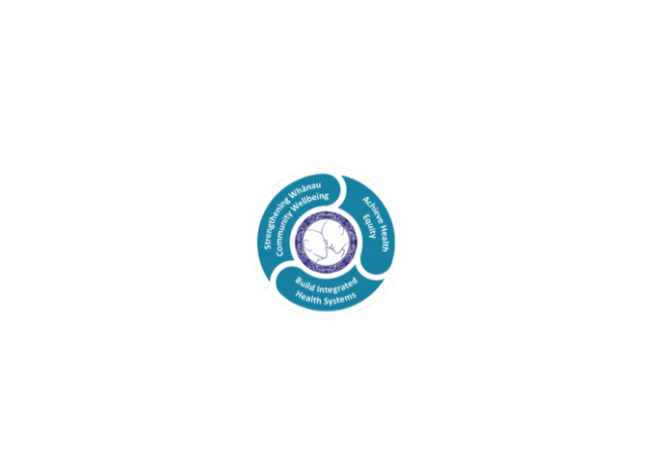

* Achieve equity in Māori health
* Build an Integrated health system
* Strengthen people, whānau & community wellbeing

### THREE CORE VALUES

Manaakitanga respect and acknowledgment of each other’s intrinsic value and contribution

Integrity truthfully and consistently acting collectively for the common good

Accountability collective and individual ownership for clinical and financial outcomes and sustainability

### TE ITI KAHURANGI – THE LAKES WAY, OUR PLACE, OUR CULTURE – WE WILL

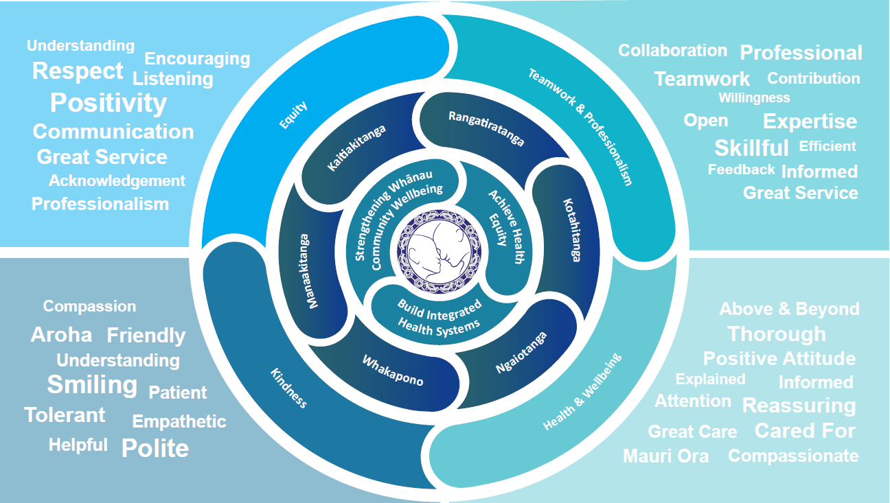

### TE TIRITI O WAITANGI

**Our expression of Te Tiriti o Waitangi**

The text of Te Tiriti, including the preamble and the three articles, along with the Ritenga Māori declaration, are the enduring foundation of our approach to achieving health and independence. Based on these foundations, we will strive to achieve the following four goals, each expressed in terms of mana.

**Mana whakahaere**

Effective and appropriate kaitiakitanga and stewardship over the health and disability system. Mana whakahaere is the exercise of control in accordance with tikanga, kaupapa and kawa Māori. This goes beyond the management of assets and resources and towards enabling Māori aspirations for health and independence.

**Mana motuhake**

Enabling the right for Māori to be Māori (Māori self-determination); to exercise their authority over their lives and to live on Māori terms and according to Māori philosophies, values and practices, including tikanga Māori.

**Mana tangata**

Achieving equity in health and disability outcomes for Māori, enhancing the mana of people across their life course and contributing to the overall health and wellbeing of Māori.

**Mana Māori**

Enabling Ritenga Māori (Māori customary rituals), which are framed by te ao Māori (the Māori world), enacted through tikanga Māori (Māori philosophy and customary practices) and encapsulated within mātauranga Māori (Māori knowledge).

Te Whatu Ora Lakes is committed within the framework of the New Zealand Public Health and Disability Act (2000) to supporting the Crown’s commitment to upholding its Tiriti promises.

### ORGANISATION STRUCTURE

