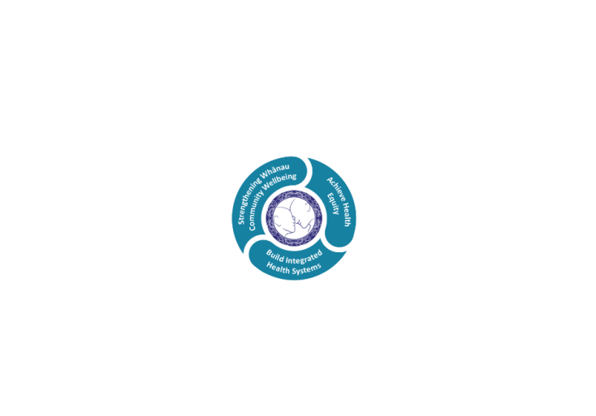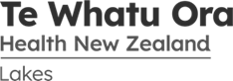

# POSITION DESCRIPTION

|  |  |  |
| --- | --- | --- |
| **Position:** | Oral Health Promoter - Rotorua | |
| **Responsible To:** | Community Oral Health Service Manager | |
| **Direct Reports:** | Nil | |
| **Location:** | Rotorua & Taupō | |
| **Functional Relationships:** | **Internal:**  Oral Health Manager  Dental Therapists and Assistants  Taupo/Turangi Dental Educator  Professional Advisor  WCF Clinical Director | **External:**  Preschool staff, parents, caregivers including; kindergarten, Kohanga, day care, playgroups and early childhood centres  Public Health Dentist  Toi Te Ora  Plunket and Well Child Services  Health Rotorua PHO  Rotorua Area Primary Health Service providers: General practitioners and practice nurses  Te Whakaruruhau  Public Health Promoters  Community Groups  Ministry of Health  National Fluoridation Coordinator and other advocates  Dentists with OHA Contract  School Personnel  School Wellness Centres  Public Health Nurses  Community Health Workers  Iwi / Hapu Groups |
| **Financial Delegations:** | Nil | |
| **Date:** | 9 September 2024 | |

### Primary purpose(s) of the position

* The primary purpose of the role is to implement culturally appropriate health promotion actions, in accordance with national plan requirements addressing equity for Māori and meeting Te Tiriti o Waitangi obligations.
* Oral Health Educators work to improve, promote and protect the health of our population, in the communities we service, with a focus on equity.
* The position requires building and maintaining effective and trusted relationships with key stakeholders and community groups to plan, implement, manage and evaluate health promotion activities. Health Promotion activities will be underpinned by Te Tiriti o Waitangi and health promotion frameworks including the Ottawa Charter and Te Whare Tapa Wha.
* This role will work collaboratively with all key stakeholders in a way that is consistent with Te Whatu Ora’s vision and values. This way of working will ultimately benefit all our communities and contribute to improving population health outcomes.

| **Key Objectives** | **Description** | **Expected Outcomes** |
| --- | --- | --- |
| **Enrolment** | Increase the rate of enrolment in the Oral Health Services Contract and/or the Community Oral Health Service. | * Encourage and increase early preschool enrolment by liaising with preschool centres in the Rotorua region including kindergarten, Kohanga, day cares, playgroups, early childhood centres. * Issue and collect preschool enrolment forms. * Follow up enrolments from Rotorua Area Primary Health Services (RAPHS) list to target pre-schoolers not enrolled and identify dual enrolments. * Liaise with school staff to encourage adolescent enrolment and attendance for dental appointments. * Target groups identified and clearly defined. * Increase in early preschool enrolment. |
| **Public Relations and Communications** | To increase the focus on preschool oral health. To network and extend links to other providers of primary health care. | * Maintain highly effective public relations and communications. * Develop and maintain good working relationships with key people to assist in identifying targeted client group. * Develop a good working relationship with contracted dentists, dental therapists, school personnel and other health professionals. * Effective interpersonal relationships with adolescents are maintained, handled sensitively and with confidentiality. * Promote and maintain good relationships with dental therapists, parents, teachers and community. * Networks established within the community. * Oral health promotion carried out in a professional manner with due regard for the client group, cultural values and community needs. * A positive and innovative attitude is displayed for all oral health promotion activities. * Liaison with other health promoters and health professionals is timely and effective. * Clear, simple, up to date and consistent oral health messages targeted to priority groups. * Advocate for the fluoridation of water supplies in the Rotorua region and be involved in any opportunities to promote water fluoridation. |
| **Education and Promotion** | To focus on preventative oral health activities for preschool children. To contribute to the reduction in health inequalities by ensuring accessibility, effectiveness and acceptability of services to Maori. Increase oral health awareness and promote the value of continued regular dental care. | * To strategise and plan to meet the needs of the targeted client group. * Research, access and develop resources for oral health promotion. * Provide preventive advice and guidance to staff, parents/caregivers and children of preschool groups. * Implement and deliver oral health promotion, messages and education programmes to the client groups. * Deliver clear, simple, up to date and consistent oral health messages through lessons, talks, notices, newsletters, pamphlets or other appropriate media. * Actively network and interact with preschool centres and other health providers to promote and support programmes that will lead to improved oral health status. * Respond to community requests for information and can be part of a health promotion team on oral health issues such as “Lift the Lip”, Health expos, well child days. * Attend if requested or initiate attendance at Kohanga hui/ AGMs, Plunket/ well child sessions, new mother coffee group meetings to present oral health education information. * Provide anticipatory guidance about oral health at antenatal classes. |
| **Assistance at Screening Sessions** | To improve early childhood oral health by identifying children at greatest risk early and targeting finite resources to children at highest need. To facilitate earlier access to oral health services for preschool children at greatest risk of oral disease. Liaise with dental contractors and be responsive to requests from dentists to contact teenagers who have failed appointments. Requests from dentists or dental therapists are logged. Work with contracted dentists and dental therapists to increase the uptake and completion of dental treatment by adolescents. | * • Liaise and co-ordinate with dental therapists for screening of at risk preschool groups. * • Liaise with preschool centre to arrange appointment time for therapist and educator to visit. * • Check existing enrolments and issue forms for new enrolments. * • Assist therapists at screening session by documenting, completing and issuing necessary forms and taking the opportunity to provide oral health advice and guidance. * • Dental charts accurately record dental health instruction given. * • Screening sessions at preschool groups organized efficiently and effectively. |
| **Administration and Documentation** | Maintain records and provide information as required by the dental leadership team or Regional Coordinator. | * Data collection, correspondence, records and referrals are accurate, timely and complete. * Monthly record of activities reported. * To collect and distribute adolescent transfer cards to contracted dentists and dental therapists. |
| **Professional Development** |  | * Participates in orientation and in-service training. * Effectively identifies own training and development needs. * Is able to seek comment on own performance from colleagues and clients and acts on that feedback to improve own performance. * Attends Lakes mandatory training including Fire Safety, Electrical Safety, Basic CPR. |
| **Clinical, Ethical and Legal Safety** | To demonstrate and maintain a high competence, standards are met. | * Policies and procedures of Lakes Community Oral Health Service and Dental Council of New Zealand are followed. * Ethical Standards of conduct are practiced. * Confidentiality of patient information is maintained at all times. |
| **Team Member** |  | * A professional appearance is maintained at all times. * Effectively communicates co-operatively with colleagues and other professionals. * Demonstrates a commitment to team work. * Demonstrates the ability to share the responsibility for team objectives. * Participates and contributes at regular team meetings. * Regular team meetings attended with therapists, assistants and Taupo/Turangi educators. |
| **Utilisation of Telehealth** | Health care is delivered using digital technology where participants may be separated by time and/or distance. | ALLIED STAFF   * Service provision is in line with the New Zealand Health Strategy and the New Zealand Allied Health Best Practice Guide for Telehealth to provide care “closer to home”. * Patient centric care which will give patients the option of telephone or video appointments where there is no need for an in-person appointment. |

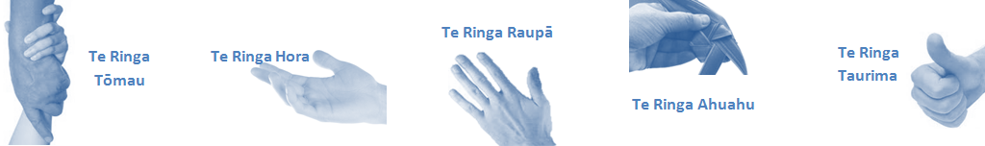

| **Capabilities** | **Capability Definition** | **Achievement Indicators** |
| --- | --- | --- |
| **Communication and Personal Interaction**  **Te Ringa Hora**  ***the open hand (denoting someone who is sociable)*** | Communicates relevant information in a timely manner to those who need to know at a level that is understood. | * Transfers information effectively verbally and writes clearly, coherently and succinctly. * Shares well thought out, concise and timely information with others using appropriate mediums. * Organisational updates are provided to staff by way of relaying in general terms but more importantly what affect it has on the unit and how staff can help where necessary to achieve any requirements. * Builds team spirit, facilitates resolution of conflict within the team, promotes/protects team reputation, shows commitment to contributing to the teams’ success. * Maintains and promotes high standards of social, ethical and organisational norms. |
| Fosters a team environment and encourages collaboration between team and departments within Lakes. | * Articulates differing perspectives on an issue and can see the merit of alternative points of view. * Works with other managers and teams to streamline processes for the best efficiency for both teams. * Provides staff who have concerns about another team process, a different point of view to consider. |
| Connects with people to build trust and confidence. | * Connects with others, listens, reads people and situations and communicates tactfully. * Gets to know their team members and treats them with respect, valuing their individuality and contributions. |
| **Strategy & Performance**  **Te Ringa Raupā**  ***the roughened hand (symbolising a hard worker)*** | Delegates appropriately within team utilising individual skills to achieve results. | * Understands individuals’ strengths and weaknesses to utilise or increase skills for those individuals. * Assigns and sub-delegates staff to teams to allow for development and succession planning. |
| Understands the unit requirements and the implications of the units achievements on the overall service delivery. | * Ensures decision making complies with organisational strategies. * Recognises decisions made within the unit affect overall results of the service and Lakes. * Works with Service Manager to maximise unit efficiency. |
| **Development and Change**  **Te Ringa Ahuahu**  ***the hand that shapes or fashions something (refers to someone who is innovative)*** | Works to include staff in change minimising barriers to implementation. | * Questions traditional ways of doing things when choosing a course of action or finds new combinations of old elements to form an innovative solution. * Continually strives for new and improved work processes that will result in greater effectiveness and efficiencies. * Openly broaches concern with staff from the outset asking for their ideas and input. * Gives examples of what might help to resolve the issue/concern. * Seeks opportunities to improve performance and seeks feedback to measure and improve. * Encourages staff participation in possible solution process. * Allows staff input to possible solutions to concern. * Gives careful consideration to staff ideas and offers alterations to suggestions where necessary. |
| Articulates decisions and reasoning behind change enable buy-in to results. | * Develops an informative response to the team including trends, data, process and benefits of the decided process/change. * Allows feedback to decision to enable ‘tinkering’ to be made where appropriate. |
| **Personal Accountability**  **Te Ringa Tōmau**  ***the hand that is trustworthy*** | Manages own and encourages others to foster work/life balance. | * Ensures regular breaks are taken and own annual leave accruals are used within the 12 months following accrual. * Ensures employees within their service are taking regular annual leave breaks for the purpose of rest/recreation throughout the year. |
| Actively manages own career aspirations and development. | * Is constantly striving to acquire and maintain knowledge, skills and/or experience. * Has own career development plan and succession planning. * Seeks out development opportunities to expand knowledge and capability. * Engages in projects and activities readily which are above and beyond scope of current role. |
| **Culture and Values**  **Te Ringa Taurima**  ***the hand that nurtures, encourages, supports*** | Makes decisions based on facts and without personal bias. | * Is proactive and effective when problem solving is required. * Engages with staff member/managers/multi-disciplinary team when concerns are raised to best understand their point of view. * Appropriately investigates the concern looking at trends, situation and practices. * Critically examines repeatable risk factors. |
| Engages with mentors and supervisors for personal skill development. | * Is constantly striving to acquire and maintain knowledge, skills and/or experience. * Demonstrates a commitment to and takes responsibility for going professional development. |
| Plans, prioritises and organises work to deliver on short and long term goals. | * Purposeful about where time is invested. * Delivers relevant results within expected timeframes. |
| Encourages and promotes Lakes values and expectations. | * Role models expected behaviours and practices. * Treats staff, patients and visitors with dignity and respect. * Uses appropriate empathy to gain organisational objectives. * Is solution focused. |

| **Compulsory Requirements** | **Description** | **Expected Outcomes** |
| --- | --- | --- |
| **Māori Health** | Māori philosophies and values of health are demonstrated in work practice. | * Meaningful relationships are established with Te Aka Matua (Rotorua and Taupo Hospitals) and Te Whatu Ora Lakes Maori Health division in the planning and delivery of services. * Practices are consistent with Te Tiriti o Waitangi /The Treaty of Waitangi when working with Māori. * Delivery of safe services for Māori are facilitated by ensuring they can access treatment options and are involved in the planning and delivery of their care. * Māori are enabled to access and participate in cultural activities provided by the Te Whatu Ora Lakes. * A commitment to improving the wellbeing of Māori by increasing cultural knowledge in the Te Whatu Ora Lakes is shown. |
| **Te Iti Kahurangi** | The Lakes Way, Our Place Our Culture | * Works within the Te Iti Kahurangi framework and supporting guide document. |
| **Record Keeping** |  | * Complies with the Te Whatu Ora Lakes Corporate Records Management policy to create and maintain full and accurate records. |
| **Quality & Risk** | Patient safety is paramount to the service we deliver at Te Whatu Ora Lakes. This is to be achieved in a clinical governance framework that is culturally responsive and identifies and manages risk and opportunities to improve. | * Employees are supported to lead by example and implement a culture of continuous quality improvement. * Risks that may prevent Te Whatu Ora Lakes from achieving their goals are identified, reported, and managed. * Māori patients are provided patient-centred care to achieve positive Māori health outcomes. * Needs of Māori are reviewed and reported in the further development of practice, process and or policy. * Evidence-based methodologies are used to support improvements, e.g. kaupapa Māori methodology. * Quality care is provided to certification standards. |
| **Health & Safety** | Each individual is responsible for ensuring the safety of themselves, their colleagues, patients and their visitors and to comply with all organisational health and safety policies, procedures and guidelines. | * Implementation and reinforcement of a proactive healthy work place culture which reflects relevant Te Whatu Ora Lakes policy and legislative requirements. * Healthy lifestyles are actively promoted and participated in, within the work area. * Employees participate in Health and Safety within areas of work. * Health and Safety activities are appropriately documented within specified timeframes. * Health and Safety policies have been read and understood and are applied in the workplace. * Health and Safety policies are appropriately documented within specified timeframes and incidents are reported immediately. * Any opportunities for improving Health and Safety are reported and acted upon in a timely manner. * All near misses/incident/accidents are reported to the appropriate line manager within 24 hours. |

**Signatures:**

|  |  |
| --- | --- |
| Line Manager:  (position description approved): |  |
| Employee:  (acceptance of position description): |  |

*(Please also initial all other pages to show acceptance of position description.)*

|  |  |  |
| --- | --- | --- |
| **Person Specification** | **Essential:** | **Desirable:** |
| **Education and Qualifications:** |  | * NZDA or AUT Dental Assistants Certificate (or be willing to undertake this course of study) |
| **Experience:** | * Education * Promotion | * Previous Dental Assistance Experience or other related dental positions. |
| **Knowledge:** | * Te Tiriti O Waitangi in the provision of health care services and support to Māori. * Te Tiriti O Waitangi in practice, process, policy development and decision making. * Te Whatu Ora Lakes is a Reorua organisation knowledge and understanding of Te Reo/ Correct pronunciation. * Health Practitioners Competence Assurance Act (2003) * Code of Health and Disability Services Consumers Rights (1996) * Current New Zealand Health Structure * Privacy Act (1993) and Health Information Privacy Code (1994) * Health and Safety in Employment Act (1992) * Accreditation Standards for Health and Disability Support Services and Quality Health NZ |  |
| **Skills:** | * Proficiency in Te Reo Māori * Ability to apply Te Ao Māori culture and practices * Sound interpersonal skills and the ability to communicate successfully with a wide range of people. * Good standard of written skills. * High standard of organisational skills. * Ability to work in a team model. * Demonstrated commitment to cultural safety. * Demonstrated ability to relate well to young children. * Demonstrated ability to relate well to adolescents. * Computer literate in Word, Excel and Outlook. | * Fluent in Te Reo Māori |
| **Personal Attributes:** | * Demonstrate a desire to improve oral health awareness in the targeted client group. * Demonstrated regard for cultural values to achieve health outcomes. * Ability to work as part of a team and independently. * Commitment to on-going professional development. * Must meet all conditions under a Worker Safety Check (requirement of the Vulnerable Children’s Act). * Dependable self-reliant attitude to work. * Understand needs of children, their families and whanau. * Ability to be smoke free at work. * Professional appearance is maintained at all times. * Current drivers’ license with no restrictions. | * Non-smoker preferred. |

**ABOUT TE WHATU ORA LAKES**

At Te Whatu Ora Lakes we place the highest value on the health and wellbeing of everyone in our community. As such all healthcare workers are expected to play a part in the creation and promotion of an environment which lives the following vision, mission and values:

### VISION

Healthy Communities – Mauriora! In this vision Mauriora refers to the Mauri - being the life essence and the source of well-being, and ora - describing the state of wellness.

### STRATEGIC MISSION

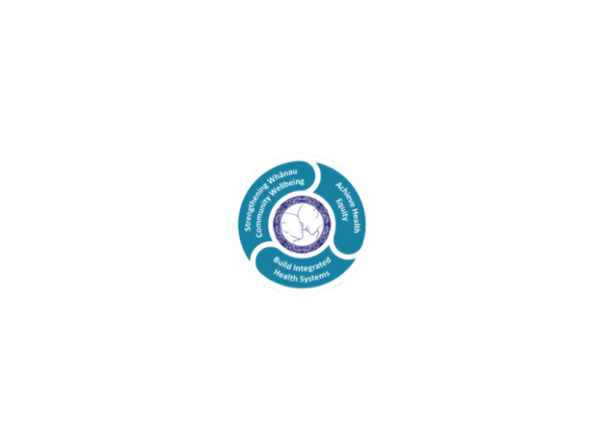

* Achieve equity in Māori health
* Build an Integrated health system
* Strengthen people, whanau & community wellbeing

### THREE CORE VALUES

Manaakitanga respect and acknowledgment of each other’s intrinsic value and contribution

Integrity truthfully and consistently acting collectively for the common good

Accountability collective and individual ownership for clinical and financial outcomes and sustainability

### TE ITI KAHURANGI – THE LAKES WAY, OUR PLACE, OUR CULTURE – WE WILL

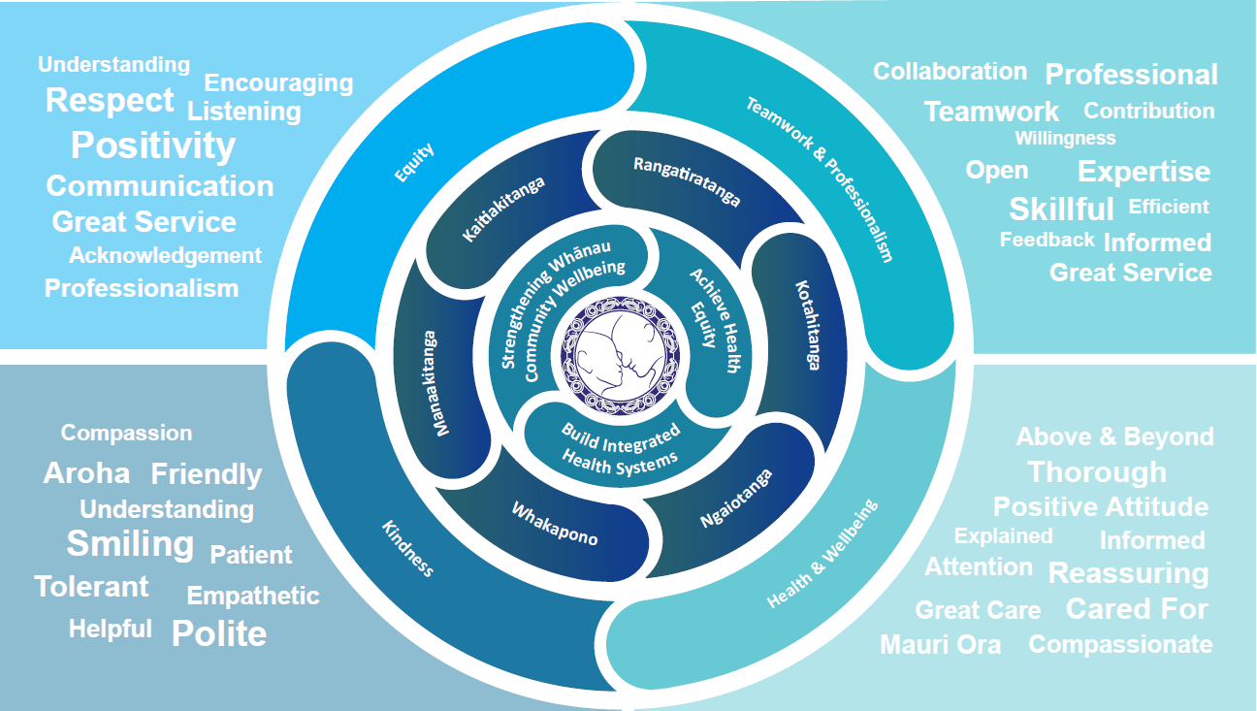

### TE TIRITI O WAITANGI

**Our expression of Te Tiriti o Waitangi**

The text of Te Tiriti, including the preamble and the three articles, along with the Ritenga Māori declaration, are the enduring foundation of our approach to achieving health and independence. Based on these foundations, we will strive to achieve the following four goals, each expressed in terms of mana.

**Mana whakahaere**

Effective and appropriate kaitiakitanga and stewardship over the health and disability system. Mana whakahaere is the exercise of control in accordance with tikanga, kaupapa and kawa Māori. This goes beyond the management of assets and resources and towards enabling Māori aspirations for health and independence.

**Mana motuhake**

Enabling the right for Māori to be Māori (Māori self-determination); to exercise their authority over their lives and to live on Māori terms and according to Māori philosophies, values and practices, including tikanga Māori.

**Mana tangata**

Achieving equity in health and disability outcomes for Māori, enhancing the mana of people across their life course and contributing to the overall health and wellbeing of Māori.

**Mana Māori**

Enabling Ritenga Māori (Māori customary rituals), which are framed by te ao Māori (the Māori world), enacted through tikanga Māori (Māori philosophy and customary practices) and encapsulated within mātauranga Māori (Māori knowledge).

Te Whatu Ora Lakes is committed within the framework of the New Zealand Public Health and Disability Act (2000) to supporting the Crown’s commitment to upholding its Tiriti promises.

### ORGANISATION STRUCTURE

