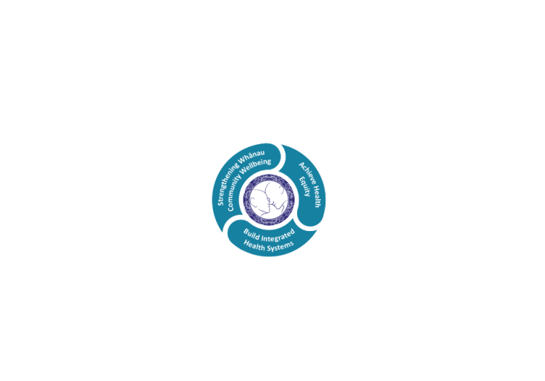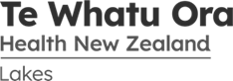

# POSITION DESCRIPTION

|  |  |  |
| --- | --- | --- |
| **Position:** | Medical Radiation Technologist with an extended Scope of Practice in MRI. | |
| **Responsible To:** | Radiology Manager | |
| **Direct Reports:** | Grade MRT | |
| **Location:** | Rotorua & Taupō | |
| **Functional Relationships:** | **Internal**  All Radiology Staff  Clerical Staff  Nursing Staff  Allied Health Staff  Medical Staff  Manawa Pou Staff  Other Departments | **External:**  Patients  Family / Whanau |
| **Financial Delegations:** | Nil | |
| **Date:** | January, 2024 | |

### Primary purpose(s) of the position

* To participate in and support the provision of a quality and timely general Radiology Service to the Rotorua and Taupo communities.
* To participate in the provision of a quality Magnetic Resonance Imaging Service being delivered to the Rotorua and Taupo communities

| **Key Objectives** | **Description** | **Expected Outcomes** |
| --- | --- | --- |
| **General Clinical Practice** | **Is competent and supports patient care and management.** | * Demonstrates a wide skill base in plain radiography * Examinations are carried out according to policy and procedure guidelines * Appropriate documentation is maintained according to LDHB and Department policies * Assists the Radiologist and clinicians with more complex examinations * Clinical practice demonstrates knowledge of radiation protection, QA and infection control requirements * Participates in the evening, on call and weekend rosters for both sites, as required, to enable maintenance of 24-hr 7-day service. |
| **MRI Clinical**  **practice** |  | * Demonstrates in depth knowledge of MRI procedures and techniques, or currently training in the MRI Scope of Practice * Develops a wider base of applied knowledge in MRI * Examinations are carried out according to Policy and procedure guidelines * Maintains appropriate documentation according to Lakes DHB and Department policies * Assists the Radiologists with more complex examinations * Advice and/or assistance are actively sought from the Radiologists. Professional Advisor and Grade MR MRT when required * Clinical practice demonstrates knowledge of MRI safety procedures as appropriate |
| **Communication and Team Work** | **Is an essential requirement towards providing an efficient and professional service.** | * Function as an effective team member and maintain good communication with other team members at all times * Ensures patients/clients are well informed regarding the requested procedure * Patients’ rights to dignity, privacy and confidentiality with all written and computerised information, telephone calls and verbal communication is respected and maintained at all times * Refers potential problems to appropriate co-ordinator * Participates in relevant staff meetings * Provides support for orientation of staff and staff training * Develops a role of responsibility within the department * Promotes health education * Liaises with the Grade MRT MRI, and the Professional Advisor for applications for leave * Liaises with the Taupo Grade, Taupo staff and the Professional Advisor for applications for leave * An efficient service is maintained to meet departmental requirements at all times |
| **Continuous Quality Improvement** | **Is a key aspect for all clinical practitioners.** | * Contributes to policy/protocol research and maintenance as required * Works toward achievement and maintenance of IANZ Accreditation * Participates in Radiology Quality Assurance programme * Maintains all documentation according to department policy * Avails of training opportunities when offered |
| **Professional Development** | **An individual is expected to, and is supported, to maintain own professional development.** | * Has gained, or is working towards Post Graduate qualification in MRI * Commitment to continuing professional development * Knowledge/skills – attributes required for effective performance within the Radiology Department are developed and maintained * Participates in educational programmes both internally and externally * Actively involved in continuing professional development meeting all MRTB requirements. * Documents all continuing education activities * Code of Ethics/Professional standards of conduct are maintained as per the MRTB |

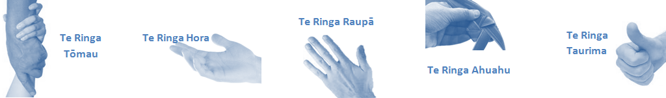

| **Capabilities** | **Capability Definition** | **Achievement Indicators** |
| --- | --- | --- |
| **Communication and Personal Interaction**  **Te Ringa Hora**  ***the open hand (denoting someone who is sociable)*** | Communicates relevant information in a timely manner to those who need to know at a level that is understood. | * Transfers information effectively verbally and writes clearly, coherently and succinctly. * Shares well thought out, concise and timely information with others using appropriate mediums. * Organisational updates are provided to staff by way of relaying in general terms but more importantly what affect it has on the unit and how staff can help where necessary to achieve any requirements. * Builds team spirit, facilitates resolution of conflict within the team, promotes/protects team reputation, shows commitment to contributing to the teams’ success. * Maintains and promotes high standards of social, ethical and organisational norms. |
| Fosters a team environment and encourages collaboration between team and departments within Lakes. | * Articulates differing perspectives on an issue and can see the merit of alternative points of view. * Works with other managers and teams to streamline processes for the best efficiency for both teams. * Provides staff who have concerns about another team process, a different point of view to consider. |
| Connects with people to build trust and confidence. | * Connects with others, listens, reads people and situations and communicates tactfully. * Gets to know their team members and treats them with respect, valuing their individuality and contributions. |
| **Strategy & Performance**  **Te Ringa Raupā**  ***the roughened hand (symbolising a hard worker)*** | Delegates appropriately within team utilising individual skills to achieve results. | * Understands individuals’ strengths and weaknesses to utilise or increase skills for those individuals. * Assigns and sub-delegates staff to teams to allow for development and succession planning. |
| Understands the unit requirements and the implications of the units achievements on the overall service delivery. | * Ensures decision making complies with organisational strategies. * Recognises decisions made within the unit affect overall results of the service and Lakes. * Works with Service Manager to maximise unit efficiency. |
| **Development and Change**  **Te Ringa Ahuahu**  ***the hand that shapes or fashions something (refers to someone who is innovative)*** | Works to include staff in change minimising barriers to implementation. | * Questions traditional ways of doing things when choosing a course of action or finds new combinations of old elements to form an innovative solution. * Continually strives for new and improved work processes that will result in greater effectiveness and efficiencies. * Openly broaches concern with staff from the outset asking for their ideas and input. * Gives examples of what might help to resolve the issue/concern. * Seeks opportunities to improve performance and seeks feedback to measure and improve. * Encourages staff participation in possible solution process. * Allows staff input to possible solutions to concern. * Gives careful consideration to staff ideas and offers alterations to suggestions where necessary. |
| Articulates decisions and reasoning behind change enable buy-in to results. | * Develops an informative response to the team including trends, data, process and benefits of the decided process/change. * Allows feedback to decision to enable ‘tinkering’ to be made where appropriate. |
| **Personal Accountability**  **Te Ringa Tōmau**  ***the hand that is trustworthy*** | Manages own and encourages others to foster work/life balance. | * Ensures regular breaks are taken and own annual leave accruals are used within the 12 months following accrual. * Ensures employees within their service are taking regular annual leave breaks for the purpose of rest/recreation throughout the year. |
| Actively manages own career aspirations and development. | * Is constantly striving to acquire and maintain knowledge, skills and/or experience. * Has own career development plan and succession planning. * Seeks out development opportunities to expand knowledge and capability. * Engages in projects and activities readily which are above and beyond scope of current role. |
| **Culture and Values**  **Te Ringa Taurima**  ***the hand that nurtures, encourages, supports*** | Makes decisions based on facts and without personal bias. | * Is proactive and effective when problem solving is required. * Engages with staff member/managers/multi-disciplinary team when concerns are raised to best understand their point of view. * Appropriately investigates the concern looking at trends, situation and practices. * Critically examines repeatable risk factors. |
| Engages with mentors and supervisors for personal skill development. | * Is constantly striving to acquire and maintain knowledge, skills and/or experience. * Demonstrates a commitment to and takes responsibility for going professional development. |
| Plans, prioritises and organises work to deliver on short and long term goals. | * Purposeful about where time is invested. * Delivers relevant results within expected timeframes. |
| Encourages and promotes Lakes values and expectations. | * Role models expected behaviours and practices. * Treats staff, patients and visitors with dignity and respect. * Uses appropriate empathy to gain organisational objectives. * Is solution focused. |

| **Compulsory Requirements** | **Description** | **Expected Outcomes** |
| --- | --- | --- |
| **Māori Health** | Māori philosophies and values of health are demonstrated in work practice. | * Meaningful relationships are established with Te Aka Matua (Rotorua and Taupo Hospitals) and Te Whatu Ora Lakes Maori Health division in the planning and delivery of services. * Practices are consistent with Te Tiriti o Waitangi /The Treaty of Waitangi when working with Māori. * Delivery of safe services for Māori are facilitated by ensuring they can access treatment options and are involved in the planning and delivery of their care. * Māori are enabled to access and participate in cultural activities provided by the Te Whatu Ora Lakes. * A commitment to improving the wellbeing of Māori by increasing cultural knowledge in the Te Whatu Ora Lakes is shown. |
| **Te Iti Kahurangi** | The Lakes Way, Our Place Our Culture | * Works within the Te Iti Kahurangi framework and supporting guide document. |
| **Record Keeping** |  | * Complies with the Te Whatu Ora Lakes Corporate Records Management policy to create and maintain full and accurate records. |
| **Quality & Risk** | Patient safety is paramount to the service we deliver at Te Whatu Ora Lakes. This is to be achieved in a clinical governance framework that is culturally responsive and identifies and manages risk and opportunities to improve. | * Employees are supported to lead by example and implement a culture of continuous quality improvement. * Risks that may prevent Te Whatu Ora Lakes from achieving their goals are identified, reported, and managed. * Māori patients are provided patient-centred care to achieve positive Māori health outcomes. * Needs of Māori are reviewed and reported in the further development of practice, process and or policy. * Evidence-based methodologies are used to support improvements, e.g. kaupapa Māori methodology. * Quality care is provided to certification standards. |
| **Health & Safety** | Each individual is responsible for ensuring the safety of themselves, their colleagues, patients and their visitors and to comply with all organisational health and safety policies, procedures and guidelines. | * Implementation and reinforcement of a proactive healthy work place culture which reflects relevant Te Whatu Ora Lakes policy and legislative requirements. * Healthy lifestyles are actively promoted and participated in, within the work area. * Employees participate in Health and Safety within areas of work. * Health and Safety activities are appropriately documented within specified timeframes. * Health and Safety policies have been read and understood and are applied in the workplace. * Health and Safety policies are appropriately documented within specified timeframes and incidents are reported immediately. * Any opportunities for improving Health and Safety are reported and acted upon in a timely manner. * All near misses/incident/accidents are reported to the appropriate line manager within 24 hours. |

**Signatures:**

|  |  |
| --- | --- |
| Line Manager:  (position description approved): |  |
| Employee:  (acceptance of position description): |  |

*(Please also initial all other pages to show acceptance of position description.)*

|  |  |  |
| --- | --- | --- |
| **Person Specification** | **Essential:** | **Desirable:** |
| **Education and Qualifications:** | * A qualified Medical Radiation Technologist currently registered with the Medical Radiation Technologists Board. * Actively involved in continuing professional development meeting all MRTB requirements. | * .. |
| **Experience:** | * Demonstrated clinical practice in general radiography. * Demonstrated clinical practice in general and musculo-skeletal MRI scanning * Demonstrated clinical practice in neurological, oncological and vascular MRI scanning desirable | * .. |
| **Knowledge:** | * Te Tiriti O Waitangi in the provision of health care services and support to Māori. * Te Tiriti O Waitangi in practice, process, policy development and decision making. * Te Whatu Ora Lakes is a Reorua organisation knowledge and understanding of Te Reo/ Correct pronunciation. * Involvement with professional organization – NZIMRT | * .. |
| **Skills:** | * Pronunciation of Te Reo Māori words and names * An ability to perform with the minimum of supervision. * Effective communication and interpersonal skills * Effective time management skills * Demonstrated IV cannulation skills desirable | * Te Reo Māori.. |
| **Personal Attributes:** | * Be punctual, enthusiastic and dependable team member. * Commitment to maintaining and extending own level of knowledge. * A commitment to providing quality care and imaging. * Demonstrate cultural sensitivity | * Non-smoker preferred. * Leadership and Supervisor Skills * Driver’s License |

**ABOUT TE WHATU ORA LAKES**

At Te Whatu Ora Lakes we place the highest value on the health and wellbeing of everyone in our community. As such all healthcare workers are expected to play a part in the creation and promotion of an environment which lives the following vision, mission and values:

### VISION

Healthy Communities – Mauriora! In this vision Mauriora refers to the Mauri - being the life essence and the source of well-being, and ora - describing the state of wellness.

### STRATEGIC MISSION

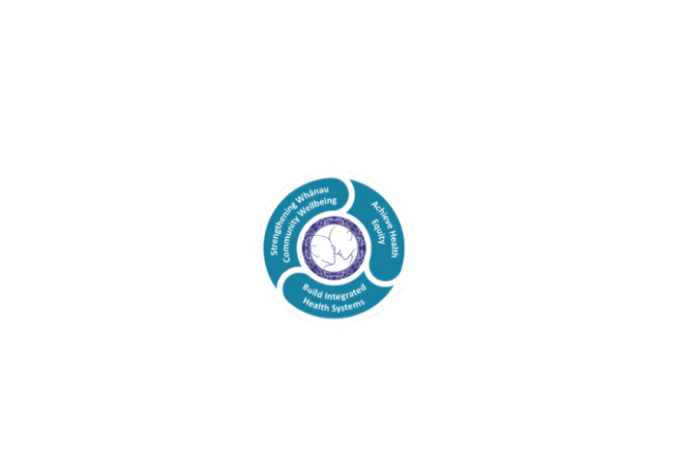

* Achieve equity in Māori health
* Build an Integrated health system
* Strengthen people, whanau & community wellbeing

### THREE CORE VALUES

Manaakitanga respect and acknowledgment of each other’s intrinsic value and contribution

Integrity truthfully and consistently acting collectively for the common good

Accountability collective and individual ownership for clinical and financial outcomes and sustainability

### TE ITI KAHURANGI – THE LAKES WAY, OUR PLACE, OUR CULTURE – WE WILL

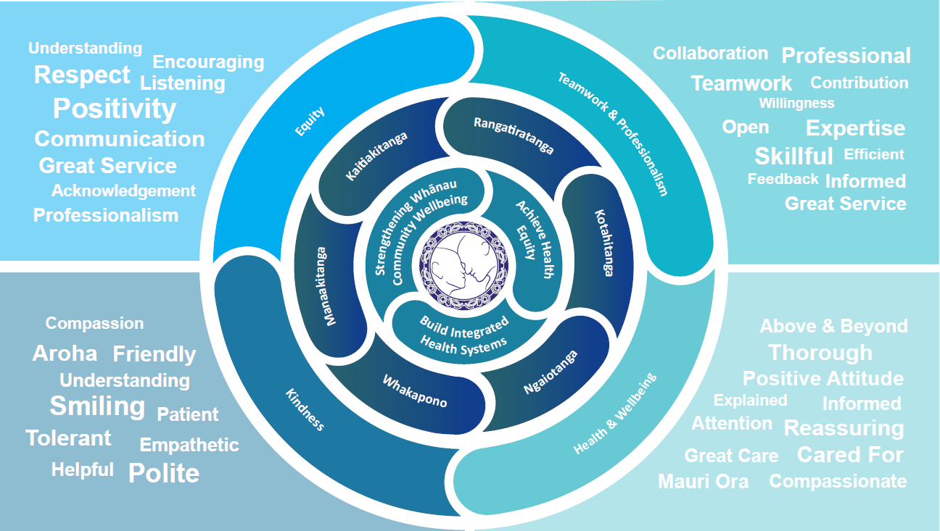

### TE TIRITI O WAITANGI

**Our expression of Te Tiriti o Waitangi**

The text of Te Tiriti, including the preamble and the three articles, along with the Ritenga Māori declaration, are the enduring foundation of our approach to achieving health and independence. Based on these foundations, we will strive to achieve the following four goals, each expressed in terms of mana.

**Mana whakahaere**

Effective and appropriate kaitiakitanga and stewardship over the health and disability system. Mana whakahaere is the exercise of control in accordance with tikanga, kaupapa and kawa Māori. This goes beyond the management of assets and resources and towards enabling Māori aspirations for health and independence.

**Mana motuhake**

Enabling the right for Māori to be Māori (Māori self-determination); to exercise their authority over their lives and to live on Māori terms and according to Māori philosophies, values and practices, including tikanga Māori.

**Mana tangata**

Achieving equity in health and disability outcomes for Māori, enhancing the mana of people across their life course and contributing to the overall health and wellbeing of Māori.

**Mana Māori**

Enabling Ritenga Māori (Māori customary rituals), which are framed by te ao Māori (the Māori world), enacted through tikanga Māori (Māori philosophy and customary practices) and encapsulated within mātauranga Māori (Māori knowledge).

Te Whatu Ora Lakes is committed within the framework of the New Zealand Public Health and Disability Act (2000) to supporting the Crown’s commitment to upholding its Tiriti promises.

### ORGANISATION STRUCTURE

