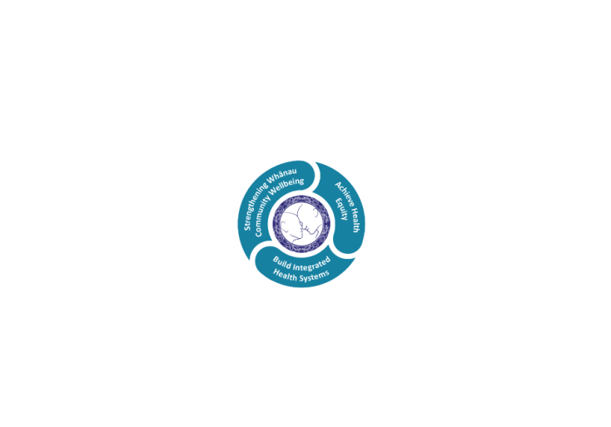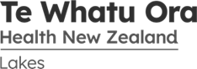

# POSITION DESCRIPTION

|  |  |  |
| --- | --- | --- |
| **Position:** | Rotational Occupational Therapist – Rotorua | |
| **Responsible To:** | Team Leader Occupational Therapy  Professional Advisor, Occupational Therapy - Rotorua. | |
| **Direct Reports:** | Nil | |
| **Location:** | Rotorua | |
| **Functional Relationships:** | **Internal:**  Senior Occupational Therapy  Occupational Therapy staff  Clerical Staff  Allied Health Staff  Medical and Nursing Staff  Professional Advisor Occupational Therapy | **External**:  Patients/carers/family/whanau  District Nursing Service  General medical Practitioners  Private Hospitals & Residential Care Facilities  Community Agencies. |
| **Financial Delegations:** | Nil | |
| **Date:** | August 2024 | |

### Primary purpose(s) of the position

### Provision of effective Occupational Therapy Services within Rotorua Hospital across the Rotational Clinical services.

| **Key Objectives** | **Description** | **Expected Outcomes** |
| --- | --- | --- |
| **To provide safe and appropriate occupational therapy for patients/clients** | Professional Standards of Practice for Occupational Therapy  Client/Patient Rights  Professional supervision, coaching and peer review | * Adherence to Standards of Practice for Occupational Therapy Process within the service area (referral, screening, assessment, planning, intervention, discharge). * Adherence to documentation Standards of Practice within the service area. * Adherence to the New Zealand Occupational Therapy Board Code of Ethics. * Adherence to the Occupational Therapy Board’s, Scope of practice with Health Practitioners Competency Assurance Act (2004) requirements. * Awareness of client/ patient rights is maintained and demonstrated in accordance with the Health and Disability Commissioner Act (1996) and Code of Health and Disability Consumer Rights, and the Privacy Act (1993). * Responsibility is taken for identifying own issues and needs for supervision and coaching, and adherence to requirements set by the OTBNZ. * Effective utilisation of supervision and coaching for staff. * Effective participation in occupational therapy peer review programme. |
| **To assist in effective delivery of occupational therapy services within service area** | Communication regarding provision of occupational therapy services.  Own workload management | * Relationships and communication with other staff, services and agencies, for co-ordination of service delivery. * Plans for improvement are implemented in consultation with Senior Occupational Therapist. * Recommendations are made to Senior Occupational Therapist regarding service changes and development. * Workload priorities are established and maintained for self in service area. |
| **To represent Occupational Therapy effectively** | Representation of occupational therapy  (Read in conjunction with Communication and Personal Interaction Capability and Strategy & Performance Capability below | * Occupational therapy is effectively represented at relevant service meetings when required. * Service issues, professional issues, objectives and performance indicators are discussed with the senior therapist. * Participation in education for other staff or groups as required by the senior therapist. * Active participation in monthly professional meetings. * Relevant projects are participated in, as required by the senior occupational therapist. * The occupational therapy role is promoted within the service area, in conjunction with the senior occupational therapist. * Professional Standards are promoted through behaviour, presentation, competent practice and initiative. |
| **To maintain Professional development of self and contribute to the professional development of others.** | Professional Development of self  (Read in conjunction with Personal Accountability Capability below)  Professional development of other Occupational Therapy staff and students | * Achievement of personal professional development objectives. * Agreement and achievement of annual performance objectives * Contribution to the staff development/ in-service programme. * Offers of clinical placements within service area are made for students via Senior /Professional Advisor. * Clinical supervision is provided for occupational therapy students in line with the requirements of the Occupational Therapy School. |
| **To assist with Management of Resources.** | Utilisation of Occupational Therapy support staff  Statistics completed  Utilisation of work areas | * Where relevant, occupational therapy assistant, clerical Staff and attendant are effectively utilised to support provision of services. * Accurate and timely statistics are maintained within the service area as required. * Recommendations are made for additional resource requirements for the service area. * Facilities and equipment are effectively utilised. * Work areas are organised, maintained and presented for effective use. * Equipment is maintained in a safe and working condition. |
| **Utilisation of Telehealth** | Health care is delivered using digital technology where participants may be separated by time and/or distance | ALLIED STAFF   * Service provision is in line with the New Zealand Health Strategy and the New Zealand Allied Health Best Practice Guide for Telehealth to provide care “closer to home”. * Patient centric care which will give patients the option of telephone or video appointments where there is no need for an in-person appointment. |

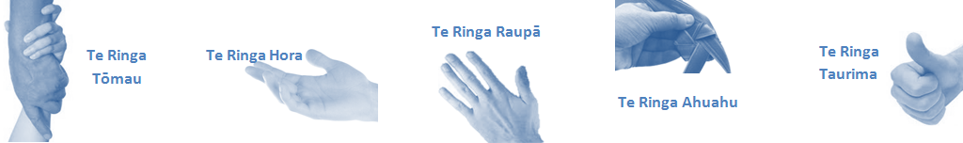

| **Capabilities** | **Capability Definition** | **Achievement Indicators** |
| --- | --- | --- |
| **Communication and Personal Interaction**  **Te Ringa Hora**  ***the open hand (denoting someone who is sociable)*** | Communicates relevant information in a timely manner to those who need to know at a level that is understood. | * Transfers information effectively verbally and writes clearly, coherently and succinctly. * Shares well thought out, concise and timely information with others using appropriate mediums. * Organisational updates are provided to staff by way of relaying in general terms but more importantly what affect it has on the unit and how staff can help where necessary to achieve any requirements. * Builds team spirit, facilitates resolution of conflict within the team, promotes/protects team reputation, shows commitment to contributing to the teams’ success. * Maintains and promotes high standards of social, ethical and organisational norms. |
| Fosters a team environment and encourages collaboration between team and departments within Lakes. | * Articulates differing perspectives on an issue and can see the merit of alternative points of view. * Works with other managers and teams to streamline processes for the best efficiency for both teams. * Provides staff who have concerns about another team process, a different point of view to consider. |
| Connects with people to build trust and confidence. | * Connects with others, listens, reads people and situations and communicates tactfully. * Gets to know their team members and treats them with respect, valuing their individuality and contributions. |
| **Strategy & Performance**  **Te Ringa Raupā**  ***the roughened hand (symbolising a hard worker)*** | Delegates appropriately within team utilising individual skills to achieve results. | * Understands individuals’ strengths and weaknesses to utilise or increase skills for those individuals. * Assigns and sub-delegates staff to teams to allow for development and succession planning. |
| Understands the unit requirements and the implications of the units achievements on the overall service delivery. | * Ensures decision making complies with organisational strategies. * Recognises decisions made within the unit affect overall results of the service and Lakes. * Works with Service Manager to maximise unit efficiency. |
| **Development and Change**  **Te Ringa Ahuahu**  ***the hand that shapes or fashions something (refers to someone who is innovative)*** | Works to include staff in change minimising barriers to implementation. | * Questions traditional ways of doing things when choosing a course of action or finds new combinations of old elements to form an innovative solution. * Continually strives for new and improved work processes that will result in greater effectiveness and efficiencies. * Openly broaches concern with staff from the outset asking for their ideas and input. * Gives examples of what might help to resolve the issue/concern. * Seeks opportunities to improve performance and seeks feedback to measure and improve. * Encourages staff participation in possible solution process. * Allows staff input to possible solutions to concern. * Gives careful consideration to staff ideas and offers alterations to suggestions where necessary. |
| Articulates decisions and reasoning behind change enable buy-in to results. | * Develops an informative response to the team including trends, data, process and benefits of the decided process/change. * Allows feedback to decision to enable ‘tinkering’ to be made where appropriate. |
| **Personal Accountability**  **Te Ringa Tōmau**  ***the hand that is trustworthy*** | Manages own and encourages others to foster work/life balance. | * Ensures regular breaks are taken and own annual leave accruals are used within the 12 months following accrual. * Ensures employees within their service are taking regular annual leave breaks for the purpose of rest/recreation throughout the year. |
| Actively manages own career aspirations and development. | * Is constantly striving to acquire and maintain knowledge, skills and/or experience. * Has own career development plan and succession planning. * Seeks out development opportunities to expand knowledge and capability. * Engages in projects and activities readily which are above and beyond scope of current role. |
| **Culture and Values**  **Te Ringa Taurima**  ***the hand that nurtures, encourages, supports*** | Makes decisions based on facts and without personal bias. | * Is proactive and effective when problem solving is required. * Engages with staff member/managers/multi-disciplinary team when concerns are raised to best understand their point of view. * Appropriately investigates the concern looking at trends, situation and practices. * Critically examines repeatable risk factors. |
| Engages with mentors and supervisors for personal skill development. | * Is constantly striving to acquire and maintain knowledge, skills and/or experience. * Demonstrates a commitment to and takes responsibility for going professional development. |
| Plans, prioritises and organises work to deliver on short and long term goals. | * Purposeful about where time is invested. * Delivers relevant results within expected timeframes. |
| Encourages and promotes Lakes values and expectations. | * Role models expected behaviours and practices. * Treats staff, patients and visitors with dignity and respect. * Uses appropriate empathy to gain organisational objectives. * Is solution focused. |

| **Compulsory Requirements** | **Description** | **Expected Outcomes** |
| --- | --- | --- |
| **Māori Health** | Māori philosophies and values of health are demonstrated in work practice. | * Meaningful relationships are established with Te Aka Matua (Rotorua and Taupo Hospitals) and Te Whatu Ora Lakes Maori Health division in the planning and delivery of services. * Practices are consistent with Te Tiriti o Waitangi /The Treaty of Waitangi when working with Māori. * Delivery of safe services for Māori are facilitated by ensuring they can access treatment options and are involved in the planning and delivery of their care. * Māori are enabled to access and participate in cultural activities provided by the Te Whatu Ora Lakes. * A commitment to improving the wellbeing of Māori by increasing cultural knowledge in the Te Whatu Ora Lakes is shown. |
| **Te Iti Kahurangi** | The Lakes Way, Our Place Our Culture | * Works within the Te Iti Kahurangi framework and supporting guide document. |
| **Record Keeping** |  | * Complies with the Te Whatu Ora Lakes Corporate Records Management policy to create and maintain full and accurate records. |
| **Quality & Risk** | Patient safety is paramount to the service we deliver at Te Whatu Ora Lakes. This is to be achieved in a clinical governance framework that is culturally responsive and identifies and manages risk and opportunities to improve. | * Employees are supported to lead by example and implement a culture of continuous quality improvement. * Risks that may prevent Te Whatu Ora Lakes from achieving their goals are identified, reported, and managed. * Māori patients are provided patient-centred care to achieve positive Māori health outcomes. * Needs of Māori are reviewed and reported in the further development of practice, process and or policy. * Evidence-based methodologies are used to support improvements, e.g. kaupapa Māori methodology. * Quality care is provided to certification standards. |
| **Health & Safety** | Each individual is responsible for ensuring the safety of themselves, their colleagues, patients and their visitors and to comply with all organisational health and safety policies, procedures and guidelines. | * Implementation and reinforcement of a proactive healthy work place culture which reflects relevant Te Whatu Ora Lakes policy and legislative requirements. * Healthy lifestyles are actively promoted and participated in, within the work area. * Employees participate in Health and Safety within areas of work. * Health and Safety activities are appropriately documented within specified timeframes. * Health and Safety policies have been read and understood and are applied in the workplace. * Health and Safety policies are appropriately documented within specified timeframes and incidents are reported immediately. * Any opportunities for improving Health and Safety are reported and acted upon in a timely manner. * All near misses/incident/accidents are reported to the appropriate line manager within 24 hours. |

**Signatures:**

|  |  |
| --- | --- |
| Line Manager:  (position description approved): |  |
| Employee:  (acceptance of position description): |  |

*(Please also initial all other pages to show acceptance of position description.)*

|  |  |  |
| --- | --- | --- |
| **Person Specification** | **Essential:** | **Desirable:** |
| **Education and Qualifications:** | * .. | * .. |
| **Experience:** | * .. | * .. |
| **Knowledge:** | * Te Tiriti O Waitangi in the provision of health care services and support to Māori. * Te Tiriti O Waitangi in practice, process, policy development and decision making. * Te Whatu Ora Lakes is a Reorua organisation knowledge and understanding of Te Reo/ Correct pronunciation. | * .. |
| **Skills:** | * Pronunciation of Te Reo Māori words and names * .. | * Te Reo Māori * .. |
| **Personal Attributes:** | * .. | * Non-smoker preferred. * .. |

**ABOUT TE WHATU ORA LAKES**

At Te Whatu Ora Lakes we place the highest value on the health and wellbeing of everyone in our community. As such all healthcare workers are expected to play a part in the creation and promotion of an environment which lives the following vision, mission and values:

### VISION

Healthy Communities – Mauriora! In this vision Mauriora refers to the Mauri - being the life essence and the source of well-being, and ora - describing the state of wellness.

### STRATEGIC MISSION

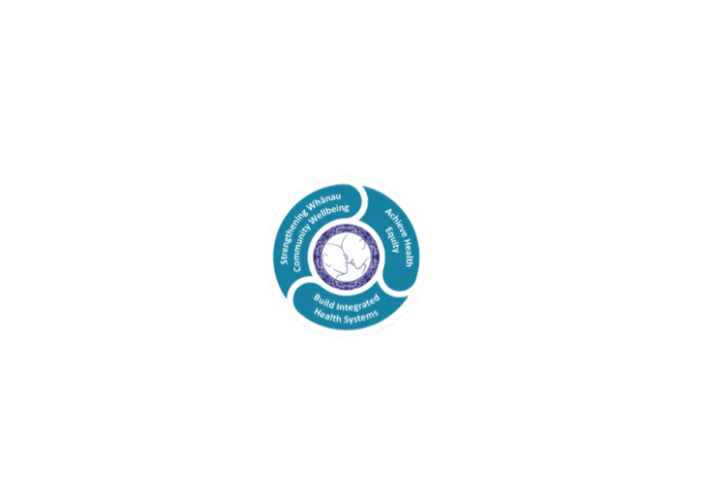

* Achieve equity in Māori health
* Build an Integrated health system
* Strengthen people, whanau & community wellbeing

### THREE CORE VALUES

Manaakitanga respect and acknowledgment of each other’s intrinsic value and contribution

Integrity truthfully and consistently acting collectively for the common good

Accountability collective and individual ownership for clinical and financial outcomes and sustainability

### TE ITI KAHURANGI – THE LAKES WAY, OUR PLACE, OUR CULTURE – WE WILL

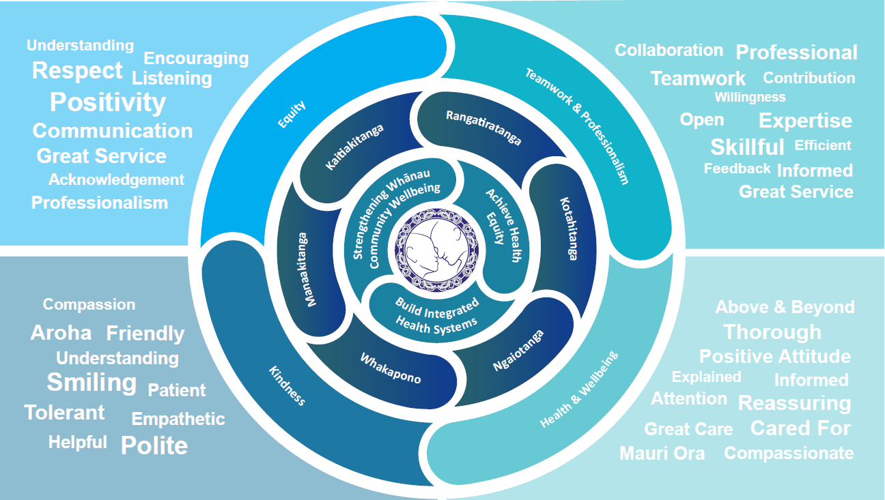

### TE TIRITI O WAITANGI

**Our expression of Te Tiriti o Waitangi**

The text of Te Tiriti, including the preamble and the three articles, along with the Ritenga Māori declaration, are the enduring foundation of our approach to achieving health and independence. Based on these foundations, we will strive to achieve the following four goals, each expressed in terms of mana.

**Mana whakahaere**

Effective and appropriate kaitiakitanga and stewardship over the health and disability system. Mana whakahaere is the exercise of control in accordance with tikanga, kaupapa and kawa Māori. This goes beyond the management of assets and resources and towards enabling Māori aspirations for health and independence.

**Mana motuhake**

Enabling the right for Māori to be Māori (Māori self-determination); to exercise their authority over their lives and to live on Māori terms and according to Māori philosophies, values and practices, including tikanga Māori.

**Mana tangata**

Achieving equity in health and disability outcomes for Māori, enhancing the mana of people across their life course and contributing to the overall health and wellbeing of Māori.

**Mana Māori**

Enabling Ritenga Māori (Māori customary rituals), which are framed by te ao Māori (the Māori world), enacted through tikanga Māori (Māori philosophy and customary practices) and encapsulated within mātauranga Māori (Māori knowledge).

Te Whatu Ora Lakes is committed within the framework of the New Zealand Public Health and Disability Act (2000) to supporting the Crown’s commitment to upholding its Tiriti promises.

### ORGANISATION STRUCTURE

