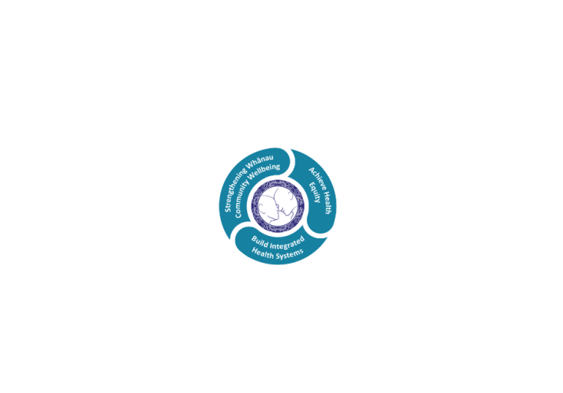

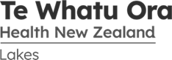

# POSITION DESCRIPTION

|  |  |  |
| --- | --- | --- |
| **Position**: | Physician Secretary | |
| **Responsible to:** | Medicine Service | |
| **Direct Reports:** | Admin Team Leader | |
| **Location:** | Rotorua | |
| **Functional relationships:** | **Internal:**  Service Manager  CD/HOD, Internal Medicine  P.A. to Service Manager  Physicians  Medicine Admin Team  Medicine Transcriptionists  Clinical Nurse Managers  Clinical Nurse Specialists  Allied Health Team Leaders  Management Accountant  Medical Management Unit  Medical Registrars  Ambulatory Service  Laboratory Service  Radiology Department  Emergency Department  Spotless Service  Inpatient Units  Elective Services  Referral Centre  Te Aka Matua Kaupapa  Clinical Records  Stores/Purchasing  Facilities  All other customers and clients of the service | **External**:  General Practices/Health Centres  Patients  QE Hospital  Lakes Prime Care  Private Providers  Other DHBs. |
|  |  | |
| **Date**: | August 2022. | |

### Primary purpose(s) of the position

To provide administration and functional support for Physicians in all areas other than direct patient interaction, by ensuring that all information systems are maintained and all administrative activities are coordinated in a professional and timely way. This includes word processing, filing, organisation of meetings and other activities

|  |  |  |
| --- | --- | --- |
| **Key Objectives** | Description | Expected Outcomes |
| **Administrative & Clerical support** | To provide a confidential, comprehensive and professional administrative service to the Consultant Physicians, Medicine Service | * Secretarial duties for CD, HOD – Internal Medicine / Rehab Services & Director for Medical Education for Medicine, * Assists with compilation, typing and circulation of Physician rosters incorporating leave (Holiday, CME, Sick & Professional mtg) into timetable and make necessary alterations to fixed sessions when they occur. * Supports the Director of Education with the programme and processes for Medical Junior Doctors – RMOs & HO. * Co-ordinates travel arrangements and booking of cars through Fleetwise for Physicians. * Support for Physician meetings is provided. Agenda items are requested and emailed out prior to meeting. Minutes of meeting typed and circulated once approved by chair of meeting. * Support for Motor Neurone Disease meetings. Agenda items are requested and emailed out prior to meeting. Minutes of meeting typed and circulated once approved by chair of meeting. * Support for MDM meetings. * Supports Hon Secretary/Treasurer. * Coordinates with physicians regarding individual outlook.. * Collates received results from Clinical Physiology and Radiology ensuring all relevant information is retrieved prior to giving to Physician concerned. * To provide, as required a consistently high standard of typing for physicians. * Word processing to be appropriately formatted including edited where necessary. * All patient-related information transcribed is accurately electronically uploaded into the CIS system as soon as verified by physician. * Clinic schedules are maintained and updated on database and appropriate parties informed. * Physicians planned outpatient lists are checked regularly with outcome sent to Ambulatory Service booking clerks. * When isolated results are sent to the Consultant these will be married to the appropriate correspondence for Consultant review. * To obtain notes/correspondence as requested to allow proper assessment of results. * To chase up and find investigation results and correspondence from other hospitals/private clinics. Compilation of patient information for private versus public funding for tests ie CT, MRI etc * To chase up and determine why (certain investigations have not occurred). * To book clinical cases to Radiology/Histology meetings as requested. * Circulates documents for information and/or comment. * Assist in the preparation of work for medical audit, research and related matters. * Reports, correspondence, photocopying and faxes are returned / distributed as necessary in the approved manner and within the allotted time. * Maintain incoming and outgoing paper documentation from Physician inbox and outbox. * To open and prepare all correspondence for consultant action. If correspondence refers to notes, results, letters etc that are not available these will be obtained and prepared in readiness for the consultant. * Referral allocation is compiled and referrals triaged by appropriate physician for sub specialty. * Monitor TIA email group and ensure referrals have been triaged. * Liaises with Elective Services administrator to support Endoscopy theatre lists. * Liaises with outpatient administrator to support improved ambulatory patient flow. * Liaises with Medical Management Unit to ensure weekly allocation of Registrars and HO. * Attends Administrative team meetings. * Support for Family Meeting, booking an prepping of room, liaising with the families and SMO’s, requesting patient files and relevant documentation needed. Partaking and minuting meeting. * A high degree of confidentiality is maintained. * Compilation of information for insurance companies of overseas patients hospital events, involving the physician. |
| Systems support | To ensure all information, filing and office systems are developed and maintained for the effective management of the Physician team. The work of the service is organised according to priorities, and is carried out effectively. | * Supports Physicians electronic diaries/email. * Proactively streamlines doctors work processes. * Office procedures and systems are developed, followed and maintained/updated in an accessible, current and readily retrievable manner. * System problems are identified and remedied as a priority. * Information databases are maintained as requested. * Electronic requisitions are raised according to Lakes District Health Board policy and within budget. * The medicine office environment is maintained at a professional level at all times. * Ensure patient files are tracked back electronically to Clinical Records. * All patient-related information transcribed is accurately electronically maintained in typing log book. * That procedure’s which are established to evaluate the quality of service is provided. * Must adhere to written policies and procedures which reflect current organisational standard and guidelines. * IS support for any computer issues for Physicians. I.e. access issues, remote access etc |
| General Duties | Provide administrative support as required | * Assist Medical typists with typing when able. * Undertakes administrative tasks by the Admin Team Leader and Service Manager, as may reasonably be requested. * Maintain a complete and up-to-date desk file for the position. * To forward new special authority numbers obtained from PHARMAC to the appropriate GP, patient and pharmacy etc * To find PHARMAC special authority numbers when they have been lost. * Requests for completion of forms for WINZ, ACC, Mobility Parking Stickers, Taxi vouchers, Medic alert bracelets, pendant alarms etc. * Kitchen provisions and office supplies are maintained at efficient levels. * Cover for Admin Team Leader role as required |
| Professional Development | Assumes responsibility for own development and education needs | * Own skills and knowledge updated as required. * Attends educational programmes to update and increase knowledge. * Attends courses as opportunity allows. * Gains further skills as required for the service and LDHB. * Performance Review undertaken with Admin Team Leader, Medicine Services |
| **Utilisation of Telehealth** | **Health care is delivered using digital technology where participants may be separated by time and/or distance** | * Service provision is in line with the New Zealand Health Strategy and the NZ Medical Council guidelines to provide care “closer to home” * Provision of patient centric care which will give patients the option of telephone or video appointments where there is no need for an in-person appointment. * Advise patients in the use of telemonitoring devices (where appropriate) and provide follow-up care to prevent unnecessary hospital admissions   ADMINISTRATION STAFF   * Scheduling appointments in-person, by phone, video, non-contact FSA’s and Telemonitoring and selection of the correct “mode of delivery” in the patient management system |

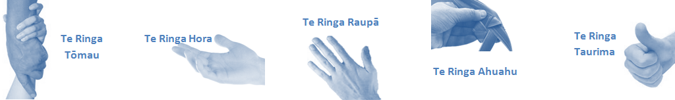

|  |  |  |
| --- | --- | --- |
| **Capabilities** | Capability definition | Achievement Indicators |
| **Communication and Personal Interaction**  **Te Ringa Hora**  ***the open hand (denoting someone who is sociable)*** | Communicates relevant information in a timely manner to those who need to know at a level that is understood. | * Transfers information effectively verbally and writes clearly, coherently and succinctly. * Shares well thought out, concise and timely information with others using appropriate mediums. * Organisational updates are provided to staff by way of relaying in general terms but more importantly what affect it has on the unit and how staff can help where necessary to achieve any requirements. * Builds team spirit, facilitates resolution of conflict within the team, promotes/protects team reputation, shows commitment to contributing to the teams success. * Maintains and promotes high standards of social, ethical and organisational norms. |
| Fosters a team environment and encourages collaboration between team and departments within the DHB. | * Articulates differing perspectives on an issue and can see the merit of alternative points of view. * Works with other managers and teams to streamline processes for the best efficiency for both teams. * Provides staff who have concerns about another team process, a different point of view to consider. |
| Connects with people to build trust and confidence. | * Connects with others, listens, reads people and situations and communicates tactfully. * Gets to know their team members and treats them with respect, valuing their individuality and contributions. |
| **Strategy & Performance**  **Te Ringa Raupā**  ***the roughened hand (symbolising a hard worker)*** | Delegates appropriately within team utilising individual skills to achieve results. | * Understands individuals strengths and weaknesses to utilise or increase skills for those individuals. * Assigns and sub-delegates staff to teams to allow for development and succession planning. |
| Understands the unit requirements and the implications of the units achievements on the overall service delivery. | * Ensures decision making complies with organisational strategies. * Recognises decisions made within the unit affect overall results of the service and the DHB. * Works with Service Manager to maximise unit efficiency. |
| **Development and Change**  **Te Ringa Ahuahu**  ***the hand that shapes or fashions something (refers to someone who is innovative)*** | Works to include staff in change minimising barriers to implementation. | * Questions traditional ways of doing things when choosing a course of action or finds new combinations of old elements to form an innovative solution. * Continually strives for new and improved work processes that will result in greater effectiveness and efficiencies. * Openly broaches concern with staff from the outset asking for their ideas and input. * Gives examples of what might help to resolve the issue/concern. * Seeks opportunities to improve performance and seeks feedback to measure and improve. * Encourages staff participation in possible solution process. * Allows staff input to possible solutions to concern. * Gives careful consideration to staff ideas and offers alterations to suggestions where necessary. |
| Articulates decisions and reasoning behind change enable buy-in to results. | * Develops an informative response to the team including trends, data, process and benefits of the decided process/change. * Allows feedback to decision to enable ‘tinkering’ to be made where appropriate. |
| **Personal Accountability**  **Te Ringa Tōmau**  ***the hand that is trustworthy*** | Manages own and encourages others to foster work/life balance. | * Ensures regular breaks are taken and own annual leave accruals are used within the 12 months following accrual. * Ensures employees within their service are taking regular annual leave breaks for the purpose of rest/recreation throughout the year. |
| Actively manages own career aspirations and development. | * Is constantly striving to acquire and maintain knowledge, skills and/or experience. * Has own career development plan and succession planning. * Seeks out development opportunities to expand knowledge and capability. * Engages in projects and activities readily which are above and beyond scope of current role. |
| **Culture and Values**  **Te Ringa Taurima**  ***the hand that nurtures, encourages, supports*** | Makes decisions based on facts and without personal bias. | * Is proactive and effective when problem solving is required. * Engages with staff member/managers/multi disciplinary team when concerns are raised to best understand their point of view. * Appropriately investigates the concern looking at trends, situation and practices. * Critically examines repeatable risk factors. |
| Engages with mentors and supervisors for personal skill development. | * Is constantly striving to acquire and maintain knowledge, skills and/or experience. * Demonstrates a commitment to and takes responsibility for going professional development. |
| Plans, prioritises and organises work to deliver on short and long term goals. | * Purposeful about where time is invested. * Delivers relevant results within expected timeframes. |
| Encourages and promotes DHB values and expectations. | * Role models expected behaviours and practices. * Treats staff, patients and visitors with dignity and respect. * Uses appropriate empathy to gain organisational objectives. * Is solution focused. |

|  |  |  |
| --- | --- | --- |
| **Compulsory Requirements** | Description | Expected Outcomes |
| **Māori Health** | Māori philosophies and values of health are demonstrated in work practice. | * Meaningful relationships are established with Te Aka Matua (Rotorua and Taupo Hospitals) and Te Whatu Ora Lakes Maori Health division in the planning and delivery of services. * Practices are consistent with Te Tiriti o Waitangi /The Treaty of Waitangi when working with Māori. * Delivery of safe services for Māori are facilitated by ensuring they can access treatment options and are involved in the planning and delivery of their care. * Māori are enabled to access and participate in cultural activities provided by the Te Whatu Ora Lakes. * A commitment to improving the wellbeing of Māori by increasing cultural knowledge in the Te Whatu Ora Lakes is shown. |
| **Te Iti Kahurangi** | The Lakes Way, Our Place Our Culture | * Works within the Te Iti Kahurangi framework and supporting guide document. |
| **Record Keeping** |  | * Complies with the Te Whatu Ora Lakes Corporate Records Management policy to create and maintain full and accurate records. |
| **Quality & Risk** | Patient safety is paramount to the service we deliver at Te Whatu Ora Lakes. This is to be achieved in a clinical governance framework that is culturally responsive and identifies and manages risk and opportunities to improve. | * Employees are supported to lead by example and implement a culture of continuous quality improvement. * Risks that may prevent Te Whatu Ora Lakes from achieving their goals are identified, reported, and managed. * Māori patients are provided patient-centred care to achieve positive Māori health outcomes. * Needs of Māori are reviewed and reported in the further development of practice, process and or policy. * Evidence-based methodologies are used to support improvements, e.g. kaupapa Māori methodology. * Quality care is provided to certification standards. |
| **Health & Safety** | Each individual is responsible for ensuring the safety of themselves, their colleagues, patients and their visitors and to comply with all organisational health and safety policies, procedures and guidelines. | * Implementation and reinforcement of a proactive healthy work place culture which reflects relevant Te Whatu Ora Lakes policy and legislative requirements. * Healthy lifestyles are actively promoted and participated in, within the work area. * Employees participate in Health and Safety within areas of work. * Health and Safety activities are appropriately documented within specified timeframes. * Health and Safety policies have been read and understood and are applied in the workplace. * Health and Safety policies are appropriately documented within specified timeframes and incidents are reported immediately. * Any opportunities for improving Health and Safety are reported and acted upon in a timely manner. * All near misses/incident/accidents are reported to the appropriate line manager within 24 hours. |

**Signatures:**

|  |  |
| --- | --- |
| Line Manager:  (position description approved): |  |
| Employee:  (acceptance of position description): |  |

*(Please also initial all other pages to show acceptance of position description.)*

|  |  |  |
| --- | --- | --- |
| **Person Specification** | **Essential:** | **Desirable:** |
| **Education and Qualifications:** | * Tertiary qualification a must.. | * 3 years secondary.. |
| **Experience:** | * At least 2 years administration work at senior level. | * .. |
| **Knowledge:** | * Te Tiriti O Waitangi in the provision of health care services and support to Māori. * Te Tiriti O Waitangi in practice, process, policy development and decision making. * Te Whatu Ora Lakes is a Reorua organisation knowledge and understanding of Te Reo/ Correct pronunciation. | * .. |
| **Skills:** | * Pronunciation of Te Reo Māori words and names * Possesses competent advanced office skills * Excellent keyboarding skills including speed, accuracy and layout. * Dictaphone skills. * Ability to assume responsibility and make quality, cost-effective decisions without direct supervision. * Ability to exercise initiative and judgement and make decisions within the scope of assigned authority.. | * Te Reo Māori |
| **Personal Attributes:** | * Adaptability and flexibility within a changing environment required in order to meet tight timetables and schedules. * Initiative and good administrative judgement required... | * Non-smoker preferred. |

**ABOUT TE WHATU ORA LAKES**

At Te Whatu Ora Lakes we place the highest value on the health and wellbeing of everyone in our community. As such all healthcare workers are expected to play a part in the creation and promotion of an environment which lives the following vision, mission and values:

### VISION

Healthy Communities – Mauriora! In this vision Mauriora refers to the Mauri - being the life essence and the source of well being, and ora - describing the state of wellness.

### STRATEGIC MISSION

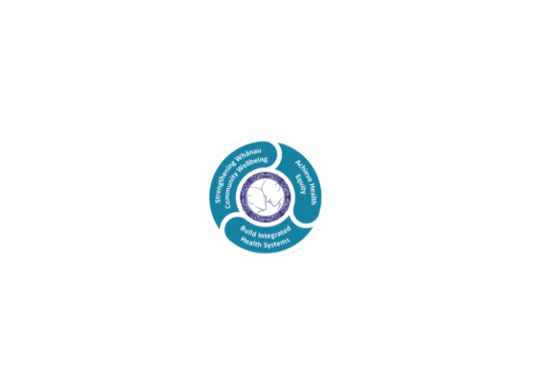

* Achieve equity in Māori health
* Build an Integrated health system
* Strengthen people, whanau & community wellbeing

### THREE CORE VALUES

Manaakitanga respect and acknowledgment of each other’s intrinsic value and contribution

Integrity truthfully and consistently acting collectively for the common good

Accountability collective and individual ownership for clinical and financial outcomes and sustainability

### TE ITI KAHURANGI – THE LAKES WAY, OUR PLACE, OUR CULTURE – WE WILL

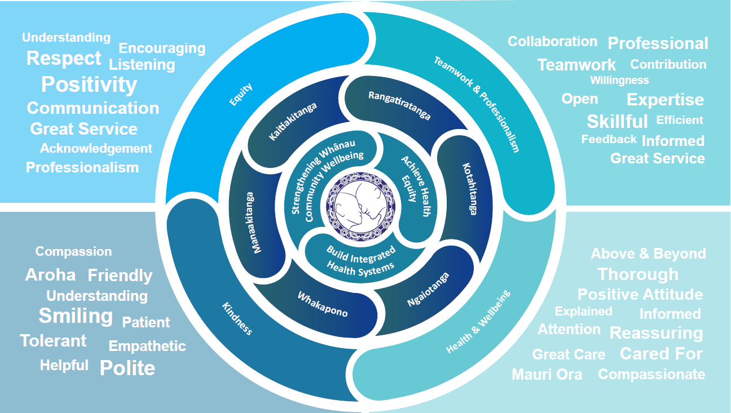

### TE TIRITI O WAITANGI

**Our expression of Te Tiriti o Waitangi**

The text of Te Tiriti, including the preamble and the three articles, along with the Ritenga Māori declaration, are the enduring foundation of our approach to achieving health and independence. Based on these foundations, we will strive to achieve the following four goals, each expressed in terms of mana.

**Mana whakahaere**

Effective and appropriate kaitiakitanga and stewardship over the health and disability system. Mana whakahaere is the exercise of control in accordance with tikanga, kaupapa and kawa Māori. This goes beyond the management of assets and resources and towards enabling Māori aspirations for health and independence.

**Mana motuhake**

Enabling the right for Māori to be Māori (Māori self-determination); to exercise their authority over their lives and to live on Māori terms and according to Māori philosophies, values and practices, including tikanga Māori.

**Mana tangata**

Achieving equity in health and disability outcomes for Māori, enhancing the mana of people across their life course and contributing to the overall health and wellbeing of Māori.

**Mana Māori**

Enabling Ritenga Māori (Māori customary rituals), which are framed by te ao Māori (the Māori world), enacted through tikanga Māori (Māori philosophy and customary practices) and encapsulated within mātauranga Māori (Māori knowledge).

Te Whatu Ora Lakes is committed within the framework of the New Zealand Public Health and Disability Act (2000) to supporting the Crown’s commitment to upholding its Tiriti promises.

### ORGANISATION STRUCTURE

