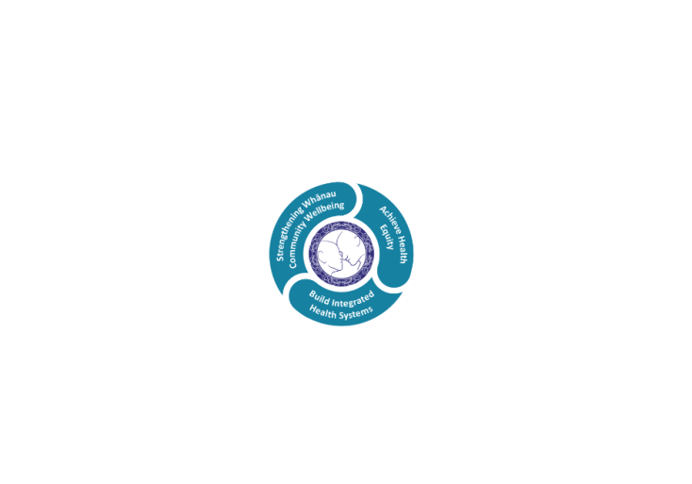

# POSITION DESCRIPTION

|  |  |  |
| --- | --- | --- |
| **Position:** | Physiotherapist Rotational | |
| **Responsible To:** | Team Leader | |
| **Direct Reports:** | Carol Turner | |
| **Location:** | Rotorua & Taupō | |
| **Functional Relationships:** | **Internal:**  Physiotherapy staff  Clerical staff  Nursing Staff  Allied Health Staff  Medical Staff  Other Departments | **External:**  Patients/carers/family/whanau  District Nursing Service  General Medical Practitioners  Private Hospitals & Residential Care Facilities  Community Agencies  Other hospitals’ |
| **Financial Delegations:** | Nil | |
| **Date:** | 02 July 2024 | |

### Primary purpose(s) of the position

To provide a high standard and effective physiotherapy service to patients within Rotorua and Taupo Hospitals within the Lakes Region.

| **Key Objectives** | **Description** | **Expected Outcomes** |
| --- | --- | --- |
| To treat patients safely and appropriately to standards of practice as set by the Physiotherapy Department, Rotorua and Taupo Hospitals | Professional Standards of practice for physiotherapy.  Own workload management.  Client/patient rights | * Appropriate assessment of patients, treatment planning and evaluation of outcomes: * Documentation of all assessments and treatments using the problem orientated medical recording system * Feedback to referrer as appropriate * Correct use and care of equipment * Management of work and organisation of work load. * Workload priorities are established and maintained. * Efficient time management. * Acceptance of responsibility as directed * Instruction of physiotherapy assistants, attendants * Follow Physiotherapy Department procedures. * Follow hospital protocols (e.g. time sheets, expense claims) * Report any damages/losses to Professional Advisor/Team Leader * Attendance at ward rounds and ward meetings as necessary and as directed by senior physiotherapists * Issue of walking aids in accordance with Departmental and Equipment Management Services policies * Keep accurate daily statistics   Complete incident forms for any accidents, incidents or near misses   * Compliance with relevant legislation e.g.: * Health and Disability Patient Code of Rights * Health Practitioners Competency Act * Privacy Act * Health and Safety in Employment * Consumer Guarantees Act   C**ontrol Information**:   * audit of patient care records * problem orientated medical recording * on the job observation and appraisal / professional development plan * feedback from wards and departments * department records/computer records * client satisfaction surveys. |
| To ensure communication is established at all levels to achieve departmental objectives | Communication regarding provision of Physiotherapy  Services | * Appropriate written and verbal communication with medical staff, patients, care givers, colleagues, aides, attendants etc. * Follow recommended procedures by accurate, legible, prompt recording * Attendance at relevant team meetings. * Check and action messages in a timely manner   **Control Information:**   * note audits * observation and appraisal * feedback |
| To maintain professional development of self and contribute to professional development of others | Professional development of self.  Professional development of other staff.  Present and participate in departmental and hospital in-service education. | * Attendance at weekly in-service education * Present at in-service and provide appropriate documentation * Development of own skills - on-going learning * Orientation of new staff, nurses and other team members * Education of other staff as directed e.g. nurses, attendants etc. * Attendance of peer reviews.  Control Information:  * attendance and contribution to departmental and service in-service education sessions * in-service plan, evaluation and record of attendance completed * observation and appraisal * completion of education checklist - Professional Development Plan |
| To participate in the development and growth of the Physiotherapy Department. | Adaptability to work where required) | * Participation in on-call and weekend roster. * Treatment of patients in areas short-staffed by sick/annual leave etc. as directed by the Professional Advisor, and Senior Physiotherapists. * Assist with physiotherapy students as directed. * Rotation to other wards/services as directed by the Professional Advisor and Senior Physiotherapists.   **Control Information:**   * on-call record keeping audits * observation and appraisal * feedback from wards etc. * 0n-call competency appraisal |
| **Utilisation of Telehealth** | Health care is delivered using digital technology where participants may be separated by time and/or distance | * Service provision is in line with the New Zealand Health Strategy and the New Zealand Allied Health Best Practice Guide for Telehealth to provide care “closer to home”. * Patient centric care which will give patients the option of telephone or video appointments where there is no need for an in-person appointment. |

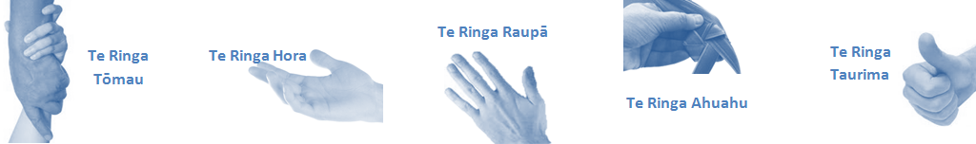

| **Capabilities** | **Capability Definition** | **Achievement Indicators** |
| --- | --- | --- |
| **Communication and Personal Interaction**  **Te Ringa Hora**  ***the open hand (denoting someone who is sociable)*** | Communicates relevant information in a timely manner to those who need to know at a level that is understood. | * Transfers information effectively verbally and writes clearly, coherently and succinctly. * Shares well thought out, concise and timely information with others using appropriate mediums. * Organisational updates are provided to staff by way of relaying in general terms but more importantly what affect it has on the unit and how staff can help where necessary to achieve any requirements. * Builds team spirit, facilitates resolution of conflict within the team, promotes/protects team reputation, shows commitment to contributing to the teams’ success. * Maintains and promotes high standards of social, ethical and organisational norms. |
| Fosters a team environment and encourages collaboration between team and departments within the Lakes region. | * Articulates differing perspectives on an issue and can see the merit of alternative points of view. * Works with other managers and teams to streamline processes for the best efficiency for both teams. * Provides staff who have concerns about another team process, a different point of view to consider. |
| Connects with people to build trust and confidence. | * Connects with others, listens, reads people and situations and communicates tactfully. * Gets to know their team members and treats them with respect, valuing their individuality and contributions. |
| **Strategy & Performance**  **Te Ringa Raupā**  ***the roughened hand (symbolising a hard worker)*** | Delegates appropriately within team utilising individual skills to achieve results. | * Understands individuals’ strengths and weaknesses to utilise or increase skills for those individuals. * Assigns and sub-delegates staff to teams to allow for development and succession planning. |
| Understands the unit requirements and the implications of the unit achievements on overall service delivery. | * Ensures decision making complies with organisational strategies. * Recognises decisions made within the unit affect overall results of the service and Lakes region. * Works with Service Manager to maximise unit efficiency. |
| **Development and Change**  **Te Ringa Ahuahu**  ***the hand that shapes or fashions something (refers to someone who is innovative)*** | Works to include staff in change minimising barriers to implementation. | * Questions traditional ways of doing things when choosing a course of action or finds new combinations of old elements to form an innovative solution. * Continually strives for new and improved work processes that will result in greater effectiveness and efficiencies. * Openly broaches concern with staff from the outset asking for their ideas and input. * Gives examples of what might help to resolve the issue/concern. * Seeks opportunities to improve performance and seeks feedback to measure and improve. * Encourages staff participation in possible solution process. * Allows staff input to possible solutions to concern. * Gives careful consideration to staff ideas and offers alterations to suggestions where necessary. |
| Articulates decisions and reasoning behind change enable buy-in to results. | * Develops an informative response to the team including trends, data, process and benefits of the decided process/change. * Allows feedback to decision to enable ‘tinkering’ to be made where appropriate. |
| **Personal Accountability**  **Te Ringa Tōmau**  ***the hand that is trustworthy*** | Manages own and encourages others to foster work/life balance. | * Ensures regular breaks are taken and own annual leave accruals are used within the 12 months following accrual. * Ensures employees within their service are taking regular annual leave breaks for the purpose of rest/recreation throughout the year. |
| Actively manages own career aspirations and development. | * Is constantly striving to acquire and maintain knowledge, skills and/or experience. * Has own career development plan and succession planning. * Seeks out development opportunities to expand knowledge and capability. * Engages in projects and activities readily which are above and beyond scope of current role. |
| **Culture and Values**  **Te Ringa Taurima**  ***the hand that nurtures, encourages, supports*** | Makes decisions based on facts and without personal bias. | * Is proactive and effective when problem solving is required. * Engages with staff member/managers/multi-disciplinary team when concerns are raised to best understand their point of view. * Appropriately investigates the concern looking at trends, situation and practices. * Critically examines repeatable risk factors. |
| Engages with mentors and supervisors for personal skill development. | * Is constantly striving to acquire and maintain knowledge, skills and/or experience. * Demonstrates a commitment to and takes responsibility for going professional development. |
| Plans, prioritises and organises work to deliver on short and long term goals. | * Purposeful about where time is invested. * Delivers relevant results within expected timeframes. |
| Encourages and promotes Rotorua Hospital values and expectations. | * Role models expected behaviours and practices. * Treats staff, patients and visitors with dignity and respect. * Uses appropriate empathy to gain organisational objectives. * Is solution focused. |

| **Compulsory Requirements** | **Description** | **Expected Outcomes** |
| --- | --- | --- |
| **Māori Health** | Māori philosophies and values of health are demonstrated in work practice. | * Meaningful relationships are established with Te Aka Matua and Rotorua and Taupo Hospitals Health division in the planning and delivery of services. * Practices are consistent with Te Tiriti o Waitangi /The Treaty of Waitangi when working with Māori. * Delivery of safe services for Māori are facilitated by ensuring they can access treatment options and are involved in the planning and delivery of their care. * Māori are enabled to access and participate in cultural activities provided within the Lakes region. * A commitment to improving the wellbeing of Māori by increasing cultural knowledge within the Lakes region. |
| **Te Iti Kahurangi** | The Lakes Way, Our Place Our Culture | * Works within the Te Iti Kahurangi framework and supporting guide document. |
| **Record Keeping** |  | * Complies with the Rotorua and Taupo Hospitals Corporate Records Management policy to create and maintain full and accurate records. |
| **Quality & Risk** | Patient safety is paramount to the service we deliver at Rotorua and Taupo Hospitals. This is to be achieved in a clinical governance framework that is culturally responsive and identifies and manages risk and opportunities to improve. | * Employees are supported to lead by example and implement a culture of continuous quality improvement. * Risks that may prevent Rotorua and Taupo Hospitals from achieving their goals are identified, reported, and managed. * Māori patients are provided patient-centred care to achieve positive Māori health outcomes. * Needs of Māori are reviewed and reported in the further development of practice, process and or policy. * Evidence-based methodologies are used to support improvements, e.g. kaupapa Māori methodology. * Quality care is provided to certification standards. |
| **Health & Safety** | Each individual is responsible for ensuring the safety of themselves, their colleagues, patients and their visitors and to comply with all organisational health and safety policies, procedures and guidelines. | * Implementation and reinforcement of a proactive healthy work place culture which reflects relevant Rotorua and Taupo Hospitals policy and legislative requirements. * Healthy lifestyles are actively promoted and participated in, within the work area. * Employees participate in Health and Safety within areas of work. * Health and Safety activities are appropriately documented within specified timeframes. * Health and Safety policies have been read and understood and are applied in the workplace. * Health and Safety policies are appropriately documented within specified timeframes and incidents are reported immediately. * Any opportunities for improving Health and Safety are reported and acted upon in a timely manner. * All near misses/incident/accidents are reported to the appropriate line manager within 24 hours. |

**Signatures:**

|  |  |
| --- | --- |
| Line Manager:  (position description approved): |  |
| Employee:  (acceptance of position description): |  |

*(Please also initial all other pages to show acceptance of position description.)*

|  |  |  |
| --- | --- | --- |
| **Person Specification** | **Essential:** | **Desirable:** |
| **Education and Qualifications:** | * New Zealand Registered Physiotherapist * Current Annual Practising Certificate * New Zealand drivers licence * Current New Zealand work visa if   applicable | * Accredited assessor (mobility) or eligible to be one * Member of Physiotherapy New Zealand |
| **Experience:** | * .. | * General clinical experience in Physiotherapy |
| **Knowledge:** | * Te Tiriti O Waitangi in the provision of health care services and support to Māori. * Te Tiriti O Waitangi in practice, process, policy development and decision making. * Rotorua and Taupo Hospitals are a Reorua organisation knowledge and understanding of Te Reo/ Correct pronunciation. * Relevant legislation and regulations including * Privacy act and Health Information Privacy Code * Health and Safety in Employment Act * Codes of Safe Practice * Health Practitioners Competency Act * Health and Disability Commissioner Act and Code of Health and Disability Consumer Rights | * .. |
| **Skills:** | * Pronunciation of Te Reo Māori words and names * Ability to learn and apply new skills demonstrated effectiveness in managing workload. | * Te Reo Māori * .. |
| **Personal Attributes:** | * .. | * Non-smoker preferred. * .. |

**ABOUT Rotorua and Taupo Hospitals**

At Rotorua and Taupo Hospitals we place the highest value on the health and wellbeing of everyone in our community. As such all healthcare workers are expected to play a part in the creation and promotion of an environment which lives the following vision, mission and values:

### VISION

Healthy Communities – Mauriora! In this vision Mauriora refers to the Mauri - being the life essence and the source of well-being, and ora - describing the state of wellness.

### STRATEGIC MISSION

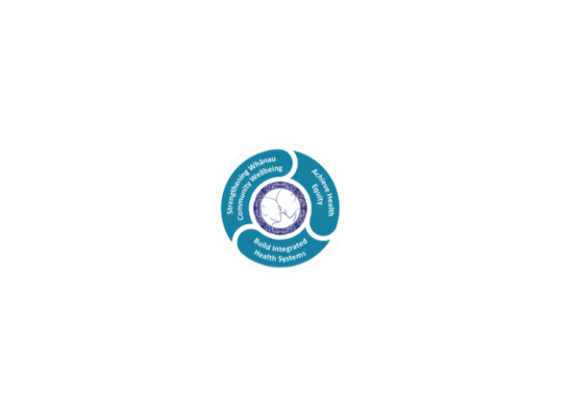

* Achieve equity in Māori health
* Build an Integrated health system
* Strengthen people, whanau & community wellbeing

### THREE CORE VALUES

Manaakitanga respect and acknowledgment of each other’s intrinsic value and contribution

Integrity truthfully and consistently acting collectively for the common good

Accountability collective and individual ownership for clinical and financial outcomes and sustainability

### TE ITI KAHURANGI – THE LAKES WAY, OUR PLACE, OUR CULTURE – WE WILL

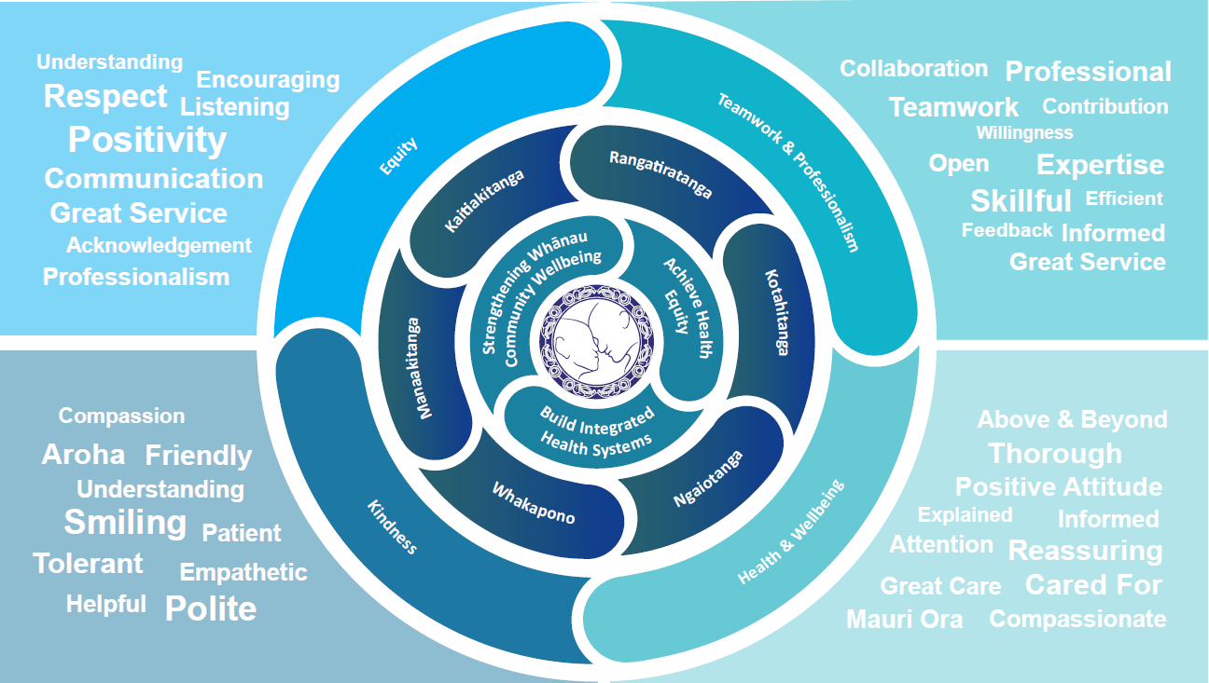

### TE TIRITI O WAITANGI

**Our expression of Te Tiriti o Waitangi**

The text of Te Tiriti, including the preamble and the three articles, along with the Ritenga Māori declaration, are the enduring foundation of our approach to achieving health and independence. Based on these foundations, we will strive to achieve the following four goals, each expressed in terms of mana.

**Mana whakahaere**

Effective and appropriate kaitiakitanga and stewardship over the health and disability system. Mana whakahaere is the exercise of control in accordance with tikanga, kaupapa and kawa Māori. This goes beyond the management of assets and resources and towards enabling Māori aspirations for health and independence.

**Mana motuhake**

Enabling the right for Māori to be Māori (Māori self-determination); to exercise their authority over their lives and to live on Māori terms and according to Māori philosophies, values and practices, including tikanga Māori.

**Mana tangata**

Achieving equity in health and disability outcomes for Māori, enhancing the mana of people across their life course and contributing to the overall health and wellbeing of Māori.

**Mana Māori**

Enabling Ritenga Māori (Māori customary rituals), which are framed by te ao Māori (the Māori world), enacted through tikanga Māori (Māori philosophy and customary practices) and encapsulated within mātauranga Māori (Māori knowledge).

Te Whatu Ora Lakes is committed within the framework of the New Zealand Public Health and Disability Act (2000) to supporting the Crown’s commitment to upholding its Tiriti promises.

### ORGANISATION STRUCTURE

