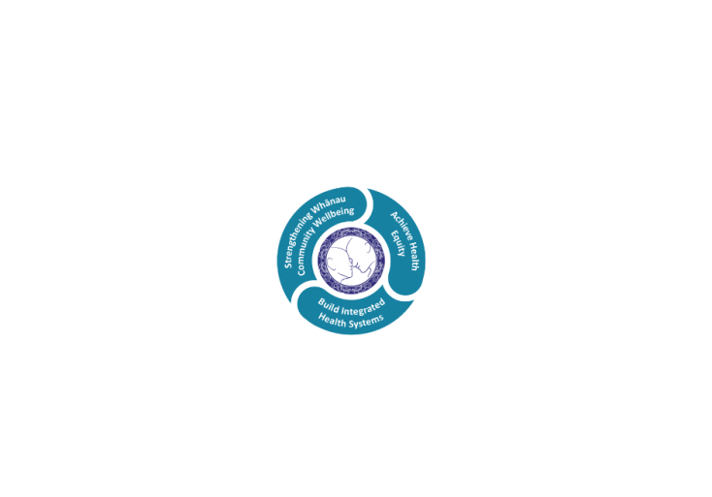



# POSITION DESCRIPTION

|  |  |  |
| --- | --- | --- |
| **Position**: | HSS National Bowel Screening Programme (NBSP) Engagement and Promotion – Te Aka Matua Kaupapa Māori Service | |
| **Responsible to:** | Pou Manukura – Te Aka Matua Manager | |
| **Location:** | Rotorua & Taupō | |
| **Functional relationships:** | **Internal (Lakes District)**:   * Professional leads and Managers * NBSP Programme Manager * NBSP Clinical lead * NBSP Clinical Nurse Coordinator * Endoscopy Clinical Nurse Coordinator * Endoscopy Unit staff * Te Aka Matua staff * Taupo Hospital staff | **External**:   * Relationship Manager, National Bowel Screening Programme, National prevention Directorate * Te Manawa Taki Bowel Screening and Colorectal Cancer Team * NBSP programme managers in other Health New Zealand Districts * Primary Health Organisations * General practitioner’s/practice nurses * Maori Health Providers * Pacific Health Providers * The National Coordination Centre * Community health and social service providers * Breast and Cervical Screening teams * Other healthy lifestyle programme teams * Organisers of events providing opportunity to promote the NBSP * Community Groups * Cancer Treatment services * NBSP Māori Network * NBSP Pacific Network |
| **Financial delegations:** | N/A | |
| **Date**: | 29 May 2024 | |

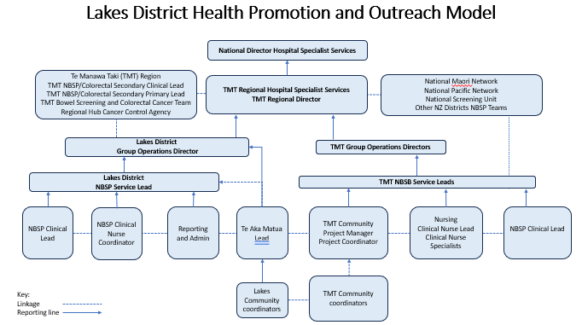

### Primary purpose(s) of the position

“He aha te mea nui o te Ao – maku e ki atu He Tangata, He Tangata, He Tangata”

**Relationship Management**

* Develop and maintain relationships with Health and Social community groups and organisations to identify opportunities for promotional activities.
* Partnerships and liaison with primary care providers PHOs, Practices, health workers and community educators working with priority populations.
* Partnership and liaison with Breast Screening, Cervical Screening, and other healthy lifestyle teams/ programmes
* Ensure that the service is delivered in a professional manner consistent with each individual’s physical, emotional, spiritual and cultural needs.
* Develop and maintain positive working relationships with all members of the National Bowel Screening Programme (NBSP) Team.
* Establish and develop relationships with the National Coordination Centre, National Prevention Directorate regarding NBSP.
* Develop and maintain relationship and share learnings with National Bowel Screening Māori Network.
* Develop and maintain relationship and share learnings with National Bowel Screening Pacific Network

**Provisions of Bowel Screening**

* Carry out promotional activities as agreed with the Lakes National Bowel Screening Programme Manager, including symptomatic services promotion.
* Develop relationships with General Practices, Practice Nurses, and Service providers in the Lakes District.
* In consultation with the Endoscopy/NBSP Clinical Nurse Coordinator, providing cultural support to participants who have tested positive for FIT test, including providing education and encouragement to support them to attend colonoscopy appointments or alternative assessments including symptomatic participants if necessary.
* Enrolling of Priority groups into the NBSP, by way of referring them to the National Coordination Centre (NCC) or use Community Initiative Campaign Strategy (CICS) initiatives.
* Offering and organizing transport to those that require it to attend appointments.
* Offering your attendance of support if required by participants.
* Ensure culturally responsive approaches to engaging with individuals and whanau are identified and adopted.
* Follow-up lists of participants on outreach provided by the Endoscopy/NBSP Clinical Nurse Coordinator to encourage participation and checking for updated contact details with Lakes iPM system and/or participants GP.
* Some evening or weekend work will be required to attend meeting and events as well as to contact participants who cannot be contacted during normal working hours.
* Be flexible in the level of involvement required by the NBSP Team and broaden support to other Screening teams and/ or healthy lifestyle programs.
* Develop a good working knowledge of bowel screening, colorectal symptomatic and colonoscopy processes and referral pathways.

**Support quality systems and reporting mechanisms**

* Records are kept ensuring that activities and outcomes can be reported as required.
* Ensure messages are accurate and consistent with the NBSP key messages.
* Provide regular Key Performance Indicator reporting.

**Data Management and Information Technology**

* Demonstrate ability to access and use available clinical IT information systems (as they relate to bowel screening).
* Is conversant with applications required for specific discipline/role. For example, iPM, Excel, Outlook, etc.
* Develop a good knowledge of Bowel Screening Register (BSR) as it relates to enrolment of eligible participants, ordering kits and recording outreach activities.
* Maintain own professional development by attending relevant IT and other educational programmes.

**Professional Development**

* Undertake professional development as part of ongoing career and skill development.
* Maintain current professional knowledge and skills relevant to the role.
* Training needs are identified with the Programme Manager.

**Key Relationships**

The position holder will be required to interact on a regular basis with a range of Stakeholders including but not limited to those listed below.

Situations may often call for tact, diplomacy and will require information to be handled in a discreet and sensitive manner.

In conflict situations you will be required to exercise sound judgement, negotiation and persuasiveness skills, toward facilitating a workable outcome.

There may be a requirement to work after hours as whānau and health promotion activities can be late afternoon, evening and at the weekend.

|  |  |
| --- | --- |
| **Responsibilities** | |
| **Quality and Patient Safety collective Responsibilities** | * Support the strategic quality objectives within their area of responsibility. * Ensure care is safe, effective, compassionate and dignified. * Foster a culture of openness and improvement, with patient and whanau at the centre. * Develop good multidisciplinary team working and networks to ensure delivery of good quality care. * Ensure the team work to up to date policies and guidelines. * Ensure an annual clinical audit plan is implemented to provide evidence of improvement and good participant/patient outcome. * Ensure that clinical teams have active and effective mortality and morbidity reviews * Identify and manage risks to the quality of care * Review and monitor progress through the use of key quality indicators/performance indicators and take action to improve as needed. * Receive patient feedback – national inpatient survey, complaints, feedback cards, compliments and act on area where improvement required. |
| **Organisational Responsibilities** | * Being accountable for own work and provide a high-quality service and contributes to quality improvement and risk minimisation activities. * Complies with the Health New Zealand Corporate Records Management policy requirements to create and maintain full and accurate records. * Knows department emergency response plan, able to initiate an emergency response and participate in response as applicable to the role. * Service implements strategies to provide accessible, equitable and culturally responsive services for priority participants/patients and whanau to improve health experience and outcomes and reduce health inequities. * To participate in and comply with the requirements of the Health and Safety at Work Act 2015 and associated Health New Zealand policies. * Leads by example and ensures compliance with the established Health and Safety frameworks and systems for achieving best practice in hazard management within own service. * Communicating to staff through orientation, meetings, training, policy and documentation usage, their role with hazard management in the workplace. |

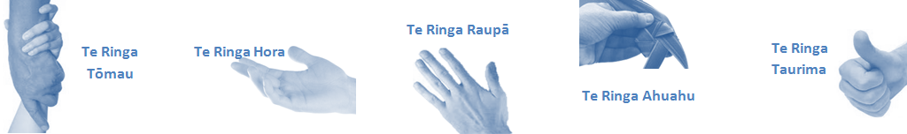

| **Capabilities** | **Capability definition** | **Achievement Indicators**  *(Examples – add/ amend or delete as specific to role using matrix to assist)* |
| --- | --- | --- |
| **Communication and Personal Interaction**  **Te Ringa Hora**  ***the open hand (denoting someone who is sociable)*** | Openly communicates and cooperates with all levels of Lakes employees, patients and visitors. | * Listens actively, absorbs message and responds appropriately. * Builds effective working relationships. * Establishes rapport with others and gains their respect while being adaptive in relating to different types of people and situation. * Openly and constructively participates in conversations with md team, patients, managers and visitors * Patients and visitors are appropriately welcomed and treated while within Lakes * Collegiality with teammates and md teams   Accepts differences of opinion can occur but these happen respectfully and without any continued animosity |
| **Strategy & Performance**  **Te Ringa Raupā**  ***the roughened hand (symbolising a hard worker)*** | Spends energy on delivering role requirements and meeting objectives  Organises own time to deliver on required tasks and duties | * Has an energetic approach to work and is self-motivated. * Accepts direction and instruction of manager but is able to work effectively without direction or guidance. * Organises time and resources effectively. * Understands and work towards achievement of the organisation’s goals. * On shift is busy completing shift duties. * Utilises effective time management strategies to meet shift duties and works towards achieving objectives in any spare moments. |
| **Development and Change**  **Te Ringa Ahuahu**  ***the hand that shapes or fashions something (refers to someone who is innovative)*** | Accepts change in day to day practices and contributes to decision making of the team.  Makes suggestions to increase efficiency of the unit. | * Can adjust behaviour to the demands of the work environment in order to remain productive through periods of transition, ambiguity, uncertainty and stress * Works with managers and team to make any changes within practices work * Contributes to change processes, offering solution based ideas * Constructively makes suggestions to improve process or practices and gain efficiencies * Accepts when ideas are not accepted for implementation |
| **Personal Accountability**  **Te Ringa Tōmau**  ***the hand that is trustworthy*** | Is open with manager and colleagues and open to accepting feedback and critique to improve upon practice.  Looks for and undertakes development activities appropriate for role and career development. | * Offers constructive criticism and accepts feedback. * Establishes rapport with others and gains their respect while being adaptive in relating to different types of people and situations, to allow improvements to be made. * Accepts all feedback and participates in feedback discussions appropriately * Responds and queries how improvements can be made * Advises manager wherever issues may be impacting on performance * Recognises areas that could be improved in own practice * Requests learning and development opportunities to enhance practice in role and/ or to assist where improvements can be made |
| **Culture and Values**  **Te Ringa Taurima**  ***the hand that nurtures, encourages, supports*** | Operates in line with Lakes values and expectations and professional codes of conduct. | * Demonstrates a commitment to cultural safety by meeting and exceeding the cultural needs of clients/ customers/ colleagues. * Incorporates the Lakes Way into day-to-day business activities * Shows respect for patients, colleagues, * managers, md teams * Utilises the Lakes Way philosophy to engage with patients, visitors and md * teams |

|  |  |  |
| --- | --- | --- |
| **Compulsory Requirements** | Description | Expected Outcomes |
| **Māori Health** | Māori philosophies and values of health are demonstrated in work practice. | * Meaningful relationships are established with Te Aka Matua (Rotorua and Taupo Hospitals) and Health New Zealand Lakes Maori Health division in the planning and delivery of services. * Practices are consistent with Te Tiriti o Waitangi /The Treaty of Waitangi when working with Māori. * Delivery of safe services for Māori are facilitated by ensuring they can access treatment options and are involved in the planning and delivery of their care. * Māori are enabled to access and participate in cultural activities provided by the Health New Zealand Lakes. * A commitment to improving the wellbeing of Māori by increasing cultural knowledge in the Health New Zealand Lakes is shown. |
| **Te Iti Kahurangi** | The Lakes Way, Our Place Our Culture | * Works within the Te Iti Kahurangi framework and supporting guide document. |
| **Record Keeping** |  | * Complies with the Health New Zealand Lakes Corporate Records Management policy to create and maintain full and accurate records. |
| **Quality & Risk** | Patient safety is paramount to the service we deliver at Health New Zealand Lakes. This is to be achieved in a clinical governance framework that is culturally responsive and identifies and manages risk and opportunities to improve. | * Employees are supported to lead by example and implement a culture of continuous quality improvement. * Risks that may prevent Health New Zealand Lakes from achieving their goals are identified, reported, and managed. * Māori patients are provided patient-centred care to achieve positive Māori health outcomes. * Needs of Māori are reviewed and reported in the further development of practice, process and or policy. * Evidence-based methodologies are used to support improvements, e.g. kaupapa Māori methodology. * Quality care is provided to certification standards. |
| **Health & Safety** | Each individual is responsible for ensuring the safety of themselves, their colleagues, patients and their visitors and to comply with all organisational health and safety policies, procedures and guidelines. | * Implementation and reinforcement of a proactive healthy workplace culture which reflects relevant Health New Zealand Lakes policy and legislative requirements. * Healthy lifestyles are actively promoted and participated in, within the work area. * Employees participate in Health and Safety within areas of work. * Health and Safety activities are appropriately documented within specified timeframes. * Health and Safety policies have been read and understood and are applied in the workplace. * Health and Safety policies are appropriately documented within specified timeframes and incidents are reported immediately. * Any opportunities for improving Health and Safety are reported and acted upon in a timely manner. * All near misses/incident/accidents are reported to the appropriate line manager within 24 hours. |

**Signatures:**

|  |  |
| --- | --- |
| Line Manager:  (position description approved): |  |
| Employee:  (acceptance of position description): |  |

*(Please also initial all other pages to show acceptance of position description.)*

|  |  |  |
| --- | --- | --- |
| **Person Specification** | **Essential:** | **Desirable:** |
| **Education and Qualifications:** | * Current clean drivers licence |  |
| **Experience:** | * Previous experience in health or social   Sector. |  |
| **Knowledge:** | * Cultural Specialist with advanced knowledge and understanding of the cultural and spiritual norms of the whanau * Has a working knowledge of Lakes Maori communities, whanau, hapu and iwi. * Treaty of Waitangi and its application to the health setting | * Lakes Policies and Procedures * Privacy Act (1993) and Health Information Privacy Code (1994) * Health and Safety in Employment Act (1992) * Health & Disability Commissioner (Code of Health and Disability Services Consumers’ Rights) Regulations (1996) * Vulnerable Children Act 2014 |
| **Skills:** | * Fluency in Te Reo * Sound knowledge of powhiri, karakia, whaikorero, whakapapa * Competent cultural facilitator and advisor * Competent verbal, written and presentation skills, in both Maori and English * Intermediate level knowledge of Microsoft Office, Outlook, and computers * iPM data systems capable * Competent in Maori models/service delivery e.g. Takarangi | * Adept and knowledgeable in kawa and tikanga of Te Arawa and Ngati Tuwharetoa. |
| **Personal Attributes:** | * Warm caring personality * Able to relate with people from all walks of life. * Passionate about whanau healthy living and wellbeing | * Non-smoker preferred. |

**ABOUT** Health New Zealand **LAKES**

At Health New Zealand Lakes we place the highest value on the health and wellbeing of everyone in our community. As such all-healthcare workers are expected to play a part in the creation and promotion of an environment which lives the following vision, mission and values:

### VISION

Healthy Communities – Mauriora! In this vision Mauriora refers to the Mauri - being the life essence and the source of wellbeing, and ora - describing the state of wellness.

### STRATEGIC MISSION

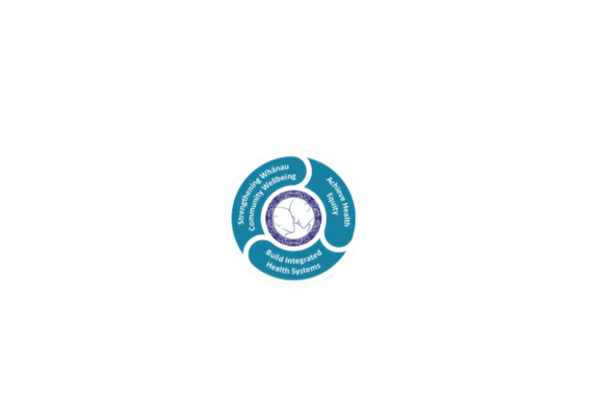

* Achieve equity in Māori health
* Build an Integrated health system
* Strengthen people, whanau & community wellbeing

### THREE CORE VALUES

Manaakitanga respect and acknowledgment of each other’s intrinsic value and contribution

Integrity truthfully and consistently acting collectively for the common good

Accountability collective and individual ownership for clinical and financial outcomes and sustainability

### TE ITI KAHURANGI – THE LAKES WAY, OUR PLACE, OUR CULTURE – WE WILL

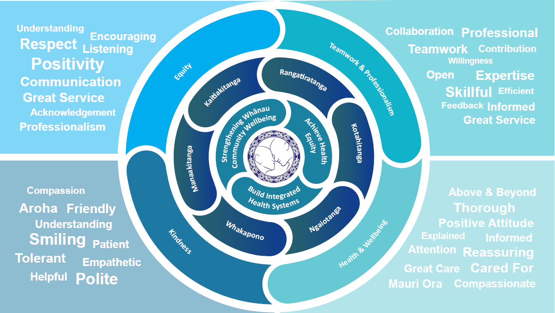

### TE TIRITI O WAITANGI

**Our expression of Te Tiriti o Waitangi**

The text of Te Tiriti, including the preamble and the three articles, along with the Ritenga Māori declaration, are the enduring foundation of our approach to achieving health and independence. Based on these foundations, we will strive to achieve the following four goals, each expressed in terms of mana.

**Mana whakahaere**

Effective and appropriate kaitiakitanga and stewardship over the health and disability system. Mana whakahaere is the exercise of control in accordance with tikanga, kaupapa and kawa Māori. This goes beyond the management of assets and resources and towards enabling Māori aspirations for health and independence.

**Mana motuhake**

Enabling the right for Māori to be Māori (Māori self-determination); to exercise their authority over their lives and to live on Māori terms and according to Māori philosophies, values and practices, including tikanga Māori.

**Mana tangata**

Achieving equity in health and disability outcomes for Māori, enhancing the mana of people across their life course and contributing to the overall health and wellbeing of Māori.

**Mana Māori**

Enabling Ritenga Māori (Māori customary rituals), which are framed by te ao Māori (the Māori world), enacted through tikanga Māori (Māori philosophy and customary practices) and encapsulated within mātauranga Māori (Māori knowledge).

Health New Zealand Lakes is committed within the framework of the New Zealand Public Health and Disability Act (2000) to supporting the Crown’s commitment to upholding its Tiriti promises.