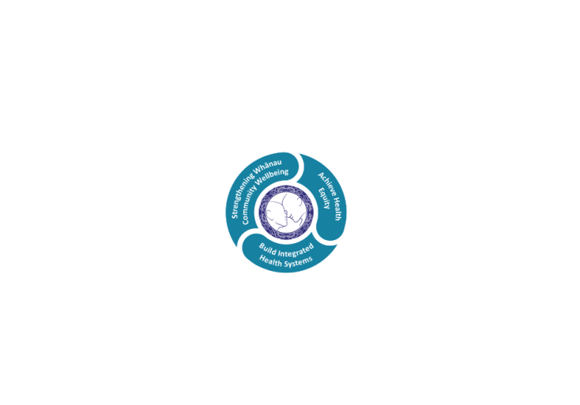



# POSITION DESCRIPTION

|  |  |  |
| --- | --- | --- |
| **Position**: | Intern Pharmacist | |
| **Responsible to:** | Pharmacy Manager | |
| **Direct Reports:** | N/A | |
| **Location:** | Rotorua & Taupō | |
| **Functional relationships:** | **Internal:**  Pharmacy staff  Clerical Staff  Nursing Staff  Allied Health Staff  Medical Staff  Other Departments | **External**:  Patients  • Other hospital staff and pharmacy organisations (Pharmacy Council, PSNZ, NZHPA)  • Hospital staff from other localities  • Community pharmacists and health care professionals  • Universities and other training providers  • PHARMAC, Pharmaceutical suppliers and contractors |
| **Financial delegations:** | N/A | |
| **Date**: | April 2024 | |

**This is a training position**

### Primary purpose(s) of the position

This is a training position. The Intern Pharmacist must always practice under the supervision of a registered practising pharmacist. The Intern Pharmacist must undertake the Pharmaceutical Society of New Zealand (PSNZ) pre-registration training programme (EVOLVE) and demonstrate competence in all areas of practise prior to registration as a Pharmacist.

To provide clinical pharmacy services and safe medication supply and use at Rotorua and Taupo Hospitals ensuring optimal utilisation of medicines by patients through evidence-based medicine and clinical practice

|  |  |  |
| --- | --- | --- |
| **Key Objectives** | Description | Expected Outcomes |
| **Clinical pharmacy service** | The provision of clinical pharmacy services by participating in clinical pharmacy activities at ward level as rostered to ensure optimal and safe utilisation of medicines for and by patients through evidence-based medicine and practice | * Takes responsibility for a ward, or group of wards, providing pharmaceutical care to patients on this/these ward(s). * Provision of patient-focused clinical pharmacy services to wards and departments e.g. patient admission and discharge including medicines history taking, admission and discharge reconciliations and counselling, participation in ward rounds, clinical medication reviews of ‘at risk’ patients, chart reviews, as described in the guidelines and protocols for clinical pharmacy * To implement the guidance provided in Pharmac’s HML. * To be aware of and provide, as appropriate, clinical pharmacy services to meet the particular needs and preferences of Maori consumers. * A collegial working relationship with pharmacy, medical and nursing staff to implement strategies for the effective use of drugs * Interaction and sharing of ideas between health professionals * The provision of education to medical, nursing and other health practitioners in the appropriate use, administration and storage of pharmaceuticals * The provision of accurate, timely and independent drug information to hospital staff * The implementation and promotion of preferred prescribing guidelines in conjunction with the Medication Safety Committee * Participate in requested audits with the necessary education processes |
| **Operational services** | The provision of medication supply including dispensing, impresting, and requisitioning and all related stock management including ordering, receipting, and stock taking | * To directly participate in the dispensing and supply of medicines * All medicines are supplied or dispensed meeting all legal, ethical standards and regulations, Good Manufacturing Practice (GMP), pharmacy standard operating procedures, clinical guidelines or protocols, or clinical trial protocols * When required/requested to participate and ensure general pharmacy duties are carried out, e.g. stock takes, inpatient and outpatient dispensing, ward imprest supplies, chemotherapy dispensing, ordering and receipt of pharmaceuticals, desk-based chart reviews, drug information, supply and auditing of CDs within the hospital and attend Pharmacy meetings and clinical pharmacy education sessions * To implement the guidance of Te Whatu Ora Lakes protocols, guidelines or clinical pathways * To adhere to Pharmac HML rules and guidance * To participate in the weekend roster as scheduled |
| **Safety** | Demonstrates clinical, legal and cultural safety to practice | * To be aware of and practise in accordance with protocols that promote the safe use of medicines through clinical pharmacy services * To be aware of and assist with the implementation of local LDHB Medicines Safety programmes and national Quality Use of Medicines strategies recommended by the Ministry of Health Quality Use of Medicines Group * To be aware of and practise in accordance with Lakes District Health Board’s:   + Health and safety protocols   + Infection Control protocols   + Bicultural protocol   + Human resources protocol * To be aware of and practise in accordance with:   + Health and Disability Consumer Code of Rights   + Health Information Privacy Code   + Pharmacy Council of NZ Code of Ethics   + Quality Standards for Pharmacy in NZ |
| **Professionalism** | Demonstrates accountability and responsibility for professional pharmacy practice | * To be actively involved in promoting professional practice. * To maintain own health and well-being, and to refer to relevant support personnel as necessary * To co-ordinate with the Pharmacy Manager , other pharmacists and pharmacy technicians * To support Pharmacy Technicians and Assistants as necessary |
| **Communications** | Interact effectively with healthcare consumers, family / whanau members and health team workers | * To demonstrate good communication and listening skills * To develop good presentation and training skills * To function as an effective team member * To demonstrate a professional attitude in all interactions * To ensure correct and pertinent information is communicated appropriately using the available tools via the correct channels * To seek appropriate assistance with conflict situations |
| **Time management** | Demonstrates effective time management, teamwork and resource utilisation | * To develop time management and priority setting skills * To ensure resources are used in an economic and responsible manner |
| **Education** | Attends and participates in teaching activities with pharmacy colleagues, medical and nursing staff, health care practitioners, and health care consumers. | * To keep updated with current pharmaceutical practice * To deliver patient education using motivational interviewing skills. * To present at group training sessions as requested |
| **Professional Development** | Take responsibility for undertaking the EVOLVE training programme seeking appropriate input from your preceptor and other peers | * To meet with your Preceptor Pharmacists at regular intervals as agreed to review and discuss progress * To complete all assignments and practice activities as prescribed by the PSNZ, achieving a minimum competent grading * To complete 3-monthly appraisals with your Preceptor Pharmacist undertaking a self-appraisal of competence / achievement prior to meeting * To attend all PSNZ training days, and the Assessment Centre evaluation * To participate personally in internal and external continuing education programmes   + departmental CE meetings   + external meetings as agreed with feedback at departmental CE meetings. |

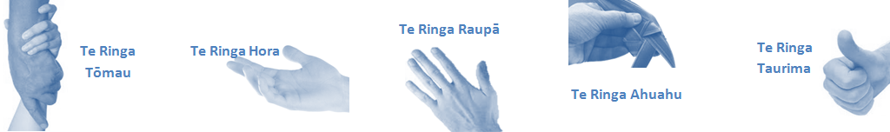

|  |  |  |
| --- | --- | --- |
| **Capabilities** | Capability definition | Achievement Indicators |
| **Communication and Personal Interaction**  **Te Ringa Hora**  ***the open hand (denoting someone who is sociable)*** | Communicates relevant information in a timely manner to those who need to know at a level that is understood. | * Transfers information effectively verbally and writes clearly, coherently and succinctly. * Shares well thought out, concise and timely information with others using appropriate mediums. * Organisational updates are provided to staff by way of relaying in general terms but more importantly what affect it has on the unit and how staff can help where necessary to achieve any requirements. * Builds team spirit, facilitates resolution of conflict within the team, promotes/protects team reputation, shows commitment to contributing to the teams success. * Maintains and promotes high standards of social, ethical and organisational norms. |
| Fosters a team environment and encourages collaboration between team and departments within the DHB. | * Articulates differing perspectives on an issue and can see the merit of alternative points of view. * Works with other managers and teams to streamline processes for the best efficiency for both teams. * Provides staff who have concerns about another team process, a different point of view to consider. |
| Connects with people to build trust and confidence. | * Connects with others, listens, reads people and situations and communicates tactfully. * Gets to know their team members and treats them with respect, valuing their individuality and contributions. |
| **Strategy & Performance**  **Te Ringa Raupā**  ***the roughened hand (symbolising a hard worker)*** | Delegates appropriately within team utilising individual skills to achieve results. | * Understands individuals strengths and weaknesses to utilise or increase skills for those individuals. * Assigns and sub-delegates staff to teams to allow for development and succession planning. |
| Understands the unit requirements and the implications of the units achievements on the overall service delivery. | * Ensures decision making complies with organisational strategies. * Recognises decisions made within the unit affect overall results of the service and the DHB. * Works with Service Manager to maximise unit efficiency. |
| **Development and Change**  **Te Ringa Ahuahu**  ***the hand that shapes or fashions something (refers to someone who is innovative)*** | Works to include staff in change minimising barriers to implementation. | * Questions traditional ways of doing things when choosing a course of action or finds new combinations of old elements to form an innovative solution. * Continually strives for new and improved work processes that will result in greater effectiveness and efficiencies. * Openly broaches concern with staff from the outset asking for their ideas and input. * Gives examples of what might help to resolve the issue/concern. * Seeks opportunities to improve performance and seeks feedback to measure and improve. * Encourages staff participation in possible solution process. * Allows staff input to possible solutions to concern. * Gives careful consideration to staff ideas and offers alterations to suggestions where necessary. |
| Articulates decisions and reasoning behind change enable buy-in to results. | * Develops an informative response to the team including trends, data, process and benefits of the decided process/change. * Allows feedback to decision to enable ‘tinkering’ to be made where appropriate. |
| **Personal Accountability**  **Te Ringa Tōmau**  ***the hand that is trustworthy*** | Manages own and encourages others to foster work/life balance. | * Ensures regular breaks are taken and own annual leave accruals are used within the 12 months following accrual. * Ensures employees within their service are taking regular annual leave breaks for the purpose of rest/recreation throughout the year. |
| Actively manages own career aspirations and development. | * Is constantly striving to acquire and maintain knowledge, skills and/or experience. * Has own career development plan and succession planning. * Seeks out development opportunities to expand knowledge and capability. * Engages in projects and activities readily which are above and beyond scope of current role. |
| **Culture and Values**  **Te Ringa Taurima**  ***the hand that nurtures, encourages, supports*** | Makes decisions based on facts and without personal bias. | * Is proactive and effective when problem solving is required. * Engages with staff member/managers/multi disciplinary team when concerns are raised to best understand their point of view. * Appropriately investigates the concern looking at trends, situation and practices. * Critically examines repeatable risk factors. |
| Engages with mentors and supervisors for personal skill development. | * Is constantly striving to acquire and maintain knowledge, skills and/or experience. * Demonstrates a commitment to and takes responsibility for going professional development. |
| Plans, prioritises and organises work to deliver on short and long term goals. | * Purposeful about where time is invested. * Delivers relevant results within expected timeframes. |
| Encourages and promotes DHB values and expectations. | * Role models expected behaviours and practices. * Treats staff, patients and visitors with dignity and respect. * Uses appropriate empathy to gain organisational objectives. * Is solution focused. |

|  |  |  |
| --- | --- | --- |
| **Compulsory Requirements** | Description | Expected Outcomes |
| **Māori Health** | Māori philosophies and values of health are demonstrated in work practice. | * Meaningful relationships are established with Te Aka Matua (Rotorua and Taupo Hospitals) and Te Whatu Ora Lakes Maori Health division in the planning and delivery of services. * Practices are consistent with Te Tiriti o Waitangi /The Treaty of Waitangi when working with Māori. * Delivery of safe services for Māori are facilitated by ensuring they can access treatment options and are involved in the planning and delivery of their care. * Māori are enabled to access and participate in cultural activities provided by the Te Whatu Ora Lakes. * A commitment to improving the wellbeing of Māori by increasing cultural knowledge in the Te Whatu Ora Lakes is shown. |
| **Te Iti Kahurangi** | The Lakes Way, Our Place Our Culture | * Works within the Te Iti Kahurangi framework and supporting guide document. |
| **Record Keeping** |  | * Complies with the Te Whatu Ora Lakes Corporate Records Management policy to create and maintain full and accurate records. |
| **Quality & Risk** | Patient safety is paramount to the service we deliver at Te Whatu Ora Lakes. This is to be achieved in a clinical governance framework that is culturally responsive and identifies and manages risk and opportunities to improve. | * Employees are supported to lead by example and implement a culture of continuous quality improvement. * Risks that may prevent Te Whatu Ora Lakes from achieving their goals are identified, reported, and managed. * Māori patients are provided patient-centred care to achieve positive Māori health outcomes. * Needs of Māori are reviewed and reported in the further development of practice, process and or policy. * Evidence-based methodologies are used to support improvements, e.g. kaupapa Māori methodology. * Quality care is provided to certification standards. |
| **Health & Safety** | Each individual is responsible for ensuring the safety of themselves, their colleagues, patients and their visitors and to comply with all organisational health and safety policies, procedures and guidelines. | * Implementation and reinforcement of a proactive healthy work place culture which reflects relevant Te Whatu Ora Lakes policy and legislative requirements. * Healthy lifestyles are actively promoted and participated in, within the work area. * Employees participate in Health and Safety within areas of work. * Health and Safety activities are appropriately documented within specified timeframes. * Health and Safety policies have been read and understood and are applied in the workplace. * Health and Safety policies are appropriately documented within specified timeframes and incidents are reported immediately. * Any opportunities for improving Health and Safety are reported and acted upon in a timely manner. * All near misses/incident/accidents are reported to the appropriate line manager within 24 hours. |

**Signatures:**

|  |  |
| --- | --- |
| Line Manager:  (position description approved): |  |
| Employee:  (acceptance of position description): |  |

*(Please also initial all other pages to show acceptance of position description.)*

|  |  |  |
| --- | --- | --- |
| **Person Specification** | **Essential:** | **Desirable:** |
| **Education and Qualifications:** | * Have graduated with a degree in Pharmacy and been accepted into the EVOLVE training programme to complete a Pharmacist internship * Have energy, initiative, self-motivation and problem solving skills * Have integrity with respect for confidentiality * Be personable with good communication skills, but have sufficient assertiveness to work in a collegial environment * Experience, skills, understanding or the ability to work with Maori.. |  |
| **Experience:** | * Can demonstrate understanding of clinical pharmacy services relevant to transitions of care.. | * .. |
| **Knowledge:** | * Te Tiriti O Waitangi in the provision of health care services and support to Māori. * Te Tiriti O Waitangi in practice, process, policy development and decision making. * Te Whatu Ora Lakes is a Reorua organisation knowledge and understanding of Te Reo/ Correct pronunciation. * Current Medicines Act and Regulations * Current Misuse of Drugs Act and Regulations * Quality Standards for Pharmacy in New Zealand * Pharmaceutical of Society of New Zealand Code of Ethics * Current Privacy Act and Health Information Privacy Code * Current Health and Safety in Employment Act * Current Health and Disability Commissioner (Code of Health and Disability Service Consumer’s Right) Regulation. | * .. |
| **Skills:** | * Pronunciation of Te Reo Māori words and names * Initiative, energy, self-motivation and problem solving skills * Good communication skills * Good presentation skills * Ability to prioritise demands.. | * Te Reo Māori |
| **Personal Attributes:** | * Be personable and be able to work in a collegial environment.. | * Non-smoker preferred.   . |

**ABOUT TE WHATU ORA LAKES**

At Te Whatu Ora Lakes we place the highest value on the health and wellbeing of everyone in our community. As such all healthcare workers are expected to play a part in the creation and promotion of an environment which lives the following vision, mission and values:

### VISION

Healthy Communities – Mauriora! In this vision Mauriora refers to the Mauri - being the life essence and the source of well being, and ora - describing the state of wellness.

### STRATEGIC MISSION

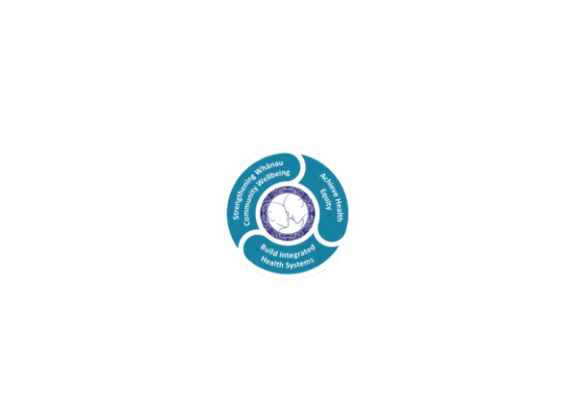

* Achieve equity in Māori health
* Build an Integrated health system
* Strengthen people, whanau & community wellbeing

### THREE CORE VALUES

Manaakitanga respect and acknowledgment of each other’s intrinsic value and contribution

Integrity truthfully and consistently acting collectively for the common good

Accountability collective and individual ownership for clinical and financial outcomes and sustainability

### TE ITI KAHURANGI – THE LAKES WAY, OUR PLACE, OUR CULTURE – WE WILL

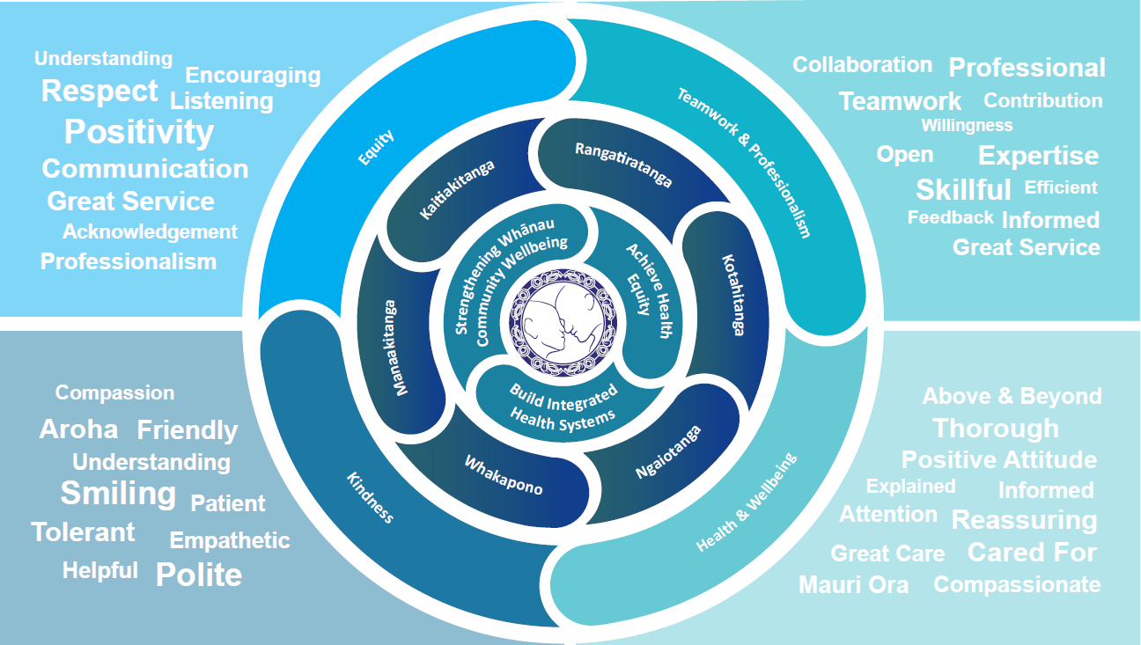

### TE TIRITI O WAITANGI

**Our expression of Te Tiriti o Waitangi**

The text of Te Tiriti, including the preamble and the three articles, along with the Ritenga Māori declaration, are the enduring foundation of our approach to achieving health and independence. Based on these foundations, we will strive to achieve the following four goals, each expressed in terms of mana.

**Mana whakahaere**

Effective and appropriate kaitiakitanga and stewardship over the health and disability system. Mana whakahaere is the exercise of control in accordance with tikanga, kaupapa and kawa Māori. This goes beyond the management of assets and resources and towards enabling Māori aspirations for health and independence.

**Mana motuhake**

Enabling the right for Māori to be Māori (Māori self-determination); to exercise their authority over their lives and to live on Māori terms and according to Māori philosophies, values and practices, including tikanga Māori.

**Mana tangata**

Achieving equity in health and disability outcomes for Māori, enhancing the mana of people across their life course and contributing to the overall health and wellbeing of Māori.

**Mana Māori**

Enabling Ritenga Māori (Māori customary rituals), which are framed by te ao Māori (the Māori world), enacted through tikanga Māori (Māori philosophy and customary practices) and encapsulated within mātauranga Māori (Māori knowledge).

Te Whatu Ora Lakes is committed within the framework of the New Zealand Public Health and Disability Act (2000) to supporting the Crown’s commitment to upholding its Tiriti promises.

### ORGANISATION STRUCTURE

