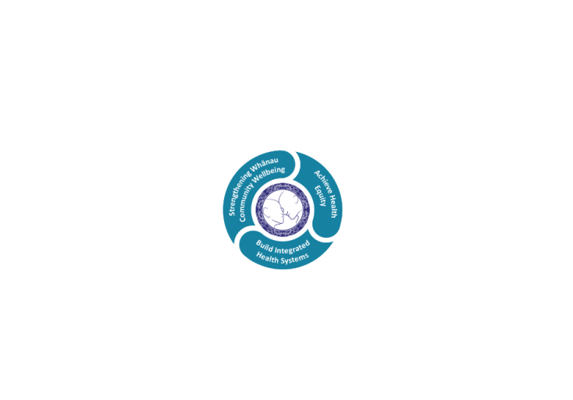

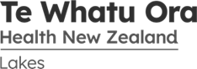

# POSITION DESCRIPTION

|  |  |  |
| --- | --- | --- |
| **Position**: | Recruitment Administrator | |
| **Responsible to:** | Recruitment Team Leader | |
| **Direct Reports:** | N/A.. | |
| **Location:** | Rotorua | |
| **Functional relationships:** | **Internal:**  Talent Acquisition Team Leader  Talent Acquisition Team  Human Resources Consultants  HR Information Officer  Health & Safety Team  Service Managers  Payroll  Clinical Nurse Managers  Team Leaders all departments  Management Accountants  All Lakes District staff  Other Regional teams | **External**:  Recruitment Agencies  Advertising Agencies  Registration Bodies  Immigration Service  Secondary Schools  Polytechnics and Universities  Prospective employees |
| **Financial delegations:** | N/A | |
| **Date**: | March 2024.. | |

### Primary purpose(s) of the position

Assists to ensure delivery of a high quality, responsive and efficient end to end recruitment service for non-medical staff and to support workforce initiatives that increase the pool of suitable candidates.

To provide high quality office management and support to the Recruitment Team by ensuring that administrative activities are co-ordinated in a professional and timely manner.

|  |  |  |
| --- | --- | --- |
| **Key Objectives** | Description | Expected Outcomes |
| **Office Management/Administrative Support** | Provide comprehensive administration support for the Recruitment Team. | * Recruitment administrative process and filing systems developed, maintained, reviewed and refined where appropriate. * Documentation generated, circulated and collated within specified timeframes and in the line with Te Whatu Ora Lakes administrative standards * Administrative tasks completed efficiently, accurately and within established timeframes * Supplies ordered through the FMIS system. * Requisitions raised for all relevant invoices for funding approval |
| **Recruitment** | To assist the Recruitment Team Leader to provide a high quality and responsive recruitment and selection service to appoint the best candidates in accordance with Lakes District Health Board policies and legislative requirements. | * Clear and concise recruitment advice provided to Managers and Staff * Liaise with Managers to ensure requirements for new recruitment vacancies are met and assist and support their request to initiate a recruitment process * Is the Taleo Systems Administrator * Offers guidance and support to candidates to allow them to apply online * Maintain a process to capture information on staff that require professional body registration and annual practising certificates to ensure that their qualifications are validated prior to commencement * Maintains a process to capture information on staff that require work permits/work visa, do not commence until this documentation has been sighted and validated * Deliver effective candidate care to ensure candidates feel valued and supported throughout the recruitment process to assist with retention of employees * Assist to implement the annual Recruitment Plan for Te Whatu Ora Lakes. * Participation with DHBNZ in regards to national recruitment projects * Ensure all new employees meet the Vulnerable Children’s Act requirements – specifically in regards to Worker Safety Checking * Process NZ Police Vetting and Ministry of Justice Criminal History Check requests and maintain an internal system to monitor the processed requests * Generate employment contracts as required * Provide cover for Recruitment Team Leader |
| **Health Career Promotion** | To assist the Recruitment Team Leader with promoting health careers. | * Coordinate campaigns for ongoing annual health promotion initiatives eg. Rotorua & Taupo Career Expo * Work collaboratively with Maori Health on health career promotions (Kia Ora Hauora). * Participation with regional and national activities |
| **Health Career Placement Programme** | Coordinate the Programme (workplace experience for secondary students) for Te Whatu Ora Lakes. | * Maintain working relationships with local secondary school career advisors * Coordinate Te Whatu Ora Lakes staff and secondary schools to provide workplace placements and or Career Seminars |
| **Organisation Orientation** | Organise and facilitate Organisation Orientation in conjunction with the Recruitment Team Leader. | * Ensure the programme schedule meets organisational requirements * Maintain a process to ensure all new staff attend organisational orientation * Ensure the venue and facilities are clean & tidy and refreshments are provided * Liaise with presenters to ensure presentations and related documents and information are current and up to date * Facilitate the presenters to ensure the programme runs smoothly * All new staff have attended organisational orientation within 2 months of commencement |
| **Contribution to HR effectiveness and team work** | Provide effective HR services and partnership across the organisation, providing high quality services to the HR team, managers and staff. | * Understands the work of colleagues and contributes to their success when required * Works effectively with the HR Team to ensure HR objectives are met * Actively supports induction and orientation processes * Makes decisions within financial parameters of the organisation to achieve stated goals and objectives * Provides support in the implementation and delivery of sourcing, talent and workforce initiatives * Assists in the development of new policies and procedures where appropriate and requested * Takes responsibility to provide effective support and information to the wider HR Team and its clients * Demonstrates cultural sensitivity, maintenance of confidentiality and the right to privacy * Demonstrates sensitivity and negotiation skills when dealing with staff and managers |
| **Immigration** | Accredited Employer Work Visa (AEWV) | * Thorough understanding and application of the Accredited Employer Work Visa (AEWV) process and requirements including job checks to ensure Te Whatu Ora Lakes compliance * Completion of the Employer modules every Accreditation period |
| **Worker Safety Checking** | Ensure Te Whatu Ora Lakes maintains systems and processes to ensure all new and existing employees meet the legislative requirements in relation to the Vulnerable Children’s Act 2014. | * All new staff have been checked via the NZ Police or Ministry of Justice before they commence employment * Ensure all employees employed in children’s worker roles (core & non core), have undergone and have a completed Worker Safety Risk Assessment * Ensure all existing staff transferring to a children’s worker role undergo and complete a Worker Safety Risk Assessment |

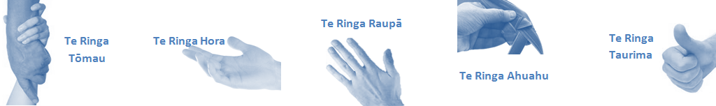

|  |  |  |
| --- | --- | --- |
| **Capabilities** | Capability definition | Achievement Indicators |
| **Communication and Personal Interaction**  **Te Ringa Hora**  ***the open hand (denoting someone who is sociable)*** | Communicates relevant information in a timely manner to those who need to know at a level that is understood. | * Transfers information effectively verbally and writes clearly, coherently and succinctly. * Shares well thought out, concise and timely information with others using appropriate mediums. * Organisational updates are provided to staff by way of relaying in general terms but more importantly what affect it has on the unit and how staff can help where necessary to achieve any requirements. * Builds team spirit, facilitates resolution of conflict within the team, promotes/protects team reputation, shows commitment to contributing to the teams success. * Maintains and promotes high standards of social, ethical and organisational norms. |
| Fosters a team environment and encourages collaboration between team and departments within the DHB. | * Articulates differing perspectives on an issue and can see the merit of alternative points of view. * Works with other managers and teams to streamline processes for the best efficiency for both teams. * Provides staff who have concerns about another team process, a different point of view to consider. |
| Connects with people to build trust and confidence. | * Connects with others, listens, reads people and situations and communicates tactfully. * Gets to know their team members and treats them with respect, valuing their individuality and contributions. |
| **Strategy & Performance**  **Te Ringa Raupā**  ***the roughened hand (symbolising a hard worker)*** | Delegates appropriately within team utilising individual skills to achieve results. | * Understands individuals strengths and weaknesses to utilise or increase skills for those individuals. * Assigns and sub-delegates staff to teams to allow for development and succession planning. |
| Understands the unit requirements and the implications of the units achievements on the overall service delivery. | * Ensures decision making complies with organisational strategies. * Recognises decisions made within the unit affect overall results of the service and the DHB. * Works with Service Manager to maximise unit efficiency. |
| **Development and Change**  **Te Ringa Ahuahu**  ***the hand that shapes or fashions something (refers to someone who is innovative)*** | Works to include staff in change minimising barriers to implementation. | * Questions traditional ways of doing things when choosing a course of action or finds new combinations of old elements to form an innovative solution. * Continually strives for new and improved work processes that will result in greater effectiveness and efficiencies. * Openly broaches concern with staff from the outset asking for their ideas and input. * Gives examples of what might help to resolve the issue/concern. * Seeks opportunities to improve performance and seeks feedback to measure and improve. * Encourages staff participation in possible solution process. * Allows staff input to possible solutions to concern. * Gives careful consideration to staff ideas and offers alterations to suggestions where necessary. |
| Articulates decisions and reasoning behind change enable buy-in to results. | * Develops an informative response to the team including trends, data, process and benefits of the decided process/change. * Allows feedback to decision to enable ‘tinkering’ to be made where appropriate. |
| **Personal Accountability**  **Te Ringa Tōmau**  ***the hand that is trustworthy*** | Manages own and encourages others to foster work/life balance. | * Ensures regular breaks are taken and own annual leave accruals are used within the 12 months following accrual. * Ensures employees within their service are taking regular annual leave breaks for the purpose of rest/recreation throughout the year. |
| Actively manages own career aspirations and development. | * Is constantly striving to acquire and maintain knowledge, skills and/or experience. * Has own career development plan and succession planning. * Seeks out development opportunities to expand knowledge and capability. * Engages in projects and activities readily which are above and beyond scope of current role. |
| **Culture and Values**  **Te Ringa Taurima**  ***the hand that nurtures, encourages, supports*** | Makes decisions based on facts and without personal bias. | * Is proactive and effective when problem solving is required. * Engages with staff member/managers/multi disciplinary team when concerns are raised to best understand their point of view. * Appropriately investigates the concern looking at trends, situation and practices. * Critically examines repeatable risk factors. |
| Engages with mentors and supervisors for personal skill development. | * Is constantly striving to acquire and maintain knowledge, skills and/or experience. * Demonstrates a commitment to and takes responsibility for going professional development. |
| Plans, prioritises and organises work to deliver on short and long term goals. | * Purposeful about where time is invested. * Delivers relevant results within expected timeframes. |
| Encourages and promotes DHB values and expectations. | * Role models expected behaviours and practices. * Treats staff, patients and visitors with dignity and respect. * Uses appropriate empathy to gain organisational objectives. * Is solution focused. |

|  |  |  |
| --- | --- | --- |
| **Compulsory Requirements** | Description | Expected Outcomes |
| **Māori Health** | Māori philosophies and values of health are demonstrated in work practice. | * Meaningful relationships are established with Te Aka Matua (Rotorua and Taupo Hospitals) and Te Whatu Ora Lakes Maori Health division in the planning and delivery of services. * Practices are consistent with Te Tiriti o Waitangi /The Treaty of Waitangi when working with Māori. * Delivery of safe services for Māori are facilitated by ensuring they can access treatment options and are involved in the planning and delivery of their care. * Māori are enabled to access and participate in cultural activities provided by the Te Whatu Ora Lakes. * A commitment to improving the wellbeing of Māori by increasing cultural knowledge in the Te Whatu Ora Lakes is shown. |
| **Te Iti Kahurangi** | The Lakes Way, Our Place Our Culture | * Works within the Te Iti Kahurangi framework and supporting guide document. |
| **Record Keeping** |  | * Complies with the Te Whatu Ora Lakes Corporate Records Management policy to create and maintain full and accurate records. |
| **Quality & Risk** | Patient safety is paramount to the service we deliver at Te Whatu Ora Lakes. This is to be achieved in a clinical governance framework that is culturally responsive and identifies and manages risk and opportunities to improve. | * Employees are supported to lead by example and implement a culture of continuous quality improvement. * Risks that may prevent Te Whatu Ora Lakes from achieving their goals are identified, reported, and managed. * Māori patients are provided patient-centred care to achieve positive Māori health outcomes. * Needs of Māori are reviewed and reported in the further development of practice, process and or policy. * Evidence-based methodologies are used to support improvements, e.g. kaupapa Māori methodology. * Quality care is provided to certification standards. |
| **Health & Safety** | Each individual is responsible for ensuring the safety of themselves, their colleagues, patients and their visitors and to comply with all organisational health and safety policies, procedures and guidelines. | * Implementation and reinforcement of a proactive healthy work place culture which reflects relevant Te Whatu Ora Lakes policy and legislative requirements. * Healthy lifestyles are actively promoted and participated in, within the work area. * Employees participate in Health and Safety within areas of work. * Health and Safety activities are appropriately documented within specified timeframes. * Health and Safety policies have been read and understood and are applied in the workplace. * Health and Safety policies are appropriately documented within specified timeframes and incidents are reported immediately. * Any opportunities for improving Health and Safety are reported and acted upon in a timely manner. * All near misses/incident/accidents are reported to the appropriate line manager within 24 hours. |

**Signatures:**

|  |  |
| --- | --- |
| Line Manager:  (position description approved): |  |
| Employee:  (acceptance of position description): |  |

*(Please also initial all other pages to show acceptance of position description.)*

|  |  |  |
| --- | --- | --- |
| **Person Specification** | **Essential:** | **Desirable:** |
| **Education and Qualifications:** | * 6th Form certificate or NCEA3 * Trade Certificate in relevant skill set eg: typing/administration | * Certificate in a Human Resources related field |
| **Experience:** | * Minimum 5 years relevant administration experience in a large organisation | * Experience delivering information to groups of people will be an advantage |
| **Knowledge:** | * Te Tiriti O Waitangi in the provision of health care services and support to Māori * Te Tiriti O Waitangi in practice, process, policy development and decision making * Knowledge of the health system and/or an understanding of the public sector |  |
| **Skills:** | * Pronunciation of Te Reo Māori words and names * Skills and experience in computer systems, particularly Word, Excel and e-Technology to enhance service delivery * Demonstrates an ability to be creative, use of initiative to develop new systems and a methodical approach to their work * Demonstrates an effective communication style that promotes good working relationships with customer/client groups * Demonstrates the ability to work within a team | * Te Reo Māori |
| **Personal Attributes:** | * Excellent work ethic * Sense of humour | * Non-smoker preferred |

**ABOUT TE WHATU ORA LAKES**

At Te Whatu Ora Lakes we place the highest value on the health and wellbeing of everyone in our community. As such all healthcare workers are expected to play a part in the creation and promotion of an environment which lives the following vision, mission and values:

### VISION

Healthy Communities – Mauriora! In this vision Mauriora refers to the Mauri - being the life essence and the source of well being, and ora - describing the state of wellness.

### STRATEGIC MISSION

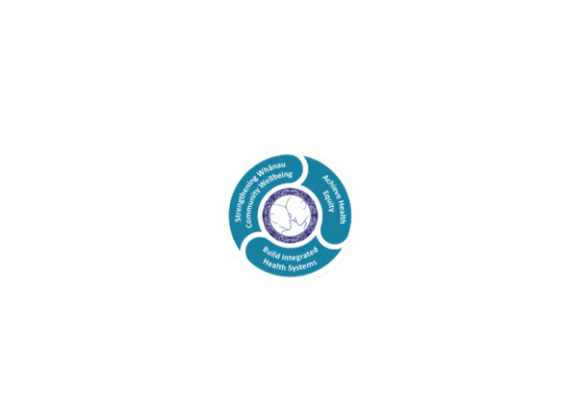

* Achieve equity in Māori health
* Build an Integrated health system
* Strengthen people, whanau & community wellbeing

### THREE CORE VALUES

Manaakitanga respect and acknowledgment of each other’s intrinsic value and contribution

Integrity truthfully and consistently acting collectively for the common good

Accountability collective and individual ownership for clinical and financial outcomes and sustainability

### TE ITI KAHURANGI – THE LAKES WAY, OUR PLACE, OUR CULTURE – WE WILL

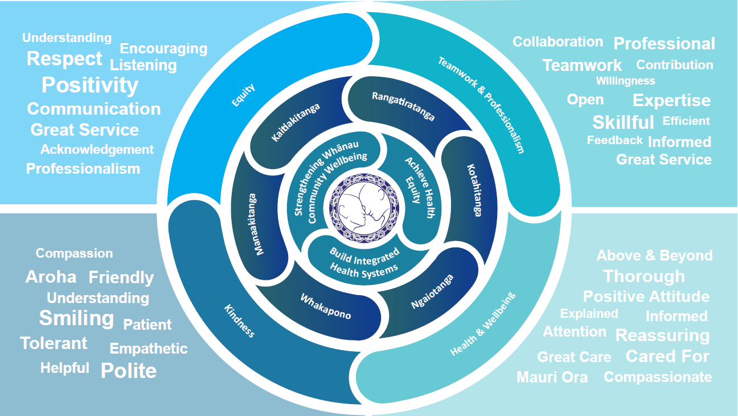

### TE TIRITI O WAITANGI

**Our expression of Te Tiriti o Waitangi**

The text of Te Tiriti, including the preamble and the three articles, along with the Ritenga Māori declaration, are the enduring foundation of our approach to achieving health and independence. Based on these foundations, we will strive to achieve the following four goals, each expressed in terms of mana.

**Mana whakahaere**

Effective and appropriate kaitiakitanga and stewardship over the health and disability system. Mana whakahaere is the exercise of control in accordance with tikanga, kaupapa and kawa Māori. This goes beyond the management of assets and resources and towards enabling Māori aspirations for health and independence.

**Mana motuhake**

Enabling the right for Māori to be Māori (Māori self-determination); to exercise their authority over their lives and to live on Māori terms and according to Māori philosophies, values and practices, including tikanga Māori.

**Mana tangata**

Achieving equity in health and disability outcomes for Māori, enhancing the mana of people across their life course and contributing to the overall health and wellbeing of Māori.

**Mana Māori**

Enabling Ritenga Māori (Māori customary rituals), which are framed by te ao Māori (the Māori world), enacted through tikanga Māori (Māori philosophy and customary practices) and encapsulated within mātauranga Māori (Māori knowledge).

Te Whatu Ora Lakes is committed within the framework of the New Zealand Public Health and Disability Act (2000) to supporting the Crown’s commitment to upholding its Tiriti promises.

### ORGANISATION STRUCTURE

