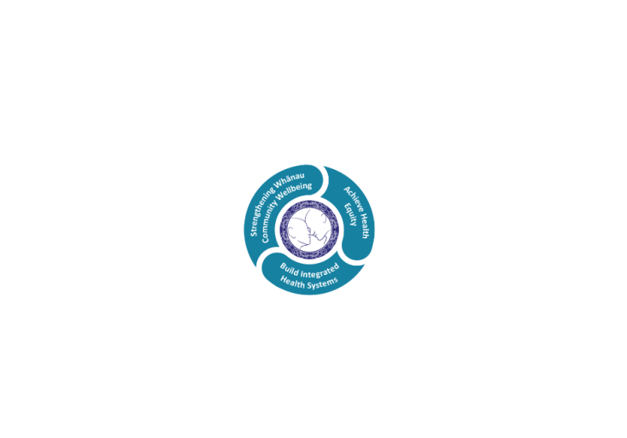

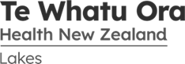

# POSITION DESCRIPTION

|  |  |  |
| --- | --- | --- |
| **Position**: | Information Systems Service Desk Analyst Level 1 | |
| **Responsible to:** | Information Systems Service Desk Team Leader | |
| **Direct Reports:** | 0 | |
| **Location:** | Rotorua & Taupo | |
| **Functional relationships:** | **Internal:**  Clerical Staff  Nursing Staff  Allied Health Staff  Medical Staff  Other Departments | **External**:  External Contractors  Other Regions (Previously DHB’s)  Regional and National Health Services |
| **Financial delegations:** | N/A | |
| **Date**: | February 2024 | |

### Primary purpose(s) of the position

The IS Service Desk Analyst role will ensure proper computer and/or device operation so that end users can accomplish business tasks. This includes receiving, prioritising, documenting, and actively resolving end user incidents and requests. Problem resolution may involve the use of diagnostic and service request tracking tools, or visiting a user and/or hardware while supporting cyber-security best practises and guidelines.

This role will work closely with the Asset Management Specialist and assist with processing Information Systems Department inwards goods, receipting hardware and ensuring bar codes are applied to new assets. Updating the asset register, ensuring all hardware and software databases are up to date. Stored IS equipment is to be kept in a tidy and well organised fashion.

This role will also ensure hardware, software, and license requirements are recorded and managed throughout their lifecycles. Quarterly End of Life cycles are managed, and defined new hardware purchasing recommendations are to be presented to senior management and stakeholders as older equipment is replaced by newer model hardware.

|  |  |  |
| --- | --- | --- |
| **Key Objectives** | Description | Expected Outcomes |
| **Strategic Planning** | * Participate in IT department operational and strategic planning including fostering innovation, planning projects, and organize and negotiate the allocation of resources. | * Able to articulate and explain information systems decisions and strategies in relation to the strategic documents. * Documented proposals and initiatives are in line with organisational goals and strategies. |
| **Asset Management** | Process all requests for Information Systems (IS) hardware and/or software requests, checking that the requested asset is optimal for the workload required. Maintain the asset life cycle management process and procedures from receipt to disposal.  Develop and maintain a system for staff to obtain information about hardware and software purchasing requirements, quotations and relevant information about deliveries.  Ensure that all IS assets are recorded in full in the Te Whatu Ora – Lakes asset management system.  Develop and maintain annual procurement budgets for all IS software and hardware assets replacements.  Investigate options to reduce asset replacement costs. Document in detail, options and recommendations so that they can be presented to Management.  Maintain build documentation, process workflows and training material for other staff/temporary staff to complete processes.  Manage the New Technology” on boarding review process and ensure it is consistent across all IS software and hardware assets. Where this crosses boundaries with other teams, ensure they are aware of the review process and help document the outcomes.  Manage break/fix hardware assets and ensure they are rotated out as per best practice. Storage facilities are clean, tidy and comply with Health and Safety requirements.  Track asset movements and ensure that details are added to the Lakes asset management database.  Monthly and AD-HOC reporting requirements for all IS assets.  Ensure all hardware assets are maintained secure as per the requirements of the New Zealand Information Security Manual (NZISM) and Protective Security Requirements (PSR). This includes through the use of security technology, threat management software and where necessary, physical security. End of life process include secure wipe or destruction to ensure no patient identifiable data can be recovered.  Monitor assets to ensure they are running at optimum levels.  Ensure licence management is monitored to save cost to Lakes.  Liaise with staff and Service Managements to ensure that new and/or replacement hardware/software is fit for purpose and that alternative options are considered. | * All IS software and hardware assets are recorded within the Lakes asset management database. * Assets are secure and well managed. * Reporting is current and includes all IS assets. * Budgets are maintained and can be reported on at any time. * Documentation for builds, process workflows and procedures are current. * New technologies/software are implemented with a well-planned strategy and IS staff are aware of pending implementations. * All new or replacement hardware/software has been reviewed and alternatives discussed with staff and Service Managers. Replacement desktop and laptops are checked against less expensive Thin Client options. |
| **Customer Support** | * Offer recommendations and alternatives for all software and hardware requests. * Communicate clearly with all customers. * Build rapport and elicit problem details from support desk customers where it relates to IS software or hardware assets. * Manage the inactive accounts process and procedures. * Establish and enforce support desk service levels agreements in consultation with end users to establish problem resolution expectations and timeframes. * Be familiar with current virus/security threats, symptoms and actions. * Perform post-resolution follow-ups to support requests where it relates to software or hardware maintenance/licencing. * Evaluate documented resolutions and analyse trends for ways to prevent future problems. * Apply approved diagnostic utilities to aid troubleshooting. * Assess need for any system reconfigurations (minor or significant) based on request trends and make recommendations. | * End users calls are answered promptly and courteously every time. * All calls to the support desk are logged and documented * Calls are prioritised and when required allocated to the Support Analysts according to the priority. * Calls should be tracked and updated with relevant information at every step of the resolution. * Virus incidents are handled and resolved or escalated as appropriate. * If calls are not being actioned promptly follow up with the relevant Support Analyst. * End users are contacted post-resolution to ensure the user is satisfied with the resolution. * After the end user is satisfied with the resolution, then resolve the call. * Offer suggestions on how to resolve long standing problems or repetitive calls. * Maintain an awareness of customer needs and information system problems, particularly with reference to the health industry and its unique requirements. * Effective communications with the end users and staff of the information systems department. * Prioritising user demands and project work to meet service levels, user and project deadlines. * Provide an effective support function for Te Whatu Ora - Lakes that meets agreed service levels. * Long term inactive accounts are checked and where necessary recorded and escalated for further action |
| **Administration** | * Be familiar with the business as usual (BAU) applications supported, including Clinical Information System, Galen Patient Management System, Electronic Document Management System, Content Management System, Microsoft Office Applications, and Telecommunication Systems. * Be familiar with Disaster Response Planning (DRP) and Business Continuity Planning for core business applications. * Ensuring Te Whatu Ora – Lakes standards, procedures and processes being adhered to. * Be available to assist with after-hours work on occasions. * Track and analyse trends in support desk requests and activities, generate statistical reports. * Actively participate in regular Information Systems Department meetings. * Preparation and documentation of Information System support desk policies and procedures for users of Te Whatu Ora - Lakes Information Systems. * Participation in IS projects as required. * Preparation of support documentation for Te Whatu Ora - Lakes end users. * Perform preventive maintenance, including checking and cleaning of workstations, printers and peripherals. * Proficient use of the utilities and applications that are installed on Te Whatu Ora - Lakes computers. * Conversant with all Information Systems operated by Te Whatu Ora - Lakes. * Be “On-Call” a maximum of one week in four. Rostered early start / late finish times are required to support Te Whatu Ora – Lakes for extended business hours. * Effective application support for the core systems used by Te Whatu Ora - Lakes. * Familiar with and able to articulate DR and BC plans include the loss of core applications / systems and recovery processes from the outage. * Comprehensive documentation up to date, accessible and accurate. * Software licences are accurately tracked documented and audited. * Awareness and adherence to Te Whatu Ora - Lakes policies and procedures. * Be able to work effectively in a team environment. * Desktop equipment is adequately maintained to minimise faults. * Be aware of and effectively use the tools provided to the IS department. * Demonstrate knowledge of the information systems in use at Te Whatu Ora - Lakes. * Manage Inwards Goods process for all IS Department deliveries. * Preparation and documentation for end users and IS staff (policies and procedures, build documentation, application documentation, standards etc.). * Follow best practices (ITIL) and policies. * Monitor systems for issues and failures with an aim to alerting others before it affects the users. | * Effective application support for the core systems used by Te Whatu Ora - Lakes. * Familiar with and able to articulate DR and BC plans include the loss of core applications / systems and recovery processes from the outage. * Comprehensive documentation up to date, accessible and accurate. * Awareness and adherence to Te Whatu Ora - Lakes policies and procedures. * Be able to work effectively in a team environment. * Be aware of and effectively use the tools provided to the IS department. * Demonstrate knowledge of the information systems in use at Te Whatu Ora - Lakes |
| **Security** | * Monitor systems to ensure they are secure and operate at optimal levels. * Ensure user account documentation is complete, accounts are correct and records maintained. * Ensure remote user accounts are audited and any accounts no longer required are disabled. * All USB devices and media are scanned for threats prior to being accessed. * Internal and external threats are monitored and reported to senior staff. |  |

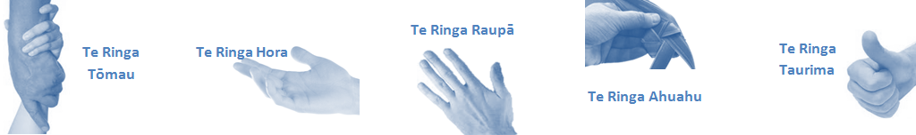

|  |  |  |
| --- | --- | --- |
| **Capabilities** | Capability definition | Achievement Indicators |
| **Communication and Personal Interaction**  **Te Ringa Hora**  ***the open hand (denoting someone who is sociable)*** | Openly communicates and cooperates with all levels of Lakes employees, patients and visitors | * Listens actively, absorbs message and responds appropriately. * Builds effective working relationships. * Establishes rapport with others and gains their respect while being adaptive in relating to different types of people and situation. * Openly and constructively participates in conversations with management team, service managers and colleagues. * Collegiality with team mates and management teams. * Accepts differences of opinion can occur but these happen respectfully and without any continued animosity |
| **Strategy & Performance**  **Te Ringa Raupā**  ***the roughened hand (symbolising a hard worker)*** | Spends energy on delivering role requirements and meeting objectives | * Has an energetic approach to work and is self- motivated. * Accepts direction and instruction of manager but is able to work effectively without direction or guidance. * Organises time and resources effectively. * Understands and work towards achievement of the organisation’s goals. |
| Organises own time to deliver on required tasks and duties | * Utilises effective time management strategies to meet shift duties and works towards achieving objectives in any spare moments. |
| **Development and Change**  **Te Ringa Ahuahu**  ***the hand that shapes or fashions something (refers to someone who is innovative)*** | Accepts change in day to day practices and contributes to decision making of the team. | * Can adjust behaviour to the demands of the work environment in order to remain productive through periods of transition, ambiguity, uncertainty and stress |
| Makes suggestions to increase efficiency of the unit. | * Works with managers and team to make any changes within practices work * Contributes to change processes, offering solution based ideas. * Constructively makes suggestions to improve process or practices and gain efficiencies. * Accepts when ideas are not accepted for implementation. |
| **Personal Accountability**  **Te Ringa Tōmau**  ***the hand that is trustworthy*** | Is open with team leader, manager and colleagues and open to accepting feedback and critique to improve upon practice. | * Offers constructive criticism and accepts feedback. * Establishes rapport with others and gains their respect while being adaptive in relating to different types of people and situations, to allow improvements to be made. * Accepts all feedback and participates in feedback discussions appropriately. * Responds and queries how improvements can be made * Advises manager wherever issues may be impacting on performance. |
| Looks for and undertakes development activities appropriate for role and career development. | * Recognises areas that could be improved in own practice. * Requests learning and development opportunities to enhance practice in role and/ or to assist where improvements can be made. * Recognises and facilitates the rights of Māori clients and their whanau to participate in cultural activities. * Has a working knowledge of the Te Whatu Ora - Lakes Māori communities. |
| **Culture and Values**  **Te Ringa Taurima**  ***the hand that nurtures, encourages, supports*** | Operates in line with Lakes values and expectations and professional codes of conduct. | * Demonstrates a commitment to cultural safety by meeting and exceeding the cultural needs of clients/ customers / colleagues. * Incorporates the Lakes Way into day to day business activities. * Shows respect for, colleagues, managers, and vendors. * Utilises the Lakes Way philosophy to engage with patients, visitors and multi-disciplinary teams. |

|  |  |  |
| --- | --- | --- |
| **Compulsory Requirements** | Description | Expected Outcomes |
| **Māori Health** | Māori philosophies and values of health are demonstrated in work practice. | * Meaningful relationships are established with Te Huinga Takiora Māori in the planning and delivery of services. * Practices are consistent with Te Tiriti o Waitangi /The Treaty of Waitangi when working with Māori. * Delivery of safe services for Māori are facilitated by ensuring they can access treatment options and are involved in the planning and delivery of their care. * Māori are enabled to access and participate in cultural activities provided by the Lakes DHB. * A commitment to improving the wellbeing of Māori by increasing cultural knowledge in the Lakes DHB is shown. |
| **Te Iti Kahurangi** | The Lakes Way, Our Place Our Culture | * Works within the Te Iti Kahurangi framework and supporting guide document. |
| **Record Keeping** |  | * Complies with the Lakes DHB Corporate Records Management policy to create and maintain full and accurate records. |
| **Quality & Risk** | Patient safety is paramount to the service we deliver at Lakes District Health Board. This is to be achieved in a clinical governance framework that is culturally responsive and identifies and manages risk and opportunities to improve. | * Employees are supported to lead by example and implement a culture of continuous quality improvement. * Risks that may prevent Lakes DHB from achieving their goals are identified, reported, and managed. * Māori patients are provided patient-centred care to achieve positive Māori health outcomes. * Needs of Māori are reviewed and reported in the further development of practice, process and or policy. * Evidence-based methodologies are used to support improvements, e.g. kaupapa Māori methodology. * Quality care is provided to certification standards. |
| **Health & Safety** | Each individual is responsible for ensuring the safety of themselves, their colleagues, patients and their visitors and to comply with all organisational health and safety policies, procedures and guidelines. | * Implementation and reinforcement of a proactive healthy work place culture which reflects relevant Lakes DHB policy and legislative requirements. * Healthy lifestyles are actively promoted and participated in, within the work area. * Employees participate in Health and Safety within areas of work. * Health and Safety activities are appropriately documented within specified timeframes. * Health and Safety policies have been read and understood and are applied in the workplace. * Health and Safety policies are appropriately documented within specified timeframes and incidents are reported immediately. * Any opportunities for improving Health and Safety are reported and acted upon in a timely manner. * All near misses/incident/accidents are reported to the appropriate line manager within 24 hours. |

**Signatures:**

|  |  |
| --- | --- |
| Line Manager:  (position description approved): |  |
| Employee:  (acceptance of position description): |  |

*(Please also initial all other pages to show acceptance of position description.)*

|  |  |  |
| --- | --- | --- |
| **Person Specification** | **Essential:** | **Desirable:** |
| **Education and Qualifications:** | * 2 years’ experience within an enterprise Information Technology environment or equivalent experience. * One years’ experience in Microsoft Networks and Windows Operating Systems or equivalent experience. * A tertiary qualification in IS | * Microsoft 365 Certification: Modern desktop administrator associate certification * Microsoft MCSA Windows 10 Implementing and Managing Windows ITIL Foundation certification certified |
| **Experience:** | * Application support experience with Microsoft Office products. * Knowledge of Enterprise asset management tools. * Knowledge of application deployment toolsets | * Experience working with licence and asset management tools. * Entry level application support experience with all Microsoft applications, current Microsoft operating systems, hospital based administration systems and corporate support systems. * Microsoft Systems Centre Configuration Management knowledge. * Hospital information systems including the patient management system. * Familiar with the Health Industry. |
| **Knowledge:** | * Te Tiriti O Waitangi in the provision of health care services and support to Māori. * Te Tiriti O Waitangi in practice, process, policy development and decision making. * Excellent technical problem solving methodologies. | * Working knowledge of a range of diagnostic utilities |
| **Skills:** | * Pronunciation of Te Reo Māori words and names * Excellent written and oral communication skills and strong documentation skills * Excellent interpersonal skills, with a focus on rapport-building, listening, and questioning skills. | * Te Reo Māori * Good understanding of Te Whatu Ora – Lakes’ goals and objectives |
| **Personal Attributes:** | * Ability to conduct research into a wide range of computing issues * Ability to absorb and retain information quickly * Ability to present ideas in user-friendly language * Highly self-motivated and directed * Keen attention to detail * Proven analytical and problem-solving abilities. * Ability to effectively prioritize and execute tasks in a high-pressure environment * Experience working in a team-oriented, collaborative environment * Time management skills * Stress tolerance * Commitment to quality systems and services * An understanding of providing service level agreements deliverables * On call availability * Additional working hours as required. * Sitting for extended periods of time. * Dexterity of hands and fingers to operate a computer keyboard, mouse, power tools, and to handle other computer components. * Ability to lift and transport moderately heavy objects, such as computers and peripherals. | * Non-smoker preferred.. |

**ABOUT TE WHATU ORA LAKES**

At Te Whatu Ora Lakes we place the highest value on the health and wellbeing of everyone in our community. As such all healthcare workers are expected to play a part in the creation and promotion of an environment which lives the following vision, mission and values:

### VISION

Healthy Communities – Mauriora! In this vision Mauriora refers to the Mauri - being the life essence and the source of well being, and ora - describing the state of wellness.

### STRATEGIC MISSION

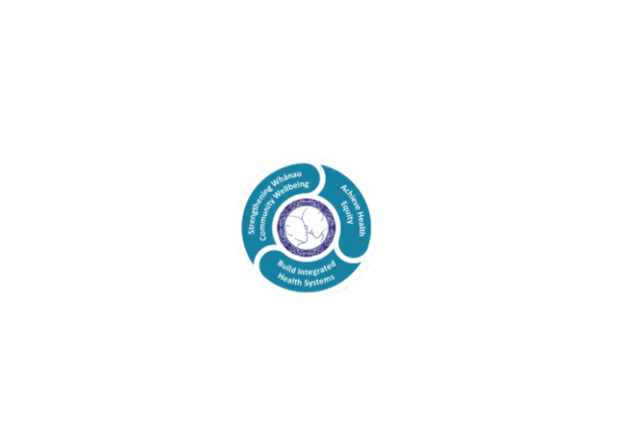

* Achieve equity in Māori health
* Build an Integrated health system
* Strengthen people, whanau & community wellbeing

### THREE CORE VALUES

Manaakitanga respect and acknowledgment of each other’s intrinsic value and contribution

Integrity truthfully and consistently acting collectively for the common good

Accountability collective and individual ownership for clinical and financial outcomes and sustainability

### TE ITI KAHURANGI – THE LAKES WAY, OUR PLACE, OUR CULTURE – WE WILL

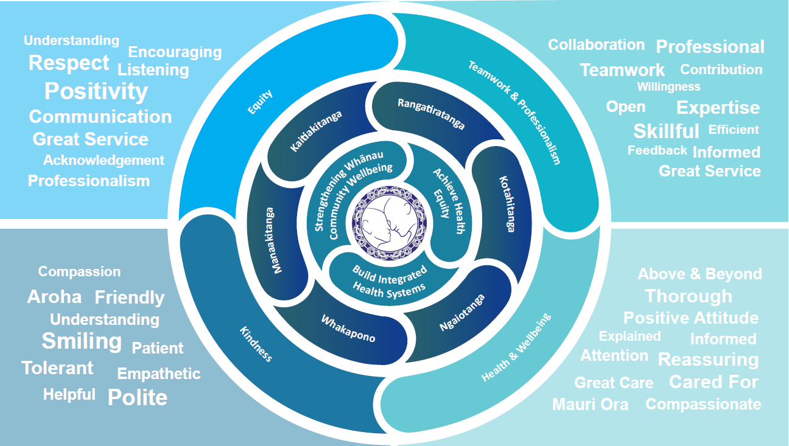

### TE TIRITI O WAITANGI

**Our expression of Te Tiriti o Waitangi**

The text of Te Tiriti, including the preamble and the three articles, along with the Ritenga Māori declaration, are the enduring foundation of our approach to achieving health and independence. Based on these foundations, we will strive to achieve the following four goals, each expressed in terms of mana.

**Mana whakahaere**

Effective and appropriate kaitiakitanga and stewardship over the health and disability system. Mana whakahaere is the exercise of control in accordance with tikanga, kaupapa and kawa Māori. This goes beyond the management of assets and resources and towards enabling Māori aspirations for health and independence.

**Mana motuhake**

Enabling the right for Māori to be Māori (Māori self-determination); to exercise their authority over their lives and to live on Māori terms and according to Māori philosophies, values and practices, including tikanga Māori.

**Mana tangata**

Achieving equity in health and disability outcomes for Māori, enhancing the mana of people across their life course and contributing to the overall health and wellbeing of Māori.

**Mana Māori**

Enabling Ritenga Māori (Māori customary rituals), which are framed by te ao Māori (the Māori world), enacted through tikanga Māori (Māori philosophy and customary practices) and encapsulated within mātauranga Māori (Māori knowledge).

Te Whatu Ora Lakes is committed within the framework of the New Zealand Public Health and Disability Act (2000) to supporting the Crown’s commitment to upholding its Tiriti promises.

### ORGANISATION STRUCTURE

