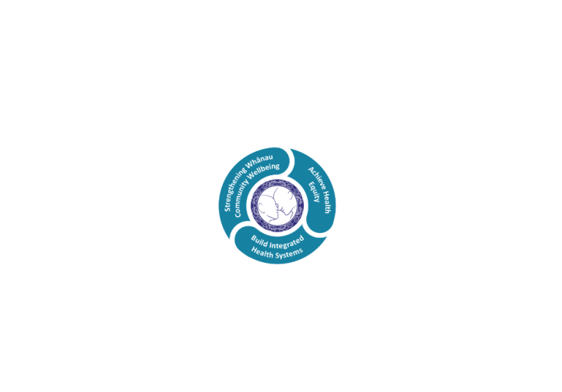

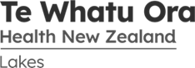

# POSITION DESCRIPTION

|  |  |  |
| --- | --- | --- |
| **Position**: | Administration Support – Clinical Records | |
| **Responsible to:** | Manager Clinical Records and Coding | |
| **Location:** | Rotorua & Taupo | |
| **Functional relationships:** | **Internal**:  Administrative Staff  Clerical Staff  Nursing Staff  Allied Health Staff  Medical Staff  Other Departments | **External**:  GPs  Other hospital  All provider of care to Te Whatu Ora  Patients |
| **Date**: | January 2024 | |

### Primary purpose(s) of the position

1. Provide an administrative support role within the Clinical Records team to ensure that relevant clinical information is –
   * Filed accurately and that patient records are readily locatable for on-going patient care.
   * Scanned and uploaded to the clinical information system (LCWS) when required to be available electronically for wider clinical access.
2. Provide an administrative support role for the **Clinical Coding** team to locate and retrieve patient records and documentation to facilitate the completion of clinical coding within the agreed timeframes.
3. Rotate roles within the Clinical Records Department to provide leave cover where needed and assist in the provision of a quality service which is critical to effective patient care and clinical support, and for meeting internal and external information provision.

.

|  |  |  |
| --- | --- | --- |
| **Key Objectives** | Description | Expected Outcomes |
| **Leave Cover** | * Be conversant with the responsibilities of all roles within the Clinical Records department and provide leave cover for team members as required by the Team Leader. | * The risk of backlogs of essential patient information is minimised * Deadlines are maintained for the provision of timely patient information * A seamless service is provided by the department to all areas of the organisation |
| **Filing - Incoming** | * Assist with filing in-coming correspondence, reports, and results into the appropriate position within the patient record. | * Patient records contain the most recent correspondence, reports and results available, and these are easily located within the appropriate section of the record. |
| **Filing Patient Records** | * Assist with filing patient records in the filing rooms strictly in accordance with the alpha numeric filing system. | * All patient records, when not in use, are appropriately filed in the main filing room and are readily locatable when required. |
| **Tracking** | * Make full and appropriate use of the electronic tracking system (PDT) to facilitate speed and accuracy in locating patient records for all patient records leaving and returning to the department. * Assist with ensuring that all patient records returned to the department are electronically logged to the appropriate location and distributed accordingly. * Assist with monitoring the electronic request screen and action requests appropriately. | * The rapid retrieval of patient clinical records is ensured with records not currently in the filing room being easily locatable by use of the electronic tracking system. * All patient records returned to the department are appropriately tracked to the main filing room, or correct location within the office, and are readily locatable when required. * A timely and up to date service for requesting patient records is provided to all users. |
| **Electronic Documentation** | * Assist with the scanning and saving of patient correspondence and results from tertiary providers, along with other agreed documents, for uploading into LCWS to provide electronic access to non-Lakes clinical information and to minimise the provision of hard copy patient records for those patients requiring on-going care. * To have a commitment to the further development of electronic documentation to provide greater access to shared information and improved communication. | * Documentation for Lakes patients becomes increasingly available in electronic format on the clinical information system for clinical and administrative purposes. * Confidence in electronic documentation is generated and maintained to support further roll-out of paper-light outpatient clinics. * Processes meet the legislative requirements for the electronic storage of documentation covered by the Public Records Act. |
| **Coding Support**  **Coding Support**  *cont..* | * Monitor the outstanding coding report and locate patient records which are not tracked into the Clinical Coding Service within an agreed period post discharge from Lakes DHB hospitals. * Support the Coding team with other administrative tasks when needed. | * Clinical coders have the patient records and documentation required to complete all clinical coding within the strict internal deadlines required for contract and financial reporting purposes, as well as for submission to the national collection - NMDS. * Delays are avoided at critical times in the month through the consistency of workload for the coders during the reporting period. * The coding team are able to be dedicated to achieving the team targets for coding completion and the quality of coding outcomes with fewer distractions from their primary purpose. |
| **Audits** | * Assist with assembling patient records for clinical and quality audits as required and track to appropriate location. Liaise with requestor of the audit records re timeframes to ensure minimum disruption to other users. | * Patient Records are made available in a timely manner for auditing where possible yet remain locatable for acute retrieval as required. |
| **Update Non-Active Records** | * Retrieve non-active patient records from the non-active filing room on a regular basis or as required for acute situations. | * All existing patient records are updated following a new contact with Rotorua hospital to maintain continuity of care in accordance with current legislation and Lakes DHB policy. |
| **Culling** | * Assist with the culling of non-active patient records in accordance with the Public Records Act (2005) and Lakes DHB policy. | * The active filing room is kept current and access to non-active patient records is maintained. |
| **Filing Rooms** | * Carry out duties in filing areas in such a way that they are at all times tidy and safe for other users of the service. | * The filing rooms are a safe working environment for staff including the after hours users of the department. |
| **Customer Focus** | * Perform other duties as required by the Team Leader to ensure the provision of a customer focused service. | * Clinical Records and Clinical Coding provide an appropriate and effective service and meet expected performance standards. |

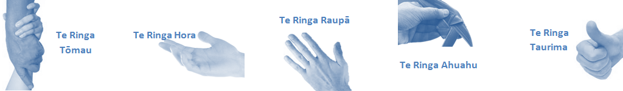

|  |  |  |  |  |  |  |  |  |  |  |  |  |  |  |  |  |  |  |  |  |  |  |  |  |  |  |  |  |  |
| --- | --- | --- | --- | --- | --- | --- | --- | --- | --- | --- | --- | --- | --- | --- | --- | --- | --- | --- | --- | --- | --- | --- | --- | --- | --- | --- | --- | --- | --- |
| |  |  |  | | --- | --- | --- | | **Capabilities** | **Capability definition** | **Achievement Indicators** | | **Communication and Personal Interaction**  **Te Ringa Hora**  ***the open hand (denoting someone who is sociable)*** | Openly communicates and cooperates with all levels of DHB employees, patients and visitors. | * Listens actively, absorbs message and responds appropriately. * Builds effective working relationships. * Establishes rapport with others and gains their respect while being adaptive in relating to different types of people and situation. * Openly and constructively participates in conversations with colleagues, patients, managers and visitors * Patients and visitors are appropriately welcomed and treated while within the DHB * Collegiality with team mates and all staff. * Accepts differences of opinion can occur but these happen respectfully and without any continued animosity | | **Strategy & Performance**  **Te Ringa Raupā**  ***the roughened hand (symbolising a hard worker)*** | Spends energy on delivering role requirements and meeting objectives | * Has an energetic approach to work and is self motivated. * Accepts direction and instruction of manager but is able to work effectively without direction or guidance. * Organises time and resources effectively. * Understands and work towards achievement of the organisation’s goals. * On shift is busy completing shift duties. | | Organises own time to deliver on required tasks and duties | * Utilises effective time management strategies to meet shift duties and works towards achieving objectives in any spare moments. | | **Development and Change**  **Te Ringa Ahuahu**  ***the hand that shapes or fashions something (refers to someone who is innovative)*** | Accepts change in day to day practices and contributes to decision making of the team. | * Can adjust behaviour to the demands of the work environment in order to remain productive through periods of transition, ambiguity, uncertainty and stress | | Makes suggestions to increase efficiency of the unit. | * Works with managers and team to make any changes within practices work * Contributes to change processes, offering solution based ideas * Constructively makes suggestions to improve process or practices and gain efficiencies * Accepts when ideas are not accepted for implementation | | **Personal Accountability**  **Te Ringa Tōmau**  ***the hand that is trustworthy*** | Is open with manager and colleagues and open to accepting feedback and critique to improve upon practice. | * Offers constructive criticism and accepts feedback. * Establishes rapport with others and gains their respect while being adaptive in relating to different types of people and situations, to allow improvements to be made. * Accepts all feedback and participates in feedback discussions appropriately * Responds and queries how improvements can be made * Advises manager wherever issues may be impacting on performance | | Looks for and undertakes development activities appropriate for role and career development. | * Recognises areas that could be improved in own practice * Requests learning and development opportunities to enhance practice in role and/ or to assist where improvements can be made * Recognises and facilitates the rights of Māori clients and their whanau to participate in cultural activities. * Has a working knowledge of the Lakes DHB Māori communities. | | **Culture and Values**  **Te Ringa Taurima**  ***the hand that nurtures, encourages, supports*** | Operates in line with DHB values and expectations and professional codes of conduct. | * Demonstrates a commitment to cultural safety by meeting and exceeding the cultural needs of clients / customers / colleagues. * Incorporates the Lakes Way into day to day business activities * Shows respect for patients, colleagues. * Utilises the Lakes Way philosophy to engage with patients, visitors and other staff. | | | | |  |  |
| **Compulsory Requirements** | Description | Expected Outcomes |
| **Māori Health** | Māori philosophies and values of health are demonstrated in work practice. | * Meaningful relationships are established with Te Aka Matua (Rotorua and Taupo Hospitals) and Te Whatu Ora Lakes Maori Health division in the planning and delivery of services. * Practices are consistent with Te Tiriti o Waitangi /The Treaty of Waitangi when working with Māori. * Delivery of safe services for Māori are facilitated by ensuring they can access treatment options and are involved in the planning and delivery of their care. * Māori are enabled to access and participate in cultural activities provided by the Te Whatu Ora Lakes. * A commitment to improving the wellbeing of Māori by increasing cultural knowledge in the Te Whatu Ora Lakes is shown. |
| **Te Iti Kahurangi** | The Lakes Way, Our Place Our Culture | * Works within the Te Iti Kahurangi framework and supporting guide document. |
| **Record Keeping** |  | * Complies with the Te Whatu Ora Lakes Corporate Records Management policy to create and maintain full and accurate records. |
| **Quality & Risk** | Patient safety is paramount to the service we deliver at Te Whatu Ora Lakes. This is to be achieved in a clinical governance framework that is culturally responsive and identifies and manages risk and opportunities to improve. | * Employees are supported to lead by example and implement a culture of continuous quality improvement. * Risks that may prevent Te Whatu Ora Lakes from achieving their goals are identified, reported, and managed. * Māori patients are provided patient-centred care to achieve positive Māori health outcomes. * Needs of Māori are reviewed and reported in the further development of practice, process and or policy. * Evidence-based methodologies are used to support improvements, e.g. kaupapa Māori methodology. * Quality care is provided to certification standards. |
| **Health & Safety** | Each individual is responsible for ensuring the safety of themselves, their colleagues, patients and their visitors and to comply with all organisational health and safety policies, procedures and guidelines. | * Implementation and reinforcement of a proactive healthy work place culture which reflects relevant Te Whatu Ora Lakes policy and legislative requirements. * Healthy lifestyles are actively promoted and participated in, within the work area. * Employees participate in Health and Safety within areas of work. * Health and Safety activities are appropriately documented within specified timeframes. * Health and Safety policies have been read and understood and are applied in the workplace. * Health and Safety policies are appropriately documented within specified timeframes and incidents are reported immediately. * Any opportunities for improving Health and Safety are reported and acted upon in a timely manner. * All near misses/incident/accidents are reported to the appropriate line manager within 24 hours. |

**Signatures:**

|  |  |
| --- | --- |
| Line Manager:  (position description approved): |  |
| Employee:  (acceptance of position description): |  |

*(Please also initial all other pages to show acceptance of position description.)*

|  |  |  |
| --- | --- | --- |
| **Person Specification** | **Essential:** | **Desirable:** |
| **Education and Qualifications:** | * Secondary schooling * Computer applications |  |
| **Experience:** | * Administrative experience * Proven ability to work autonomously |  |
| **Knowledge:** | * Te Tiriti O Waitangi in the provision of health care services and support to Māori. * Te Tiriti O Waitangi in practice, process, policy development and decision making. * Te Whatu Ora Lakes is a Reorua organisation knowledge and understanding of Te Reo/ Correct pronunciation. * An understanding and active commitment to Te Whatu Ora Lakes Declaration of Fidelity and the maintaining of all aspects of patient confidentiality. | * Privacy Act, Health Information Act * An awareness of the Health Information Code and Privacy Act 1993 * Some knowledge of anatomy and medical terminology with an understanding of clinical issues and procedures, or similar health experience |
| **Skills:** | * Excellent computer skills * Time management skills with the ability to meet set timeframes * Organised, logical, and methodical planning and work processes * Pronunciation of Te Reo Māori words and names |  |
| **Personal Attributes:** | * Ability to relate effectively to a wide range of people * Well presented and tidy in appearance at all times * Ability to maintain calm disposition under stress * Capable of working unsupervised and as a team player * Self motivated and uses initiative | * Non-smoker preferred. |

**ABOUT TE WHATU ORA LAKES**

At Te Whatu Ora Lakes we place the highest value on the health and wellbeing of everyone in our community. As such all healthcare workers are expected to play a part in the creation and promotion of an environment which lives the following vision, mission and values:

### VISION

Healthy Communities – Mauriora! In this vision Mauriora refers to the Mauri - being the life essence and the source of well being, and ora - describing the state of wellness.

### STRATEGIC MISSION

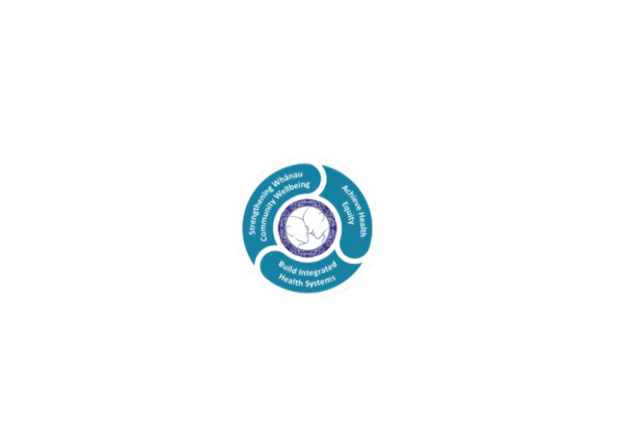

* Achieve equity in Māori health
* Build an Integrated health system
* Strengthen people, whanau & community wellbeing

### THREE CORE VALUES

Manaakitanga respect and acknowledgment of each other’s intrinsic value and contribution

Integrity truthfully and consistently acting collectively for the common good

Accountability collective and individual ownership for clinical and financial outcomes and sustainability

### TE ITI KAHURANGI – THE LAKES WAY, OUR PLACE, OUR CULTURE – WE WILL

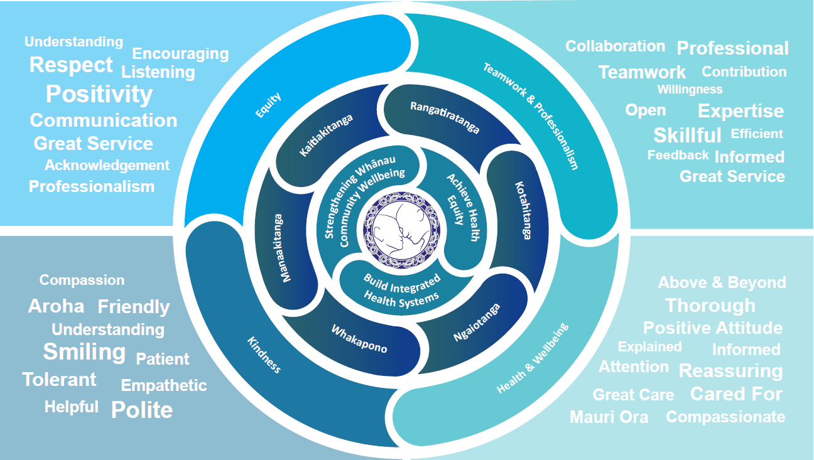

### TE TIRITI O WAITANGI

**Our expression of Te Tiriti o Waitangi**

The text of Te Tiriti, including the preamble and the three articles, along with the Ritenga Māori declaration, are the enduring foundation of our approach to achieving health and independence. Based on these foundations, we will strive to achieve the following four goals, each expressed in terms of mana.

**Mana whakahaere**

Effective and appropriate kaitiakitanga and stewardship over the health and disability system. Mana whakahaere is the exercise of control in accordance with tikanga, kaupapa and kawa Māori. This goes beyond the management of assets and resources and towards enabling Māori aspirations for health and independence.

**Mana motuhake**

Enabling the right for Māori to be Māori (Māori self-determination); to exercise their authority over their lives and to live on Māori terms and according to Māori philosophies, values and practices, including tikanga Māori.

**Mana tangata**

Achieving equity in health and disability outcomes for Māori, enhancing the mana of people across their life course and contributing to the overall health and wellbeing of Māori.

**Mana Māori**

Enabling Ritenga Māori (Māori customary rituals), which are framed by te ao Māori (the Māori world), enacted through tikanga Māori (Māori philosophy and customary practices) and encapsulated within mātauranga Māori (Māori knowledge).

Te Whatu Ora Lakes is committed within the framework of the New Zealand Public Health and Disability Act (2000) to supporting the Crown’s commitment to upholding its Tiriti promises.

### ORGANISATION STRUCTURE

