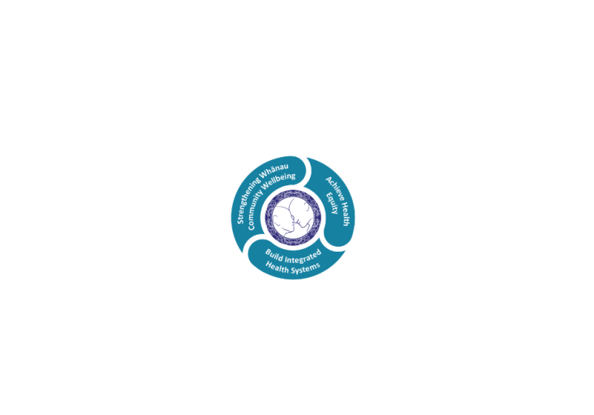

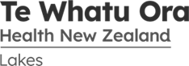

# POSITION DESCRIPTION

|  |  |  |
| --- | --- | --- |
| **Position**: | Administration Support – Clinical Records | |
| **Responsible to:** | Manager Clinical Records and Coding | |
| **Location:** | Rotorua & Taupo | |
| **Functional relationships:** | **Internal**:  Clerical Staff  Nursing Staff  Allied Health Staff  Medical Staff  Other Departments | **External**:  GPs  Other hospital  All provider of care to Te Whatu Ora  Patients |
| **Date**: | October 2022 | |

### Primary purpose(s) of the position

1. Ensure the timely provision of patient files for paper-based Outpatient clinics with emphasis on the appropriateness, completeness, and tidiness of the clinical information within the file.

2. Assist with ensuring the timely availability of electronic documentation and the provision of supporting documentation to the services providing paper-light Outpatient clinics placing emphasis on the completeness and appropriateness of the electronic information available.

3. Provide an administrative support role within the Clinical Records team to ensure that relevant clinical information is –

• Filed accurately and that patient records are readily locatable for on-going patient care.

• Scanned and uploaded to the clinical information system when required to be available electronically for wider clinical access.

|  |  |  |
| --- | --- | --- |
| **Key Objectives** | Description | Expected Outcomes |
| **Clinic Appointments** | Retrieve and supply all patient records required for daily outpatient clinics, including for other Lakes DHB facilities as appropriate, four days prior to the clinic’s date. All patient records for late additions to the clinics must be supplied immediately. | * All patient records are available for clinical staff prior to the patient presenting for their clinic appointment. * Patient clinical records contain the most recent hardcopy correspondence, reports and results available, with all documentation secured and easily located by the clinician within the appropriate section of the record. * Patient information regarding treatment at other hospitals is available if needed for continuity of patient care. |
| **Clinic Enquiries** | Respond to telephone, fax and email enquiries related to Outpatient clinics as required and in conjunction with the Note Preparation team. | A prompt and responsive service is provided for the retrieval of patient records for late additions / changes to Outpatient clinics, and other requests. |
| **Incoming Mail** | Open and sort mail as soon as possible following delivery, and circulate all mail appropriately within the department. | Departmental mail, including loose patient correspondence, reports and results, is sorted and readily available following delivery to the department. All identified mail for scanning and uploading into patient records is appropriately checked and sorted. |
| **Electronic Documentation** | * Assist with the scanning and saving of patient correspondence and results from tertiary providers, along with other agreed documents, for uploading into HealthViews to provide electronic access to non-Lakes clinical information and to minimise the provision of hard copy patient records for those patients requiring on-going care. * To have a commitment to the further development of electronic documentation to provide greater access to shared information and improved communication. | * Documentation for Lakes patients becomes increasingly available in electronic format on the clinical information system for clinical and administrative purposes. * Confidence in electronic documentation is generated and maintained to support further roll-out of paper-light outpatient clinics. * Processes meet the legislative requirements for the electronic storage of documentation covered by the Public Records Act. |
| **Filing Incoming** | Assist with filing in-coming correspondence, reports, and results into the appropriate position within the patient record. | Patient records contain the most recent correspondence, reports and results available, and these are easily located within the appropriate section of the record. |
| **Filing Patient Records** | Assist with filing patient records in the filing rooms strictly in accordance with the alpha numeric filing system. | All patient records, not in use, are appropriately filed in the main filing room and are readily locatable when required. |
| **Tracking** | * Make full and appropriate use of the electronic tracking system to facilitate speed and accuracy in locating patient records for all patient records leaving and returning to the department. * Assist with ensuring that all patient records returned to the department are electronically logged to the appropriate location and distributed accordingly. * Assist with monitoring the electronic request screen and action requests appropriately. | * The rapid retrieval of patient clinical records is ensured with records not currently in the filing room being easily locatable by use of the electronic tracking system. * All patient records returned to the department are appropriately tracked to the main filing room, or correct location within the office, and are readily locatable when required. * A timely and up to date service for requesting patient records is provided to all users. |
| **Audits** | Assist with assembling patient records for clinical and quality audits as required and track to appropriate location. Liaise with requestor of the audit records re timeframes to ensure minimum disruption to other users. | Patient Records are made available in a timely manner for auditing where possible yet remain locatable for acute retrieval as required. |
| **Update Non-Active Records** | Retrieve non-active patient records from the non-active filing room on a regular basis or as required for acute situations. | All existing patient records are updated following a new contact with Rotorua hospital to maintain continuity of care in accordance with current legislation and Lakes DHB policy. |
| **Culling** | Assist with the culling of non-active patient records in accordance with the Public Records Act (2005) and Lakes DHB policy. | The active filing room is kept current and access to non-active patient records is maintained. |
| **Filing Rooms** | Carry out duties in filing areas in such a way that they are at all times tidy and safe for other users of the service. | The filing rooms are a safe working environment for staff including the after hours users of the department. |
| **Customer Focus** | Perform other duties as required by the Team Leader to ensure the provision of a customer focused service. | Clinical Records and Clinical Coding provide an appropriate and effective service and meet expected performance standards. |

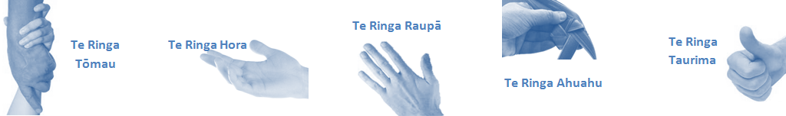

|  |  |  |
| --- | --- | --- |
| **Capabilities** | Capability definition | Achievement Indicators  *(Examples – add/ amend or delete as specific to role using matrix to assist)* |
| **Communication and Personal Interaction**  **Te Ringa Hora**  ***the open hand (denoting someone who is sociable)*** | Communicates relevant information in a timely manner to those who need to know at a level that is understood. | * Transfers information effectively verbally and writes clearly, coherently and succinctly. * Shares well thought out, concise and timely information with others using appropriate mediums. * Organisational updates are provided to staff by way of relaying in general terms but more importantly what affect it has on the unit and how staff can help where necessary to achieve any requirements. * Builds team spirit, facilitates resolution of conflict within the team, promotes/protects team reputation, shows commitment to contributing to the teams success. * Maintains and promotes high standards of social, ethical and organisational norms. |
| Fosters a team environment and encourages collaboration between team and departments within the DHB. | * Articulates differing perspectives on an issue and can see the merit of alternative points of view. * Works with other managers and teams to streamline processes for the best efficiency for both teams. * Provides staff who have concerns about another team process, a different point of view to consider. |
| Connects with people to build trust and confidence. | * Connects with others, listens, reads people and situations and communicates tactfully. * Gets to know their team members and treats them with respect, valuing their individuality and contributions. |
| **Strategy & Performance**  **Te Ringa Raupā**  ***the roughened hand (symbolising a hard worker)*** | Delegates appropriately within team utilising individual skills to achieve results. | * Understands individuals strengths and weaknesses to utilise or increase skills for those individuals. * Assigns and sub-delegates staff to teams to allow for development and succession planning. |
| Understands the unit requirements and the implications of the units achievements on the overall service delivery. | * Ensures decision making complies with organisational strategies. * Recognises decisions made within the unit affect overall results of the service and the DHB. * Works with Service Manager to maximise unit efficiency. |
| **Development and Change**  **Te Ringa Ahuahu**  ***the hand that shapes or fashions something (refers to someone who is innovative)*** | Works to include staff in change minimising barriers to implementation. | * Questions traditional ways of doing things when choosing a course of action or finds new combinations of old elements to form an innovative solution. * Continually strives for new and improved work processes that will result in greater effectiveness and efficiencies. * Openly broaches concern with staff from the outset asking for their ideas and input. * Gives examples of what might help to resolve the issue/concern. * Seeks opportunities to improve performance and seeks feedback to measure and improve. * Encourages staff participation in possible solution process. * Allows staff input to possible solutions to concern. * Gives careful consideration to staff ideas and offers alterations to suggestions where necessary. |
| Articulates decisions and reasoning behind change enable buy-in to results. | * Develops an informative response to the team including trends, data, process and benefits of the decided process/change. * Allows feedback to decision to enable ‘tinkering’ to be made where appropriate. |
| **Personal Accountability**  **Te Ringa Tōmau**  ***the hand that is trustworthy*** | Manages own and encourages others to foster work/life balance. | * Ensures regular breaks are taken and own annual leave accruals are used within the 12 months following accrual. * Ensures employees within their service are taking regular annual leave breaks for the purpose of rest/recreation throughout the year. |
| Actively manages own career aspirations and development. | * Is constantly striving to acquire and maintain knowledge, skills and/or experience. * Has own career development plan and succession planning. * Seeks out development opportunities to expand knowledge and capability. * Engages in projects and activities readily which are above and beyond scope of current role. |
| **Culture and Values**  **Te Ringa Taurima**  ***the hand that nurtures, encourages, supports*** | Makes decisions based on facts and without personal bias. | * Is proactive and effective when problem solving is required. * Engages with staff member/managers/multi disciplinary team when concerns are raised to best understand their point of view. * Appropriately investigates the concern looking at trends, situation and practices. * Critically examines repeatable risk factors. |
| Engages with mentors and supervisors for personal skill development. | * Is constantly striving to acquire and maintain knowledge, skills and/or experience. * Demonstrates a commitment to and takes responsibility for going professional development. |
| Plans, prioritises and organises work to deliver on short and long term goals. | * Purposeful about where time is invested. * Delivers relevant results within expected timeframes. |
| Encourages and promotes DHB values and expectations. | * Role models expected behaviours and practices. * Treats staff, patients and visitors with dignity and respect. * Uses appropriate empathy to gain organisational objectives. * Is solution focused. |

|  |  |  |
| --- | --- | --- |
| **Compulsory Requirements** | Description | Expected Outcomes |
| **Māori Health** | Māori philosophies and values of health are demonstrated in work practice. | * Meaningful relationships are established with Te Aka Matua (Rotorua and Taupo Hospitals) and Te Whatu Ora Lakes Maori Health division in the planning and delivery of services. * Practices are consistent with Te Tiriti o Waitangi /The Treaty of Waitangi when working with Māori. * Delivery of safe services for Māori are facilitated by ensuring they can access treatment options and are involved in the planning and delivery of their care. * Māori are enabled to access and participate in cultural activities provided by the Te Whatu Ora Lakes. * A commitment to improving the wellbeing of Māori by increasing cultural knowledge in the Te Whatu Ora Lakes is shown. |
| **Te Iti Kahurangi** | The Lakes Way, Our Place Our Culture | * Works within the Te Iti Kahurangi framework and supporting guide document. |
| **Record Keeping** |  | * Complies with the Te Whatu Ora Lakes Corporate Records Management policy to create and maintain full and accurate records. |
| **Quality & Risk** | Patient safety is paramount to the service we deliver at Te Whatu Ora Lakes. This is to be achieved in a clinical governance framework that is culturally responsive and identifies and manages risk and opportunities to improve. | * Employees are supported to lead by example and implement a culture of continuous quality improvement. * Risks that may prevent Te Whatu Ora Lakes from achieving their goals are identified, reported, and managed. * Māori patients are provided patient-centred care to achieve positive Māori health outcomes. * Needs of Māori are reviewed and reported in the further development of practice, process and or policy. * Evidence-based methodologies are used to support improvements, e.g. kaupapa Māori methodology. * Quality care is provided to certification standards. |
| **Health & Safety** | Each individual is responsible for ensuring the safety of themselves, their colleagues, patients and their visitors and to comply with all organisational health and safety policies, procedures and guidelines. | * Implementation and reinforcement of a proactive healthy work place culture which reflects relevant Te Whatu Ora Lakes policy and legislative requirements. * Healthy lifestyles are actively promoted and participated in, within the work area. * Employees participate in Health and Safety within areas of work. * Health and Safety activities are appropriately documented within specified timeframes. * Health and Safety policies have been read and understood and are applied in the workplace. * Health and Safety policies are appropriately documented within specified timeframes and incidents are reported immediately. * Any opportunities for improving Health and Safety are reported and acted upon in a timely manner. * All near misses/incident/accidents are reported to the appropriate line manager within 24 hours. |

**Signatures:**

|  |  |
| --- | --- |
| Line Manager:  (position description approved): |  |
| Employee:  (acceptance of position description): |  |

*(Please also initial all other pages to show acceptance of position description.)*

|  |  |  |
| --- | --- | --- |
| **Person Specification** | **Essential:** | **Desirable:** |
| **Education and Qualifications:** | * Secondary schooling * Computer applications |  |
| **Experience:** | * Administrative experience * Proven ability to work autonomously |  |
| **Knowledge:** | * Te Tiriti O Waitangi in the provision of health care services and support to Māori. * Te Tiriti O Waitangi in practice, process, policy development and decision making. * Te Whatu Ora Lakes is a Reorua organisation knowledge and understanding of Te Reo/ Correct pronunciation. * An understanding and active commitment to Te Whatu Ora Lakes Declaration of Fidelity and the maintaining of all aspects of patient confidentiality. | * Privacy Act, Health Information Act * An awareness of the Health Information Code and Privacy Act 1993 * Some knowledge of anatomy and medical terminology with an understanding of clinical issues and procedures, or similar health experience |
| **Skills:** | * Excellent computer skills * Time management skills with the ability to meet set timeframes * Organised, logical, and methodical planning and work processes |  |
| **Personal Attributes:** | * Ability to relate effectively to a wide range of people * Well presented and tidy in appearance at all times * Ability to maintain calm disposition under stress * Capable of working unsupervised and as a team player * Self motivated and uses initiative | * Non-smoker preferred. |

**ABOUT TE WHATU ORA LAKES**

At Te Whatu Ora Lakes we place the highest value on the health and wellbeing of everyone in our community. As such all healthcare workers are expected to play a part in the creation and promotion of an environment which lives the following vision, mission and values:

### VISION

Healthy Communities – Mauriora! In this vision Mauriora refers to the Mauri - being the life essence and the source of well being, and ora - describing the state of wellness.

### STRATEGIC MISSION

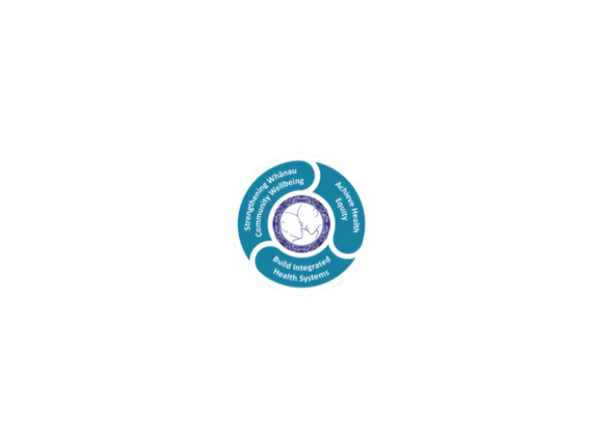

* Achieve equity in Māori health
* Build an Integrated health system
* Strengthen people, whanau & community wellbeing

### THREE CORE VALUES

Manaakitanga respect and acknowledgment of each other’s intrinsic value and contribution

Integrity truthfully and consistently acting collectively for the common good

Accountability collective and individual ownership for clinical and financial outcomes and sustainability

### TE ITI KAHURANGI – THE LAKES WAY, OUR PLACE, OUR CULTURE – WE WILL

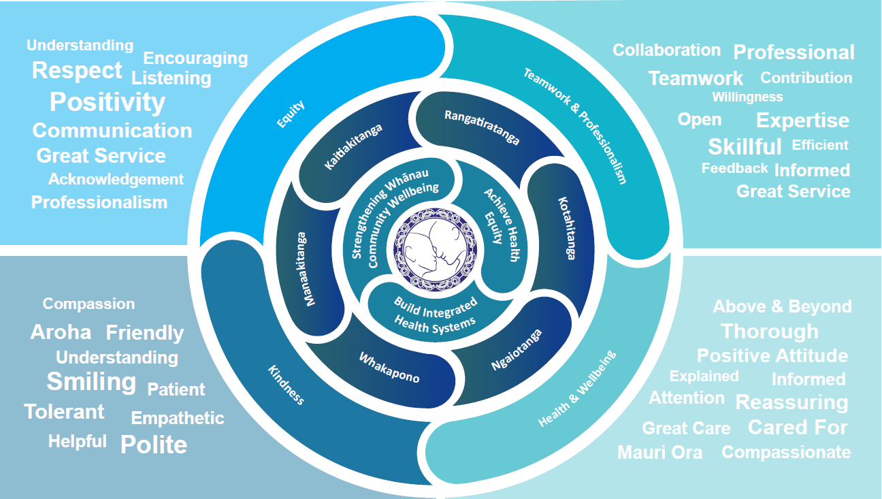

### TE TIRITI O WAITANGI

**Our expression of Te Tiriti o Waitangi**

The text of Te Tiriti, including the preamble and the three articles, along with the Ritenga Māori declaration, are the enduring foundation of our approach to achieving health and independence. Based on these foundations, we will strive to achieve the following four goals, each expressed in terms of mana.

**Mana whakahaere**

Effective and appropriate kaitiakitanga and stewardship over the health and disability system. Mana whakahaere is the exercise of control in accordance with tikanga, kaupapa and kawa Māori. This goes beyond the management of assets and resources and towards enabling Māori aspirations for health and independence.

**Mana motuhake**

Enabling the right for Māori to be Māori (Māori self-determination); to exercise their authority over their lives and to live on Māori terms and according to Māori philosophies, values and practices, including tikanga Māori.

**Mana tangata**

Achieving equity in health and disability outcomes for Māori, enhancing the mana of people across their life course and contributing to the overall health and wellbeing of Māori.

**Mana Māori**

Enabling Ritenga Māori (Māori customary rituals), which are framed by te ao Māori (the Māori world), enacted through tikanga Māori (Māori philosophy and customary practices) and encapsulated within mātauranga Māori (Māori knowledge).

Te Whatu Ora Lakes is committed within the framework of the New Zealand Public Health and Disability Act (2000) to supporting the Crown’s commitment to upholding its Tiriti promises.

### ORGANISATION STRUCTURE

