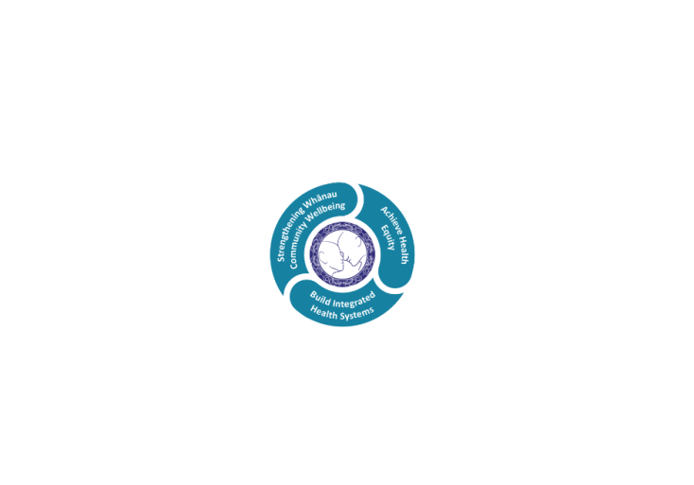

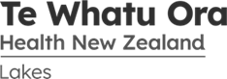

# POSITION DESCRIPTION

|  |  |  |
| --- | --- | --- |
| **Position**: | Trainee Cardiac Sonographer | |
| **Responsible to:** | Team Leader, Clinical Physiology | |
|  |  | |
| **Location:** | Rotorua & Taupo | |
| **Functional relationships:** | **Internal:**  Administrative Staff  Nursing Staff  Allied Health Staff  Medical Staff  Other Departments | **External**:  Equipment companies |
| **Financial delegations:** | Not applicable | |
| **Date**: | August 2022 | |

### Primary purpose(s) of the position

Train to competently perform Transthoracic Echocardiograms including bubble and contrast studies. Train to assist with Trans oesophageal Echocardiograms.

Complete the Post Graduate Diploma in Cardiac Ultrasound (QUT)

Work to achieve full MRTB registration as a qualified Cardiac Sonographer

Maintain exceptional patient care

|  |  |  |
| --- | --- | --- |
| **Key Objectives** | Description | Expected Outcomes |
| **Transthoracic Echo** | Learn the skills required to competently perform a comprehensive TTE, including bubble and contrast studies | * By the completion of training, is able to complete a TTE as per the CSANZ minimum standards and department protocol * By the completion of training, is able to recognise pathology and extend the ultrasound examination appropriately * By the completion of training, is competent at identifying pathology and able to complete a preliminary report * By the completion of training, is able to recognise and elevate clinical concerns appropriately * Register with MRTB as a Trainee Cardiac Sonographer, at the completion of training, meet the requirements to upgrade registration to qualified Cardiac Sonographer * Echo lists are performed at both Rotorua and Taupo Hospitals |
| **TOE** | Learn the skills required to assist the Cardiologist in image acquisition during TOE | * Learn to assist with patient preparation for TOE * Learn to perform appropriate image acquisition during TOE * Learn to clean the TOE probe using the Tristel wipes process |
| **General** |  | * Keep clinical rooms stocked with linen and consumables * Keep reporting stations clean and tidy * Report any equipment faults or concerns to the Team Leader * Clean ultrasound equipment as per H&S and department protocols |
| **Graduate Diploma in Cardiac Ultrasound** | Successfully complete the GDip in Cardiac Ultrasound, QUT | * Complete the Graduate Diploma from the first available QUT enrolment date after commencement of employment |

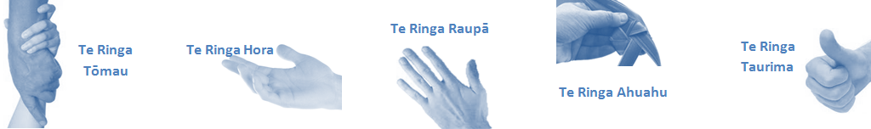

|  |  |  |
| --- | --- | --- |
| **Capabilities** | Capability definition | Achievement Indicators |
| **Communication and Personal Interaction**  **Te Ringa Hora**  ***the open hand (denoting someone who is sociable)*** | Openly communicates and cooperates with all levels of DHB employees, patients and visitors. | * Listens actively, absorbs message and responds appropriately. * Builds effective working relationships. * Establishes rapport with others and gains their respect while being adaptive in relating to different types of people and situation. * Openly and constructively participates in conversations with md team, patients, managers and visitors * Patients and visitors are appropriately welcomed and treated while within the DHB * Collegiality with team mates and md teams * Accepts differences of opinion can occur but these happen respectfully and without any continued animosity |
| **Strategy & Performance**  **Te Ringa Raupā**  ***the roughened hand (symbolising a hard worker)*** | Spends energy on delivering role requirements and meeting objectives | * Has an energetic approach to work and is self motivated. * Accepts direction and instruction of manager but is able to work effectively without direction or guidance. * Organises time and resources effectively. * Understands and work towards achievement of the organisation’s goals. * On shift is busy completing shift duties. |
| Organises own time to deliver on required tasks and duties | * Utilises effective time management strategies to meet shift duties and works towards achieving objectives in any spare moments. |
| **Development and Change**  **Te Ringa Ahuahu**  ***the hand that shapes or fashions something (refers to someone who is innovative)*** | Accepts change in day to day practices and contributes to decision making of the team. | * Can adjust behaviour to the demands of the work environment in order to remain productive through periods of transition, ambiguity, uncertainty and stress * Accepts when ideas are not accepted for implementation |
| Makes suggestions to increase efficiency of the unit. | * Works with managers and team to make any changes within practices work * Contributes to change processes, offering solution based ideas * Constructively makes suggestions to improve process or practices and gain efficiencies |
| **Personal Accountability**  **Te Ringa Tōmau**  ***the hand that is trustworthy*** | Is open with manager and colleagues and open to accepting feedback and critique to improve upon practice. | * Offers constructive criticism and accepts feedback. * Establishes rapport with others and gains their respect while being adaptive in relating to different types of people and situations, to allow improvements to be made. * Accepts all feedback and participates in feedback discussions appropriately * Responds and queries how improvements can be made * Advises manager wherever issues may be impacting on performance |
| Looks for and undertakes development activities appropriate for role and career development. | * Recognises areas that could be improved in own practice * Requests learning and development opportunities to enhance practice in role and/ or to assist where improvements can be made |
| **Culture and Values**  **Te Ringa Taurima**  ***the hand that nurtures, encourages, supports*** | Operates in line with DHB values and expectations and professional codes of conduct. | * Demonstrates a commitment to cultural safety by meeting and exceeding the cultural needs of clients/customers/colleagues. * Incorporates the Lakes Way into day to day business activities * Shows respect for patients, colleagues, managers, md teams * Utilises the Lakes Way philosophy to engage with patients, visitors and md teams |

|  |  |  |
| --- | --- | --- |
| **Compulsory Requirements** | Description | Expected Outcomes |
| **Māori Health** | Māori philosophies and values of health are demonstrated in work practice. | * Meaningful relationships are established with Te Aka Matua (Rotorua and Taupo Hospitals) and Te Whatu Ora Lakes Maori Health division in the delivery of services. * Practices are consistent with Te Tiriti o Waitangi /The Treaty of Waitangi when working with Māori. * Delivery of safe services for Māori are facilitated * Māori are enabled to access and participate in cultural activities provided by the Te Whatu Ora Lakes. * A commitment to improving the wellbeing of Māori by increasing cultural knowledge in the Te Whatu Ora Lakes is shown. |
| **Te Iti Kahurangi** | The Lakes Way, Our Place Our Culture | * Works within the Te Iti Kahurangi framework and supporting guide document. |
| **Record Keeping** |  | * Complies with the Te Whatu Ora Lakes Corporate Records Management policy to create and maintain full and accurate records. |
| **Quality & Risk** | Patient safety is paramount to the service we deliver at Te Whatu Ora Lakes. This is to be achieved in a clinical governance framework that is culturally responsive and identifies and manages risk and opportunities to improve. | * Employees are supported to lead by example and implement a culture of continuous quality improvement. * Risks that may prevent Te Whatu Ora Lakes from achieving their goals are identified and reported. * Māori patients are provided patient-centred care to achieve positive Māori health outcomes. * Evidence-based methodologies are used to support improvements, e.g. kaupapa Māori methodology. * Quality care is provided to certification standards. |
| **Health & Safety** | Each individual is responsible for ensuring the safety of themselves, their colleagues, patients and their visitors and to comply with all organisational health and safety policies, procedures and guidelines. | * Implementation and reinforcement of a proactive healthy work place culture which reflects relevant Te Whatu Ora Lakes policy and legislative requirements. * Healthy lifestyles are actively promoted and participated in, within the work area. * Employees participate in Health and Safety within areas of work. * Health and Safety policies have been read and understood and are applied in the workplace. * Health and Safety policies are appropriately documented within specified timeframes and incidents are reported immediately. * Any opportunities for improving Health and Safety are reported and acted upon in a timely manner. * All near misses/incident/accidents are reported to the appropriate line manager within 24 hours. |

**Signatures:**

|  |  |
| --- | --- |
| Line Manager:  (position description approved): |  |
| Employee:  (acceptance of position description): |  |

*(Please also initial all other pages to show acceptance of position description.)*

|  |  |  |
| --- | --- | --- |
| **Person Specification** | **Essential:** | **Desirable:** |
| **Education and Qualifications:** | * University Bachelors degree | * Undergraduate degree in Science or Health Science. |
| **Experience:** |  | * Work experience in a health care setting |
| **Knowledge:** | * Te Tiriti O Waitangi in the provision of health care services and support to Māori. * Te Tiriti O Waitangi in practice, process, policy development and decision making. * Te Whatu Ora Lakes is a Reorua organisation knowledge and understanding of Te Reo/ Correct pronunciation. |  |
| **Skills:** | * Pronunciation of Te Reo Māori words and names. | * Te Reo Māori |
| **Personal Attributes:** | * Excellent communication skills * Excellent self-management skills, proactive, initiative and resilient * Excellent study habits. * Excellent attention to detail * Able to work well as a team * Dedication to patient care | * Non-smoker preferred. |

**ABOUT TE WHATU ORA LAKES**

At Te Whatu Ora Lakes we place the highest value on the health and wellbeing of everyone in our community. As such all healthcare workers are expected to play a part in the creation and promotion of an environment which lives the following vision, mission and values:

### VISION

Healthy Communities – Mauriora! In this vision Mauriora refers to the Mauri - being the life essence and the source of well being, and ora - describing the state of wellness.

### STRATEGIC MISSION

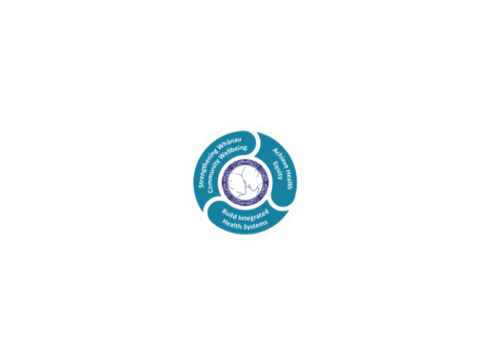

* Achieve equity in Māori health
* Build an Integrated health system
* Strengthen people, whanau & community wellbeing

### THREE CORE VALUES

Manaakitanga respect and acknowledgment of each other’s intrinsic value and contribution

Integrity truthfully and consistently acting collectively for the common good

Accountability collective and individual ownership for clinical and financial outcomes and sustainability

### TE ITI KAHURANGI – THE LAKES WAY, OUR PLACE, OUR CULTURE – WE WILL

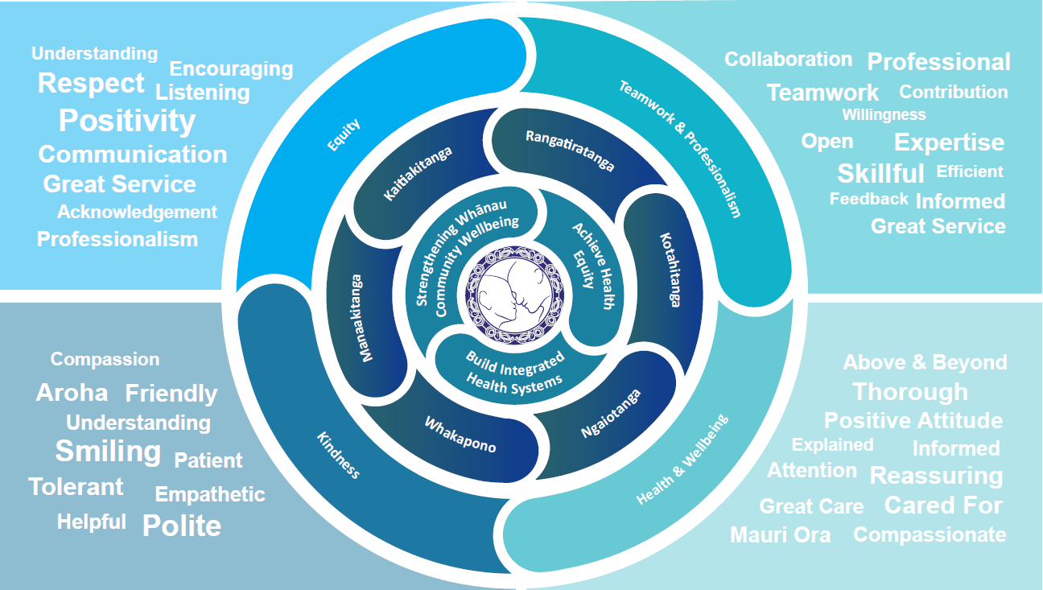

### TE TIRITI O WAITANGI

**Our expression of Te Tiriti o Waitangi**

The text of Te Tiriti, including the preamble and the three articles, along with the Ritenga Māori declaration, are the enduring foundation of our approach to achieving health and independence. Based on these foundations, we will strive to achieve the following four goals, each expressed in terms of mana.

**Mana whakahaere**

Effective and appropriate kaitiakitanga and stewardship over the health and disability system. Mana whakahaere is the exercise of control in accordance with tikanga, kaupapa and kawa Māori. This goes beyond the management of assets and resources and towards enabling Māori aspirations for health and independence.

**Mana motuhake**

Enabling the right for Māori to be Māori (Māori self-determination); to exercise their authority over their lives and to live on Māori terms and according to Māori philosophies, values and practices, including tikanga Māori.

**Mana tangata**

Achieving equity in health and disability outcomes for Māori, enhancing the mana of people across their life course and contributing to the overall health and wellbeing of Māori.

**Mana Māori**

Enabling Ritenga Māori (Māori customary rituals), which are framed by te ao Māori (the Māori world), enacted through tikanga Māori (Māori philosophy and customary practices) and encapsulated within mātauranga Māori (Māori knowledge).

Te Whatu Ora Lakes is committed within the framework of the New Zealand Public Health and Disability Act (2000) to supporting the Crown’s commitment to upholding its Tiriti promises.

### ORGANISATION STRUCTURE

